**ACTIVITY DIAGRAM TEH BOSTON**

**APSI**

**KELOMPOK 13:**

**MUHAMMAD MUFLIH SYAFIQ- 10110038**

**ZIDDAN DZATILLAH AKBAR- 10110064**

**PRODI D3 SISTEM INFORMASI**

**JURUSAN TEKNOLOGI INFORMASI DAN KOMPUTER**

**POLITEKNIK NEGERI SUBANG**

**2025**

1. **UseCase**

1. Login

1. Register

1. Kelola data calon

1. Kelola data produk

1. Melihat Dashboard

1. Lihat data akun

1. Kelola bahan baku

1. Kelola data akun

1. Melihat status

1. Daftar mitra

1. Melihat informasi

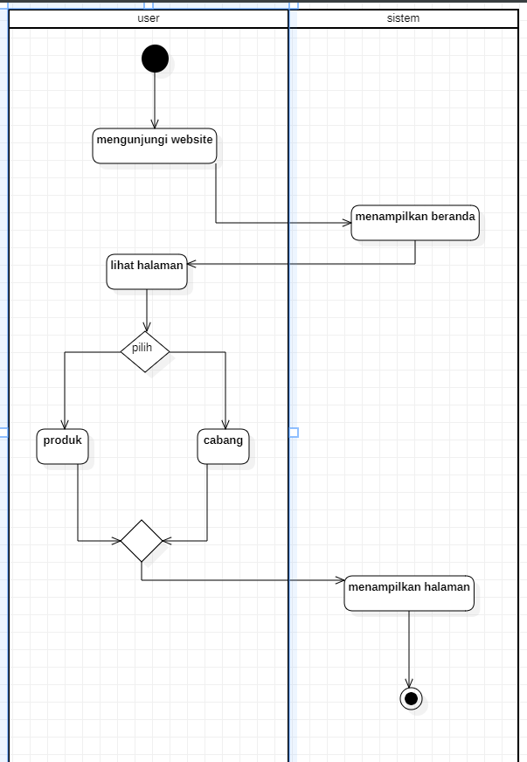

1. Mencatat transaksi

1. Laporan dokumentasi

1. Data Franchisee

1. Lihat laporan survey

1. ­­­­­­­­­­­Kelola Transaksi

1. Kelola Data Ulasan

1. Kelola Data Franchise baru

1. Lihat Data Calon

1. Kelola Data Laporan

1. Memberikan Ulasan

1. Melihat Data Diri

1. Melihat Franchisee

1. Tambah Franchisee

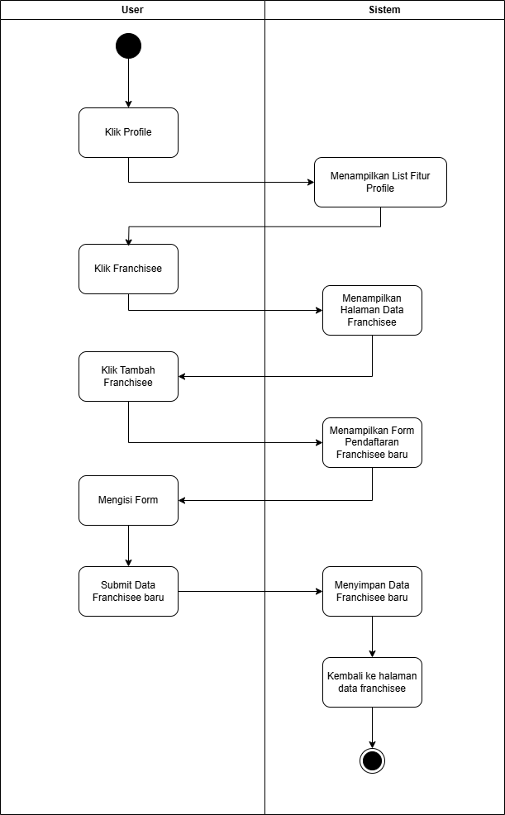

1. Setting Akun

1. Melihat Dashboard Franchisee

1. Setting Akun Kasir

1. Cetak PDF

1. Logout

**SEQUENCE**

1. **Login**
2. **Register**
3. **Kelola data calon**

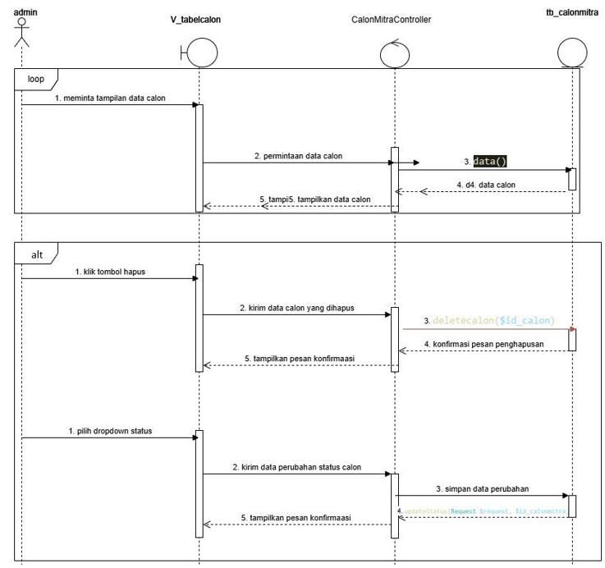



1. **Kelola data produk**



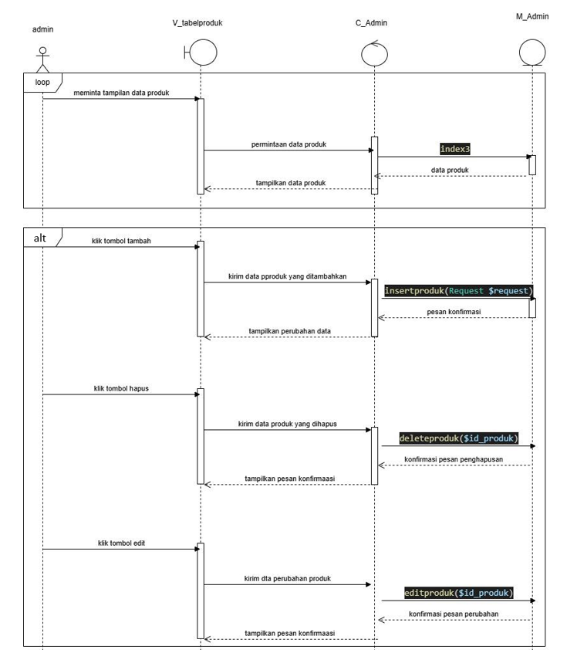



1. **Melihat laporan franchise**

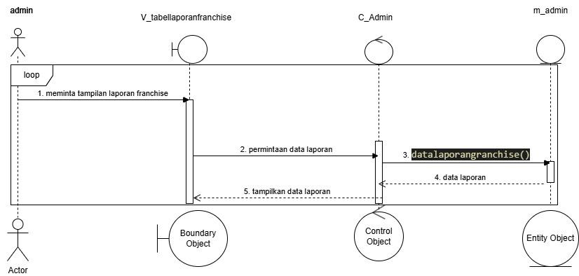

1. **Lihat data akun**

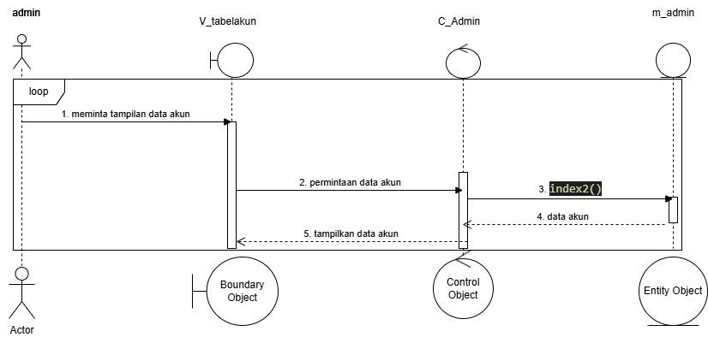

1. **Kelola bahan baku**

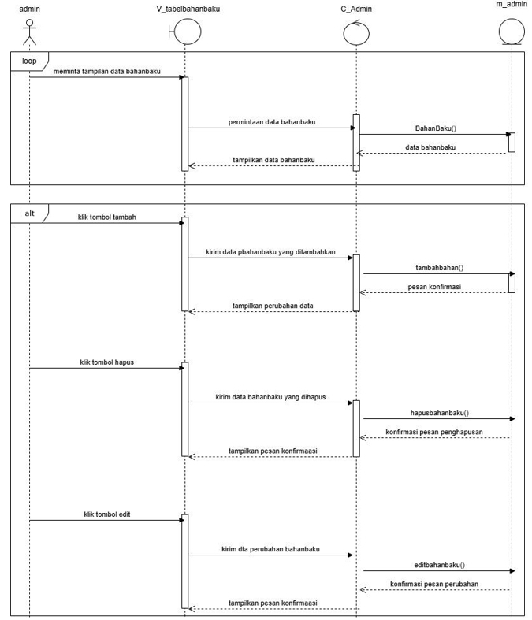



1. **Kelola data akun**

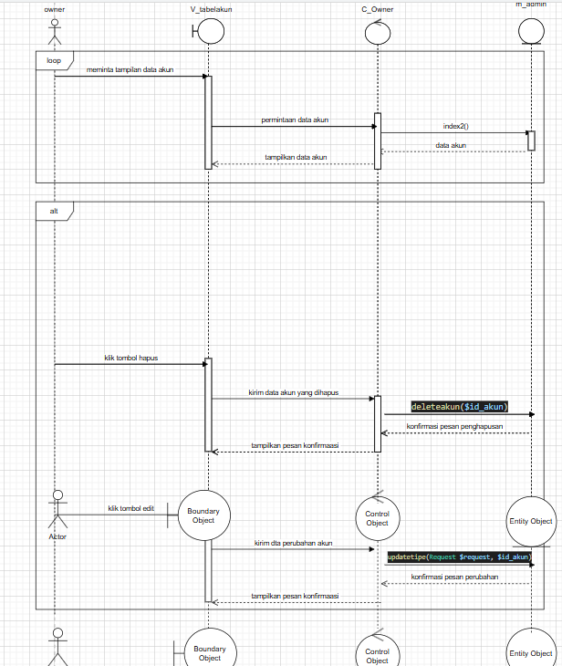

1. **Melihat status**

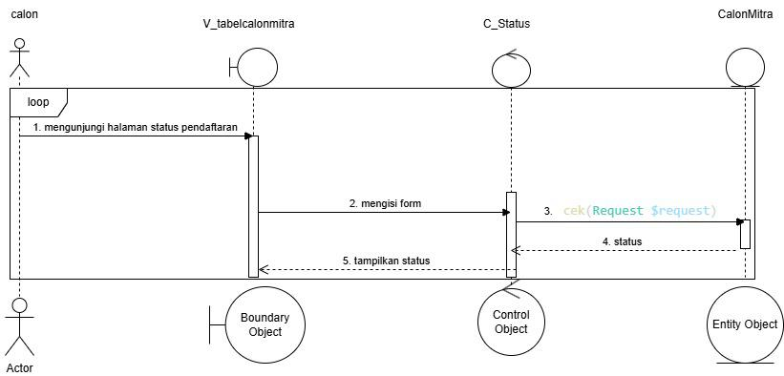

1. **Status mitra**

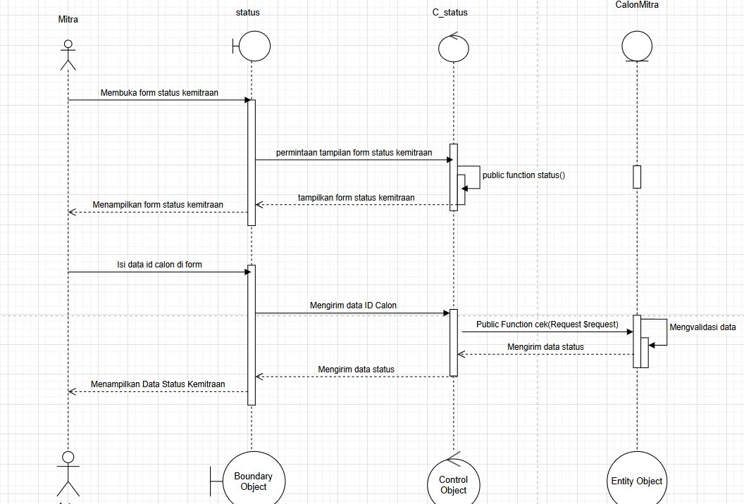

1. **Daftar mitra**

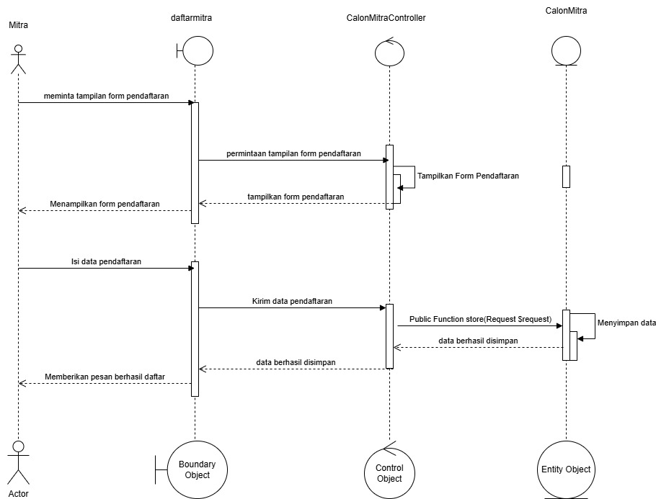

1. **Melihat informasi**

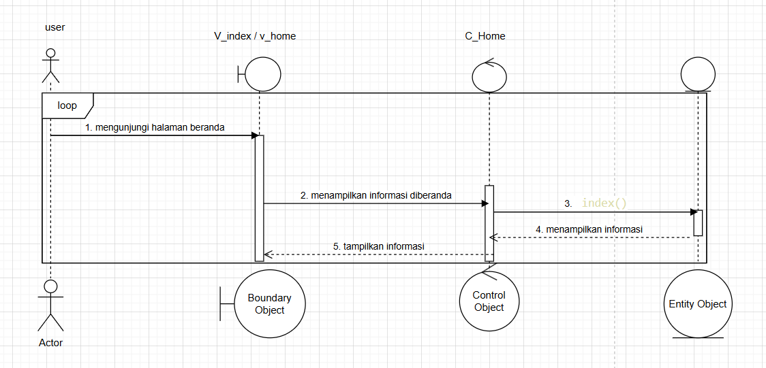

1. **Mencatat transaksi**

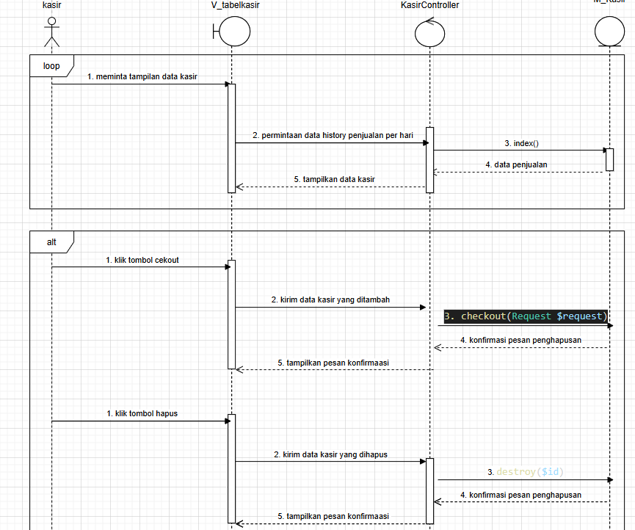

1. **Laporan dokumnetasi**

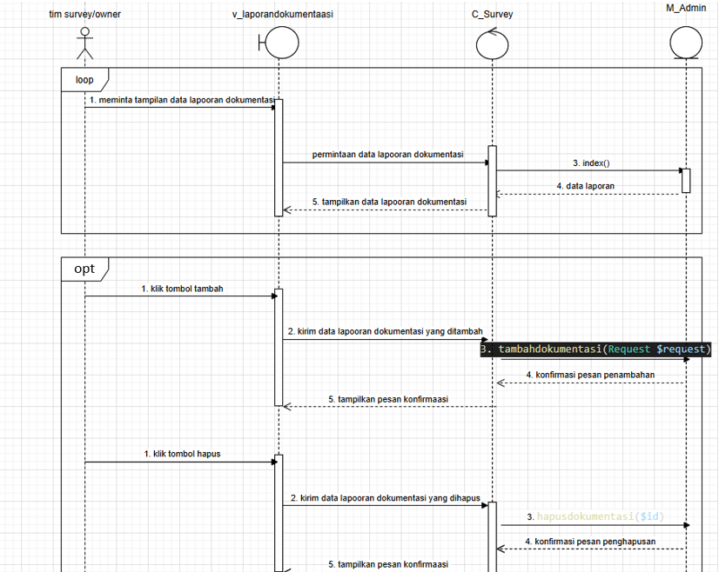



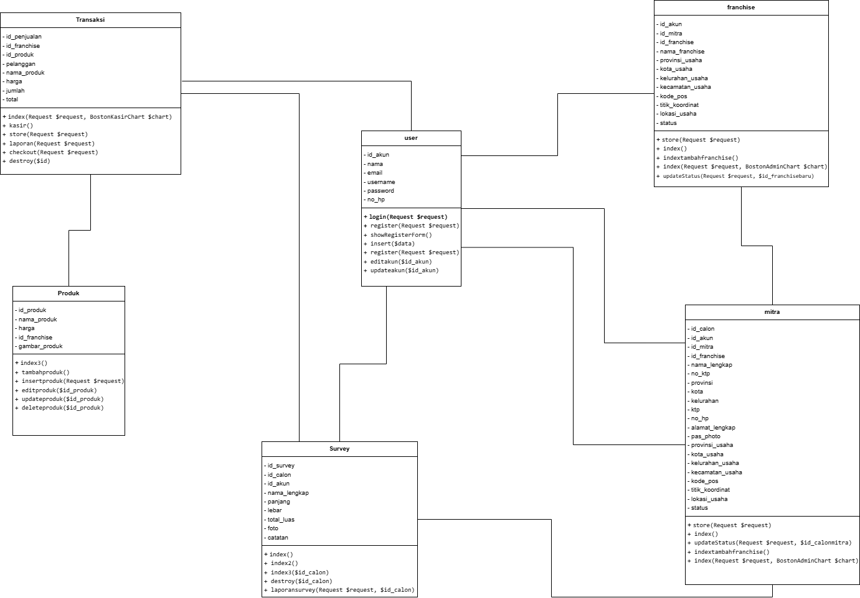**CLASS**