Stop The Express

1. Introduction
This simple game uses openGL, openAL libraries for graphics(sounds). Player can order a new lives, invulnerability and extra time. Most images are downloaded from fotolia gallery. More about images in chapter 5.1.

2. Controllers

2.1 ExpressViewController
This is main controller. His pourpose is init/destroy openGL context and call functions for update scene and draw scene. It also handles touches.

2.2 StartViewController
This is first controller after start. His responsibilities are counting of lives and levels and start other controlers.

2.3 HOFViewController
It displays simple table with best players.

2.4 AddViewController
If player reach score for displaying in Hall of Fame, this controller simply asks him for his name. No inforation is sent anywhere.

2.5 ParentalGateViewController
Because game is intendend for players of age 4+ and player is able to buy lives, this parental gate is required. It prevents kids from buying something by ask them for simple mathematical question.

2.6 BuyViewController
BuyViewController, initiates downloading pricelist, diplay it. The player is able to make order. Ater order, BuyViewController is reseted and player is able to make new order.

3. Data model

3.1 Determine motion directions from motion device
Look at this picture:

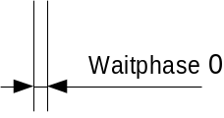
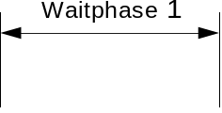
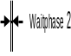
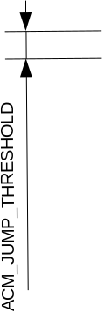
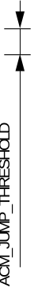
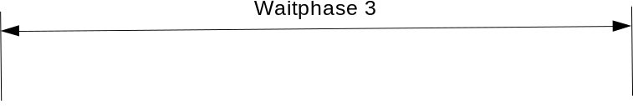
t
abs
1

When player starts move up, absolute value of motion vector incereases from 1(one g) to more. We are switched to waitphase 1. There is is a good point for signaling jump state. But player does not drop the phone and starts deccelerating. We are go over waitphase 2 to waitphase 3. Then, player returns to original position and starts decellerating again. Here is again positive peak and this peak should be filtered out because player really doesn want to jump. Now, many small peaks follows. So, there is a small problem with detecting end of jumping. There are two possibilities of end. One is, when four time in row abs is within range <1-ACM_JUMP_THRESHOLD, 1+ACM_JUP_THRESHOLD>. The second is, when we in waitphase3 and abs decreases less than 10%.

3.2 Detecting moves for left, right and down
Counting of these moves within plane defined by vector az,ax and vector ay. When player rotates with the device more than ACM_RECOGNIZING_ANGLE (φ), we are able to determive that we are in blue area. It is simple right triangle.

y
x,z
ay
φ
ay tan(φ)
Rotation
detected
area
abs(ax,az)

3.3 TextureItem
Textureitem item is base drawing function. Contructor load a bitmap(in any fomat) draw it to memory a store coords. DrawAtPoint draws bitmap with original size to specified point. One more complicated function DrawAtRect takes rect – it can be stretched, extended or mirrored(width<0). The second parameter is mask(only image under mask is drawn).

Image can be rectangle, one side can extend MAX_TEXTURE_SIZE(1024) but the second not. Because this app uses velry large bitmaps, all of them could not be stored in video memory and they are loaded into VRAM in every draw request. Optimization is posibble by reducing quality of images. Then, you can store all images in VRAM and uses only it's name(small int number) for identifying. In this game is this technique use only for bitmap of MAX_TEXTURE_SIZE_INMEMORY(16).

3.4 TextureManager
Texture manager performs small optimalisation. More items can share the same image data.

3.5 Items
All model items inherits from interface ModelObjectBase. Most of them stores data for behaviour and drawing.

3.6 AudioItem
AudioItem represents one sound for game. Constructor uses AudioToolbox library for load samples. Play function plays sound for one time.

3.7 AudioRailItem
Modifies AudioItem as infinite loop. On Stop Command plays second sound.

3.8 AudioManager
Optimizes sound. Many sounds can share the same resources.

3.9 IAPHelper
Performs command to SKPayment queue. Commands are restorePurchases, productRequest, buy.

3.10 IAPProducts
Performas command into IAPHelper, stores pricelist and purchased items.

3.11 KeychainService
KeychainService stores values about purchased product to the ios keychain. Used by IAPProducts.

3.12 HOF
Stores hall of fame results. Data are stored in file.

4 View

4.1 Drawed Items
All drawn items are implementing interface GraphicObjectBase. They have information from model and only stores the textureItems object. The are mostly call DrawAtRect functions.

5 Data

5.1 Images
The set of images are in property of server fotolia.com(new adobe stock). Most of the images are cars and locos.
- Fotolia_24259175_XXL
- Fotolia_25852047_XXL
- Fotolia_30024272_XXL
- Fotolia_34525479_V
- Fotolia_37860758_XL
- Fotolia_46666532_L
- Fotolia_51509481_XL

You have to download them. Then, these images must be adapted. If you want skip this, send me these images (me@zdenekskulinek.cz) and i will send you back images adapted.

Launch image and icons contains image from author Freepik. He requires to have his name on the image „Designed by Freepik“

All rest image is mine and these are free for use in this game.

5.2 Sounds
All sound are my property. You may use them in this game only.

6 Libraries

6.1 openGL
This simple game uses openGL library for graphics. All objects are rectangles covered with texture.

6.2 openAL

6.3 AudioToolBox

6.4 GoogleFirebird
You need update file googleservice-info plist. This file is downloaded from firebird account.

