Test Case Id: 02 |  | Test Purpose: User can navigate the side bar category “Dashboard”
Environment: Cypress 5.2.0
Preconditions: User enters the website https://docs.cypress.io
Test Case Steps: 6
Step No | Procedure |  | Response | Pass/Fail
1 | Check if the drop-down list options are readable and not truncated due to field size limits. |  | As expected.  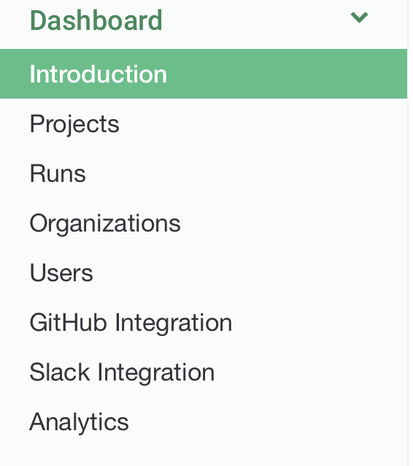 | Pass
2 | The side bar menu is accesible on smaller screens. |  | As expected.  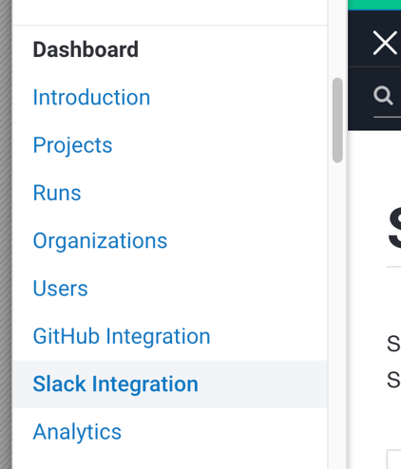 | Pass
3 | The side bar “Dashboard” displays the right content after the clicking on the option. |  | As expected. | Pass
4 | The colour changes after hovering on the selected option. |  | As expected.  The color changes to green.  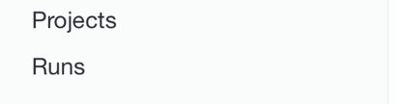  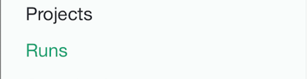 | Pass
5 | The options open up after clicking on the “Dashboard” field and the field is fully functional. |  | As expected. | Pass
6 | The linked options redirect the user to the right URL. |  | As expected.  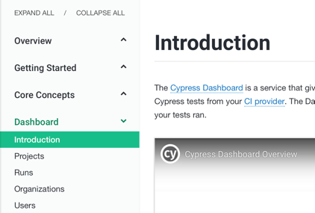 | Pass
7
8
9
10
Comments:
Related Tests:
Author: Zdenko Mucina |  |  | Checker:

