**Overview**

As discussed in original design documents, the code was initially intended to be built using Jenkins and Docker, however after a good amount of work with Jenkins, the switch to GitHub was made. Switching to GitHub allows for easier build and testing management, as well it is easier to set up in a new environment.

**GitHub Actions**

To set up the GitHub actions, you can fork the repository and the actions will be carried over. They may need to be imported in, which can be done in the actions tab of the forked repository.



Once set up, there are two action configurations, the first, Build & Test, will compile the code, then run all the tests. It will as well do a code-coverage analysis, to ensure test coverage remains high. The following is an example of the coverage statistics from the most recent version:

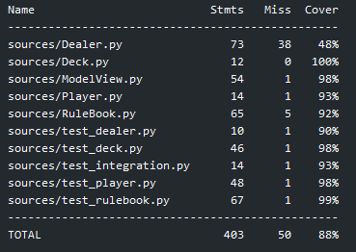

In addition to testing, the code will also be linted. After the test and build process, the code will be flagged as passing in GitHub. This occurs every time code is pushed to the repository

The second configuration, release, will create a GitHub release deploying the app. To run this config, a tag will have to be created following the format: vx.x.x where x is a number signifying version. Using the command ‘git push origin <tag>’ will cause the release configuration to run. Following this a release will be created under the releases section in the repository.



To run the program, the following command is used:

Python sources/dealer.py

**Jenkins & Docker**

For the Jenkins setup, the server will need to be setup, then the Jenkinsfile used to create a pipeline. The Jenkinsfile is still in the code currently despite not being, in my opinion, the best method for creation. Jenkins will compile the code, test the code, then stash a compiled version of the program. It does not occur automatically after GitHub pushes because the server is locally running. The Jenkins server may be set up with the following guide: <https://www.jenkins.io/doc/tutorials/build-a-python-app-with-pyinstaller/>