Documentation pour la classe Neuron obtenable avec help(Neuron) :

class Neuron(builtins.object)

| fields:

| input_size: int

| beta: list of the coefficitents used in the linear combination of the

| outputs of the previous layer

|

| Methods defined here:

|

| __init__(self, input_size)

| Creates a Neuron object with random coefficients

| ----

| input:

| input_size: int -> n_c where c is the layer of the neuron

| ----

| output:

| void

|

| comb_lin(self, Zc)

| Returns the sum of beta * Z

| ----

| Input:

| Zc: array of length n_c -> outputs of the previous layer

| ----

| output:

| out: float -> sum of beta * Z

|

| compute_output(self, Zc)

| Given the outputs of the previous layer, computes the output of

| this neuron

| ----

| input:

| Zc : array of length n_c -> outputs of the previous layer

| ----

| output:

| out : float -> output of the neuron

Documentation pour la classe NeuralNetwork obtenable avec help(NeuralNetwork) :

class NeuralNetwork(builtins.object)

| fields:

| format: array of integers of size C -> (n_c)_c

| neuron_layers: array of arrays ofNeurons array length C. The c th layer has length n_c

| -> a line represents a layer of neurons

| Z_layers: float array array -> stores the current output of each Neurons

| learning_Rate: float -> learning Rate used for backpropagation

| current_input: float array of size p -> the input being computed

| errors: float array of size n_C -> the error of each line

| derivatives: float array -> derivatives[c][k][j] = dR / dbeta_(j, k)^c

|

| Methods defined here:

|

| __init__(self, format, p)

| Creates a NeuralNetwork object with random coefficients and a given

| size for each layer

| ----

| input:

| format: array of integer of size C -> (n_c)_c

| p: int -> the numberof column used as input of the network

| ----

| output:

| void

|

| compute_all(self, database, outputs)

| Make the every line go through the network, storing the errors of each one

| ----

| input:

| database: array of shape (N, p) -> the training database

| outputs: array of shape (N, n_C) -> the expected outputs (y)

| ----

| output:

| void

|

| compute_derivatives(self, expected_output)

| Adds the derivative of R_i with respect of every coefficient to the

| derivative matrix

| ----

| input:

| expected_output: float array of length n_C -> the outputs expected

| for the current inputs

| ----

| output:

| void

|

| compute_error(self, expected_output)

| Returns the current error

| ----

| input:

| expected_output: float array of size n_C -> y

| ----

| output:

| res: float -> R_i(theta)

|

| compute_one(self, input)

| Make the input go through the network and stores the outputs of each layer

| ----

| input:

| input: array of floats of size p -> (x_i)_i

| ----

| output:

| void

|

| deriv_Z(self, m, cz, j, k, cb)

| Returns the derivative of Z_m^cz with respect to beta_(j, k)^cb

| ----

| input:

| m, cz, j, k, cb: int

| ----

| output:

| res: float -> the derivative

|

| deriv_error_i(self, j, k, c, expected_output)

| Returns the derivative of R_i with respect to beta_(j, k)^c

| ----

| input:

| j, k, c: int

| expected_output: float array of length n_C -> the outputs expected

| for the current inputs

| ----

| output:

| res: float -> the derivative

|

| predict(self, database)

| Predicts the outputs for each line of the database

| ---

| input:

| database: float array of shape (N, p)

| ----

| output:

| prediction: float array of shape (N, n_C)

|

| total_error(self)

| Returns the error of one line

| ----

| input:

| void

| ----

| output:

| res: float -> R = \sum_i R_i

|

| train(self, database, outputs, n)

| Trains the network on the database

| ----

| input:

| database: float array of shape (N, p)

| outputs: float array of shape (N, n_C)

| n: int -> how many times the database will go through the network

| ----

| output:

| error_list: float array of length n -> the error after each turn

|

| update_coeff(self)

| Update every coefficient of the network using backpropagation

| ----

| input:

| void

| ----

| output:

| void

Bon fonctionnement :

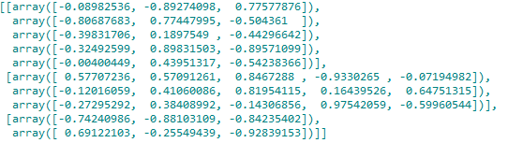Coefficients initiaux, générés aléatoirement dans $\left[-1, 1\right]$, pour un réseau avec des entrées de taille 3, une couche de 5 neurones, une de 3 neurones puis deux sorties.   
Les rectangles sont pour la suite.



On fait passer l’entrée $\left(1, 1, 1\right)$ dans le réseau.   
Ligne 1 et 2 : sortie des neurones des couches 1 et 2.   
Ligne 3 : sortie du réseau de neurone (on applique pas sigma).   
Rectangles pour ce qui suit

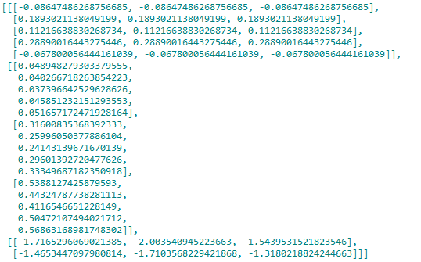

Les dérivées par rapport à chaque coefficient (première couche en haut, dernière en bas).   
Par exemple, on a que $\frac{∂R_{i}}{∂β_{1, 1}^{2}}=-2\left(y_{i,1}-{\hat{y}}_{i,1}\right)Z_{1}^{2}$ par application de la formule. On a $y_{i,1}=0, {\hat{y}}_{i,1}=-1.47…, Z_{1}^{2}=0.58…$ (termes encadrés en rouge avant), on trouve bien le même résultat.

De même, on a $\frac{∂R_{i}}{∂β_{1,1}^{1}}=-2Z_{1}^{2}\left(1-Z_{1}^{2}\right)Z_{1}^{1}\left(\left(y_{i,1}-{\hat{y}}_{-i},1\right)β_{1,1}^{2}+\left(y_{i,2}-{\hat{y}}_{i,2}\right)β_{1,2}^{2}\right)$ $=-2 *0.58262103 * \left(1 - 0.58262103\right)* 0.44848654* \left(\left(0 + 1.47310989\right)* -0.74240986+ \left(1 + 0.25754533\right)* 0.69122103\right)=0.489…$

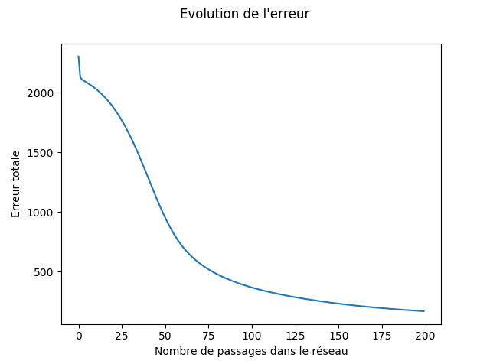

Évolution de l’erreur sur un échantillon de 4500 lignes de la base de données de spam (après mise à l’échelle), pour 200 passages dans un réseau $[5, 3, 2]$, avec un learning rate constant de $\frac{0.5}{4500}$.   
Le procédé a pris plusieurs heures, et la prédiction sur les 101 lignes restant a montré un taux de réussite de 97%.