Sprint 2 Defense Report: Implemented Features & Verification
Project: AiAdvisor (Course Planning & Academic Advisory System)
1. Overview of Sprint 2
In this second sprint, our goal was to build the core academic features of the AiAdvisor system. We wanted to make sure the platform has real data to work with before adding smart recommendations in Sprint 3. Specifically, we implemented five main user stories from our product backlog: managing courses in the catalog, managing prerequisites with loop protection, letting students browse courses, uploading transcripts with an anti-fake check, and showing students their GPA and academic progress.
Table 1. User Stories Completed in Sprint 2
#Story | Feature Title | Points | Assignee | Status
Story 6 | Manage Course Catalog | 5 SP | Dulat | Completed & Tested
Story 7 | Manage Prerequisites | 5 SP | Manas | Completed & Tested
Story 8 | Browse the Course Catalog | 3 SP | Kamila | Completed & Tested
Story 9 | Upload the Transcript | 5 SP | Manas | Completed & Tested
Story 10 | See GPA and Progress | 4 SP | Kamila | Completed & Tested

2. User Story 6: Manage Course Catalog
Role: Administrator | Story Points: 5 | Developer: Dulat
"As an administrator I want to create, edit and archive courses (code, name, credits, description, semester) so that students always see the actual catalog."
What we did in this feature:
Earlier in the project, courses were hardcoded or pulled directly without an easy way to manage them. In this sprint, we added a full course management tab in the Admin Panel. Now, an administrator can easily add a new course, change existing details, or archive a course when it is no longer offered.
Key points to highlight during defense:
• Course details: Each course stores its code (e.g., CSS 105), full name, ECTS credits, language (English/Kazakh/Russian), semester, theory teacher, practice teacher, and quota limit.
• Duplicate code prevention: The system checks that course codes are unique. If someone tries to add a course code that already exists, the server blocks it with a clear error message.
• Archiving instead of deleting: When a course is archived, it disappears from the student catalog, but historical plans and completed records are preserved safely.
• Quick semester buttons: Inside the course form, we added one-click buttons for common semesters (Fall 2026, Spring 2026, Semester 1-5) to save time when creating courses.
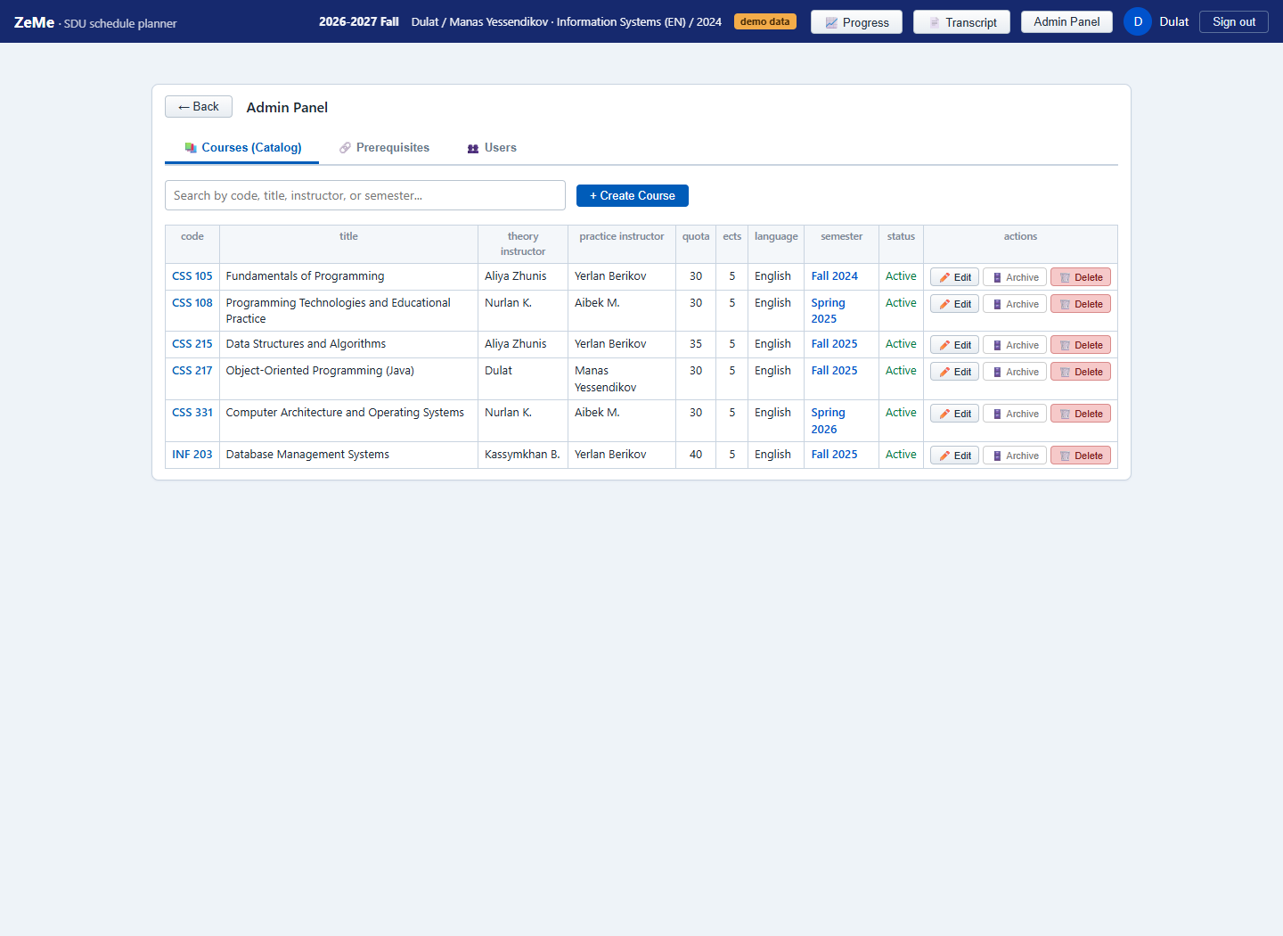
Figure 1. Course Catalog tab in the Admin Panel showing the course list, instructor assignments, quotas, and action buttons.
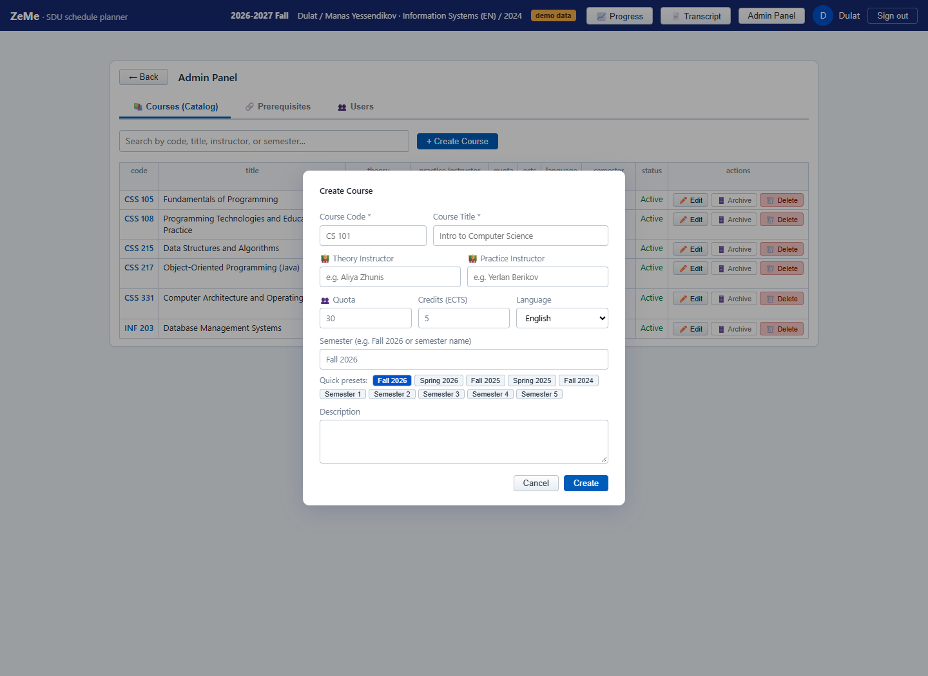
Figure 2. Course creation and edit modal with fields for teachers, quotas, and quick semester preset buttons.
3. User Story 7: Manage Prerequisites
Role: Administrator | Story Points: 5 | Developer: Manas
"As an administrator I want to define prerequisite links between courses so that the system can check whether a student can take a course."
What we did in this feature:
In our university, students cannot just take any course they want; they have to pass prerequisite courses first. In this story, we created a tool for administrators to define which course requires which other course, and what minimum grade is needed (for example, at least a C grade).
Key points to highlight during defense:
• Setting up requirements: The admin simply selects the main course and picks the required prerequisite course from a dropdown list.
• Protection against infinite loops (Cycle Detection): The most important algorithm here is loop detection. If Course A requires Course B, and an admin accidentally tries to make Course B require Course A, that would create an impossible loop. Our server checks this using a graph search algorithm (Depth-First Search) and immediately blocks the operation with a warning: 'Circular dependency detected'.
• Visual Dependency Cards: Instead of just a plain table, we created visual dependency cards so the admin can clearly see the chain of requirements (e.g. CSS 215 requires CSS 105).
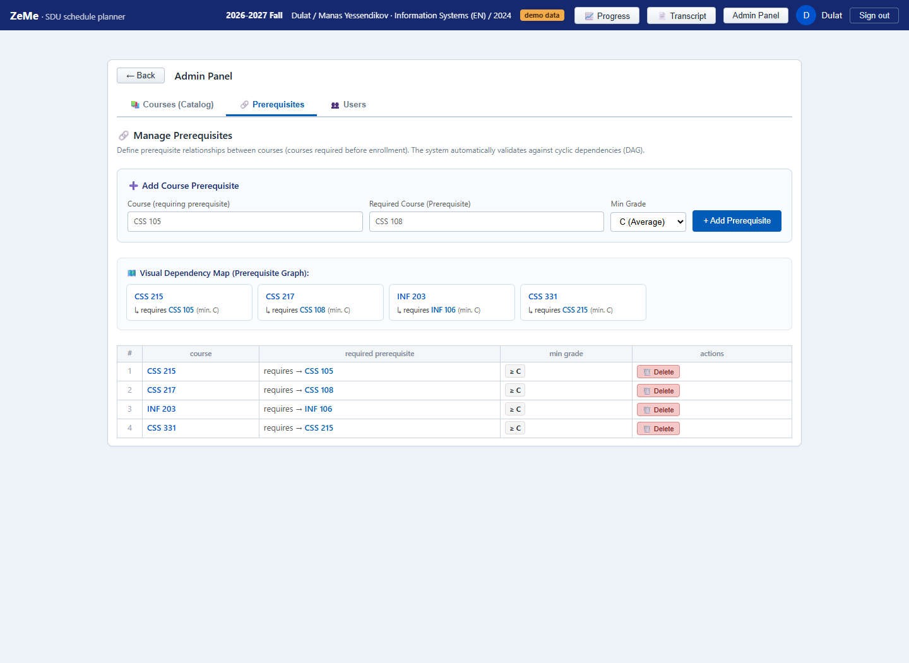
Figure 3. Prerequisites Management page with the add form, visual dependency cards, and the active prerequisites table.
4. User Story 8: Browse the Course Catalog
Role: Student | Story Points: 3 | Developer: Kamila
"As a student I want to search and filter the course catalog so that I can quickly find the courses I am interested in."
What we did in this feature:
This feature is built for students so they can easily find courses and plan their schedule. Students can search for any course by code or keyword, view all courses in their degree program broken down by semester, and see which courses are already passed or still need to be taken.
Key points to highlight during defense:
• Instant search: Students can type a course code like 'CSS 215' into the search bar, and the system opens the course details and available sections in less than two seconds.
• Semester breakdown: The curriculum is grouped clearly by semester (Semester 1 through Semester 8) with course names, credits, lecture/practice hours, and current status (Passed, Failed, Taken, Not Taken).
• Elective groups: For elective courses (like General Education Electives), the system shows how many elective choices are available in that group and lets students explore candidate courses.
• Timetable conflict check: When a student looks at sections, the system checks their current schedule and marks any time overlaps in red on the weekly grid.
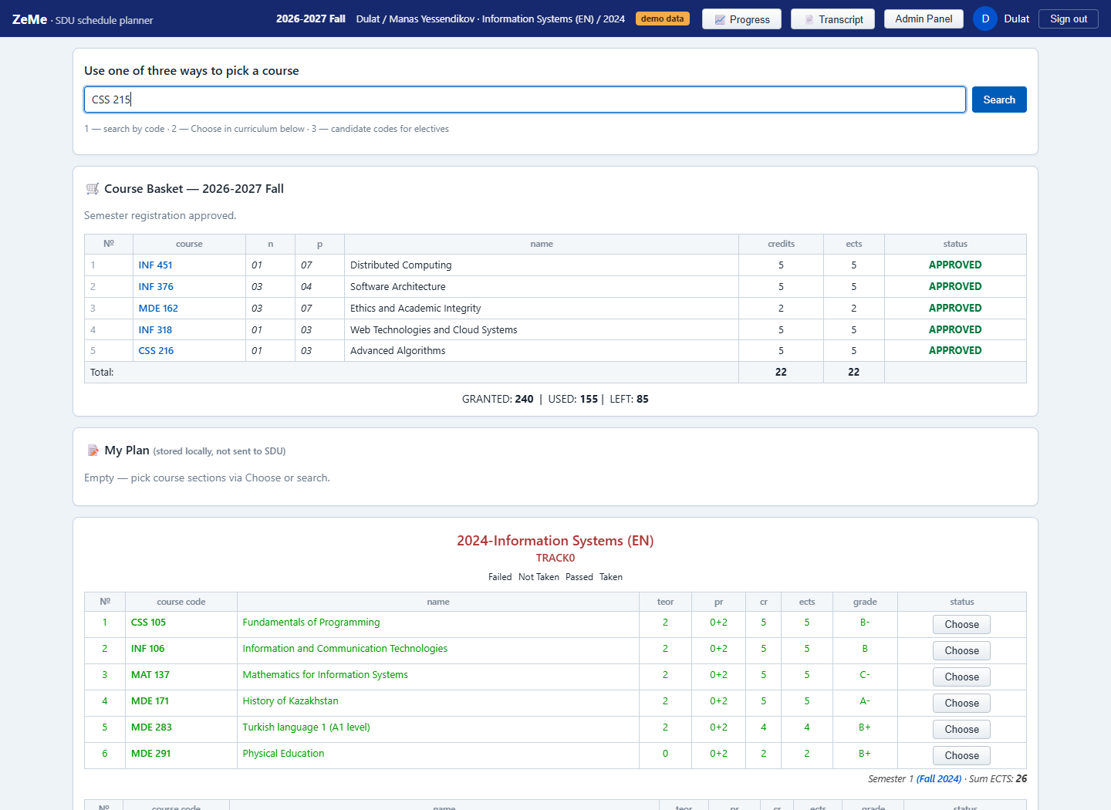
Figure 4. Student view with course search bar, approved course basket, and semester-by-semester curriculum table.
5. User Story 9: Upload the Transcript (with Anti-Fake Check)
Role: Student | Story Points: 5 | Developer: Manas
"As a student I want to upload my transcript or import my grades so that the system knows which courses I have already completed."
What we did in this feature:
Before this sprint, the system did not know the student's past grades. We built an automated transcript upload feature. A student simply downloads their official PDF transcript from the SDU portal and drags it onto the page.
Key points to highlight during defense:
• Automatic PDF text parsing: Our backend reads the PDF file, recognizes every completed course, course name, ECTS credits, letter grade (A, B+, C-, etc.), and calculates the corresponding GPA points.
• Anti-Fake verification: To prevent students from uploading someone else's transcript or faking their grades, our parser finds the Student ID inside the PDF and compares it with the ID of the student logged into the site. If the IDs match, the system displays a verified green banner. If they do not match, the upload is blocked.
• Matching with catalog: Each parsed course is checked against our course catalog. If a course is recognized, it links automatically. If not, the student can map it manually.
• Student confirmation: The student reviews all recognized courses in a table before clicking confirm, ensuring 100% accuracy in their academic record.
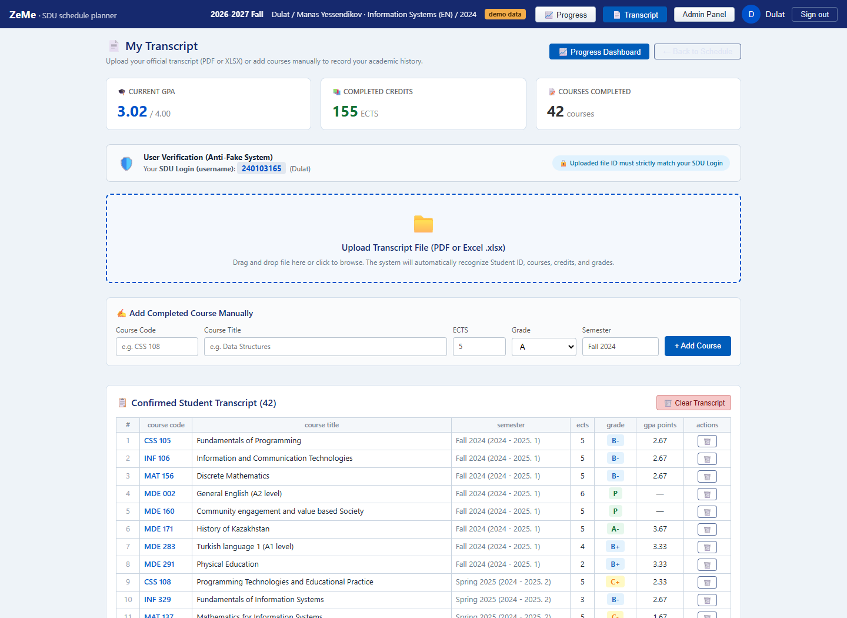
Figure 5. Transcript upload page showing the PDF upload box, Verified Student ID banner, and the recognized grades table.
6. User Story 10: See GPA and Academic Progress
Role: Student | Story Points: 4 | Developer: Kamila
"As a student I want to see my GPA and progress per semester so that I understand my current academic performance."
What we did in this feature:
Once grades are imported from the transcript, students need a clear way to see where they stand academically. We built an interactive Academic Progress Dashboard that gives students an instant overview of their progress toward graduation.
Key points to highlight during defense:
• Official ECTS-weighted GPA: The GPA is calculated strictly according to SDU rules, weighting each grade point by the course's ECTS credits. The overall cumulative GPA (e.g. 3.02) is shown right at the top.
• Degree progress bar: Shows how many credits the student has earned out of the 240 ECTS credits required for a bachelor's degree (for example, 155 / 240 credits, which is 64.6% complete).
• GPA trend chart: An interactive line chart shows how the student's cumulative GPA has changed semester by semester, making it easy to see whether performance is improving.
• Grade distribution: A clean breakdown showing how many As, Bs, Cs, and other grades the student has received.
• Detailed semester tables: Shows every semester with its own term GPA, credits earned, and the full list of courses.
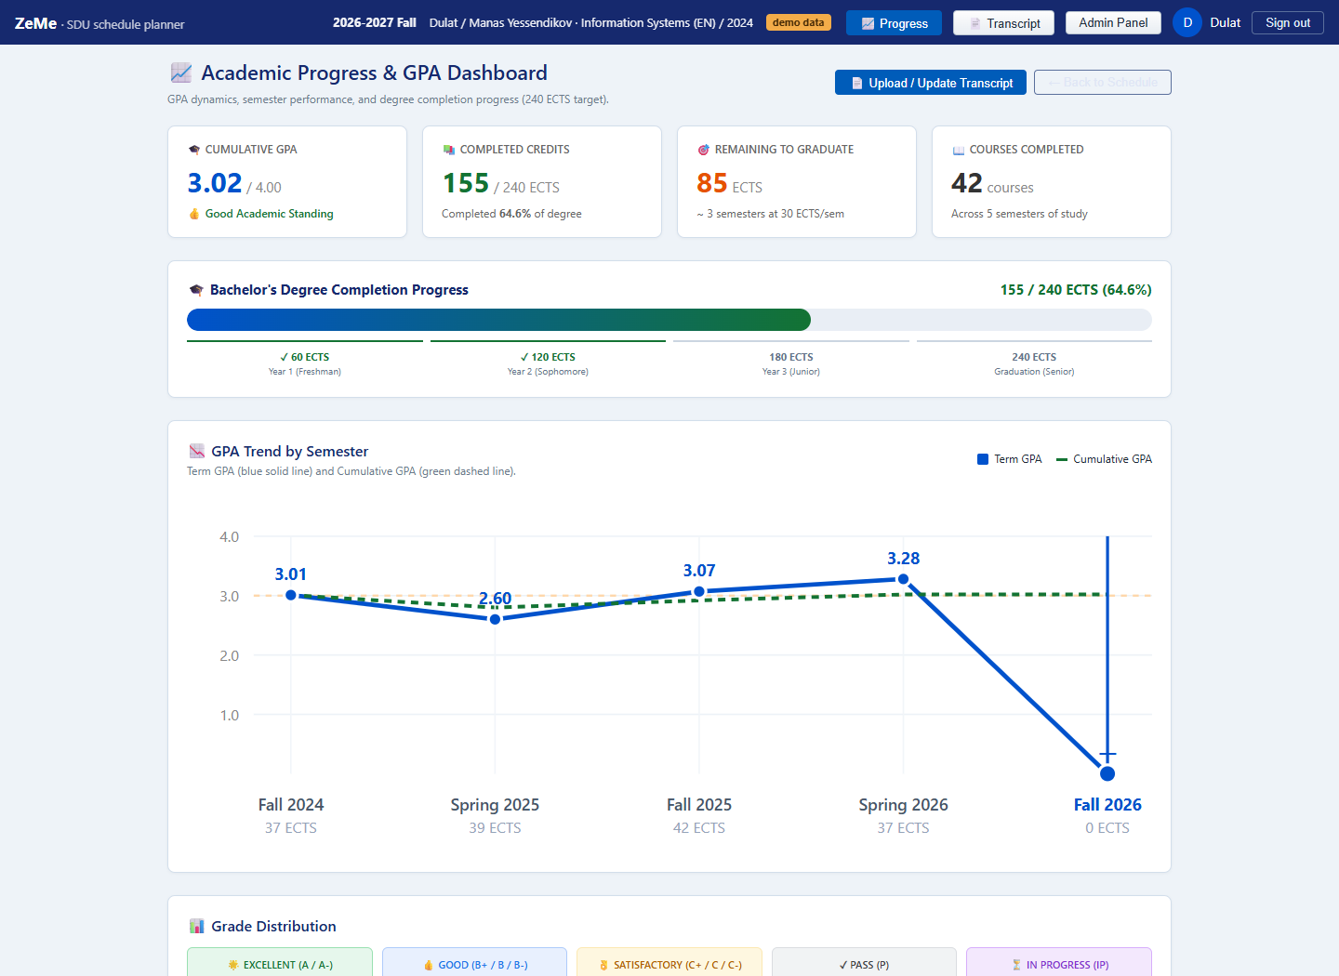
Figure 6. Progress Dashboard with Cumulative GPA card, Degree Completion bar, GPA Trend chart, and Grade Distribution.
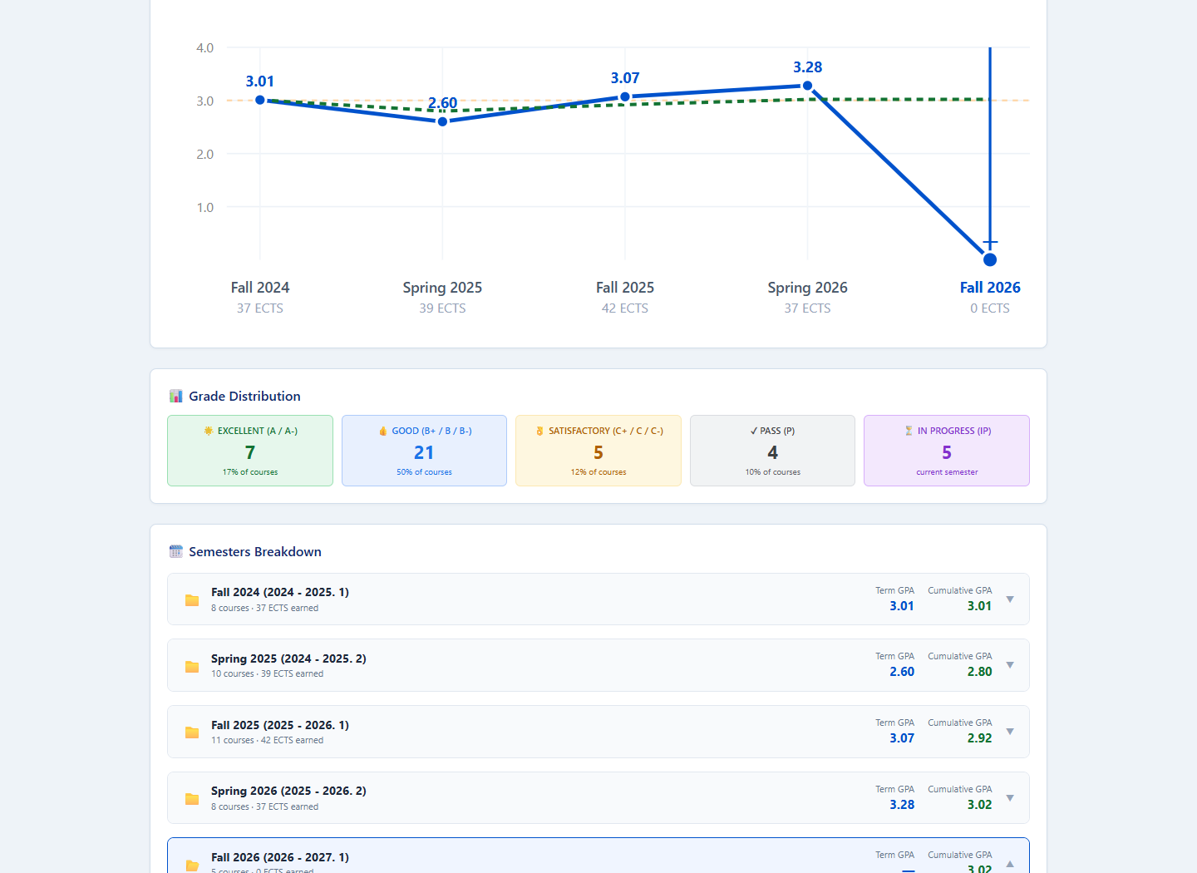
Figure 7. Semester-by-semester breakdown showing individual course grades, credits, and term GPAs.

