PC1 ip 168.192.2.2

PC3 ip 168.192.2.3

PC2 ip 168.192.2.4

.....

PC6 ip 168.192.2.7

各交换机配置命令

|  |  |
| --- | --- |
| 交换机S1配置  system-view  vlan 10  quit  vlan 20  quit  vlan 30  quit  interface Ethernet 0/0/1  port link-type trunk  port trunk allow-pass vlan 10 20 30  quit  interface Ethernet 0/0/2  port link-type trunk  port trunk allow-pass vlan 10 20 30  quit  interface Ethernet 0/0/3  port link-type trunk  port trunk allow-pass vlan 10 20 30  quit  display port vlan  quit  save  Y | 交换机S2配置  system-view  vlan 10  quit  vlan 20  quit  vlan 30  quit  interface Ethernet 0/0/1  port link-type trunk  port trunk allow-pass vlan 10 20  quit  interface Ethernet 0/0/2  port link-type access  port default vlan 10  quit  interface Ethernet 0/0/3  port link-type access  port default vlan 20  quit  display port vlan  quit  save  Y |
| 交换机S3配置  system-view  vlan 10  quit  vlan 20  quit  vlan 30  quit  interface Ethernet 0/0/1  port link-type trunk  port trunk allow-pass vlan 10 20  quit  interface Ethernet 0/0/2  port link-type access  port default vlan 10  quit  interface Ethernet 0/0/3  port link-type access  port default vlan 20  quit  display port vlan  quit  save  Y | 交换机S4配置  system-view  vlan 10  quit  vlan 20  quit  vlan 30  quit  interface Ethernet 0/0/1  port link-type trunk  port trunk allow-pass vlan 10 20 30  quit  interface Ethernet 0/0/2  port link-type access  port default vlan 20  quit  interface Ethernet 0/0/3  port link-type access  port default vlan 30  quit  display port vlan  quit  save  Y |

测试各计算机之间的互通性

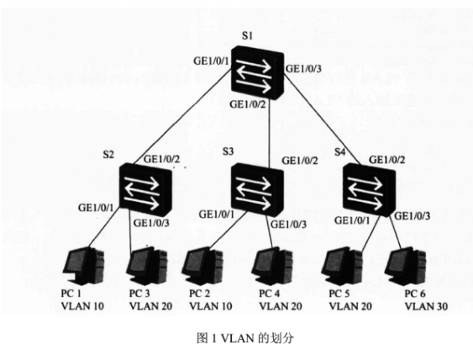

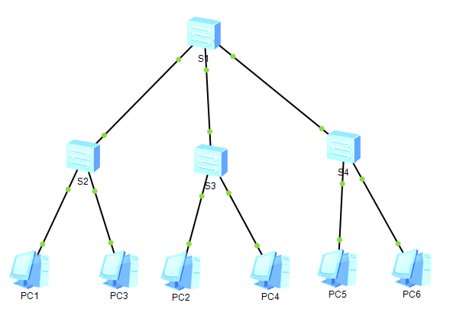

**PC1链接其它主机测试，只能与同属vlan10的PC2通信**

无法链接pc3

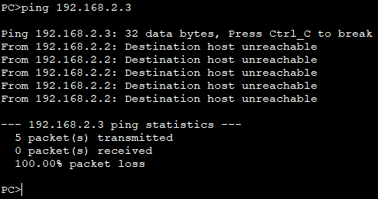

可以链接pc2

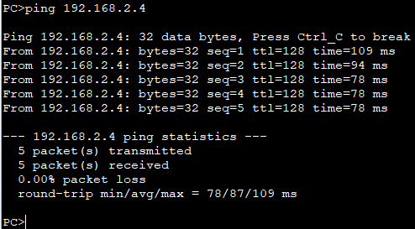

无法链接pc4

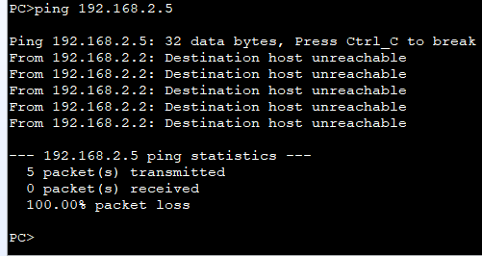

无法链接pc5

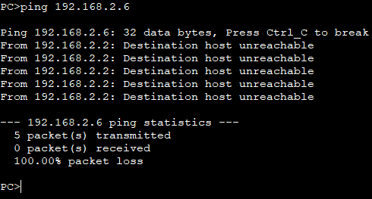

无法链接pc6

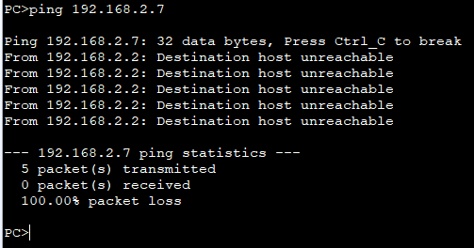

**结果正确**

**PC3链接其它主机测试，只能与同属vlan20的PC4，PC5通信**

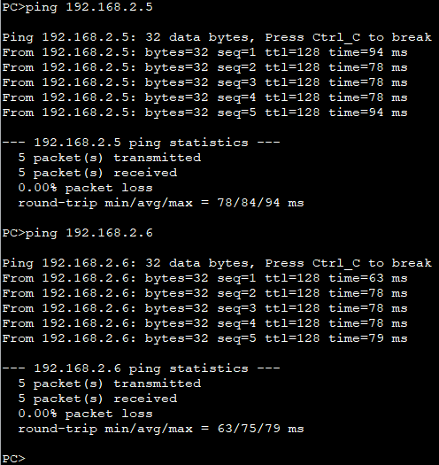

其它无法链接在此不做赘述