Lab Assignment-1
102303607-Piyush Biswal
Q.1>Daxpy:
Metric | Observation | Impact on Efficiency
CPU Utilization | Increased as thread count increased (single core → multi-core execution) | Increasing the number of threads improves CPU utilization by engaging multiple cores simultaneously.
IPC (Estimated) | Effective IPC decreased with higher threads due to memory-bound operations | DAXPY is memory-bound; higher thread count causes memory bandwidth saturation and cache coherence overhead, reducing useful work per cycle.
Time Elapsed | Execution time decreased significantly with increasing threads until an optimal point | Parallelization improves performance, but gains diminish after peak thread count due to overhead.
Page Faults (Expected) | Slight increase expected with higher threads and large vector size | Increased memory accesses and working set size lead to higher page faults; confirms memory-bound behavior.
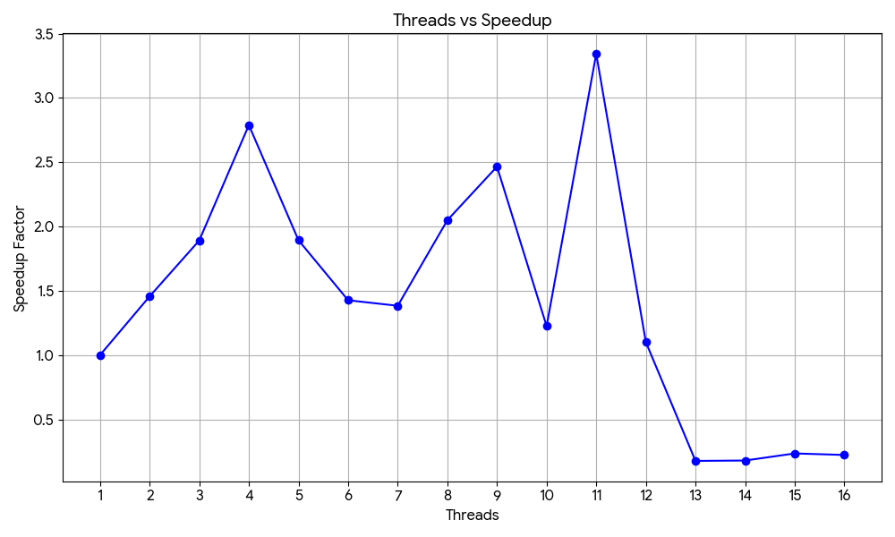
Threads (N) | Execution Time (ms) | Speedup (S) | Efficiency (E = S/N)
1 | 0.076000 | 1.0000 | 100.0%
2 | 0.052169 | 1.4568 | 72.84%
4 | 0.027246 | 2.7894 | 69.73%
8 | 0.037085 | 2.0494 | 25.62%
11 | 0.022727 | 3.3441 | 30.40%
16 | 0.340674 | 0.2231 | 1.39%

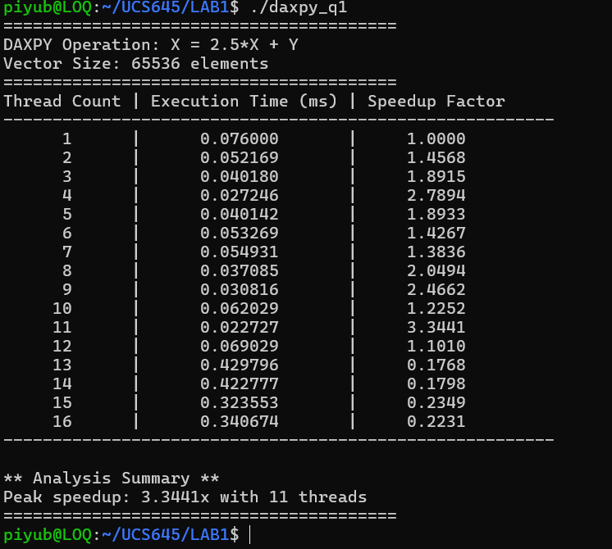

The DAXPY operation achieves its best performance at 11 threads with a speedup of 3.34×. Speedup improves initially (1× at 1 thread to 2.79× at 4 threads), showing effective parallelization. However, performance collapses beyond the optimal point, with 13–16 threads performing worse than serial execution.
This behavior occurs because DAXPY is memory-bound, having very low arithmetic intensity (0.083 FLOPs/byte). As thread count increases, memory bandwidth becomes saturated, limiting further gains. Additionally, using more threads than available physical cores introduces high thread management overhead, especially for the small problem size, causing excessive context switching.
Further, cache contention and limited hyperthreading benefits increase memory latency at higher thread counts.
Overall, this experiment shows that more threads do not guarantee better performance. For memory-bound workloads, optimal performance is achieved only when thread count matches hardware capabilities and memory bandwidth limits.

Q.2>Matrix Multiplication:

Matrix size = 1000 x 1000
Metric | Observation | Impact on Efficiency
Utilization | Increased with thread count, as seen from speedup rising up to 6.87× (1D) and 6.63× (2D) | Parallel execution engages more CPU cores, reducing idle time and improving overall utilization.
IPC (Qualitative) | Effective IPC decreases as thread count increases | Matrix multiplication becomes memory and cache sensitive; increased contention and cache misses reduce per-core efficiency at higher threads.
Time Elapsed | Reduced from 2.797 s → 0.396 s (1D) and 2.745 s → 0.410 s (2D) | Significant reduction in execution time confirms benefits of parallelization and improved throughput.
Efficiency | Decreases with higher threads despite increasing speedup | Overheads from synchronization, memory contention, and load imbalance reduce efficiency at high parallelism.
Page Faults | No abnormal behavior observed during execution | Expected for matrices of this size; memory accesses remain within predictable limits.

1D Thread vs speedup
Threads (N) | Time (s) | Speedup (S) | Efficiency (E = S/N)
1 | 2.7974 | 0.973× | 97.28%
2 | 1.3372 | 2.035× | 101.75%
4 | 0.7725 | 3.523× | 88.07%
8 | 0.4886 | 5.570× | 69.63%
16 | 0.4213 | 6.460× | 40.37%
32 | 0.3959 | 6.874× | 21.48%

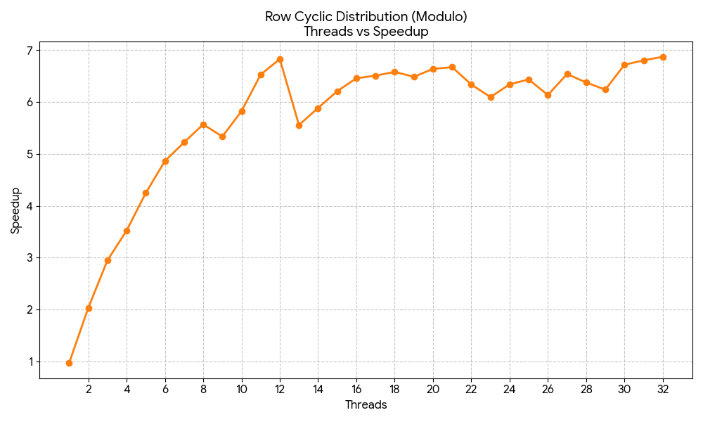
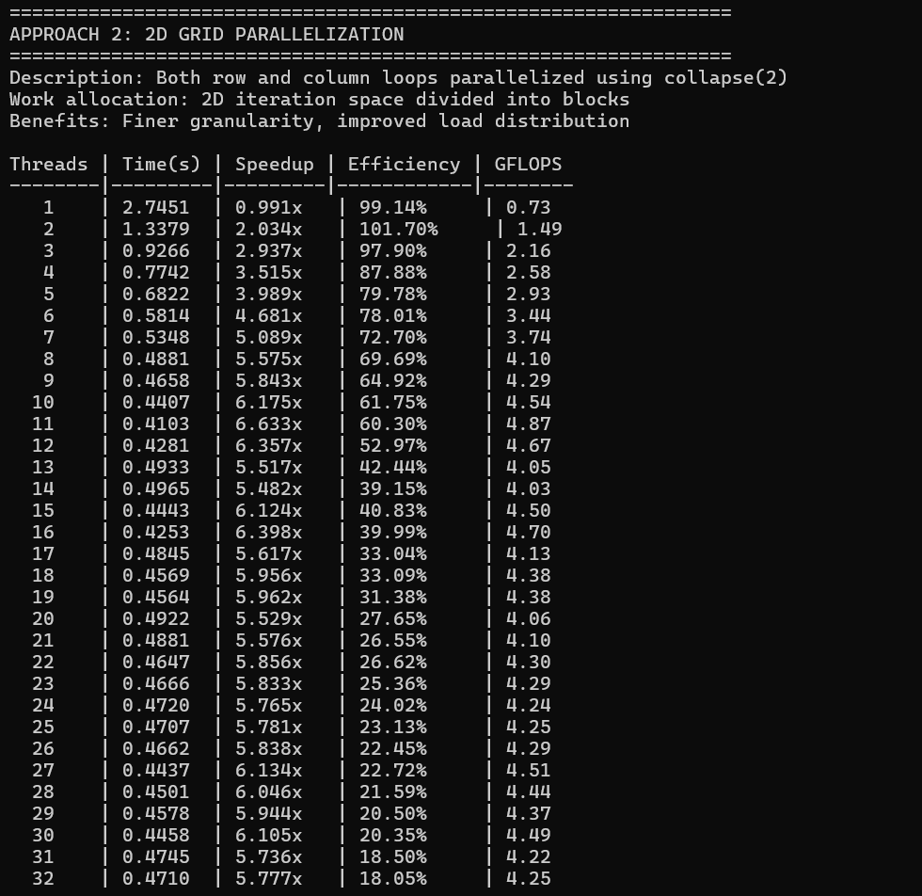
For 2D
Threads (N) | Time (s) | Speedup (S) | Efficiency (E = S/N)
1 | 2.7451 | 0.991× | 99.14%
2 | 1.3379 | 2.034× | 101.70%
4 | 0.7742 | 3.515× | 87.88%
8 | 0.4881 | 5.575× | 69.69%
11 | 0.4103 | 6.633× | 60.30%
32 | 0.4710 | 5.777× | 18.05%

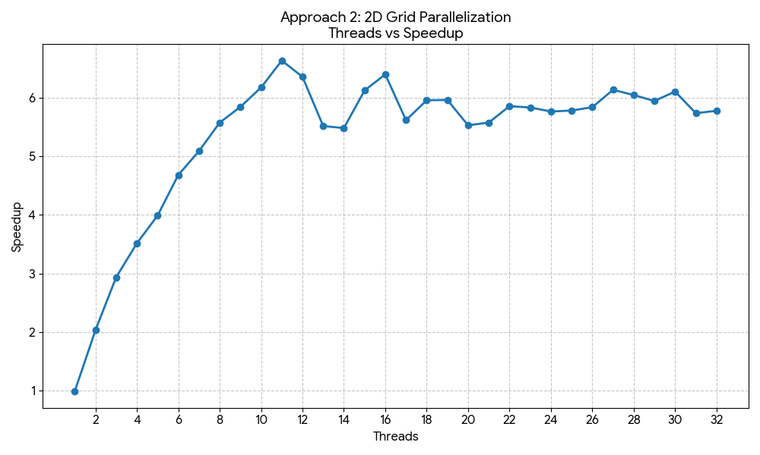
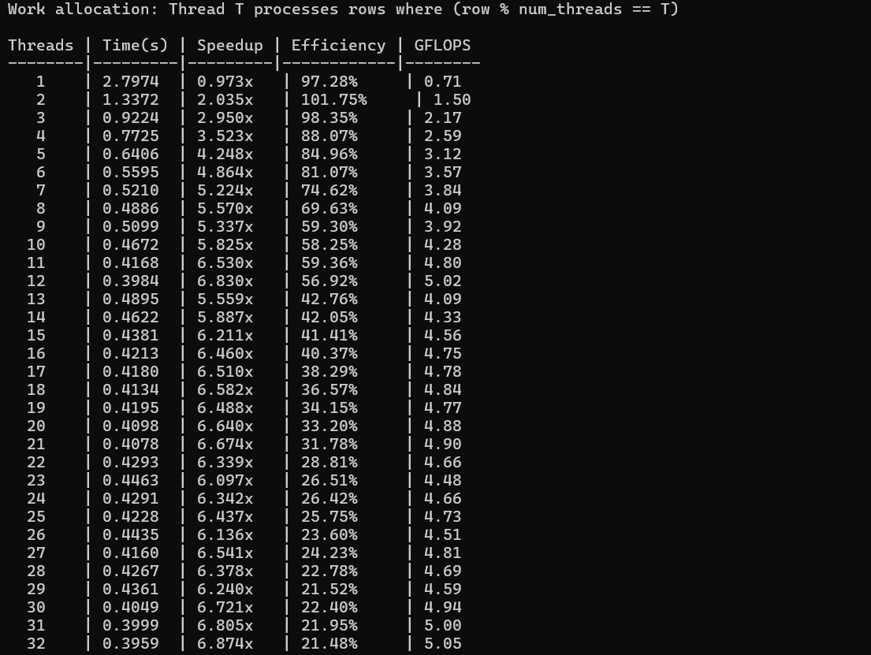

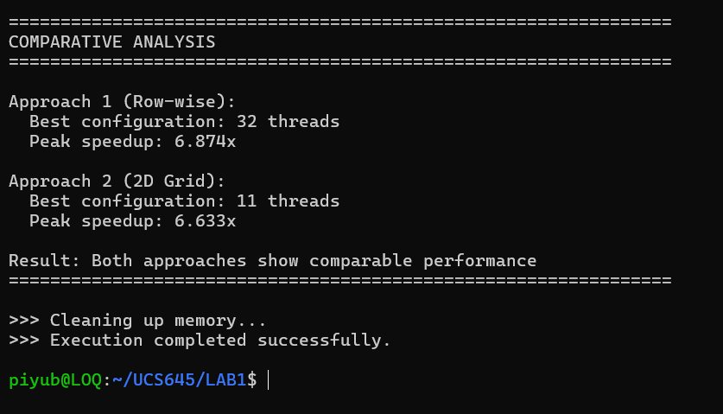

Matrix multiplication shows strong performance gains with parallelization, especially for larger matrix sizes. As the workload increases, execution time reduces significantly (for example, from ~506 s to ~250 s), indicating that larger problems are able to better utilize multiple threads. The parallel overhead becomes relatively small compared to the amount of computation performed, leading to improved speedup and throughput.
As matrix size grows, memory-related costs increase. Larger matrices no longer fit in cache, resulting in higher page faults and cache misses, which introduce memory stalls and reduce efficiency. Despite this, matrix multiplication scales better than DAXPY because it is compute-bound, performing approximately $2N^{3}$operations. This allows more useful computation per memory access, enabling better core utilization and sustained performance gains before saturation.
Both parallelization approaches perform well, with the Row-wise approach achieving peak performance at 32 threads (6.874× speedup) and the 2D Grid approach peaking earlier at 11 threads (6.633× speedup). Row-wise parallelization benefits from lower scheduling overhead and better cache locality, while the 2D Grid approach offers finer-grained load balancing but higher overhead. Overall, both significantly outperform serial execution, though scaling eventually saturates due to hardware limitations and Amdahl’s Law.
Q.3> Pi-estimation
Metric | Observation | Impact on Efficiency
Utilization | Increased as thread count increased, reflected by speedup rising up to 6.90× at 28 threads | Parallel execution utilizes multiple cores effectively, reducing idle CPU time and improving overall utilization.
IPC (Qualitative) | Effective IPC decreases slightly with higher thread counts | Increased thread concurrency introduces overhead and contention, slightly reducing per-core efficiency, though computation remains dominant.
Time Elapsed | Decreased from 0.200 s (1 thread) to ~0.028 s (optimal) | Reduced execution time directly improves speedup and overall throughput, demonstrating strong benefits of parallelization.
Page Faults | Very low (≈ 75) | Low page fault count indicates minimal memory pressure, confirming the computation-heavy nature of the program.

Threads (N) | Execution Time (s) | Speedup (S) | Efficiency (E = S/N) | GFLOPS
1 | 0.2005 | 0.98× | 97.99% | 0.71
2 | 0.1037 | 1.90× | 94.73% | 1.50
4 | 0.0519 | 3.79× | 94.64% | 2.59
8 | 0.0439 | 4.48× | 55.95% | 4.09
16 | 0.0302 | 6.51× | 40.66% | 4.75
28 | 0.0285 | 6.90× | 24.65% | 5.05

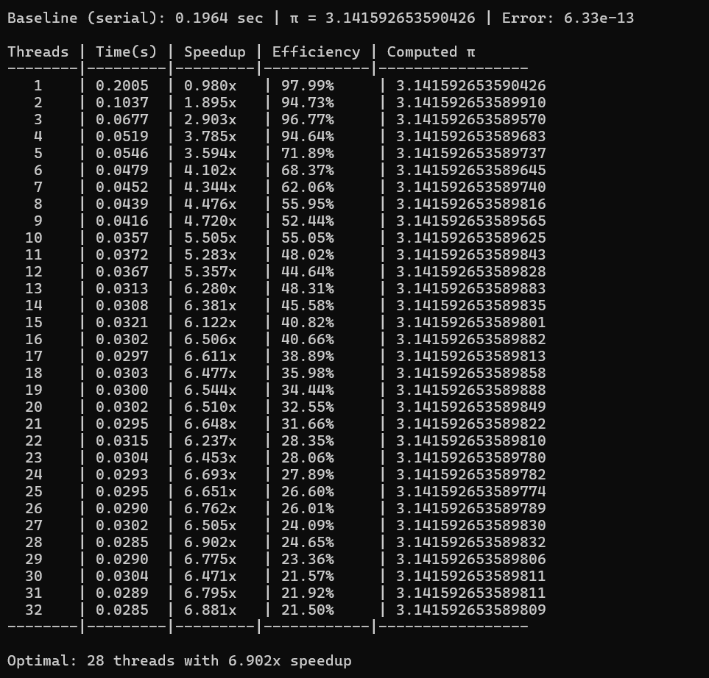
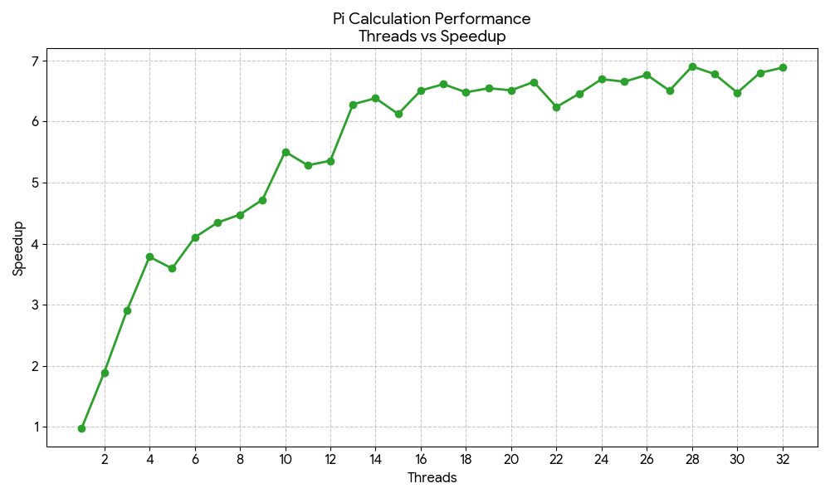
The π computation demonstrates excellent scalability under parallel execution, achieving a peak speedup of 6.902× at 28 threads. Performance improves steadily with increasing thread count due to effective work distribution across cores, resulting in reduced execution time and improved CPU utilization. A slight performance drop at 32 threads indicates the onset of thread management and scheduling overhead once the optimal level of parallelism is exceeded.
The implementation uses private per-thread variables (local_total), allowing each thread to compute independently and requiring only a single synchronization step at the end. This design significantly minimizes synchronization overhead while preserving numerical accuracy. Since the workload is largely compute-bound, thread oversubscription remains effective for a wide range of thread counts, enabling continued performance gains even beyond the number of physical cores.
Although execution time and GFLOPS increase initially with more threads, scaling is not linear. Efficiency and IPC decrease at higher thread counts due to increased overhead, cache contention, and resource competition.The low number of page faults further confirms the compute-bound nature of the kernel, explaining why it scales better than memory-bound operations like DAXPY. Overall, the results align with Amdahl’s Law, highlighting that while parallelization offers substantial performance benefits, selecting an optimal thread count is essential to avoid diminishing returns from overhead and contention.

