USER MANUAL

Administrator Store Overview
- View Store performance, sales summaries, and operational alerts.
- Open dashboard links to review cash variances, pending Stock Issues, and Fiscal Periods.
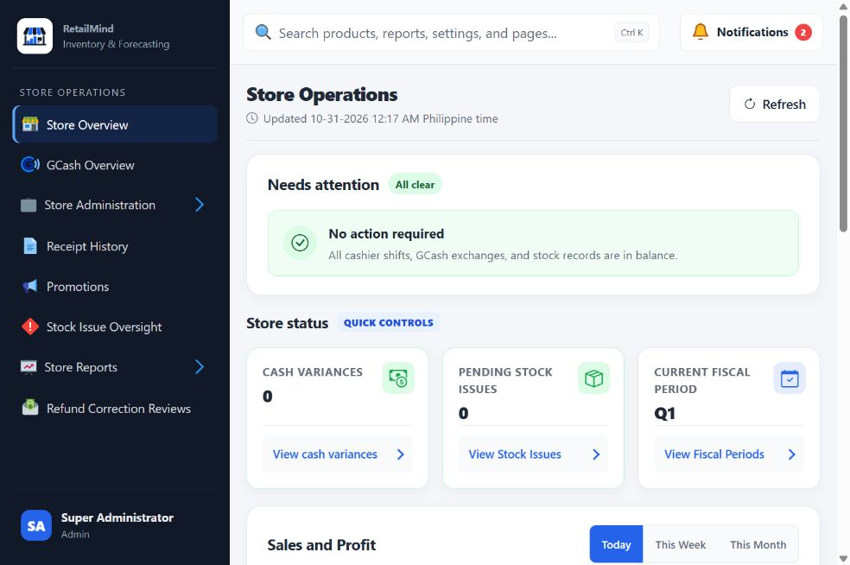

Administrator Store Staff
- View staff accounts, assigned roles, and account status.
- Add or update staff information and manage operational access.
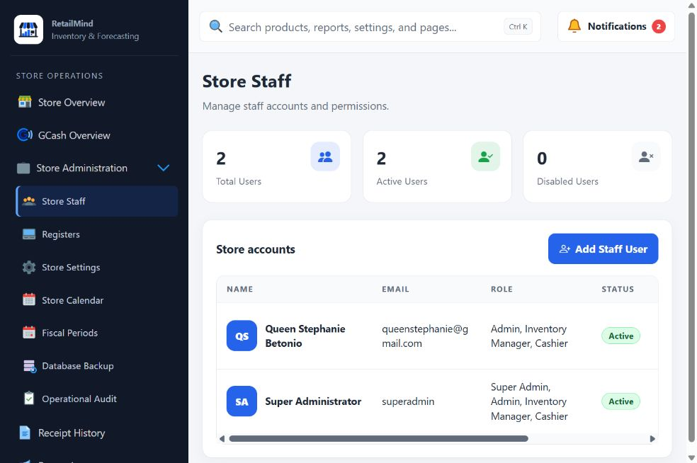

Administrator Registers
- View available Registers and their current status.
- Manage Register names, receipt paper widths, and availability.
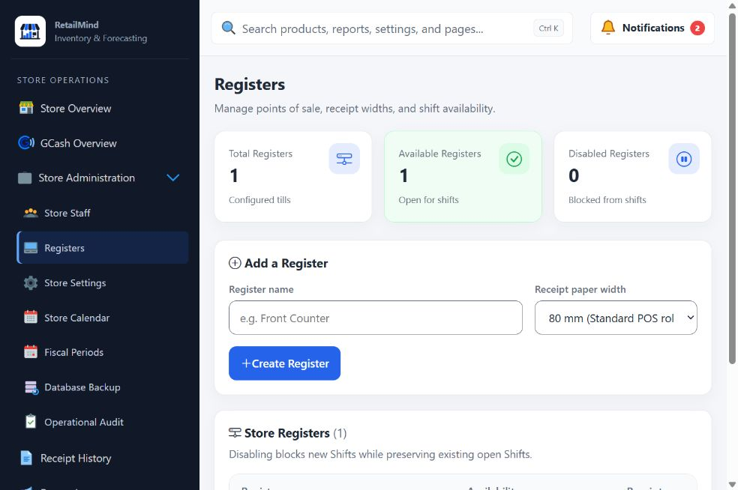

Administrator Store Settings
- View operational thresholds and review limits for the Store.
- Update the required values and select Save settings.
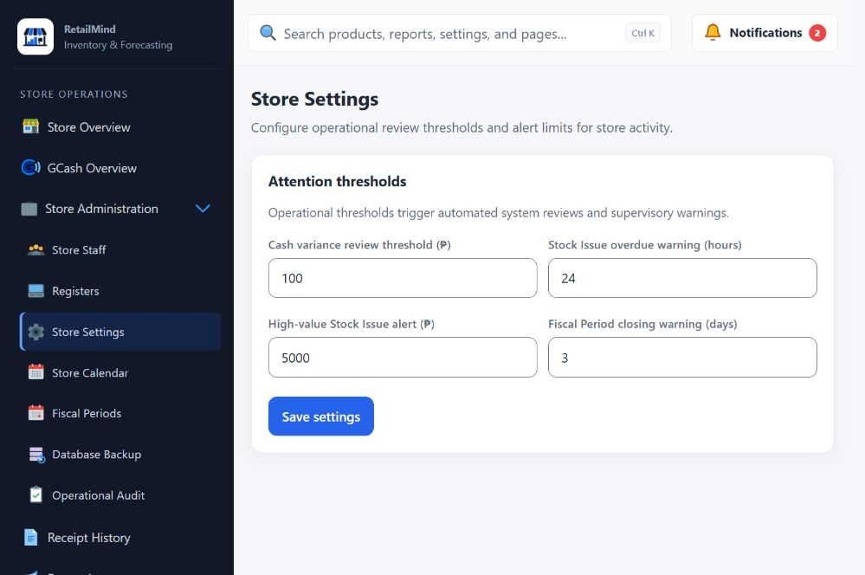

Administrator Store Calendar
- View the Store calendar and daily operating statuses.
- Record open days, closures, holidays, and exceptional closures.
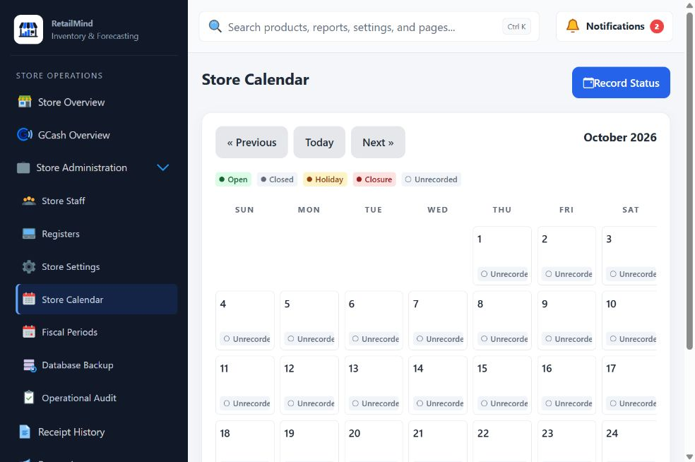

Administrator Fiscal Periods
- View and create Fiscal Periods for Store records.
- Review outstanding responsibilities before closing or locking a period.
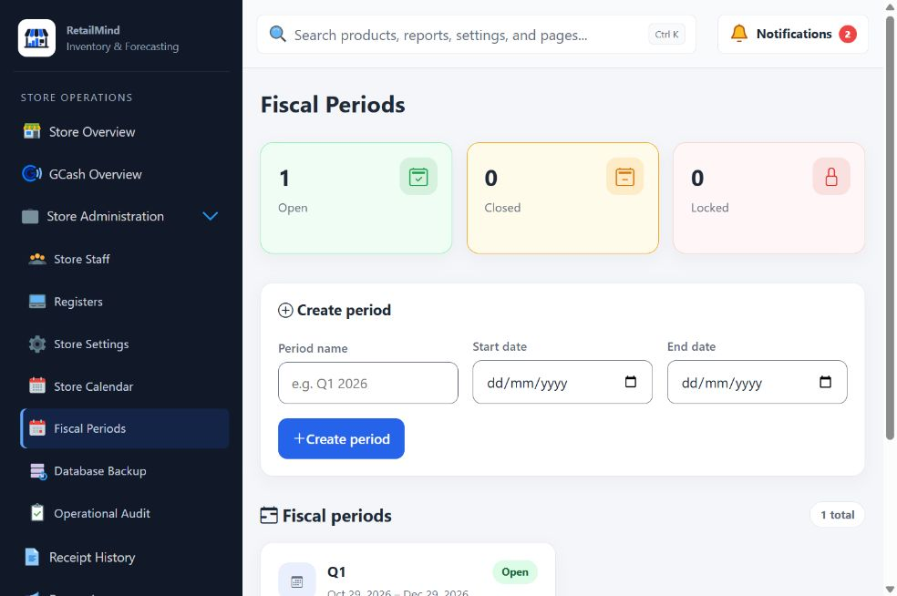

Administrator Promotions
- View and manage Store discounts and promotions.
- Set the promotion scope, discount, minimum quantity, and active dates.
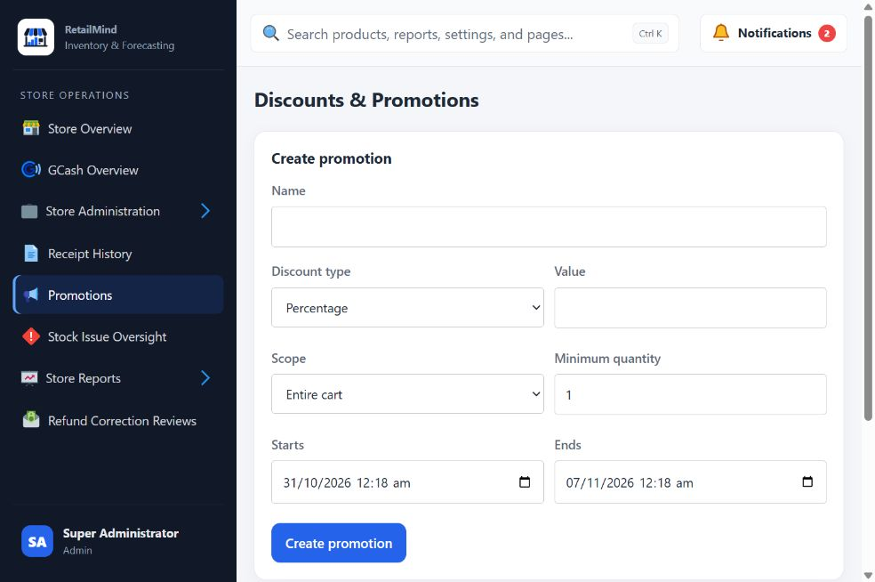

Administrator GCash Overview
- View recorded service cash, wallet balances, and GCash activity.
- Review transactions, closing checks, and unresolved exchanges.
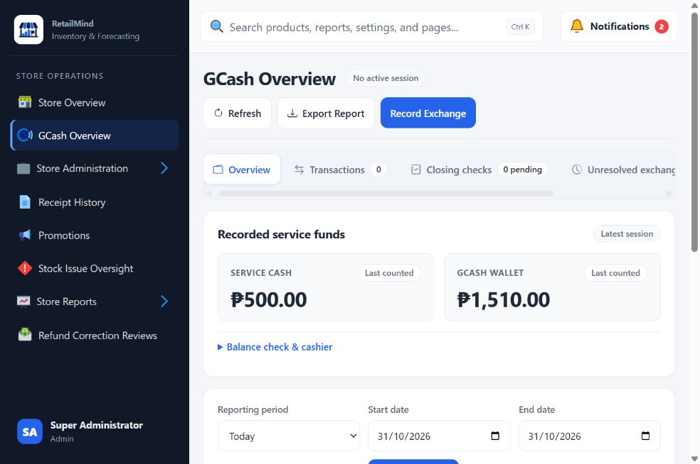

Administrator Cashier Shifts
- View Cashier Shift records, sales, drawer counts, and cash differences.
- Filter by date, Cashier, or Register to review the relevant shift.
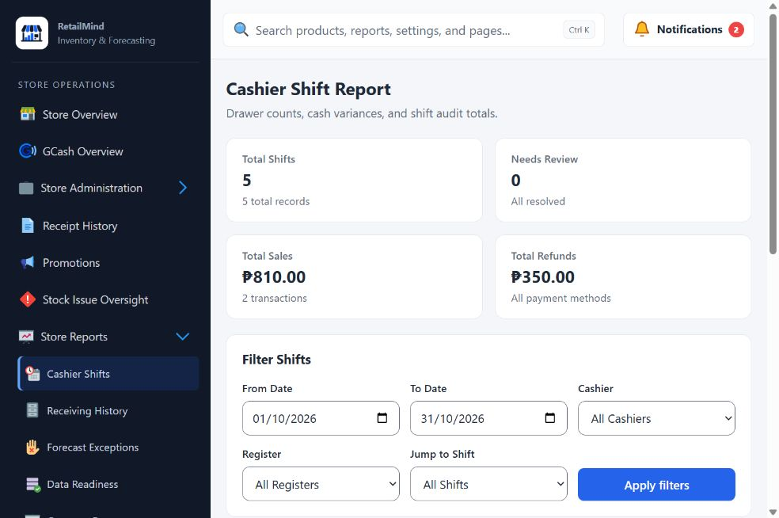

Administrator Database Backup
- Create and download an encrypted copy of Store records.
- Use a passphrase of at least 16 characters and keep it separately; lost passphrases cannot be recovered.
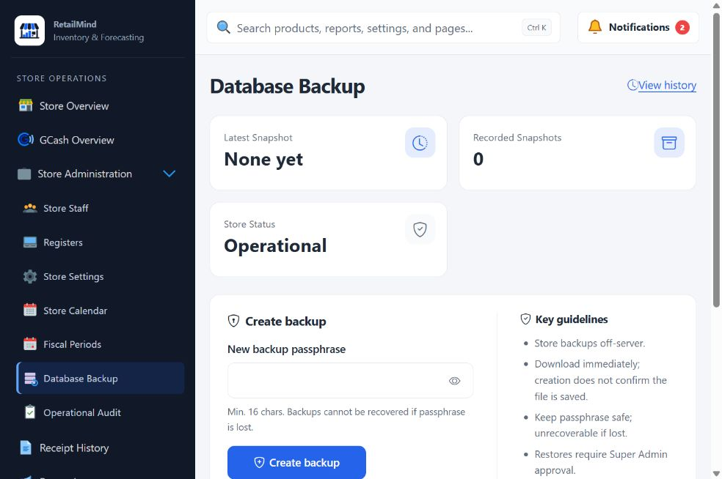

Administrator Generate Report
- View sales and other available Store reports.
- Choose the report and filters, then run, export, or print the results.
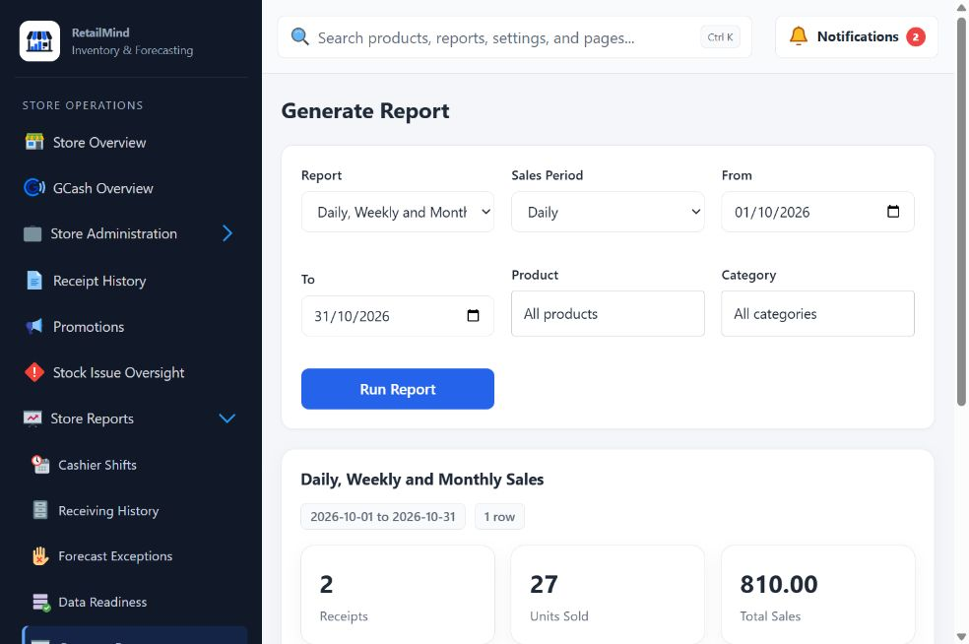

Administrator Operational Audit
- View recorded Store actions, users, modules, and timestamps.
- Search the history and open details to trace an operational event.
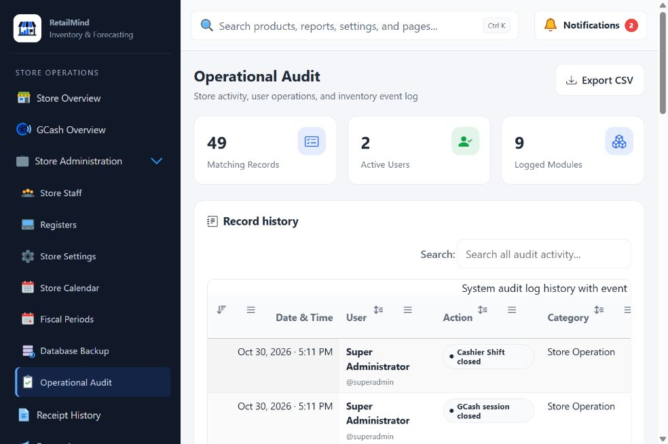

Administrator Receipt History
- View completed Store receipts and related refund information.
- Filter the list and open Full details to review the selected receipt.
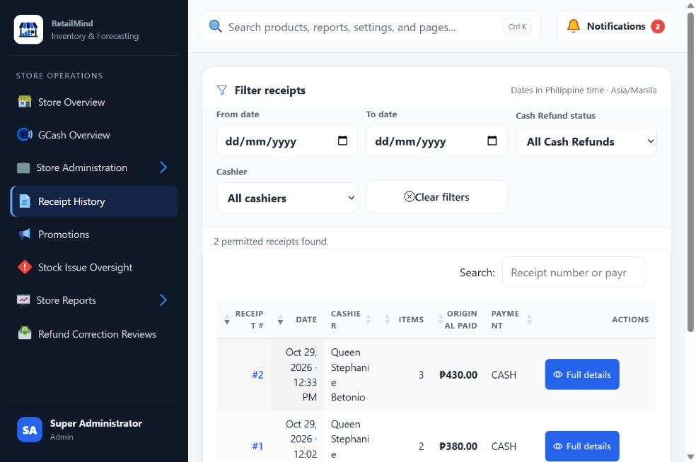

Administrator Refund Correction Reviews
- Review corrections needed after a recorded refund.
- Approve the exact cash or stock changes and assign the responsible staff.
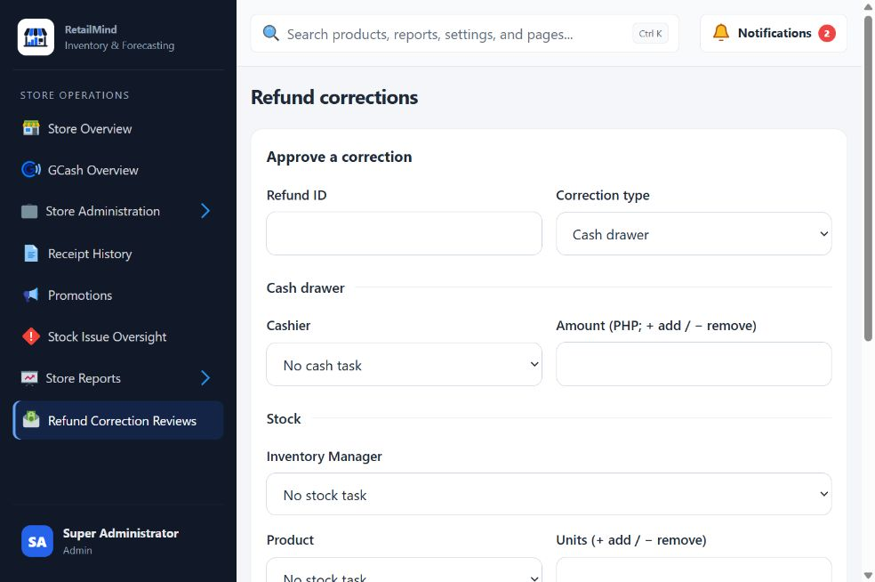

Inventory Manager Stock Overview
- View stock totals, low-stock alerts, and expiry information.
- Use the overview to identify products that need attention.
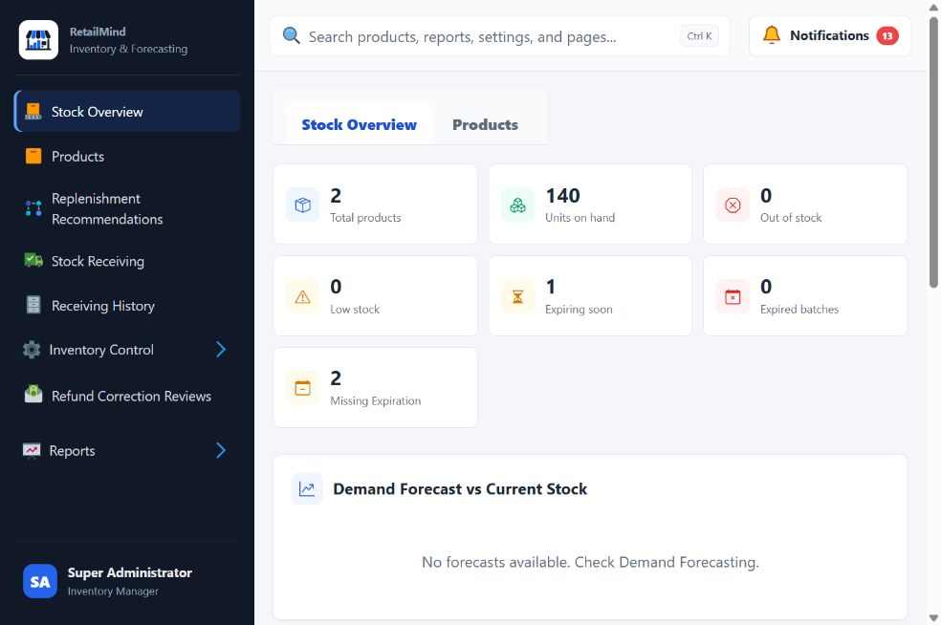

Inventory Manager Products
- View product names, prices, stock levels, and status.
- Add or update products and manage their barcode and packaging details.
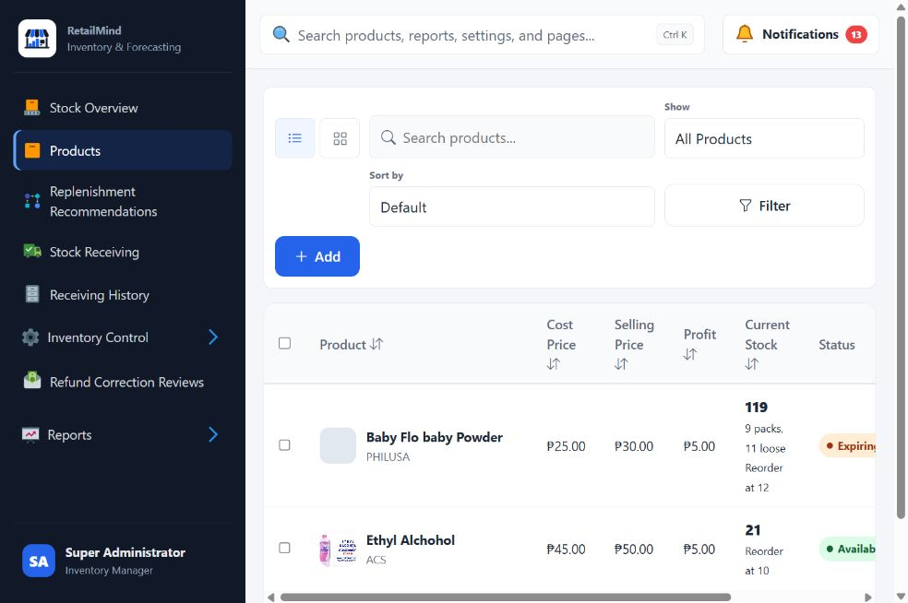

Inventory Manager Replenishment Recommendations
- View suggested buying quantities based on stock rules and available forecasts.
- Use recommendations as buying guidance; an unavailable forecast does not mean zero demand.
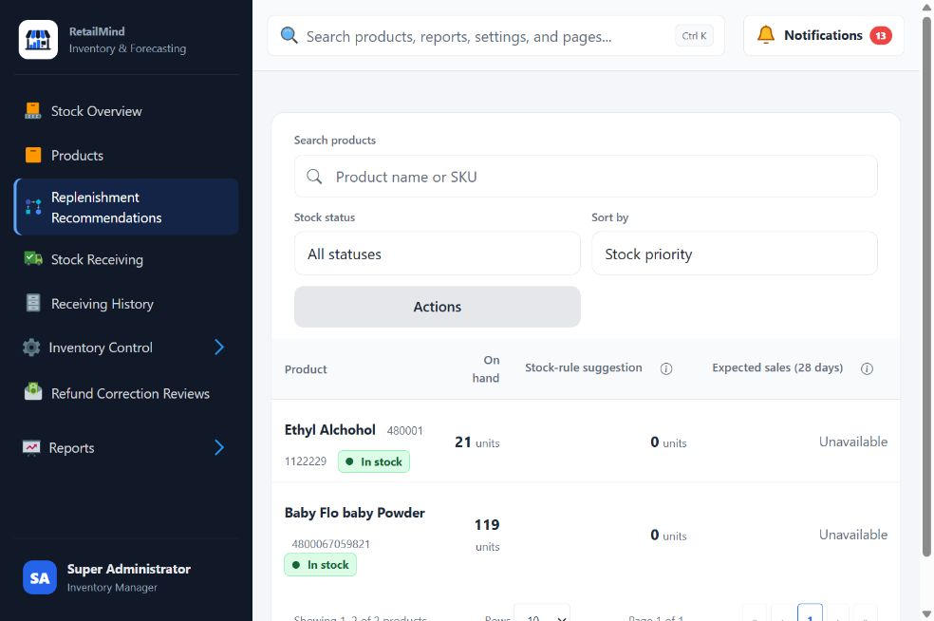

Inventory Manager Stock Receiving
- Record bought goods using the product catalog or barcode search.
- Review quantities, costs, and batch details before saving accepted stock.
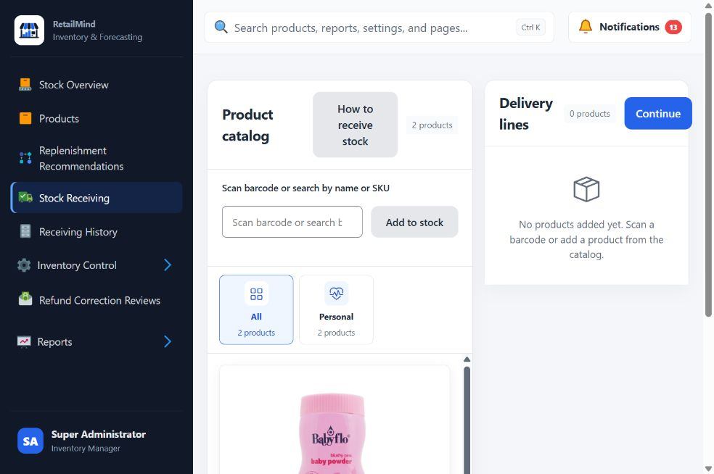

Inventory Manager Receiving History
- View the stock receipts available to your account.
- Search recorded entries and open their details to review received quantities.
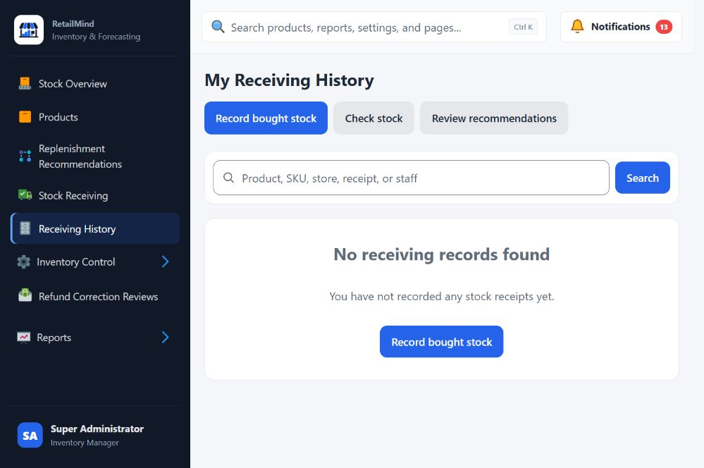

Inventory Manager Inventory Counts
- Record physical product or batch counts and the reason for a discrepancy.
- Review pending counts before approval; stock changes only after approval.
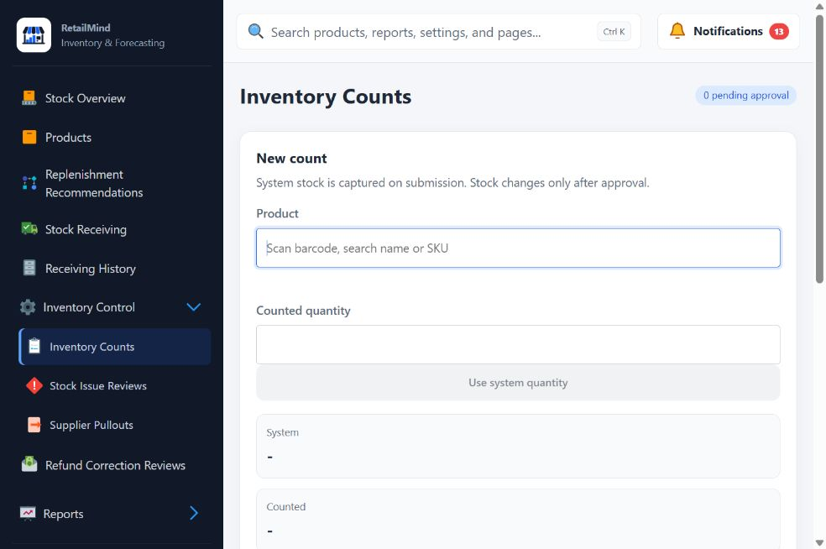

Inventory Manager Stock Issue Reviews
- View Stock Issues submitted for Inventory Manager review.
- Check the reported goods and record the appropriate decision and notes.
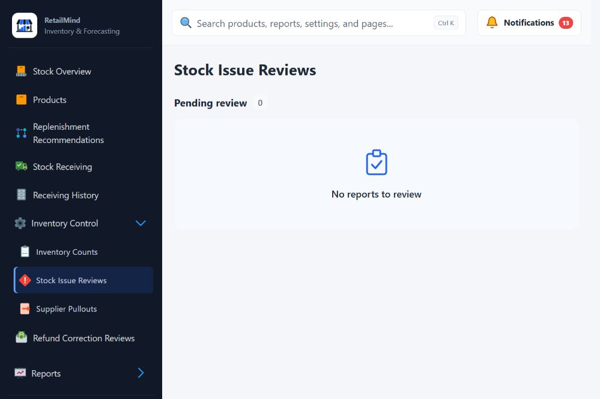

Inventory Manager Supplier Pullouts
- Record goods removed from a selected product batch.
- Enter the actual quantity and reason, then review the pullout history.
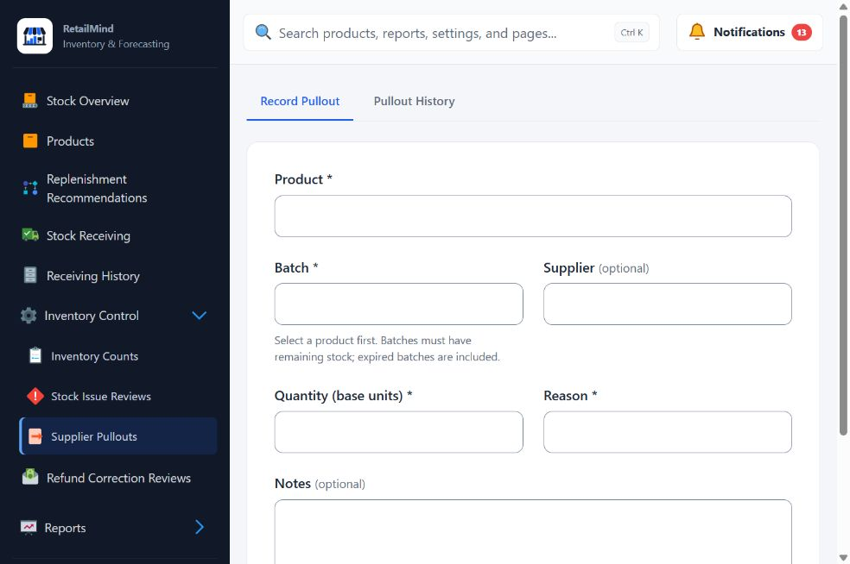

Inventory Manager Demand Forecast
- View available product demand estimates and forecast status.
- Check the forecast period and readiness before using estimates for planning.
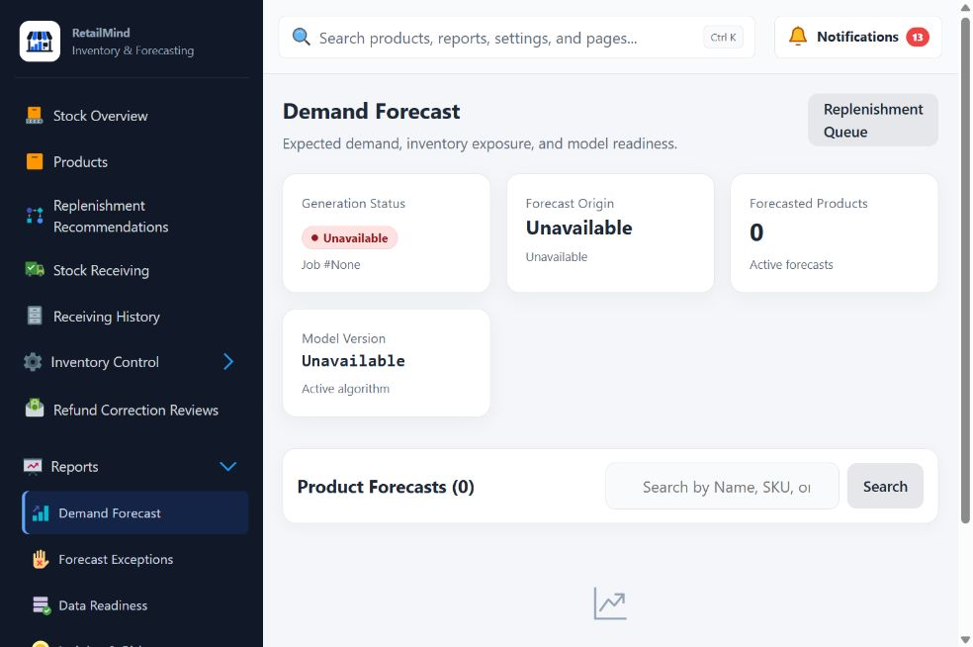

Inventory Manager Forecast Exceptions
- View products whose forecast results need further review.
- Use the exception filters to identify the affected products and reasons.
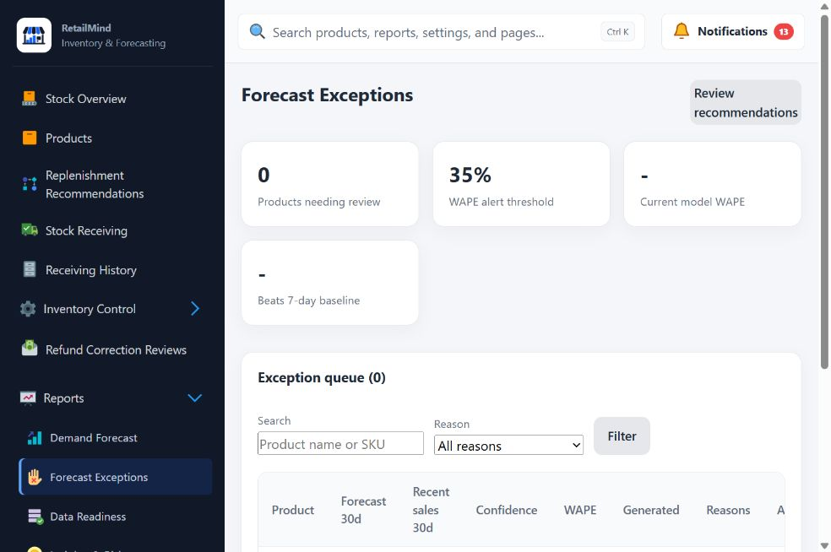

Inventory Manager Data Readiness
- View whether product history is ready for forecasting.
- Identify products needing more history or further data review.
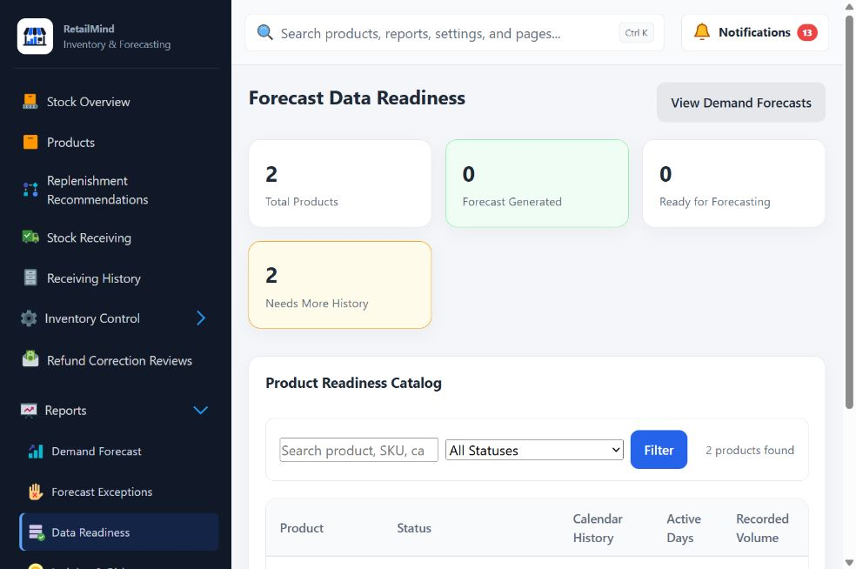

Inventory Manager Insights & Risk
- View inventory risks, including excess stock, expiry exposure, and slow-moving goods.
- Use the analysis and cycle-count information to prioritize stock checks.
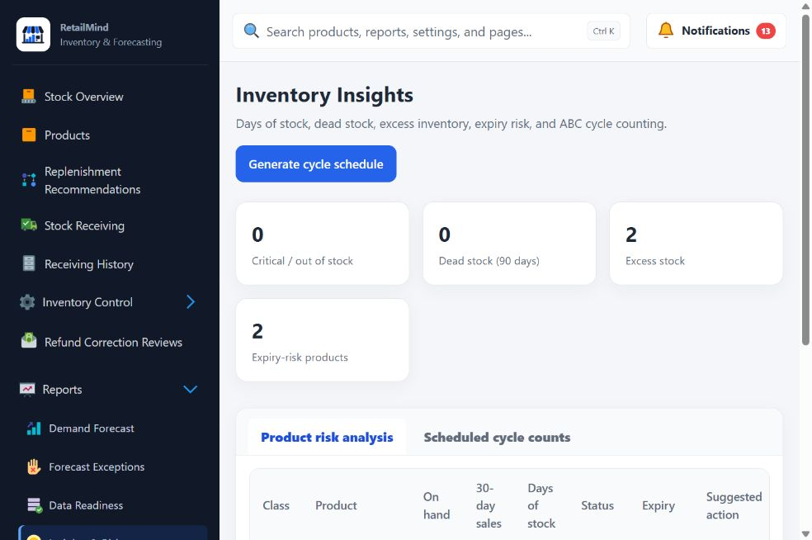

Inventory Manager Generate Report
- View the reports available in the Inventory workspace.
- Select the report and filters, then review or export its results.
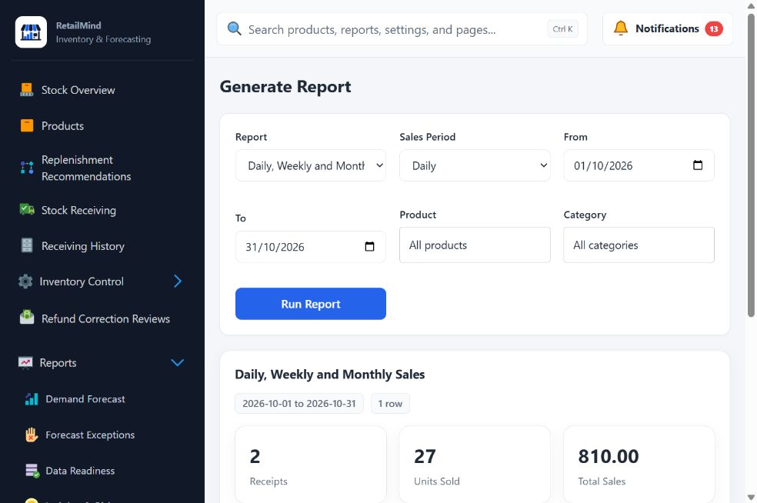

Inventory Manager Refund Correction Reviews
- View stock correction tasks assigned after an Administrator review.
- Record the approved stock action and notes while preserving the original refund.
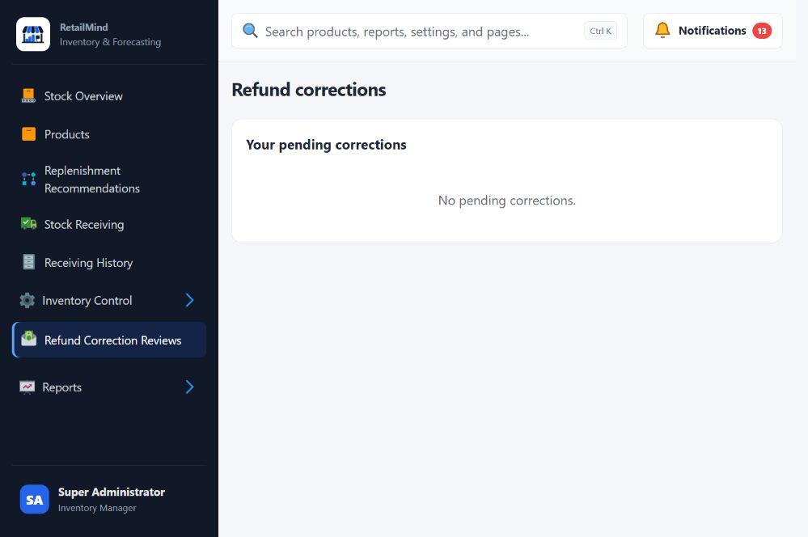

Cashier Shift
- Open a shift using an available Register and the actual starting cash.
- Review drawer movements and count cash before closing the shift.
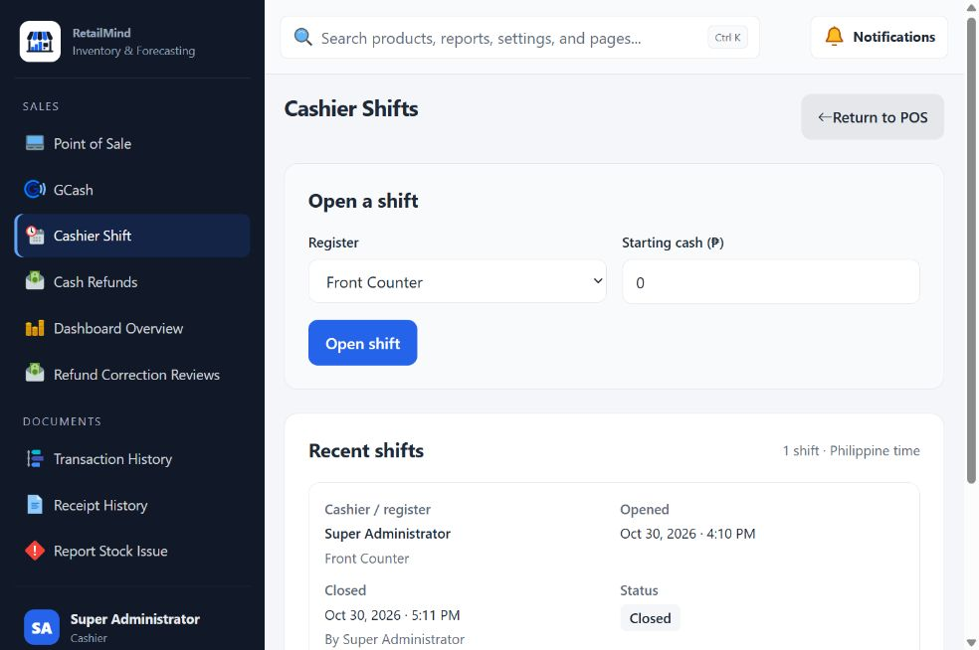

Cashier Point of Sale
- Scan or search products, review quantities, and complete customer sales.
- Open a Cashier Shift before checkout and print the receipt after a successful sale.
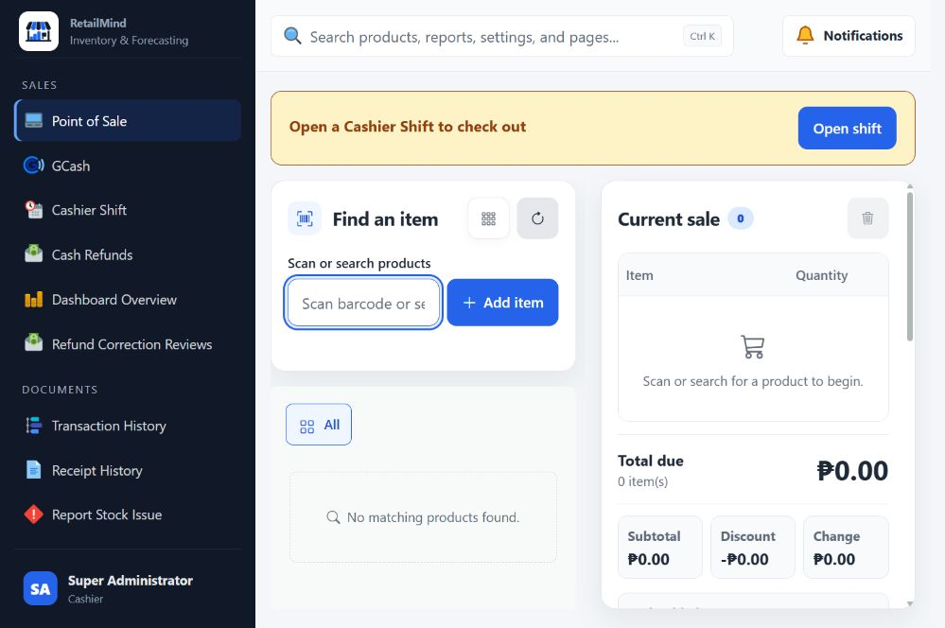

Cashier GCash
- Record Cash-In and Cash-Out exchanges, fees, and reference numbers.
- Verify actual wallet and cash movements, then reconcile or hand over service funds.
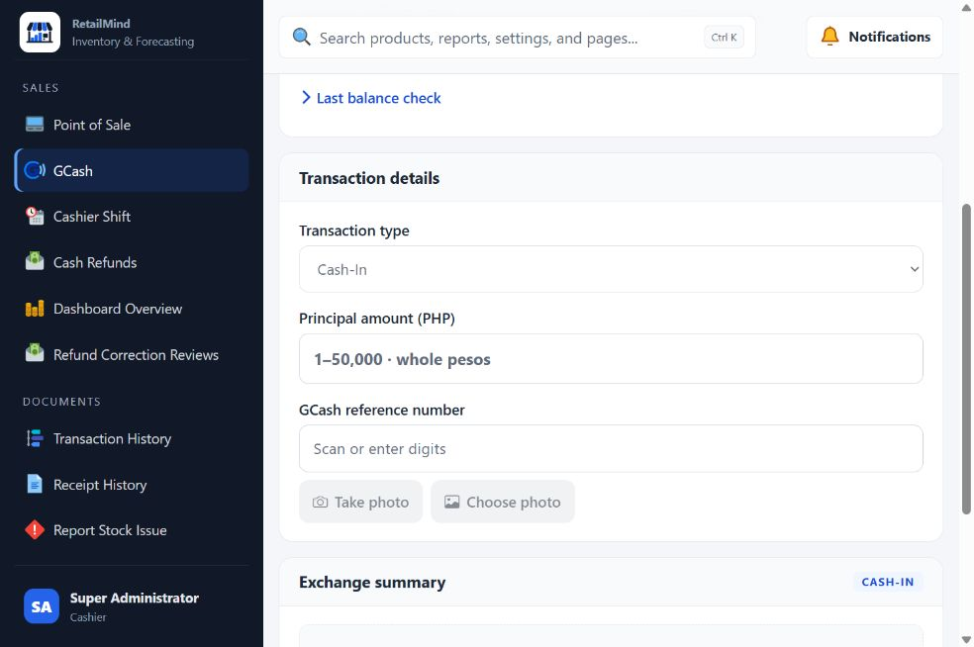

Cashier Dashboard Overview
- View daily sales, transaction totals, stock alerts, and recent activity.
- Use the Cashier and GCash tabs to review the corresponding summaries.
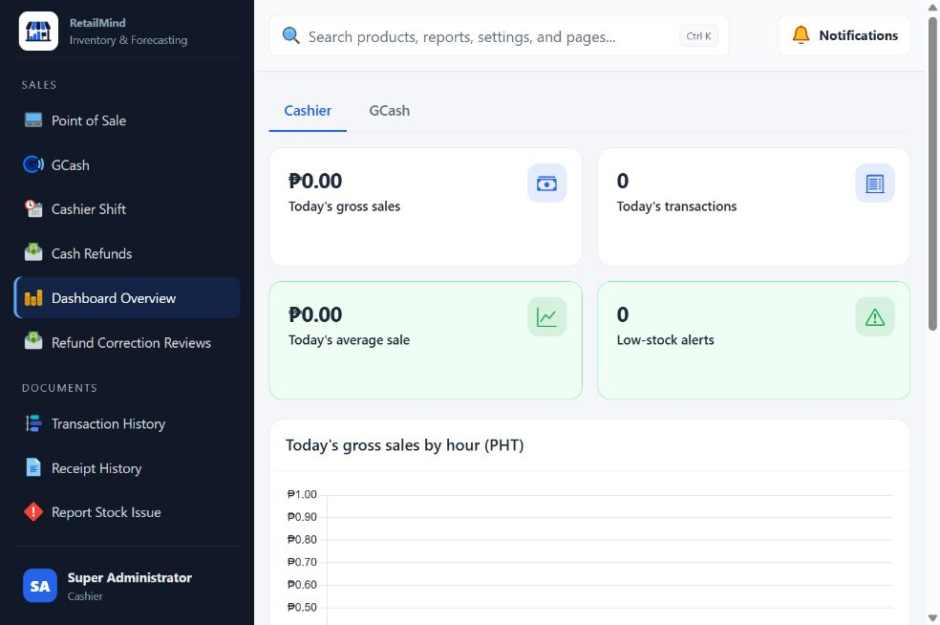

Cashier Cash Refunds
- Find the original sale and record returned quantities, item condition, and the refund reason.
- Only Restockable items return to available stock; complete the required payment verification and approvals.
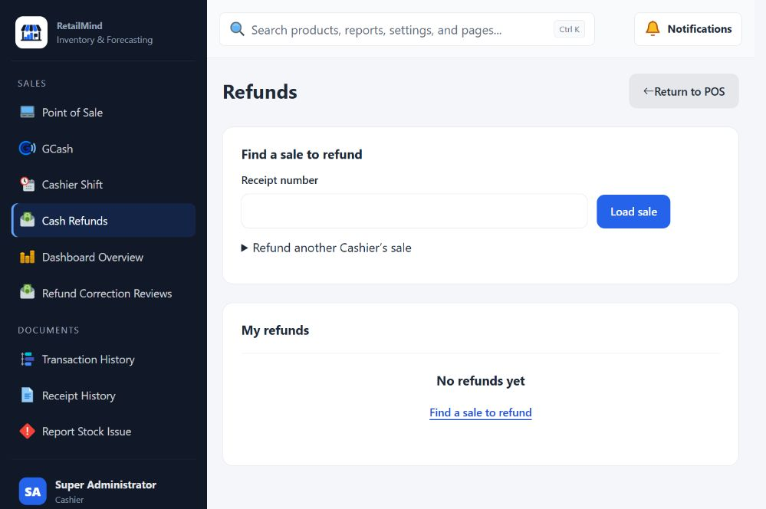

Cashier Transaction History
- View your sales, Cash Refunds, drawer movements, and shifts.
- Choose a history tab and date range to find the relevant record.
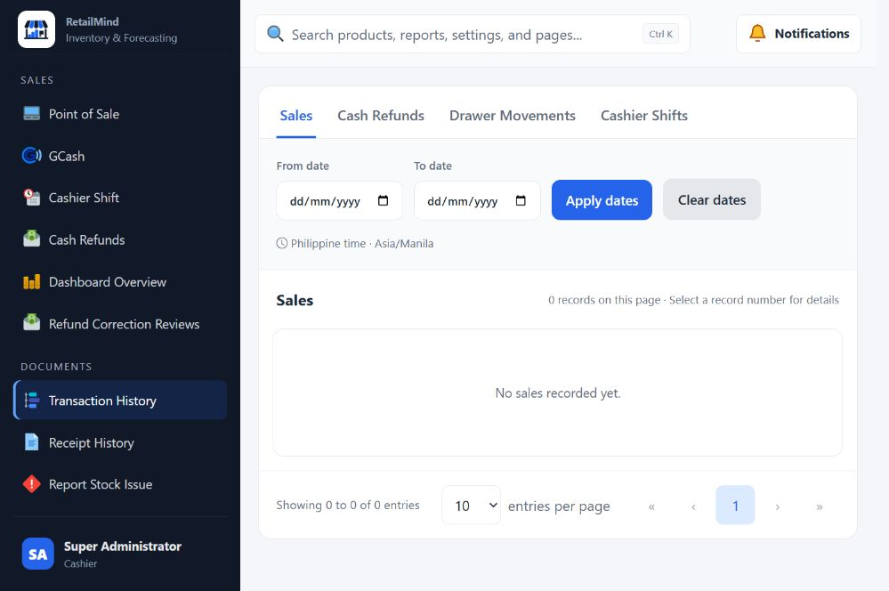

Cashier Receipt History
- View the receipts available to your Cashier account.
- Open a saved receipt to review or print it without repeating the sale.
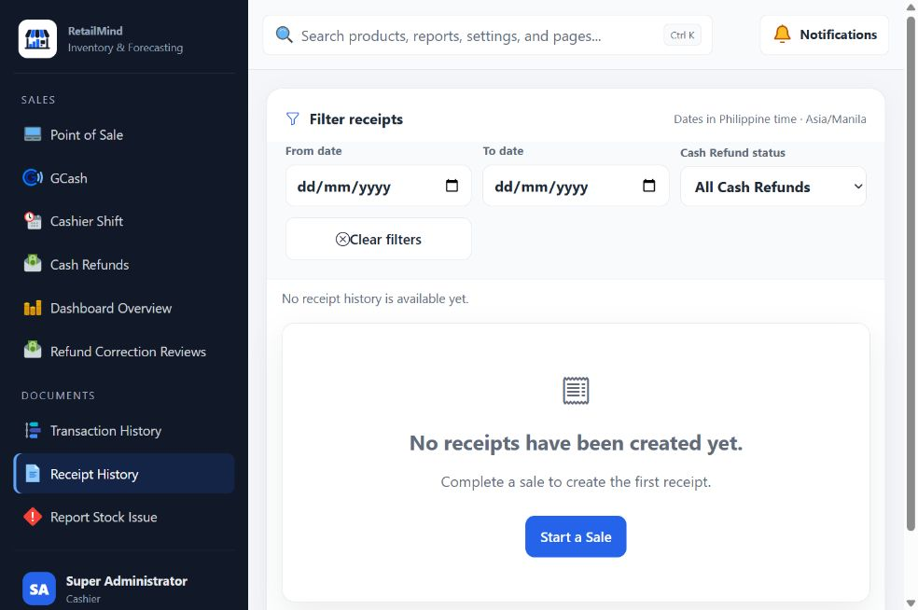

Cashier Report Stock Issue
- Report damaged, missing, expired, or other affected stock during an open shift.
- Identify the product, stock form, quantity, and explanation for Inventory Manager review.
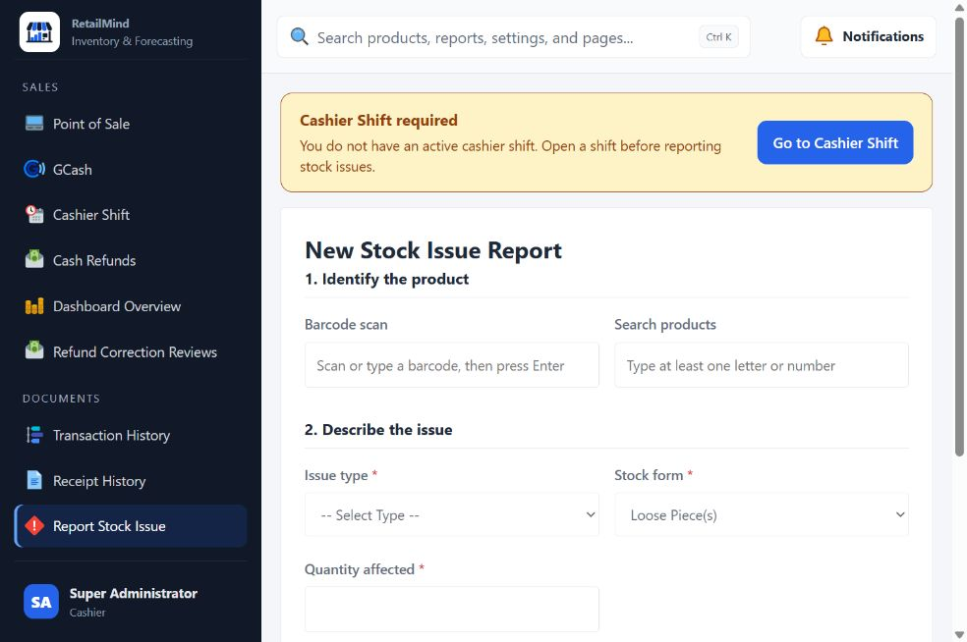

Cashier Refund Correction Reviews
- View cash correction tasks assigned after an Administrator review.
- Record the approved drawer action and required notes without rewriting the original refund.
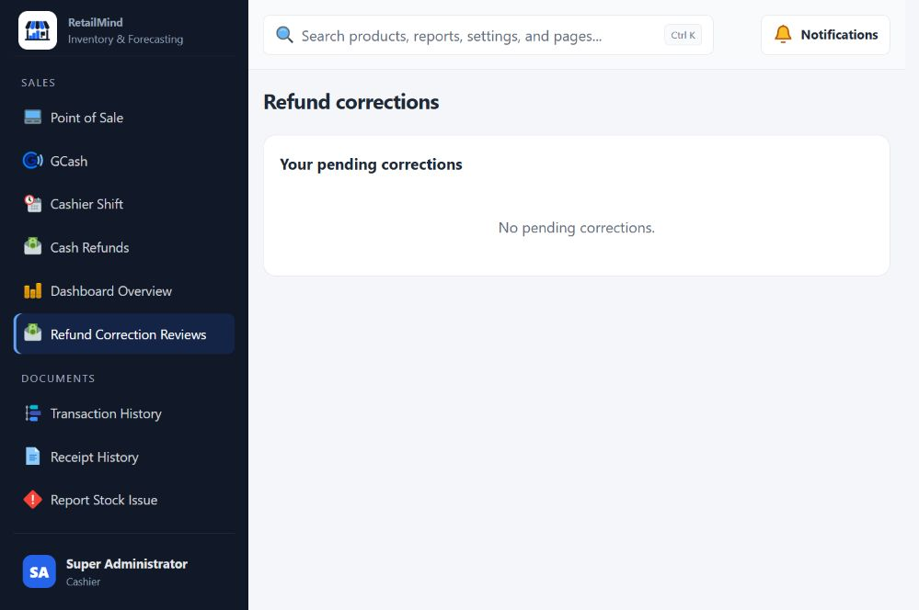

Cashier Notifications
- View notifications and unread items for your account.
- Open the related record to review any action that needs attention.
