
EcoWell: A Social Mobile Application with Geolocation for Nature – Based Mental Wellness Tracking

Reyan Ryn P. Olivar
Arlene V. Rollorata
Aime Joyce C. Sarita

A BSIT Capstone Project Proposal Submitted to the Faculty of Computing, Engineering
and Technology of Davao Oriental State University in Partial Fulfillment of the Requirements for the Degree

BACHELOR OF SCIENCE IN INFORMATION TECHNOLOGY

JULY 2026

TABLE OF CONTENTS

TITLE PAGE

Title i

Approval Sheet ii

Table of Contents iii

List of Tables v

List of Figures vi
CHAPTER 1: INTRODUCTION 1
1.1 Rationale of the Study 1
1.2 Purpose and Project Description 3
1.3 Objectives of the Study 5
1.4 Significance of the Study 6
1.5 Scope and Limitations 7
1.6 Conceptual Framework 11
1.7 Definition of Terms 13
CHAPTER 2: REVIEW OF RELATED LITERATURE 16
2.1 Literature Map 16
2.2 Related Literature 17
2.3 Synthesis 28
2.4 Related Systems 30
CHAPTER 3: MATERIALS AND METHODS 38
3.1 Software Methodology 38
3.2 System Planning 42
3.3 System Analysis 52
3.4 System Design 59
LITERATURE CITED 66

LIST OF TABLES

TABLE PAGE

Table 1. PSS-4 Scoring Matrix 23

Table 2. Stress Reduction Matrix 24

Table 3. Quite Score Matrix 25

Table 4. Comparison of Related System 36

Table 5. Cost-Benefits Analysis 46

LIST OF FIGURES

FIGURES PAGE

Figure 1. Conceptual Framework 11

Figure 2. Literature Map 16

Figure 3. Wysa App 30

Figure 4. AllTrails App 31

Figure 5. Calm-Sleep, Meditate, Relax App 32

Figure 6. Headspace: Sleep & Meditation App 33

Figure 7. Strava: Run, Bike, Walk App 34

Figure 8. Duolingo Language Learning App 35

Figure 9. Modified Waterfall 39

Figure 10. Work Breakdown Structure 50

Figure 11. Gantt Chart 51

Figure 12. BPMN of the Current System 54

CHAPTER I
INTRODUCTION

1.1 Rationale of the Study
Mental health is considered as one of the largest health issues in the world today. The World Health Organization (2022) claims that there are more than one billion people in the world having a mental health condition, and the most common ones are anxiety and depression. With the COVID-19 pandemic, things got even worse. According to WHO (2022), the number of cases of anxiety and depression has risen by a quarter in one year, or 25 percent, due to the pandemic. It is hard to seek assistance with mental health in the Philippines (Lally et al., 2019).
In the Philippines, stress has emerged as a significant concern affecting the well-being of individuals across different sectors of society. A recent survey reported an increasing number of Filipinos experiencing stress, indicating the growing relevance of stress-related concerns in the country (De Vera-Ruiz, 2025). This concern is further reflected in the workplace, as Gallup data reported by Inquirer Global Nation identified the Philippines as having the highest level of workplace stress in Southeast Asia, suggesting the considerable impact of stress on the daily lives and overall well-being of Filipino workers (Baclig, 2026). This will highlights the needs to explore the natures, since spending atleast 120 minutes a week in nature has been help to improved mental well-being (White et al., 2019c). Furthermore, accessing to professional assistance with mental health remains difficult as well, because with fewer than three psychiatrist per one million Filipinos, meaning most people cannot get help until their condition become crisis (Lally et al., 2019).

The shortage of mental health professionals is particularly evident in provincial and underserved areas, where access to psychologists, psychiatrists, and other mental health services remains limited (Lally et al., 2019). In Davao City, the Philippine Mental Health Association (PMHA)- Davao Chapter had revealed 55 cases of suicide record in one year caused of social media usage and peer pressure among the youth (Agustin, 2023). Meanwhile, another study found that high anxiety and burnout were caused by the heavy workload and time pressure faced by the government agency in Davao City (Rico et al., 2025).
In order to deal with the problem of mental health illness or mental health issues, the Davao Oriental Medical Center (DOPMC) launched the Mental Wellness Hub called “Selah” at the Mati City, Davao Oriental to provide a clinical and psychiatric support to residents (Uy, 2023). Moreover, the Department of Health (DOH) organized the community health program for schizophrenia patients in several towns, including Boston, one of the areas with the highest rate or diagnosed cases in the region (Matalam & Hembra, 2022). Although it becomes evident that mental health becomes a matter of concern for the local government. However, these efforts remain limited to treating a people who are experiencing in crisis, rather than preventing the mental health issues in daily life connected with the contact with nature. At the same time, Davao Oriental possesses natural resources that could support such preventive approaches to mental wellness, such as the Mati City Guang-guang Mangrove Park in Dahican, it valued by locals because of contribution to coastal defense and habitat preservation (Inoco & Villegas, 2024).
Despite the presence of local mental health interventions in Davao Oriental — including DOPMC's "Selah" wellness hub and DOH's community program for schizophrenia — these efforts remain focused on treating individuals already in crisis, rather than preventing mental health decline before it reaches that point. Despite the region having many green spaces that could help reduce stress, most remain underutilized for mental wellness purposes, such as the Guang-guang Mangrove Park in Dahican, Mati City, which has so far been recognized only for its ecological contributions, such as coastal defense and habitat preservation (Inoco & Villegas, 2024), with no attention given to its potential role in supporting residents' mental well-being. Given that regular contact with nature has been shown to improve mental well-being (White et al., 2019), and given the acute shortage of mental health professionals in the Philippines (Lally et al., 2019).
To address these gaps, this study proposes EcoWell, a social wellness mobile application that integrates GPS-based geolocation, stress assessment, nature-based wellness activities, AI assistant, and community engagement into a single platform. The application allows users to complete a stress assessment before and after visiting natural or green spaces, helping them monitor changes in their stress levels. EcoWell also includes a community feed where users can share the green spaces they visit, post photos and experiences, and discover nature destinations recommended by other users EcoWell seeks to encourage the residents or user of the Davao Oriental to participate in nature-based activities as a simple, accessible, and preventive way to support their overall health.

1.2 Purpose and Project Description

The purpose of this project is to develop EcoWell, a mobile application that can be use to take better care of their mental health by making it easier for them to access and benefit from nearby green spaces. The system allows users to locate parks, mangroves, trails, and other natural spots, view directions to these locations, and choose a place based on distance and how peaceful it is. Before and after visiting a chosen location, users can also answer a short set of questions to check how their stress levels have changed, giving them a simple way to see how nature is affecting their well-being over time. The application also includes helpful features such as visit reminders, current weather conditions, user ratings for each location, an AI assistant, and short guided breathing exercises to support users during their visit. To help users build a consistent habit, EcoWell also includes light gamification elements, such as visit streaks that track the users for regularly spending time in nature. Users can also connect with others through a community feed, where they can share their visit experiences, post photos, and discover nature destinations recommended by fellow users.

The combination of three features, usually provided separately, makes this project unique and innovative: finding places nearby to relax, tracking mental wellness, and motivating the user through sharing and building habits, via community streak and sharing, and encouraging through 'streak'. Most wellness apps, for example, only offer journaling tools or meditation exercises and do not link a user to actual places in close proximity, and most mapping apps help users find places where they can go, but they don't offer any means to track how the places impact on the user's stress level or to encourage repeat visits to them. EcoWell combines all these in one simple, easy-to-use platform. It is applicable to Mati City and to the entire Davao Oriental, and is a tool that is accessible, practical and preventative to encourage the people of Davao Oriental to make simple, everyday efforts at good mental health.

1.3 Objectives of the Study
General Objective
The study aims to develop EcoWell, a mobile application driven by an AI assistant that actively generates automated post-visit summaries and context-aware suggestions, integrated with Geographic Information System (GIS) navigation, social interaction features, and gamification elements, to help residents of Mati City, Davao Oriental manage their mental stress by guiding them to nearby green spaces and tracking the impact of nature-based activities on their overall well-being.
Specifically, this study aims to:
- Implemen a GIS-based navigation and geofencing module that detects user entry and exit at verified green spaces and provides real-time routing to them.
- Administer digitized pre-visit and post-visit stress assessments (PSS) and automatically compute the Stress Reduction Score, visualized through a Wellness Dashboard of stress scores, visit history, and wellness trends.
- Position the AI assistant as a core interactive driver that generates automated post-visit summaries and delivers context-aware suggestions based on users’ stress scores, visit history, and environmental conditions, complemented by gamification features such as visit streaks and the Quiet Score system to sustain user engagement.
- Develop a community feed feature that allows users to share visit experiences, post photos, and discover nature destinations recommended by other users.
- Implement data encryption measures that secure users’ sensitive information in compliance with the Data Privacy Act of 2012.

User Evaluation (Based on ISO/IEC 25010)

The evaluation of the EcoWell system will be conducted by selected residents of Mati City, Davao Oriental, mental health practitioners and Information Technology professionals using the ISO/IEC 25010 Quality Model. The evaluation will cover the functional suitability, usability, reliability, performance efficiency and security of the system, including the accuracy and completeness of its wellness and geolocation capabilities, ease of use and accessibility, stability and reliability, response time and efficiency and protection of sensitive user information. The evaluation will take into account the effectiveness of the system in fulfilling its intended functions, user-friendliness, reliability and efficiency of the system and the protection of user information.

1.4 Significance of the Study

EcoWell is expected to bring positive benefits to different groups of people in Mati City, Davao Oriental.

Residents and Community Members of Mati City and Davao Oriental. Residents will have a free, easy-to-use way to relieve stress and build healthier daily habits by spending more time in nearby green spaces.

Local Government Units (LGUs) and Local Health Authorities (DOH / City Health Office). Local health officials gain a tool that supports existing mental health programs by encouraging preventive care and helping ease the demand on clinics and psychiatrists.

Tourism and Environmental Officers. Local sites gain added value beyond ecological importance, encouraging greater community appreciation and supporting efforts to maintain and protect green spaces.

Developers and IT Researchers. This study offers a practical reference for building similar wellness-focused mobile applications.

Mental Health Practitioners. EcoWell will also benefit mental health practitioners and clinicians by giving them access to stress assessment records, Stress Reduction Score results and visit logs generated by the app, allowing them to gain richer insight into the patient behavior outside of formal consultations.

1.5 Scope and Limitations

The scope of the project is bound to the following:
- The general purpose of project is to design and implement a unified platform that guides users to nearby green spaces and allows them to track the impact of nature exposure on their mental well-being.
- The system will implement a GIS-integrated navigation module that provides a real-time routing to verified green spaces within the Mati City.
- The system will position the AI assistant as a core interactive driver, allowing users to converse with an AI-powered chatbot for stress-management guidance and wellness support. Beyond conversation, the AI assistant will automatically generate post-visit summaries from each user's stress assessment results and visit data, and will deliver context-aware suggestions, such as recommending guided breathing, grounding exercises, or specific nature-based wellness activities, based on the user's stress scores, visit history, and environmental conditions.
- The primary feature is a stress assessment module, using a simplified version of the Perceived Stress Scale (PSS), that measures the users stress levels before and after each nature visit and calculates the resulting Stress Reduction Score.
- This study is only meant for participants between 18 and 60 years. The age of 18 has been set to match the legal age of maturity as documented in Republic Act No. 6809 in the Philippines. Considering the recommendations and findings from AXA and Ipsos (2023), the target participants for the study are individuals between 18 and 60 years since this age group is likely to experience more stress as compared to the older adults.
- The system will use geofencing technology to automatically detect and log a user entry and exit within the designated green spaces that trigger the stress assessment module before and after each visit.
- The system includes Wellness Dashboard that visualizes user stress scores, visit history and wellness trends over time.
- The system includes Smart Reminder feature that sends notifications based on the users visit history and stress levels.
- The system includes Weather Based Suggestion tool that displays the current outdoor conditions in order to help users plan their visits.
- The system includes a Quiet Score rating system that allows users to rate and view noise levels at each green space.
- Community and Gamification Features, a social feed allowing users to share photos, recommend best location and including visit streaks.
- The system provides guided breathing and grounding activities through short instructional videos or animations and step-by-step instructions.
- The system allows the users to voluntarily export or share their stress assessment records and visit history such as through a PDF summary for their own personal use or to share with a healthcare provider.
- All sensitive user data are using AES-256 encryption including the stress assessment results and visit history will be protected through industry standard encryption in compliance with the Data Privacy Act of 2012.

The following factors are constraints beyond the developers control that affect the projects features and performance of EcoWell:
- The EcoWell will require an active internet connection to work, as all of its core functions depend on it.
- The Stress assessments will be based on what users personally report, which may be affected by how honest or tired they are when answering.
- The AI assistant will provide general stress-management guidance and wellness support only; it will not diagnose mental health conditions, provide medical or psychological treatment, or replace consultation with qualified mental health professionals. The answers it provides are not always accurate, complete, or suitable for all users, and should not be regarded as advice or guidance provided by a professional mental health therapist or counsellor.
- The accuracy of the location-based features will depend on the strength of the GPS signal on the user's device.
- The Quiet Score System depends entirely on voluntary user ratings rather than sensor-based measurement, meaning it reflects only what users personally feel about the noise and crowd level of a location, not actual measured noise data.
- EcoWell will be a wellness support tool, not a diagnostic or treatment app. It cannot replace professional mental health care.
- EcoWell will only be designed and tested for green spaces in Mati City, Davao Oriental.
- The Wellness Dashboard will not use the machine learning or artificial intelligence to predict the future stress trends.
- The Weather-Based Suggestion feature will only use the general weather conditions such as temperature and rain. It will not consider air quality, UV index or individual weather preferences.
- EcoWell will restrict participation to users aged 18 and above, to ensure that all participants can independently provide informed consent as data subjects under the Data Privacy Act of 2012 (RA 10173), consistent with the general age of legal capacity in the Philippines, without requiring parental or guardian intervention.
- EcoWell will set the upper age limit at 60 based on RA 9994, which classifies Filipinos aged 60 and above as senior citizens and on findings by Yang et al. (2022) that older adults face greater barriers to the smartphone adoption and use.
- The system will use standard encryption methods in order to protect the user data but it will not include advanced, enterprise-level security systems.

1.6 Conceptual Framework
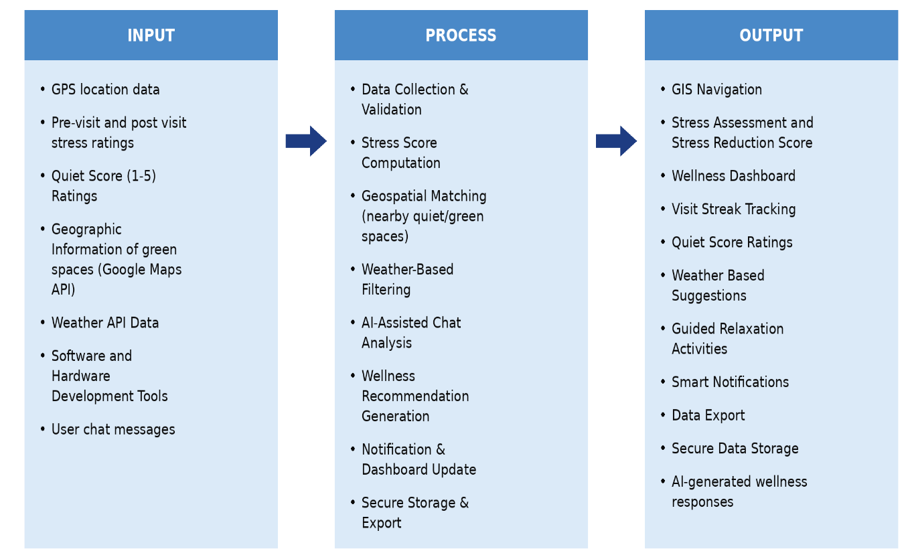
The three interrelated areas that comprise the conceptual framework of EcoWell are environmental psychology, digital health technology and data-driven behavioral feedback. The three domains will be structured and implemented using an Input-Process-Output (IPO) model as shown in Figure 1 below.

Figure 1. EcoWell Conceptual Framework (IPO Model)

As shown in Figure 1, the Input consists of the data EcoWell requires to function. GPS location data detects the users position and confirms their presence within the designated green space while the pre-visit and post-visit Stress ratings based on a simplified Perceived Stress Scale it captures how the users emotional state changes after spending time in the nature. The scores the users voluntarily submit for each location are ‘Quiet Score' and represent actual experiences of noise and crowd levels at the location.

Moreover, the geographic information from the Google Maps API supplies verified green space’s locations across the Mati City. Moreover, the data from the Weather API will enable users to schedule their visits for optimal conditions outside, and the users' messages will then be fed into the AI-driven wellbeing coach, which can offer relevant advice on managing stress and provide wellbeing support. Finally, the software and hardware tools that are mentioned, such as Flutter, Dart, and cloud services, are the technical building blocks employed in the system.

The Process phase involves the process of converting the inputs into meaningful output for the user. Data Collection and Validation collects and validates GPS location, stress ratings, Quiet Score inputs, weather data, and green space information for further processing. Stress Score Computation determines the resident's scores before and after the visit, and provides a Stress Assessment and Stress Reduction Score. Geospatial Matching will be used to link the user's GPS coordinates to data about green space from the Google Maps API to find quiet and restful places near them. Weather-Based Filtering leverages real-time weather API data to make suitable suggestions for outdoor activities and adjusts them in accordance with the weather. AI-Assisted Chat Analysis uncodes the user's chat communication, determining the user's needs and emotional state, and then the Wellness Recommendation Generation stage generates customized stress-management suggestions and relaxation exercises for the user. The resulting information is then presented in the Notification and Dashboard Update stage, updating the user's Wellness Dashboard, visit streaks and smart notifications in real time. Last but not least, Secure Storage and Export provides the ability to keep all user data encrypted, stored safely and then exported if requested.

The Output consists of the features presented to the end-users as shown in the diagram determined by the input through the development process. The GIS-based navigation feature will provide the user with directions to the nearest green space. Then the stress assessment feature will calculate the users pre-visit and post-visit stress scores and display the resulting Stress Reduction. The Wellness Dashboard will serve as the main display of the user's progress, showing their stress trends and visit history over time. Supporting features including the Visit Streak Tracker and Quiet Score System that will help the user stay consistent and visit the green spaces. Guided breathing and grounding activities, along with Smart Notifications that remind the users to visit a green space based on their recent activity. The AI-assisted wellness coach will also provide stress-management guidance and general wellness support based on the user's messages. Finally, the data export and encryption features will protect the user's information and ensure the safe and reliable use of the application.

1.7 Definition of Terms

For the purpose of this study, the following terms were used and defined to serve as reference to the readers.
AES-256 Encryption | A 256-bit encryption standard that EcoWell use to protect sensitive user data including the mood assessment results and visit history before storing the data.
Data Privacy Act of 2012 (RA 10173) | The Philippine law that governs the collection, storage and the protection of personal information. EcoWell comply with this law by encrypting the sensitive user data and by restricting the participation to users from aged 18 and above who can independently provide informed consent.
Dart | The programming language that will be used to build EcoWell for Android devices.
Flutter | The open-source mobile application framework that used to build EcoWell's Android interface.
Geofencing | A location based technology that EcoWell will use to automatically detect when the user enters or exits a designated green space and triggering the pre-visit and post-visit mood assessments.
Geographic Information System (GIS). | A system used to collect, store and display the geographic and spatial data which will power EcoWell's navigation feature by providing real-time routing to verified the green spaces.
Green Spaces | Open natural areas covered primarily with vegetations such as parks, mangroves parks and trails within Mati City that EcoWell will guide users to visit as part of its nature-based wellness activities.
Stress Reduction Score | A metric developed for EcoWell that will measure the difference between the users stress score recorded before and after a visit to a green space.
Perceived Stress Scale (PSS) | A validated self-report instrument that measures how stressful the person perceives their daily situations to be. EcoWell will use a simplified version of the PSS to record the users stress level before and after each green space visit.
Quiet Score | A rating system within the EcoWell based on a 1–5 scale that will allow the users to voluntarily rate and view the noise level and crowd density of a specific green space.
Smart Notifications | A reminder feature within the EcoWell that will send notifications to users based on their past visit history and visit the green spaces encouraging them to take time for themselves.
Visit Streak Tracker | A feature within EcoWell that monitors and display the number of consecutive days a user has completed at least one recorded visit to a green space.
Weather-Based Suggestion | A feature within EcoWell that will display the current weather conditions in Mati City such as temperature and rain to help users plan the best time for a visit.
Wellness Dashboard | A feature within EcoWell that will visualize a users stress scores, visit history and wellness trends over time.

CHAPTER II

REVIEW OF RELATED LITERATURE

2.1 Literature Map

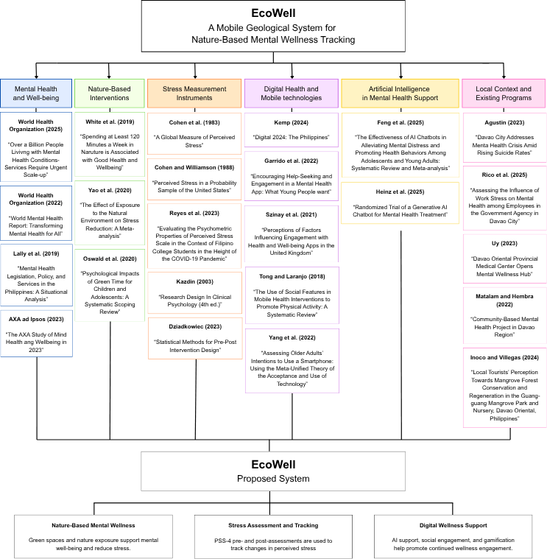
The literature map as shown in figure 2, displays the main themes that enabled the creation of EcoWell, such as mental health, nature-based interventions, stress assessment, digital health technologies, social engagement, and AI-assisted wellness support. These related studies serve as the baseline for the proposed mobile application and also pinpoint the study gap that is being tackled by the study.

Figure 2. Literature Map of EcoWell

2.2 Related Literature

Mental Health and Well-being

The rising concern on mental health had been a big issue globally. According to World Health Organization (2025) more than one billion people worldwide were struggling with various mental health problems. Anxiety and depression were the most common conditions affecting individuals of all ages, communities, and income levels (WHO, 2025). This meant the problem affected many countries, including the Philippines, where anxiety and depression have likewise been identified as the two leading mental health conditions, accounting for a significant share of disability and economic loss nationwide (WHO, 2021).

Mental health issues, in particular the anxiety and depression worsened during the COVID-19 pandemic. The World Health Organization (2022) reported a quarter increase or 25 percent in the number of people worldwide who had anxiety and depression. This rise was probably associated with the COVID-19-related restrictions which caused stress among individuals due to various factors including the loss of employment and social isolation (WHO, 2022).

The biggest barrier to mental health care in the Philippines was the lack of mental health professionals in the country. According to Lally et al. (2019), there were only three psychiatrists per one million Filipinos which is lower than the recommended number of mental health professionals that needed to provide sufficient care. As a result, most Filipinos could not get access to professional mental health assistance until their conditions became crisis. This gap in mental health care prompted the development of a mobile application that could offer help to people experiencing stress, anxiety or depression.

Most individuals of various age groups experienced severe stress, although some age brackets reported higher stress levels than others. According to AXA and Ipsos (2023), 66 percent of respondents aged 18–24 experienced stress, compared to 38 percent of those aged 55–64, based on a global survey of over 30,000 people across 16 countries and territories, including the Philippines. These statistics showed that younger generations experienced more stress, but older adults were also at risk. Therefore, developing an effective mobile application that could help individuals aged 18 to 60 years was of paramount importance, considering that stress levels among the young were high while those of older adults still required attention.

Social Support and Peer Accountability in Wellness Apps

Social support and peer interaction can help improve engagement in health and wellness applications (Szinay et al., 2021). Garrido et al. (2022) examined what young people wanted from a mental health application and found that engagement with mental health apps can be difficult to maintain. Their findings highlighted the importance of making digital mental health applications engaging and responsive to users needs. Social features can provide users with opportunities to interact with others, receive encouragement, and feel less alone while using a wellness application.

Social features have also been studied in mobile health interventions for physical activity. Tong and Laranjo (2018) found that these features can provide social support, allow users to compare their progress with others, and give rewards such as badges for completing activities. The review defined Strava as an example of social fitness app. This shows that social interaction and simple rewards can be used to motivate users to continue doing health activities.

For EcoWell, these findings support the inclusion of a community feed where users can share nature visits, photos, experiences, and recommended green spaces. Encouragement from other users can motivate continued participation, while visit streaks can provide additional motivation. Through these features, EcoWell aims to use social interaction not as its main purpose, but as a way to encourage users to engage more consistently with nature and wellness activities.

Social Dynamics in Gamified Wellness Applications

In addition to incorporating elements of social interaction into an application, researchers have explored the mechanisms by which social interaction is recognized to change behaviors. In the systematic review of gamified mental health and well-being apps by Cheng et al (2019), some of the most prevalent features included points and levels, rewards, and leaderboards, however, features that encourage social interaction and cooperation among users were among the least frequently used, and would be expected to enhance engagement through the mechanics of peer dynamics. This indicates that the social aspects of the system (as opposed to reward) are not fully exploited in the existing systems of wellness applications.

Esmaeilzadeh (2021) investigated the effect of gamification mechanisms on continued use of health and fitness apps, also noted that gamification components build up a user's information technology (IT) identity, which consequently raises continued intention to use an application and users' willingness to share information with others via the application. This means that social and gamification are mutually reinforcing – the more users feel this app is part of their daily life, the more they are ready to engage with and contribute to a collective space. For EcoWell, this helps them see how they can integrate gamification into the community feed, as the two would likely complement each other and wouldn't stand alone, so as to ensure that their users continue sharing their nature visits while continuing to use the app on a regular basis.

The results are applicable to EcoWell since the application is designed to gamify and promote social interaction to sustain engagement with nature-based wellness activities. Visit Streaks and community sharing can encourage people to visit regularly and can help them to share what they have been doing with others.

Nature-Based Interventions

Many studies looked at how spending time the nature affects the mental health. White et al. (2019) studied almost 20,000 people. They found that people who spent atleast 120 minutes a week in the nature reported better health and well-being than people who spent no time in nature. This 120 minutes figure gives a clear and realistic target. It requires only two hours of active participation across the week. This matches EcoWell approach of encouraging small and regular visits to green spaces.

Yao et al. (2020) reviewed that several studies and found that nature exposure lowered the stress signs in the body such as the blood pressure and cortisol levels. Cortisol is a hormone the body releases when it is stressed. This finding shows that natures effect on the stress can also be measured physically, not only mentally.

Oswald et al. (2020) reviewed studies on children and teenagers. They found that more time in nature was linked to better mental health while more screen time was linked to worse mental health. This finding connects to the screen time problem discussed later in this section.

These studies support the claim that many mental health and wellness benefits are directly associated with time spent in nature. EcoWell considers this evidence and integrates nature-based activities to encourage engagement with local green spaces, for example, Guang-guang Mangrove Park, to encourage users to spend more time in nature. Nature is one of EcoWell’s approaches to improving the mental wellness of Mati City residents.

Stress Measurement Instruments

There's nothing much to be gained from knowing that nature helps mental health, unless there is a reliable measure of that improvement. The Perceived Stress Scale (PSS) was originally developed by Cohen, Kamarck, and Mermelstein (1983) and has been used as a measure of perceived stress across a variety of populations, with recent validation studies supporting its continued use (Rozental et al., 2023). The scale is not asking about specific events, but whether or not a person feels in control, overwhelmed, or coping with their life. The PSS has been shortened into other forms such as the PSS-10 and the PSS-4 for brief assessments or repeated assessments (Cohen & Williamson, 1988; Rozental et al., 2023). Since then, the scale has been translated and validated into many countries outside of the United States and has proven to be a valid measure of perceived stress across cultures. This is what EcoWell aims for, as the app measures the shift in feeling before and after going into nature, not a particular stressful event.

The scale was developed and tested on non-Filipino populations; hence it was important to ensure that it remains effective in the Filipino community. Reyes et al. (2023) tested the scale on 200 Filipino college students in Davao del Sur and found it to be reliable, with a strong internal consistency score of 0.81. This shows the items of the scale measuring the same construct for all students. For EcoWell, this shows that the shortened version of the scale can be used to measure stress levels of the users before and after visiting a green space.

Stress Reduction Score

The measure, Stress Reduction Score, was created by the authors to show a user’s subjective stress level before and after engaging with a wellbeing activity on the EcoWell platform. The Stress Reduction Score is calculated using the difference of the user’s scores prior and after the activity on the Perceived Stress Scale (PSS). This methodology is based on change scores, which are extensively used in research to indicate shift in an outcome post the intervention (Kazdin, 2003; Dziadkowiec, 2023).

The PSS, developed by Cohen et al. (1983), is an instrument used to measures an individual’s perceived level of stress and is a validated tool. The Stress Reduction Score is not a validated tool— it is a derived metric based on PSS scores, created specifically to simplify how stress change is displayed on the EcoWell dashboard.

A positive Stress Reduction Score indicates a decrease in perceived stress, reflecting improvement after the activity. A value near zero suggests little or no change, while a negative value indicates increased stress. In this way, the PSS provides the underlying measurement, while Stress Reduction Score translates that measurement into a simple, easy-to-interpret indicator of change.

Item | Scoring Type | Pre-Activity Raw Answer | Pre-Activity Scored | Post-Activity Raw Answer | Post-Activity Scored
1. Felt unable to control important things in your life | Direct | 3 | 3 | 1 | 1
2. Felt confidents about your ability to handle personal problem | Reverse | 1 | 3 | 3 | 1
3. Felt that things were going your way | Reverse | 1 | 3 | 3 | 1
4. Felt difficulties were piling up so high you could not overcome them | Direct | 3 | 3 | 1 | 1
Total PSS-4 Score |  |  | 12 |  | 4
Table 1. PSS-4 Scoring Matrix

The simplified assessment EcoWell uses is the PSS-4, a 4-item short form of the 10-item PSS validated by Cohen and Williamson (1988) for use in brief, repeated self-report contexts. Each item is answered on a 0-to-4 scale (0 = Never, 1 = Almost Never, 2 = Sometimes, 3 = Fairly Often, 4 = Very Often). Two items are direct-scored, meaning the raw answer is used as-is because a higher answer reflects more stress, and two items are reverse-scored, meaning the raw answer is converted using the formula 4 − raw answer, because a higher raw answer on these items actually reflects less stress. The worked example below shows a sample user's pre-activity and post-activity responses and how each is converted into a scored value.
As shown in the table 1, the user's Total PSS-4 Score dropped from 12 before the green space visit to 4 immediately after. The Stress Reduction Score is calculated as the Pre-Activity Total minus the Post-Activity Total: 12 − 4 = 8. Because the result is positive, it indicates a meaningful decrease in perceived stress, which EcoWell displays to the user Wellness Dashboard.
Stress Reduction Score Matrix
Table 2. Stress Reduction Score Interpretation Matrix
Stress Reduction Score (PSS Score) | Interpretation | Description
>8 | Substantial Improvement | Marked reduction in perceived stress after the activity
4 to 7 | Moderate Improvement | Noticeable reduction in perceived stress
1 to 3 | Slight Improvement | Small but positive change in perceived stress
0 | No change | No measurable difference pre and post activity
-1 to -3 | Slight Decline | Perceived stress increased slightly after the activity
<-4 | Notable Decline | Marked increase in perceived stress after the activity

As shown on Table 2, it provides the Stress Reduction Score interpretation used in EcoWell. A positive Post-Activity PSS-4 score minus the Pre-Activity PSS-4 score defines the Stress Reduction Score, with higher scores indicating greater reductions in perceived stress, while lower scores indicate that the activity increased the user’s stress.

A Stress Reduction Score of 8 or greater indicates a significant improvement and provides evidence that the green space visit or wellness activity was successful in stress reduction. A Score of 7 to 4 and 3 to 1 indicates a moderate and slight improvement, respectively, while a Stress Reduction Score of 0 indicates no significant difference was noticed in perceived stress level. A negative Stress Reduction Score indicates an increase in perceived stress.
Quiet Score
The Quiet Score is a crowd-sourced indicator used in EcoWell to represent how peaceful, uncrowded, and comfortable a specific green space feels to the people who actually visit it. After every participation, a user is asked to score the place based on noise and crowd levels on a scale of 1 to 5. Unlike the Stress Reduction Score, the Quiet Score is not based on a validated psychological measure. It is self-reported, perception-based modeled after crowd-sourced review systems used by some location based apps such as AllTrails (2026), where users can leave star ratings and post subjective comments regarding their experiences. A location's displayed Quiet Score is the average of all individual ratings it has received, and it is updated automatically each time a new rating is submitted.
Score | Label | Description | Example Scenario
1 | Very Noisy / Crowded | Heavy foot traffic and loud, constant ambient noise (traffic, vendors, crowds); very difficult to relax, reflect, or decompress. | A park beside a busy market road during peak hours.
2 | Noisy /  Busy | Noticeable noise and moderate number of people, with only occasional quite lulls. | A plaza near a school around dismissal time.
3 | Moderate | Some background noise and occasional passersby, but generally tolerable for a short wellness activity. | A public park on an ordinary weekday afternoon
4 | Quiet / Peaceful | Minimal noise and few people; comfortable enough for guided breathing or reflection. | A garden path early in the morning
5 | Very Quiet / Serene | Little to no noise and largely secluded; ideal setting for mindfulness and stress-relief activities. | A forest trail or riverside spot away from traffic
Table 3. Quite Score Matrix

As shown in table 3, Quiet Score is consistent with a personal assessment of the environment rather than a measurement of an ambient environment. EcoWell considers it to be a supportive, community planning tool, and helps to evaluate effect of the environment on stress, rather than an assessment of the environment for planning. This distinction is evident in the study’s Limitations.

Digital Health and Mobile Technologies

The use of the internet adversely impacts mental health and this is very visible in the Philippines where internet use is extreme and high. One of the reports said that the average of daily internet use in the Philippines is 8 hours and 52 minutes. This was one of the surveys where the Philippines ranked very high on internet use (Kemp, 2024).

Garrido et al. (2022) reported that mental health apps that have social features or peer support are more effective in user retention. This suggests that social features can actually encourage users to be more accountable and responsible, thus more motivated to use the apps. Wellness apps struggle the most with this functionality, and this is understood because most users download wellness apps and subsequently stop using them in a short period of time (Vaghefi & Tulu, 2019). For EcoWell, simple social features like virtual check-ins or user goal reminders can be fun. However, EcoWell must ensure the design motivates users to leave the app and spend time in nature.

Older users still may care about how easy a technology is to use. After evaluating older and younger users, Yang et al. (2022) noticed older adults have more issues with smartphones. Given EcoWell is geared towards users up to age 60, the app’s interface must be as simple as possible and easy to learn, even with complicated features.

Artificial Intelligence in Mental Health Support

Researchers have studied how artificial intelligence (AI) technologies can support mental health beyond the broader categories of digital and mobile technologies. Feng et al. (2025) conducted a systematic review and meta-analysis of randomized controlled trials and found that AI-based chatbots showed a reduction in depression, anxiety, stress, and psychosomatic symptoms among adolescents and young adults. User engagement was determined to be important for the success of AI-based chatbots; repetitive content and technical issues were the main reasons for people not continuing to use the chatbots.

Heinz et al. (2025) evaluated Therabot, a generative AI mental health chatbot, in a randomized controlled trial and found clinically significant reductions in symptoms of major depressive disorder and generalized anxiety disorder, with effect sizes comparable to those of first-line psychotherapy. These findings show that AI-based tools can be an effective way to deliver mental health support at scale. Both studies demonstrated how conversational, AI-based support can help promote users emotional well-being. Based on these findings, EcoWell integrates AI to provide supportive wellness guidance.

Local Context and Existing Programs

At the local level, several studies and existing programs showed both the size of the problem and the limits of current solutions. Agustin (2023) had revealed the records of 55 suicide cases within one year in Davao City. This showed that the problem already had serious and real consequences in the region.

According to Rico et al. (2025), the research found that the heavy workloads and the time pressure can caused anxiety and burnout among the government workers in Davao City. This showed that the problem also affected both working adults and youth.

In response to these problems, the local groups created a programs to help. Uy (2023) reported that the "Selah" Mental Wellness Hub opened in Mati City, Davao Oriental in order to give a residents access to the clinical and psychiatric care. Matalam and Hembra (2022) described a Department of Health (DOH) program that supported people with schizophrenia in towns across the region. Both programs were helpful however both focused on treating people who were already in crisis. Neither program focused on helping the average resident that can help to prevent stress before it became serious. This is the gap that EcoWell aims to fill.

Furthermore, Inoco and Villegas (2024) studied the Guang-guang Mangrove Park in Dahican, Mati City. They found that the local residents valued the park for coastal protection and habitat conservation. Their study did not look at whether spending time in the park could also benefit residents mental health, even though the park is already a known and accessible green space in the same city EcoWell will serve.

2.3 Synthesis

The literature reviewed in this chapter established the clear picture of the problem this study addresses and the foundation it builds on. Globally and locally, the mental health conditions were widespread and worsening while the professional support remained limited particularly in the Philippines, in Davao Oriental specifically (World Health Organization, 2025, 2022; Lally et al., 2019; Agustin, 2023; Rico et al., 2025). The Research on nature-based interventions demonstrated that the nature exposure provides a measurable benefits for both psychological and physical stress with a specific achievable target of at least 120 minutes per week (White et al., 2019; Yao et al., 2020; Oswald et al., 2020). A reliable instrument existed to measure this improvement and its validity had been confirmed specifically within the Filipino population close to the studys own setting (Reyes et al., 2023). Meanwhile, the same digital habits contributing to Filipinos stress levels also meant that any solution needed to be mobile, accessible and easy to use across a wide age range (Kemp, 2024; Dy et al., 2023; Yang et al., 2022).

However, the reviewed literature did not identify any of the existing study or system that integrated these components into a single platform. The studies linking the nature exposure to well being were conducted in other countries, not in the Philippines and had never been tested in a locale area such as Mati City. The local mental health programs that did exist such as the "Selah" Wellness Hub and the Department of Health community initiatives were built to treat people who are already in crisis, however it does not support or prevent the daily mental health (Uy, 2023; Matalam & Hembra, 2022). In addition, the Mati City own green spaces such as the Guang guang Mangrove Park, it had been studied for their environmental value and no study had examined their potential role in supporting residents mental health (Inoco & Villegas, 2024).

Overall, this body of literature shows that the individual pieces needed for a solution already existed. There was evidence that nature helps a validated way to measure the stress locally and a better understanding of the target users digital habits, however nothing had brought them together into a single, accessible tool for the specific context of Mati City, Davao Oriental.

2.4 Related Systems

Wysa


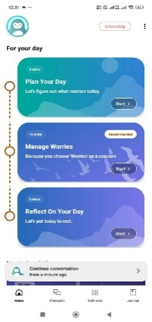
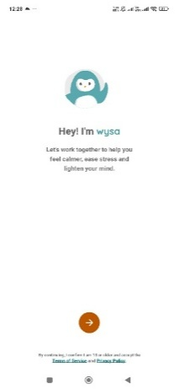
Wysa is an AI-powered mental health chatbot that used by over one million people worldwide, offering empathetic and anonymous conversations built on evidence-based techniques such as Cognitive Behavioral Therapy (CBT) and Dialectical Behavior Therapy (DBT) (Inkster et al., 2018). The app includes mood tracking, over 200 self-care tools, guided meditations, and breathing exercises and offers optional access to licensed wellbeing coaches for additional support. Its strength lies in its strong clinical backing supported by more than forty-five peer-reviewed publications and its ability to provide immediate, anonymous and stigma-free emotional support at any time (Wysa, 2026). However, its limitation is that it does not include any geolocation or navigation features and its interactions remain entirely conversational and screen-based with no connection to physical real-world environments.

Figure 3. Wysa App [Screenshot] (Version 4.3.6) (Wysa Inc.,2026)

Compared to Wysa, EcoWell shares a similar goal of providing accessible, evidence-based emotional support without requiring the users to schedule a formal appointment. EcoWell distinguishes itself by shifting the primary source of support from an AI conversation to real world nature exposure using the validated stress assessments to measure the effect of physical green space visits rather than relying on conversational interaction alone.

AllTrails

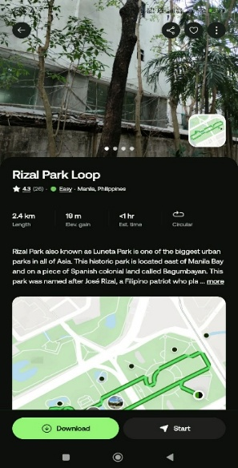
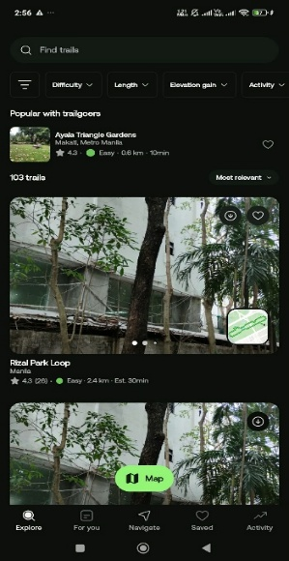
AllTrails is a popular trail finding and navigation app that provides services such as searching for trails for hiking, walking, and biking, getting information about trails, turn-by-turn navigation on the trail, and reviewing and rating trails. Its biggest strength is providing a vast database of trails found through crowd-sourcing and having offline navigation features available (Fabienne & Benoit, 2025). However, its limitation is that it does not include any mood assessment or mental wellness tracking features, meaning it cannot measure or demonstrate how a visit to a trail affects a user's emotional or physical stress levels.


Figure 4. AllTrails App [Screenshot] (Version 26.8.10) (AllTrails LLC, 2026)

Compared to AllTrails, the EcoWell adopts a similar navigation-based approach to help the users discover the outdoor locations. EcoWell distinguishes itself by adding a mood assessment layer on top of this navigation function, allowing users to see a direct, measurable link between a visit and their well-being, which AllTrails does not provide.
Calm

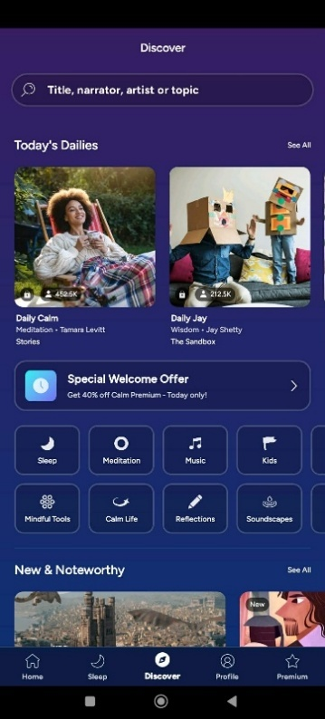
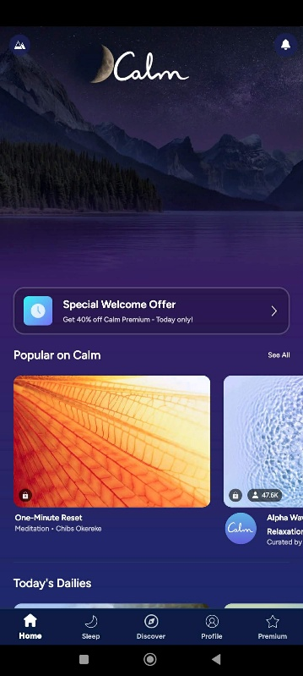

Calm is a popular mindfulness and meditation application that used by fifty million users worldwide that provides with access to various guided meditations, breathing exercises, sleep stories and calming nature sounds. One of the applications advantages stems from the high-quality, diverse content library along with a good image due to the use of famous narrators and experts (Balagam & Ajmera, 2024). On the downside, Calm is lacking location and navigation capabilities and its connection with nature involves audio exposure only.

Figure 5. Calm-Sleep, Meditate, Relax App [Screenshot] (Calm.com, Inc.,2026)

In comparison to Calm, EcoWell provides a similar guided breathing and grounding methods. In addition, EcoWell differs from Calm by relying on real outdoor activities to base users experiences in nature rather than a digital platform.
Headspace


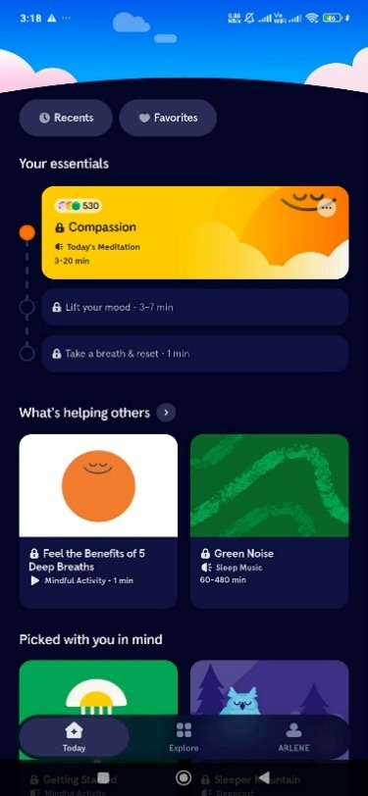
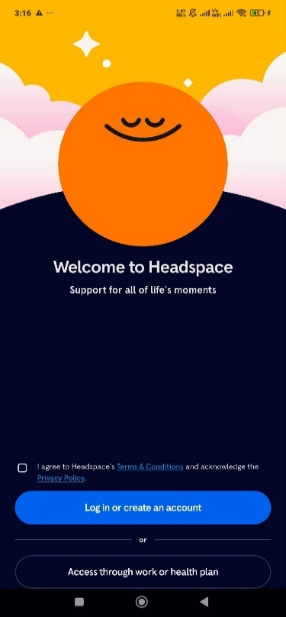
Headspace is a worldwide popular app for mindfulness and meditation application. Headspace has over 5,000 meditations, mood check-ins, breathing exercises, sleep solutions and an AI companion called Ebb. Users also get an opportunity to get professional help from qualified therapists when they feel they require structured clinical help. Its advantages come from the abundance of information and the years of research carried out around it (Healthy Mind Map, 2026).

Figure 6. Headspace: Sleep & Meditation App [Screenshot] (Headspace, 2026)

Compared to Headspace, EcoWell adopts a similar approach to guided breathing and mindfulness content. EcoWell distinguishes itself by grounding these activities in real outdoor visits rather than in-app content alone, encouraging the users to build wellness habits through direct engagement with nearby green spaces.
Strava
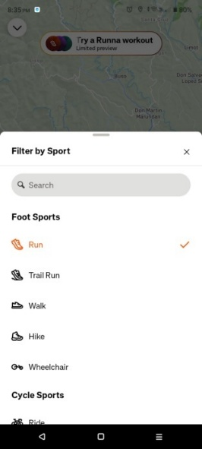
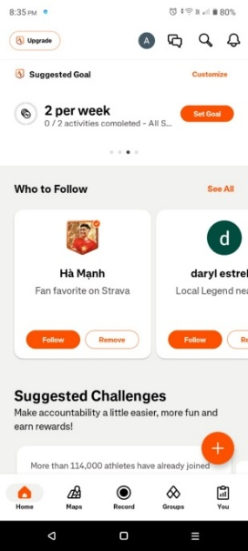

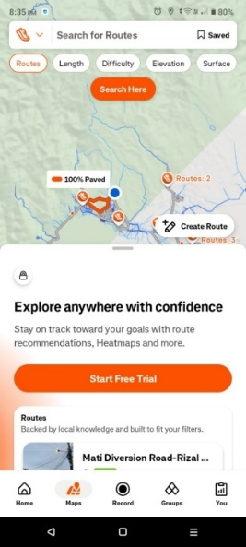
Strava helps you track and log your runs, rides, swims, and walks, and you can share your activities with the global fitness community to help stay motivated and inspired. Strava has tools for tracking your activities and providing you with feedback on distance, time, pace, and routes. Beyond that, there's a social feed that lets you engage with Strava by giving kudos or posting comments to the other user's activities. Strava users join clubs and challenges to set up shared activities to stay motivated and to keep up with their individual and collective goals (Strava, 2026).

Figure 7. Strava: Run, Bike, Walk App [Screenshot] (Strava Inc., 2026)
Compared to Strava, EcoWell adopts similar social and progress-tracking features through its community feed, visit history, and Visit Streak Tracker. Instead of focusing on fitness performance, EcoWell focuses on nature-based mental wellness by recording visits to green spaces and tracking changes in users’ stress levels before and after each visit. EcoWell therefore uses the social and motivational concepts of Strava while applying them to nature engagement and mental wellness.
Duolingo
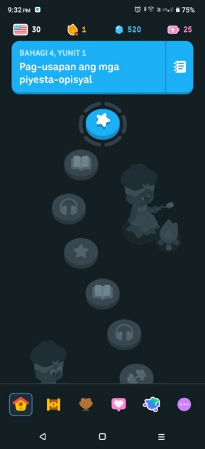
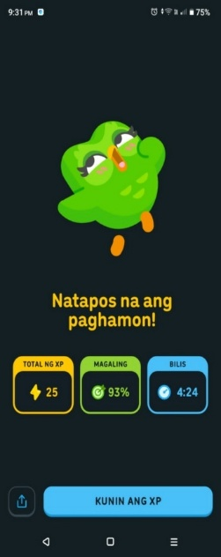
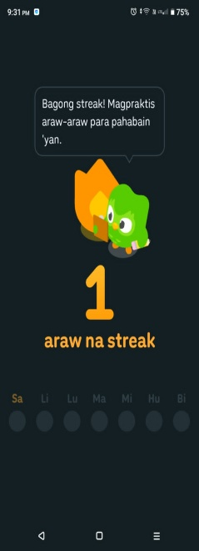

Like Strava, Duolingo helps you learn a new language in a fun way and with practice Duolingo helps you retain what you learn, a contributed factor to the gamified aspect. Duolingo offers XP and levels, and adds rewards to keep you and other users engaged and on Devl bites. Duolingo also has social features to invite, track, and compete with your friends and motivate you both to complete your Friend Quests and Friend Streaks and keep up your Duolingo Streaks (Korzekwinski et al., 2026).

Figure 8. Duolingo Language Learning App [Screenshot] (Doulingo, 2026)
Compared to Duolingo, EcoWell uses similar motivational features such as streaks and community sharing. However, EcoWell applies these features to encourage regular visits to green spaces and track changes in users’ stress levels. Thus, EcoWell combines Duolingo’s motivational concepts with geolocation, nature engagement, and mental wellness tracking.
Comparison Table of Related Systems
Table 4. Comparison of Related Systems
 | Related Systems |  |  |  |  |  | Proposed System
Features | Wysa | AllTrails | Calm | Headspace | Strava | Duolingo | EcoWell
Pre-/Post-Visit PSS-4 Stress Assessment | — | — | — | — | — | — | ✓
Stress Reduction Score | — | — | — | — | — | — | ✓
GIS Navigation | — | ✓ | — | — | ✓ | — | ✓
Geofencing | — | — | — | — | — | — | ✓
Guided Breathing and Grounding exercises | ✓ | — | ✓ | ✓ | — | — | ✓
AI Wellness Assistant | ✓ | — | — | ✓ | — | — | ✓
Weather-Based Suggestions | — | — | — | — | — | — | ✓
Quiet Score | — | — | — | — | — | — | ✓
Wellness Dashboard | ✓ | — | ✓ | ✓ | ✓ | ✓ | ✓
Visit Streak | ✓ | ✓ | ✓ | ✓ | ✓ | ✓ | ✓
Smart Reminders | ✓ | ✓ | ✓ | ✓ | ✓ | ✓ | ✓
Community Feed | — | ✓ | — | — | ✓ | ✓ | ✓
Data Export | — | ✓ | — | — | ✓ | — | ✓

As shown in the table 4, the comparison shows that the related systems provide different functions that are relevant to EcoWell. Wysa, Calm, and Headspace primarily focus on mental wellness, relaxation, and AI-assisted support, while AllTrails and Strava provide outdoor navigation and activity-related functions. Duolingo demonstrates the use of streaks, reminders, community interaction, and gamification to encourage continued user engagement. Duolingo, for example, provides feeds, friend interactions, streaks, and reminders to support regular learning habits. Strava also provides route navigation, community activity sharing, and data export features.

In comparison, EcoWell combines geolocation, geofencing, PSS-4 pre-/post-visit stress assessment, Stress Reduction Score, nature-based wellness activities, weather-based suggestions, Quiet Score, and community features in one platform. Its main distinction is that the system connects real-world green-space visits with measurable changes in perceived stress, rather than focusing only on digital wellness activities, outdoor navigation, fitness tracking, or habit formation.

CHAPTER III
MATERIALS AND METHODS
3.1 Software Methodology

The development of EcoWell: A Social Mobile Application with Geolocation for Nature-Based Mental Wellness Tracking is based on the Modified Waterfall Software Development Life Cycle (SDLC) where the PADIM (Planning, Analysis, Design, Implementation, and Maintenance) framework is utilized. The Modified Waterfall Model is an approach to software development that breaks down the process into sequential steps. This model is similar to the Waterfall Model, but allows for feedback between steps and partially overlapping steps and permits minor improvements to the system prior to the completion of the next step (McConnell, 1996).

The developers selected this methodology because EcoWell has clearly defined objectives, requirements and functionalities before the development. The application integrates several components, including GIS-based navigation, geofencing, a PSS-4 pre- and post-visit stress assessment with automated Stress Reduction Score computation, an AI-assisted wellness coach, a Quiet Score rating system, weather-based visit suggestions, a community feed, visit streaks, and AES-256 data encryption — each of which depends on requirements and design decisions that need to be finalized before coding begins. Using the Modified Waterfall Model ensures that each component is carefully planned, analyzed, designed, implemented and maintained in an organized manner that result in a reliable and high-quality mobile application.

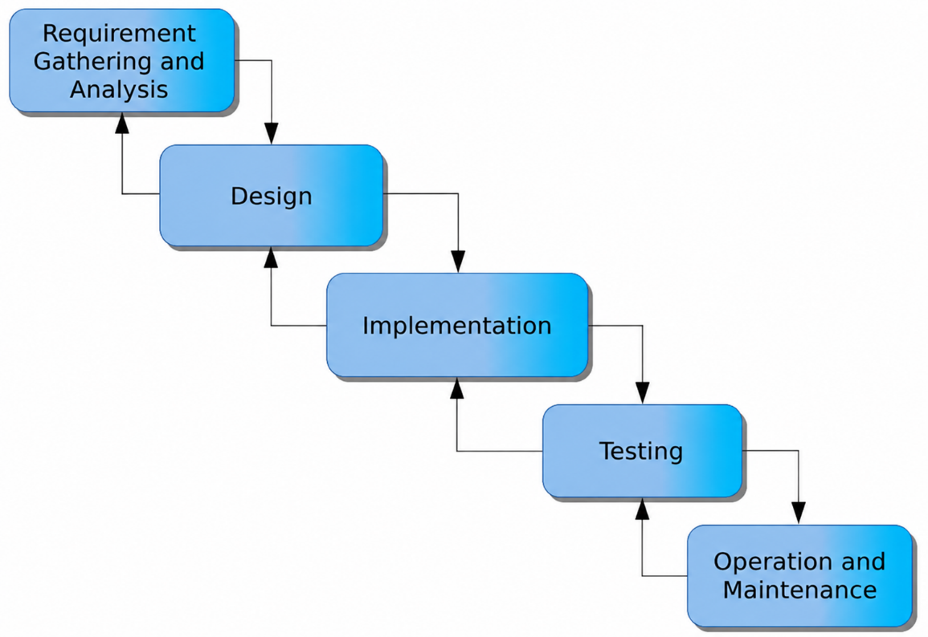
Figure 9. Modified Waterfall Model
As illustrated in Figure 9, the Modified Waterfall Model is the basis of the software development process that consist of five sequential phases with feedback loops that allow the researchers to revisit a previous phase when revisions are necessary. In the Requirement Gathering phase, the researchers identify the objectives, target users, and functional requirements of EcoWell such as GIS-based navigation, geofencing, the PSS-4 stress assessment, the AI-assisted wellness coach, and data security needs, resulting in a documented list of system requirements that will guide the succeeding phases. During the Design phase, the requirements are converted to system architecture and database and interface design. Design outputs of this phase include system diagrams, schemas of the database, and models of the design of the Quiet Score system and AES-256 encryption. In the Implementation phase, the design is translated to software. The developers build and connect all the modules of the application, and a fully functional version of EcoWell is created. During the Testing phase, the system is evaluated and designed to detect and remove bugs, errors, and inconsistencies. Each of the features including the computation of the Stress Reduction Score and the suggestion of the weather-based visit is evaluated whether or not they meet the defined requirements. During the Operation and Maintenance phase, the application is published to the public for the first time. The developers support and fix the reported issues and make the necessary changes, and improvements to enhance the performance of the application.
During requirement gathering and analysis, developers capture the purpose, user types, and functions of EcoWell. The results include a requirements specification document. This document outlines the key functionalities of EcoWell which include GIS-based navigation, geofencing, the PSS-4 pre- and post-visit stress assessment, the AI-based wellness coach, the Quiet Score rating system, weather-based suggestions for visits, the community feed, visit streaks, and AES-256 data encryption. This phase also includes a list of system constraints and user requirements which form the basis of design and development.
Based on the requirements gathered, the design phase produces the technical blueprint of the system. It include the system architecture diagrams showing how the components such as the GIS module, geofencing engine, and AI-assisted wellness coach will interact, database schemas or the entity-relationship diagrams (ERDs) representing how user data, wellness scores, and community posts will be structured and stored, and the user interface wireframes or mockups showing the layout of key screens such as the stress assessment form, Quiet Score display, and community feed. The encryption scheme for securing user data through AES-256 is also finalized during this phase.
The implementation phase of the project generates working software. Here, source code for the implementation of each component of EcoWell is created. This phase also provides a combination of all the components of the mobile application which includes GIS navigation, geofencing, stress assessment, the AI-based wellness coach, and community features. Additionally, the phase provides the results of modular unit testing for each of the features, such as the stress reduction score computation, which verifies that the features operate correctly when tested independently, before the final system integration and testing.
Finally, the testing phase provides documentation to verify system requirements. This phase includes a test plan and a test case for every functionality of the application, a bug and defect logging document, and a final test report which confirms that the functionality of the system, including weather based visit suggestions, the community feed, and the encryption functionality, meet the required system specifications and are secured for end system use.
During the deployment phase of the EcoWell system, continuous documentation keeps the system reliable through the operation and maintenance phase. This consists of deployments, log entries, user feedback, and the bugs, patches, and updates deployed after the initial releases to the end users. The user feedback section is used to capture issues and suggestions to improve AI-based personal wellness guidance (i.e. the Wellness Assistant) and the Quiet Score system which guide future enhancements to the application.
3.2 System Planning

The planning stage that serves as the foundation for the development of EcoWell: A Social Mobile Application with Geolocation for Nature-Based Mental Wellness Tracking. During this stage, the developers identified the need for a mobile application that promotes the preventive mental wellness by encouraging the users to engage with nearby green spaces within Mati City, Davao Oriental.

The concept of EcoWell was developed after reviewing the existing literature, related systems and the challenges associated with limited access to preventive mental wellness tools and the limited use of natural environments for the mental wellness. Based on these findings, the developers conceptualized a mobile application that integrates the geolocation technology with the mental wellness tracking to provide the users with a practical and accessible wellness support tool.

To prepare for the development of the project, the developers defined the project objectives, scope, target users and major system functionalities. The required software and hardware resources, development tools and external services such as Google Maps API, Weather API and AI- assistant were identified to support the implementation of the application. A development plan and project schedule were also prepared in order to ensure that each phase of the Modified Waterfall Model would be completed systematically. This planning stage established a clear direction for the successful design, development, implementation and maintenance of the EcoWell application.

Feasibility Study

EcoWell is a mobile application designed to help residents of Mati City, Davao Oriental manage their mental stress through nature-based wellness activities and geolocation technology. The application guides the users to nearby green spaces within in Mati City while allowing them to monitor the effects of nature exposure on their mental well-being. Before proceeding with the development of the system, it is necessary to determine whether the proposed project can be successfully developed, implemented and maintained within the available resources and project constraints.

This feasibility study evaluates the practicality and viability of the proposed system by examining its operational, technical and the economic feasibility. These dimensions determine whether the EcoWell can effectively meet the user needs, be developed using the available technologies and resources and provide benefits that justify the cost and effort required for its implementation. The results of this assessment demonstrate that the proposed system is feasible, sustainable and the beneficial for its intended users.

Operational Feasibility

The operational feasibility of the EcoWell was assessed to determine whether the system will function effectively among its intended users and within the community it seeks to serve.

The EcoWell is expected to be readily accepted by its target users, the residents of Mati City, Davao Oriental that start from aged of 18 to 60, since the application was designed to be simple, intuitive and accessible, requiring no specialized technical knowledge to operate. Given the widespread use of the smartphones and mobile applications among Filipinos, the researchers anticipate minimal resistance in adopting a tool that offers free, self-directed mental wellness support. Furthermore, because the system addresses a gap identified in Chapter I, that is the lack of accessible and preventive mental wellness tools in the locality, users who currently have limited or no access to professional mental health services expected to find particular value in a free, readily available alternative that allows them to take an active role in managing their own stress levels.

At present, the residents of Mati City have limited means of engaging in structured, preventive mental wellness practices. The Existing local initiatives such as the "Selah" Mental Wellness Hub primarily provide a clinical and psychiatric support to individuals that already experiencing a mental health crisis, while the shortage of mental health professionals, at fewer than three psychiatrists per one million Filipinos makes timely professional consultation difficult to obtain. In addition, residents who wish to use nearby green spaces such as the Guang-guang Mangrove Park for relaxation currently have no digital tool to guide them to these locations, nor any means of tracking whether such visits actually improve their well-being. EcoWell addresses these pain points by automating the process through GIS-based navigation, geofencing and digitized mood assessments, eliminating the need for manual tracking such as paper-based journaling, and by making preventive wellness support available anytime without requiring an appointment or a clinic visit.

The successful operation of EcoWell is also likely to be supported by relevant local institutions. The Local government offices in Mati City, particularly those involved in health and community wellness programs, as well as the health institutions such as the Davao Oriental Provincial Medical Center that operates the "Selah" Mental Wellness Hub, are expected to view EcoWell as a complementary tool that extends their preventive mental health efforts beyond the crisis intervention. Since the application aligns with existing initiatives of the Department of Health (DOH) for community-based mental health programs, it is reasonable to expect that the local government support such as the endorsement of verified green spaces or assistance in promoting the application to residents, can be secured. Additionally, the Davao Oriental State University, as the academic institution overseeing this capstone project provides an institutional support throughout the development, testing and evaluation of the system.

Economic Feasibility

The economic feasibility of the EcoWell will be evaluated by comparing the estimated costs of the development and deploying the system against its expected benefits in order to determine whether the project represents a worthwhile investment of resources for its intended users. Since the application will be built using the open-source tools and free-tier services, the development costs are expected to remain minimal, while the benefits gained in terms of improved mental wellness, stress management, and access to nature-based activities for its users are expected to outweigh these costs, making the project economically feasible.

Table 5: Cost-Benefit Analysis

COST
Category | Estimated Budget
1. Requirements Gathering and Analysis | –
2. System Design | –

3. Implementation
3.1 Firebase Backend (Blaze Plan, pay-as-you-go) | Php 20,000.00
3.2 Google Maps API (Directions/Places, usage buffer) | Php 3,000.00
3.3 AI Chatbot API (Premium/pay-as-you-go) | Php 1,500.00
4. Testing | –

5. Deployment
5.1 Conduct of User's Training | Php 3,000.00
5.2 User Evaluation | Php 1,500.00

6. Maintenance
6.1 Development and Distribution of User Manual | Php 2,000.00
6.2 Printing and Reproduction (survey/evaluation forms, user manual, bond paper & ink) | Php 1,000.00
6.3 Annual Maintenance and Updates | Php 30,000.00
Total Cost: | Php 62,000.00

BENEFITS

Time Savings: (15 hours – 4 hours) × (Php 15,000 / 22) = Php 7,500.00

Monthly Savings: (15 hours – 4 hours) × (Php 15,000 / 22) = Php 7,500.00

Annual Savings: Php 7,500.00 × 12 = Php 90,000.00
Total Benefits: | Php 90,000.00
Return on Investment (ROI) = (Net Benefits – Total Cost) / Total Cost | 0.45 or 45.16%
Payback Period = (Cost of Implementation / Monthly Savings) | 8.27 months

The economic feasibility of the EcoWell will be assessed using the Cost Benefit Analysis (CBA) in order to determine if it is economically feasible and sustainable for the proposed purpose. The analysis will include all incurred expenses, which are Firebase backend on a monthly pay-as-you-go basis for ₱20,000.00, Google Maps API buffer for ₱3,000.00 , AI chatbot API premium-tier buffer for ₱1,500.00, user training for ₱3,000.00 , and user evaluation for ₱1,500.00 , user manual preparation for ₱2,000.00, printing and reproduction for ₱1,000.00 , and annual maintenance and updates for ₱30,000.00, totaling to ₱62,000.00 . During the calculation of the CBA, the man-hours were calculated to identify the potential benefits that the system could generate based on the time that would be saved by the users having to spend only 4 hours per month studying green space and mood tracking instead of 15 hours. By calculating the hourly cost of the user, based on ₱15,000.00 monthly salary over 22 working days, and multiplying it by the saved 11 hours per month and 12 months per year, the monthly benefit would be ₱7,500.00 and the annual benefit would be ₱90,000.00. Using the calculated figures, the ROI is projected to be 45.16%, while the payback period would be 8.27 months on average, suggesting that the system would be economically viable for the users as the development cost would be recovered within one year of its use.

Technical Feasibility

The technical feasibility of the EcoWell will be determined based on whether it can be developed on existing hardware and software resources and whether it will be able to meet the systems complex and requirements.

The hardware needed to conceptualize, develop, and test the product will be available to the researchers, as it only involves a computer or a laptop sufficient to run the development systems, and Android phones needed to test the app’s GIS navigation and geofencing features. Similarly, the software needed to develop the application, including Flutter and Dart programming tools, Android Studio and Visual Studio development suites, and Weather API will also be available to the developers. These development tools are either free to use or have free versions that can be accessed without incurring additional costs. As such, the technical feasibility of the proposed solution based on hardware and software availability is achievable.

The tools selected for EcoWell are compatible with both of the developers technical skills and the objectives of the study. Flutter and Dart allow the developers to build a single, codebase capable of supporting the app's core features, including GIS-based navigation, geofencing, and the stress assessment module, without requiring separate native development skills for each platform. Firebase provides authentication, real-time data storage, and cloud functions to support the user account system, stress assessment records, and the community feed. Firebase's documentation and structure closely align to researchers' mobile-backend integration experience. Researchers can use these services to integrate location-based services, weather, and other features using the Google Maps and OpenWeather APIs. The researchers have the mobile development experience and familiarity with the tools within the mobile development stack used. The selected tools support the EcoWell system.

Firebase's real-time database and cloud functions can handle the post-visit and pre-visit stress assessments to compute the Stress Reduction Score and update the Wellness Dashboard in an orderly fashion. The Google Maps API supports the geofencing functionality required to automatically detect user entry and exit at designated green spaces, which is essential for triggering the app's stress assessment prompts. Firebase Authentication, together with AES-256 encryption for sensitive user data, is sufficient to meet the system's data privacy requirements under the Data Privacy Act of 2012 (RA 10173). Additionally, the AI assistant feature can be implemented through existing third-party AI APIs, which are designed to handle natural language processing tasks such as providing stress-management guidance without requiring the developers to build or train a language model independently. Taken together, these tools are sufficient to handle the technical demands of EcoWell's features, from geolocation and data visualization to AI-assisted interaction and secure data handling.

Based on the availability of the necessary hardware and software, the compatibility of these tools with the researchers' skills and the study's objectives, and their proven capability to support systems of similar complexity, the proposed EcoWell system is technically feasible to develop.

Work Breakdown Structure (WBS)

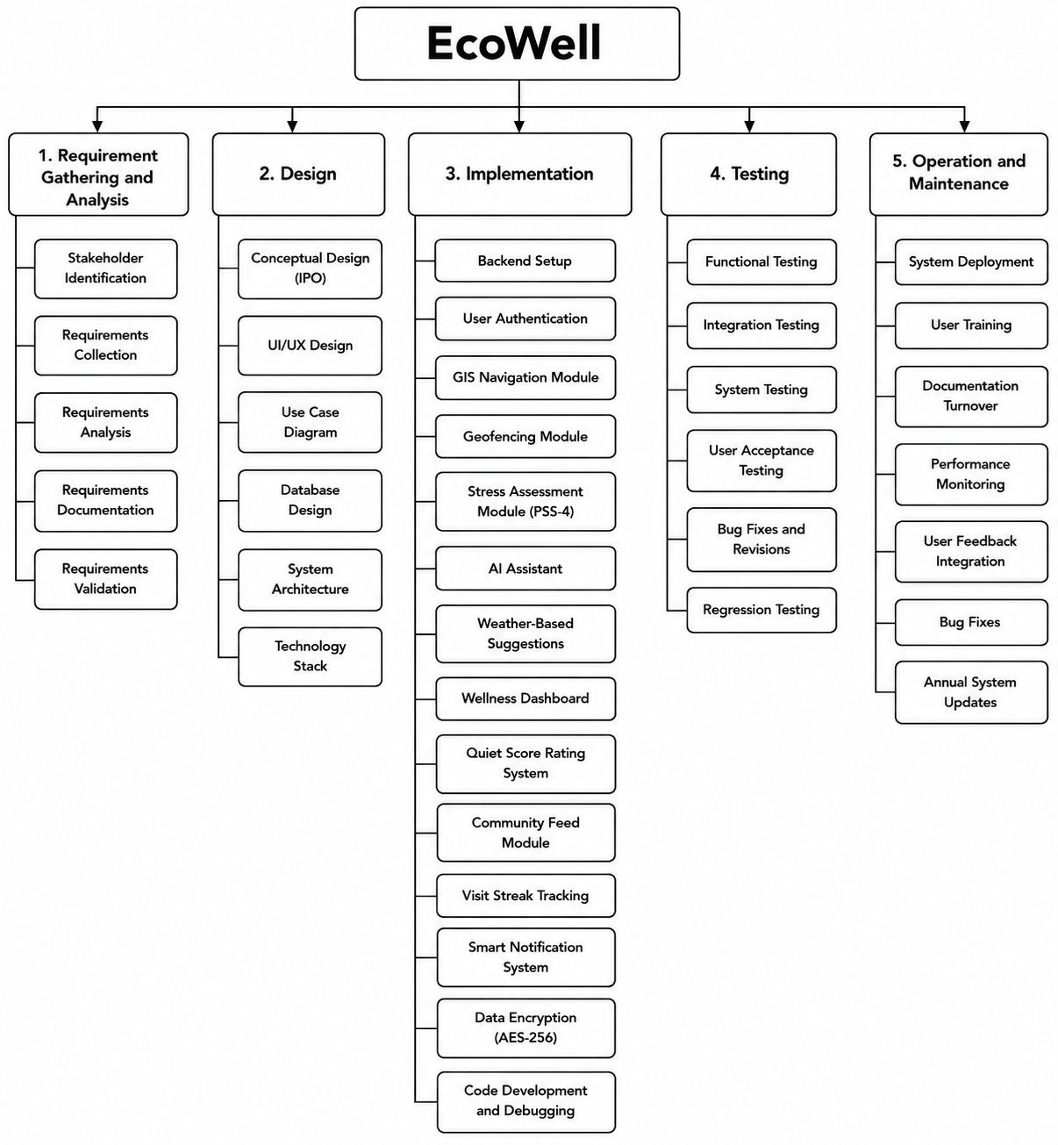
As shown in Figure 10, the Work Breakdown Structure (WBS) represents the major activities that involved in the development of EcoWell: A Social Mobile Application with Geolocation for Nature-Based Mental Wellness Tracking. It organizes the project into manageable tasks based on the phases of the Modified Waterfall Model, consisting of Requirement Gathering and Analysis, Design, Implementation, Testing, and Operation and Maintenance. Each phase contains specific activities and deliverables that contribute to the successful completion of the project. By dividing the project into smaller work of packages the WBS helps the researchers monitor the progress, assign the responsibilities, and ensure that all project requirements are completed systematically throughout the software development process.

Figure 10. Work Breakdown Structure (WBS)
Gantt Chart
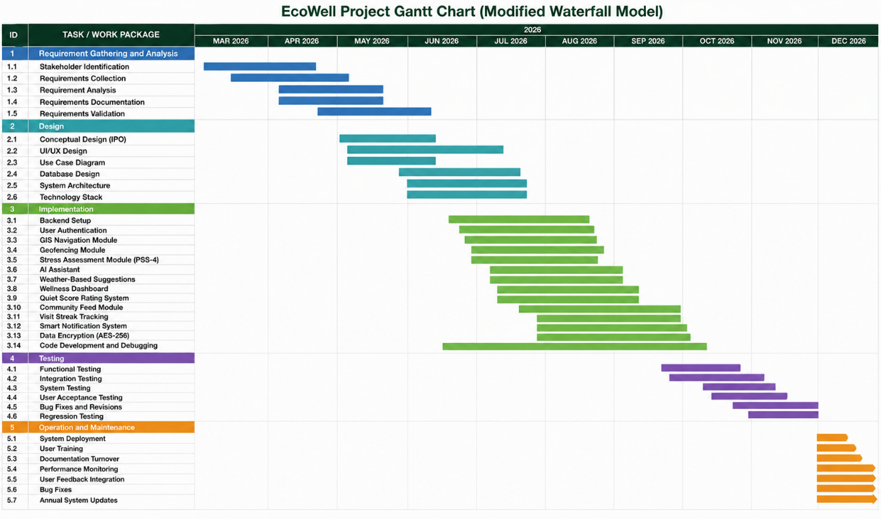
The Gantt Chart presents the planned schedule and timeline for the development of EcoWell: A Social Mobile Application with Geolocation for Nature-Based Mental Wellness Tracking from March to December 2026. It is based on the Work Breakdown Structure (WBS) and follows the phases of the Modified Waterfall Model. The chart provides a clear overview of the activities, expected duration, and the sequence in which the different tasks will be carried out. It serves as a guide for the developers in organizing, monitoring, and managing the project throughout its development.
Figure 11. Gantt Chart of EcoWell
As show in Figure 11, the project begins with the Requirement Gathering and Analysis phase in March 2026 which includes stakeholder identification, requirements collection, requirement analysis, documentation, and validation. This is followed by the Design phase that consists of conceptual design, UI/UX design, use case diagrams, database design, system architecture, and technology selection. The Implementation phase is mainly scheduled from June to October and it includes the development of the backend, user authentication, GIS navigation, geofencing, stress assessment, AI assistant, wellness dashboard, community features, notifications, data encryption, and other major system functions. These phases establish the foundation and core features of the EcoWell application.
After implementation, the Testing phase takes place from September to November 2026. It includes functional testing, integration testing, system testing, user acceptance testing, bug fixing and revisions, and regression testing to ensure that the application works properly and meets the identified requirements. Finally, the Operation and Maintenance phase is scheduled in December and includes system deployment, user training, documentation turnover, performance monitoring, user feedback integration, bug fixes, and system updates. Overall, the Gantt Chart provides the researchers with a systematic timeline for tracking project progress, managing tasks and deadlines, and ensuring that the development of EcoWell is completed within the planned period.
3.3 System Analysis
The Analysis phase corresponds to the latter part of the Requirement Gathering stage of the Modified Waterfall Model. This stage focuses on examining how residents of Mati City currently attempt to manage their stress through nature, identifying the weaknesses of this existing process, and translating the gaps established in Chapter I and the related systems reviewed in Chapter II into concrete functional and non-functional requirements for EcoWell. This involves breaking down the identified problems in depth to determine the specific features and functionalities that the system must possess in order to effectively address them. The output of this phase serves as the foundation for the system design, ensuring that every proposed feature of EcoWell is directly based on a validated user need rather than an assumed one.
Description of the Current System
The current process of visiting green spaces for mental wellness is not supported by a single integrated system. Individuals who want to relax or reduce stress usually use different mobile applications to complete the process. They first search for a green space using online map services or social media platforms. After selecting a location, they gather information about the place, such as its accessibility, available facilities, and operating hours. They also use a separate weather application to check whether the weather is suitable for outdoor activities.
If the weather is favorable, users navigate to the selected green space using a map application. Upon arriving at the location, users spend time relaxing or engaging in recreational activities without any digital support for monitoring their mental well-being. Existing applications do not automatically detect the user's arrival, provide stress assessments, or offer guided breathing and grounding exercises during the visit. In addition, users do not have access to an AI assistant that can provide mental wellness support while they are in the green space.
After completing their visit, users leave the location without receiving any feedback about the effect of the visit on their stress level. They may choose to share photos or experiences on social media, but these platforms do not measure stress reduction or monitor wellness progress. As a result, users cannot track the benefits of their visits or evaluate how nature-based activities affect their mental well-being over time.
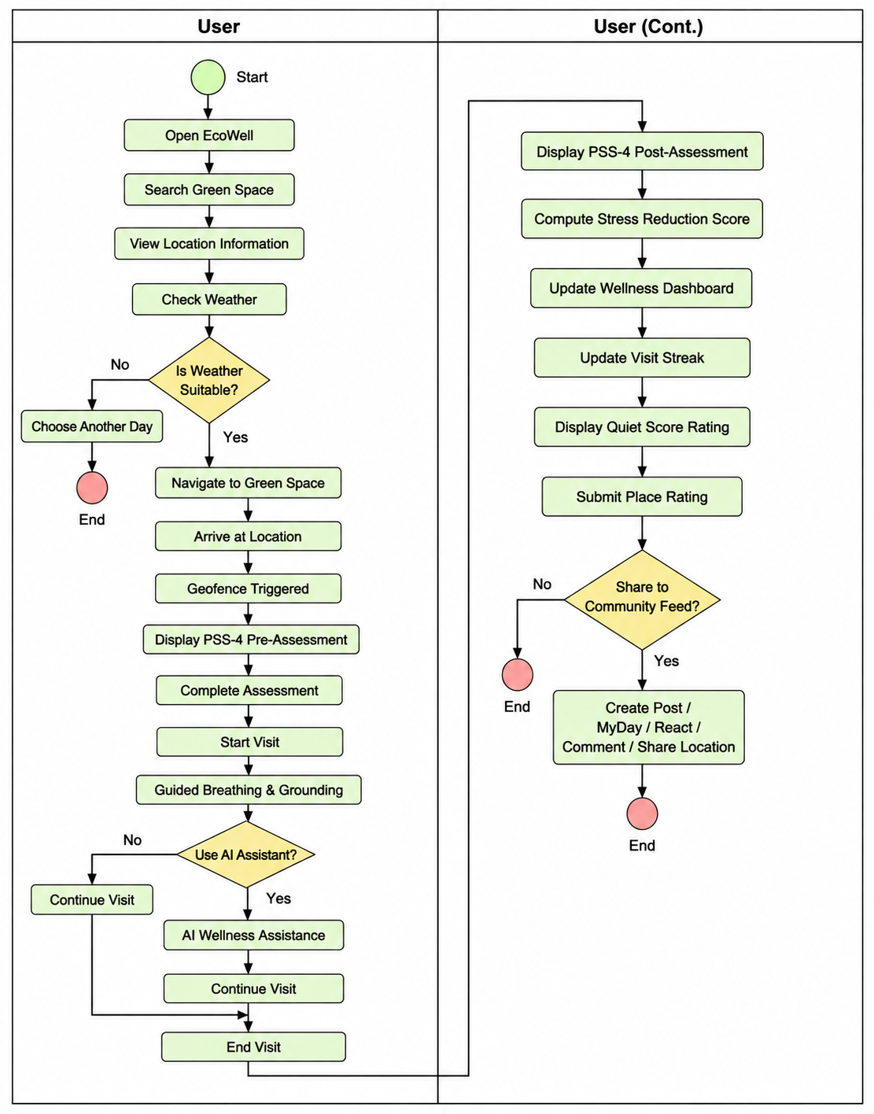
The current process is illustrated in the Business Process Model and Notation (BPMN), which shows the sequence of activities performed using different applications before, during, and after visiting a green space.

Figure 12. BPMN of the Current System
Weaknesses of the Current Process
No integrated navigation and wellness platform. As shown in Table 2.4 of Chapter II which is the comparison table of the related systems, there is no single existing system combines geolocation-based navigation with mental wellness tracking. Applications such as AllTrails provide navigation features but do not assess mental well-being, while Wysa, Calm, and Headspace offer relaxation and mood support but do not guide users to nearby green spaces. As a result, users need to switch between multiple applications to complete the process.
No measurable link between nature exposure and well-being. Existing applications do not provide pre-visit and post-visit stress assessments. Because of this, users cannot objectively determine whether visiting a green space has reduced their stress levels or improved their mental well-being. This also makes it difficult to monitor progress and maintain long-term engagement in nature-based activities.
Reliance on informal and unverified information. Residents often depend on word of mouth, social media, or general map applications when choosing a green space. These sources are not specifically designed for mental wellness and do not provide information such as environmental quality, quietness, crowd level, or wellness-related recommendations.
Limited preventive mental wellness support. As discussed in the Rationale of the Study in Chapter I, existing local services, such as the Selah Mental Wellness Hub and the Department of Health's community mental health programs, mainly focus on assessment, treatment, and intervention. Although these services are valuable, they provide limited support for preventive and everyday mental wellness practices through regular exposure to green spaces.
No centralized wellness monitoring. Current applications do not provide a wellness dashboard where users can monitor their stress levels, visit history, or overall progress. Without a centralized tracking system, users cannot easily evaluate the long-term benefits of their nature-based activities.
Lack of motivation and community engagement. Some of the existing systems do not include features such as visit streaks, community sharing, or location-based interactions that encourage users to regularly visit green spaces and share their wellness experiences with others. This may reduce long-term user engagement and participation.
Overall, these weaknesses show that residents of Mati City lack a single, reliable tool that connects them to nature while also supporting their mental wellness in a measurable way, with each gap pointing to a specific opportunity for EcoWell to fill. Addressing these weaknesses directly shaped the functional and non-functional requirements defined for the system.
Requirements Specification
Based on the weaknesses that identified in the current process and the objectives established in Chapter I, the following functional and non-functional requirements were defined to guide the Design phase of the EcoWell. The functional requirements describe the specific tasks and features that the system must be able to perform in order to meet the needs of its users. The non-functional requirements, on the other hand, define the standards that the system must meet in terms of performance, usability, security, and reliability.
Functional Requirements
The system shall allow users to:
ID | Functional Requirement
FR-01 | The system shall allow users to register, log in, and authenticate their accounts before accessing the system's features.
FR-02 | The system shall display real-time, GIS-integrated navigation to verified green spaces within Mati City using the Google Maps API.
FR-03 | The system shall automatically detect a user's entry into and exit from a designated green space using geofencing.
FR-04 | The system shall allow users to complete the digital pre-visit and post-visit stress assessments using the simplified Perceived Stress Scale (PSS-4) and automatically compute the Stress Reduction Score.
FR-05 | The system shall display a Wellness Dashboard showing stress assessment results, Stress Reduction Scores, visit history, and wellness trends over time.
FR-06 | The system shall automatically update and display the user's Visit Streak based on completed green space visits.
FR-07 | The system shall allow users to rate the quietness of a green space through the Quiet Score system and view community ratings.
FR-08 | The system shall display current weather conditions and provide weather-based suggestions before visiting a green space.
FR-09 | The system shall send smart notifications based on the user's visit history and wellness activities.
FR-10 | The system shall provide guided breathing and grounding exercises through step-by-step instructions and instructional videos.
FR-11 | The system shall allow users to interact with an AI-assisted wellness coach for general stress management and mental wellness support.
FR-12 | The system shall allow users to create posts, upload MyDay stories, react, comment, and share visited green spaces through the Community Feed.
FR-13 | The system shall allow users to export or share their stress assessment records and visit history as a PDF summary.
Non-Functional Requirements
The non-functional requirements below are organized according to the quality attributes defined under ISO/IEC 25010.
ID | Category | Non-Functional Requirement
NFR-01 | Usability | The system shall provide a simple, intuitive, and user-friendly interface that requires no specialized technical knowledge to operate.
NFR-02 | Reliability | The system shall accurately record geofence-triggered visits and stress assessment results without data loss during normal operation.
NFR-03 | Performance | The system shall load GIS navigation routes, weather information, and the Wellness Dashboard within an acceptable response time under normal network conditions.
NFR-04 | Security | The system shall protect sensitive user data, including stress assessment results and visit history, using AES-256 encryption and shall comply with the Data Privacy Act of 2012 (Republic Act No. 10173).
NFR-05 | Compatibility | The system shall be compatible with Android devices that support the Google Maps API, Weather API, and AI Assistant API.
NFR-06 | Availability | The system shall remain accessible to users whenever an active internet connection is available, as defined within the scope of the study in Chapter I.
NFR-07 | Maintainability | The system shall be designed using a modular architecture to simplify maintenance, debugging, and future feature enhancements.
NFR-08 | Portability | The system shall be developed using Flutter to support deployment on Android devices and allow future adaptation to other mobile platforms with minimal code modifications.

Proposed Solution
The proposed system, EcoWell: A Social Mobile Application with Geolocation for Nature-Based Mental Wellness Tracking, addresses the limitations of the current process by integrating geolocation, mental wellness tracking, and social interaction into a single mobile application. The system helps users locate nearby green spaces, provides navigation and weather-based suggestions, and uses geofencing to trigger pre-visit and post-visit PSS-4 stress assessments. It then computes the Stress Reduction Score and displays the results through a Wellness Dashboard.
In addition, EcoWell promotes continuous engagement through guided breathing and grounding exercises, an AI-assisted wellness coach, Visit Streaks, Quiet Score ratings, smart notifications, and a Community Feed where users can share posts and interact with others. Overall, the system provides a more convenient, preventive, and user-centered approach to supporting mental wellness through nature-based activities.
3.4 System Design
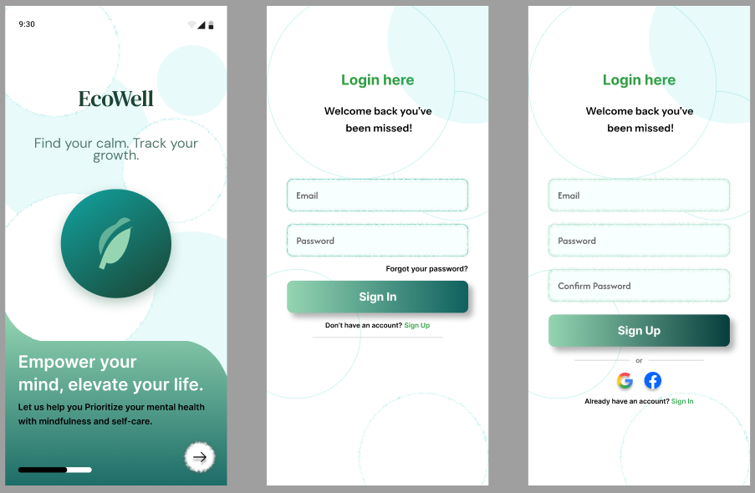
User Registration
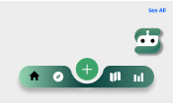
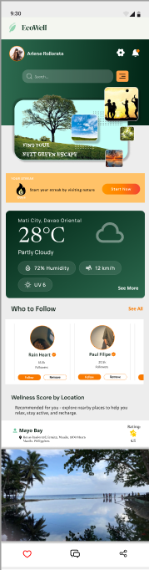
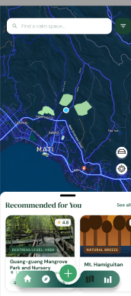
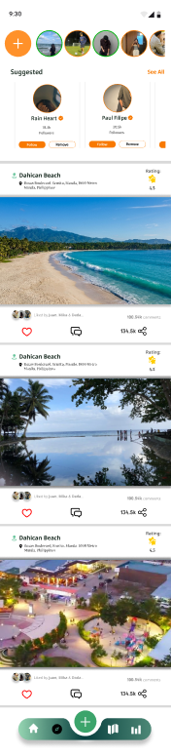
Home, Community Feed and Map Screen
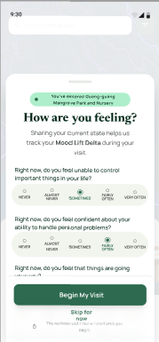
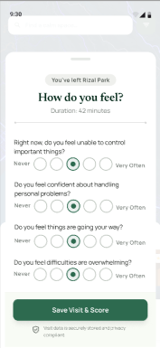
Pre-Visit and Post-Visit assessment

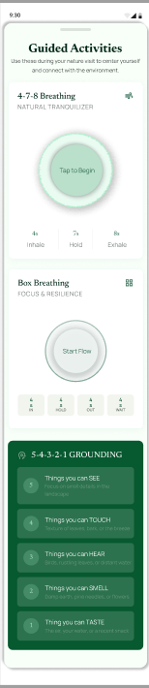
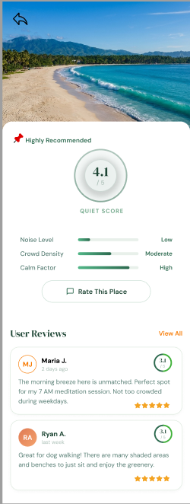
Guided Activities and Quite Score

AI- chatbot Assistant
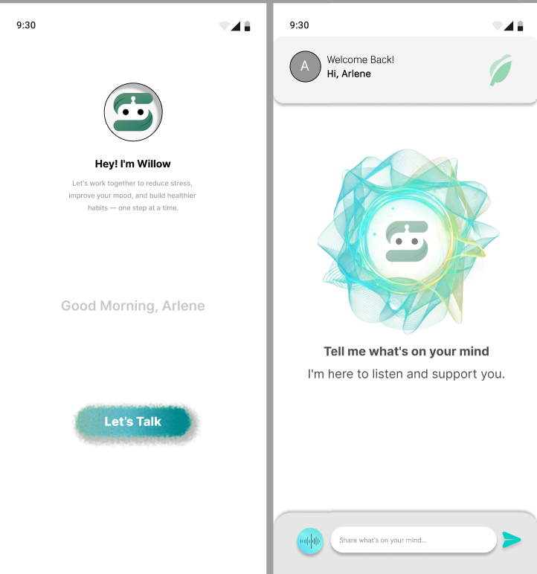

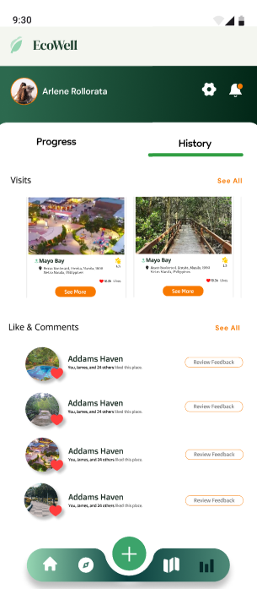
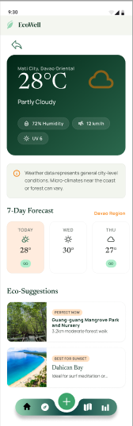
Weather Forecast and History

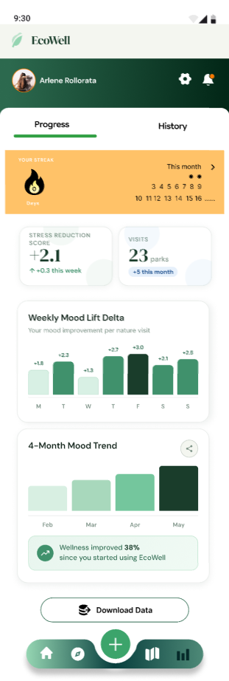
Wellness Dashboard

LITERATURE CITED

Agustin, A. (2023, May 23). Davao City addresses mental health crisis amid rising suicide rates. Philippine Information Agency. https://mirror.pia.gov.ph/news/2023/05/23/davao-city-addresses-mental-health-crisis-amid-rising-suicide-rates
AllTrails. (2026, June 12). How to write a review for a trail. AllTrails Help. https://support.alltrails.com/hc/en-us/articles/360018930652-How-to-write-a-review-for-a-trail

AXA, & Ipsos. (2023). The AXA study of mind health and wellbeing in 2023. AXA. https://www-axa-com.cdn.axa-contento-118412.eu/www-axa-com/a09d3707-ce9d-4e88-bc37-5472f9be77ae_axa_mind_health_study_2023.pdf
Balagam, I., & Ajmera, R. (2024, April 19). A breakdown of the Calm app: Tested and reviewed by 6 editors. Healthline. https://www.healthline.com/health/mental-health/calm-app-reviews

Cheng, V. W. S., Davenport, T., Johnson, D., Vella, K., & Hickie, I. B. (2019). Gamification in apps and technologies for improving mental health and well-being: Systematic review. JMIR Mental Health, 6(6), e13717. https://doi.org/10.2196/13717

Cohen, S., & Williamson, G. (1988). Perceived stress in a probability sample of the United States. In S. Spacapan & S. Oskamp (Eds.), The social psychology of health (pp. 31–67). Sage Publications. https://doi.org/10.2307/2136404

Cohen, S., Kamarck, T., & Mermelstein, R. (1983). A global measure of perceived stress. Journal of Health and Social Behavior, 24(4), 385–396. https://doi.org/10.2307/2136404

Devi, K. A., & Singh, S. K. (2023). The hazards of excessive screen time: Impacts on physical health, mental health, and overall well-being. Journal of Education and Health Promotion, 12(1), 413. https://doi.org/10.4103/jehp.jehp_447_23

Dy, A. B. C., Dy, A. B. C., & Santos, S. K. (2023b). Measuring effects of screen time on the development of children in the Philippines: a cross-sectional study. BMC Public Health, 23(1), 1261. https://doi.org/10.1186/s12889-023-16188-4

Dziadkowiec, O. (2023). Statistical methods for pre-post intervention design. Journal of Obstetric, Gynecologic & Neonatal Nursing, 53(1), 9–13. https://doi.org/10.1016/j.jogn.2023.11.010

Esmaeilzadeh, P. (2021). The influence of gamification and information technology identity on postadoption behaviors of health and fitness app users: Empirical study in the United States. JMIR Serious Games, 9(3), e28282. https://doi.org/10.2196/28282
Fabienne, & Benoit. (2025, August 5). Trails app: Why and how we use AllTrails – Our review. Novo-monde. https://www.novo-monde.com/en/alltrails-app-review/

Feng, X., Tian, L., Ho, G. W. K., Yorke, J., & Hui, V. (2025). The effectiveness of AI chatbots in alleviating mental distress and promoting health behaviors among adolescents and young adults: Systematic review and meta-analysis. Journal of Medical Internet Research, 27, e79850. https://doi.org/10.2196/79850
Garrido, S., Oliver, E., Chmiel, A., Doran, B., & Boydell, K. (2022). Encouraging help-seeking and engagement in a mental health app: What young people want. *Frontiers in Digital Health, 4*, 1045765. https://doi.org/10.3389/fdgth.2022.1045765
Healthy Mind Map. (2026). Headspace vs Healthy Mind Map: Which is better? https://healthymindmap.com/headspace-vs-healthy-mind-map/

Heinz, M. V., Mackin, D. M., Trudeau, B. M., Bhattacharya, S., Wang, Y., Banta, H. A., Jewett, A. D., Salzhauer, A. J., Griffin, T. Z., & Jacobson, N. C. (2025). Randomized trial of a generative AI chatbot for mental health treatment. NEJM AI, 2(4). https://doi.org/10.1056/AIoa2400802
Inkster, B., Sarda, S., & Subramanian, V. (2018). An empathy-driven, conversational artificial intelligence agent (Wysa) for digital mental well-being: Real-world data evaluation mixed-methods study. JMIR mHealth and uHealth, 6(11), e12106. https://doi.org/10.2196/12106

Inoco, M., & Villegas, J. (2024). Local tourists’ perception towards mangrove forest conservation and regeneration in the Guang-guang Mangrove Park and Nursery, Davao Oriental, Philippines. Davao Research Journal, 15(1). https://doi.org/10.59120/drj.v15i1.148

Kazdin, A. E. (2003). Research design in clinical psychology (4th ed.). Allyn & Bacon.

Kemp, S. (2024, February 20). Digital 2024: The Philippines — DataReportal – Global Digital Insights. DataReportal – Global Digital Insights. https://datareportal.com/reports/digital-2024-philippines
Korzekwinski, K., Ranieri, K., & Geiger, M. (2026, July 17). What is Duolingo? Everything you need to know. Scholarships360. https://scholarships360.org/college-admissions/what-is-duolingo/
Lally, M., Tully, J., & Samaniego, R. (2019). Mental health legislation, policy, and services in the Philippines: A situational analysis. BJPsych International, 16(3), 65–68. https://doi.org/10.1192/bji.2018.34
Lally, J., Tully, J., & Samaniego, R. (2019). Mental health services in the Philippines. BJPsych international, 16(3), 62–64. https://doi.org/10.1192/bji.2018.34
Matalam, C. L., & Hembra, M. S. (2022). Community-based mental health project in Davao Region. Southern Philippines Medical Center Journal of Health Care Services, 8(2), 5. https://n2t.net/ark:/76951/jhcs64m8mb
McConnell, S. (1996). Rapid development: Taming wild software schedules. Microsoft Press.
Oswald, T. K., Rumbold, A. R., Kedzior, S. G. E., & Moore, V. M. (2020). Psychological impacts of “screen time” and “green time” for children and adolescents: A systematic scoping review. PLoS ONE, 15(9), e0237725. https://doi.org/10.1371/journal.pone.0237725
Reyes, Michael, Amadem Dennes Resuento, Angelli Ripalda, Eya Wyeth Siatan, Jayson Ganzon, Trishia Kaye Telmo, Janel Jun Zita, and Ryan Dale Elnar. 2023. “Evaluating the Psychometric Properties of Cohen’s Perceived Stress Scale in the Context of Filipino College Students in the Height of the COVID-19 Pandemic”. Asian Journal of Education and Social Studies 49 (3):199-213. https://doi.org/10.9734/ajess/2023/v49i31148.

Reyes-Portillo, J. A., So, A., McAlister, K., Nicodemus, C., Golden, A., Jacobson, C., & Huberty, J. (2025). Generative AI–powered mental wellness chatbot for college student mental wellness: Open trial. JMIR Formative Research, 9, e71923. https://doi.org/10.2196/71923
Rico, Anino, Sabalburo, Apao, & Santos. (2025). Assessing the Influence of Work Stress on Mental Health among Employees in a Government Agency in Davao City. DIT ADS International Multidisciplinary Research Journal. https://doi.org/10.63941/dit.adsimrj.2025.1.3.66
Rozental, A., Forsström, D., & Johansson, M. (2023). A psychometric evaluation of the Swedish translation of the Perceived Stress Scale: a Rasch analysis. BMC Psychiatry, 23(1), 690. https://doi.org/10.1186/s12888-023-05162-4
Strava. (2026). Group challenges. Strava Support. https://support.strava.com/en-us/articles/15401736-group-challenges
Szinay, D., Perski, O., Jones, A., Chadborn, T., Brown, J., & Naughton, F. (2021). Perceptions of factors influencing engagement with health and well-being apps in the United Kingdom: Qualitative interview study. *JMIR mHealth and uHealth, 9*(12), e29098. https://doi.org/10.2196/29098
Tong, H. L., & Laranjo, L. (2018). The use of social features in mobile health interventions to promote physical activity: a systematic review. NPJ digital medicine, 1, 43. https://doi.org/10.1038/s41746-018-0051-3
Turner, K. (2024, May 15). Strava guide: How to get started on Strava. Strava Stories. https://stories.strava.com/articles/strava-guide-how-to-get-started-on-strava
Uy, M. (2023, August 15). Davao Oriental Provincial Medical Center opens Mental Wellness Hub. Philippine Information Agency. https://mirror.pia.gov.ph/news/2023/08/15/davao-oriental-provincial-medical-center-opens-mental-wellness-hub
Vaghefi, I., & Tulu, B. (2019). The continued use of mobile health apps: Insights from a longitudinal study. *JMIR mHealth and uHealth, 7*(8), e12983. https://doi.org/10.2196/12983
White, M. P., Alcock, I., Grellier, J., Wheeler, B. W., Hartig, T., Warber, S. L., Bone, A., Depledge, M. H., & Fleming, L. E. (2019c). Spending at least 120 minutes a week in nature is associated with good health and wellbeing. Scientific Reports, 9(1), 7730. https://doi.org/10.1038/s41598-019-44097-3
Why Is Mental Health Help Still Hard to Access? (2026). In Iacademy.edu.ph. https://iacademy.edu.ph/story_details?id=1431
World Health Organization. (2021). Mental health investment case: The Philippines — Prevention and management of mental health conditions. https://www.who.int/docs/default-source/wpro---documents/countries/philippines/reports/investment-case-report-mental-health-philippines-2021.pdf
World Health Organization. (2022). World mental health report: Transforming mental health for all. https://www.who.int/publications/i/item/9789240049338
World Health Organization: WHO. (2025, September 2). Over a billion people living with mental health conditions – services require urgent scale-up. World Health Organization (WHO). https://www.who.int/news/item/02-09-2025-over-a-billion-people-living-with-mental-health-conditions-services-require-urgent-scale-up
Wysa. (2026). Wysa for individuals: Your AI companion for everyday wellbeing. https://www.wysa.com/for-individuals
Yang, C.-C., Li, C.-L., Yeh, T.-F., & Chang, Y.-C. (2022). Assessing older adults' intentions to use a smartphone: Using the meta-unified theory of the acceptance and use of technology. International Journal of Environmental Research and Public Health, 19(9), 5403. https://doi.org/10.3390/ijerph19095403
Yao, W., Zhang, X., & Gong, Q. (2020). The effect of exposure to the natural environment on stress reduction: A meta-analysis. Urban Forestry & Urban Greening, 57, 126932. https://doi.org/10.1016/j.ufug.2020.126932

