Module 1: Foundations of AI.
- Definitions and Types.
- History of AI.
- Math for AI:
  - Linear Algebra Basics(Vectors, Matrices, Dot Products)
  - Probability and Statistics(Baye’s rule, distribution)
  - Logic and Boolean AlgebraModule 1: Introduction to Artificial

MODULE 1: FOUNDATIONS OF ARTIFICIAL INTELLIGENCE
Learning Objectives
By the end of this module, students should be able to:
- Define artificial intelligence and understand its core concepts
- Distinguish between different types of AI systems
- Understand the historical development and key milestones in AI
- Set up Python environment for AI development
- Implement simple rule-based AI systems
- Use basic Python libraries for AI (NumPy, pandas)
- Identify current applications and future directions of AI
- Recognize the challenges in defining and evaluating AI systems.

Module Structure
- Theory Session (2 hours): Concepts, definitions, history, types
- Practical Lab (2 hours): Python setup, basic programming, simple AI system

1. Definitions and Core Concepts
1.1 What is Intelligence?
Intelligence can be broadly defined as "the ability to solve hard problems" (Minsky, 1958). More comprehensively, it encompasses:
- The ability to learn from experience
- Adaptation to new situations
- Understanding and handling abstract concepts
- Using knowledge to manipulate one's environment
1.2 What is Artificial Intelligence?
Definitions of AI vary along two dimensions; one is concerned with thought processes and reasoning whereas the other addresses behaviour. Thus, AI can be viewed from two different perspectives as follows:
- Cognitive Science-Psychology
This perspective views AI as a process-oriented field that studies how humans gained knowledge and became knowledgeable and later they used their knowledge to solve problems or make decisions. The goal is to understand the process by which humans exhibit intelligent behaviour, and to replicate this on computers.
- Engineering
This perspective views AI as an output-oriented field which emphasizes on creating various applications which can demonstrate intelligent behaviour of humans. This view naturally emphasises techniques and technology and fosters research into the whole process of the specification, design and implementation of smart and/or self-adapting systems. The goal is to build machines which exhibit intelligent behaviour; it is of no consequence whether or not the techniques used bear any similarity to those employed by the human mind. Definitions 3 to 8 in Table 1.1 reflect this view.
Russell and Norvig (2010) added to these views criteria to measure success of the machines (or AI systems). In each view, the system is measured against human performance and the ideal concept of intelligence (or rationality). As a result, AI definitions can further be viewed in four dimensions, i.e. systems that think like humans, systems that think rationally, systems that act like humans and systems that act rationally (see Figure 1.1).
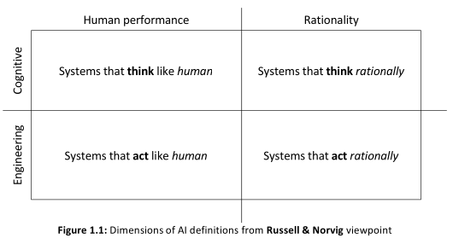
The following are several key definitions of Artificial Intelligence that have shaped the field:
- Historical Definition (McCarthy, 1956): "The science and engineering of making intelligent machines"
- Functional Definition (McCarthy, 1988): "AI is concerned with methods of achieving goals in situations in which the information available has a certain complex character.
The methods that have to be used are related to the problem presented by the situation and are similar whether the problem solver is human, a Martian, or a computer program."
- Behavioral Definition (Newell & Simon, 1976): "General intelligent action... the same scope of intelligence as we see in human action: that in any real situation behaviour appropriate to the ends of the system and adaptive to the demands of the environment can occur, within some limits of speed and complexity."
Working Definition for this Course: AI is the field of computer science dedicated to creating systems that can perform tasks that typically require human intelligence, including learning, reasoning, perception, and decision-making.
1.3 Artificial Intelligence Programs
“What is an AI program?” The obvious and hence unsatisfying answer is “any program which exhibits intelligent behaviour”; correct, yet it gives no insights into how people go about building intelligent programs, or what they consist of. The overall structure of an AI program is as illustrated in Figure 1.2. It tells us that in building an intelligent program, one needs to encode the relevant information and knowledge in a form suitable for computer processing (this is referred to as internal representation), process the information and then retranslate it back to a form understandable by humans.
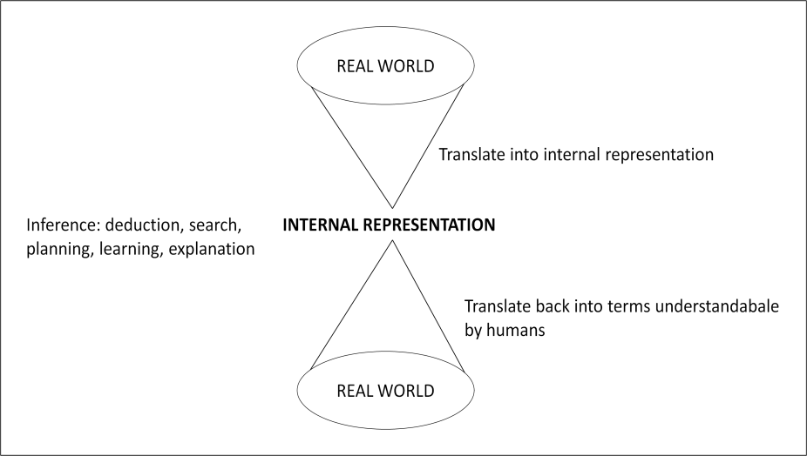
Figure 1.2: Structure of an AI program
Of course the same structure applies to any computer program, but the nature of the internal representation and how it is processed in an AI program are different; this has set AI programs apart from any conventional programs. As intelligent behaviour requires knowledge, the builder of any AI program must consider two major issues:
- knowledge representation
- knowledge application (i.e. reasoning)
It is important to highlight that representing and applying knowledge are two different things. There are some people who have a great store of knowledge, yet they seem to lack sufficient common sense, or indeed intelligence to put this knowledge to use. Truly intelligent people not only know a great deal, but they also know how to reason with this knowledge to derive new information. Equally important is their ability to direct their reasoning fruitfully thus enabling the speedy analysis of a situation, or solution of a problem.
1.4 Artificial Intelligence Program versus Conventional Program
Any AI program has the following two characteristics which conventional programs typically do not:
- there is some explicit representation of knowledge in the program
- the basis for programming is to manipulate symbols rather than numbers.
Conventional programs do indeed embody considerable amounts of knowledge; however, it is not made explicit. Instead, the knowledge remains deeply buried in the code. Two unfortunate consequences of this are that; the knowledge is difficult to modify and cannot be used to explain the program’s reasoning. The knowledge used is not readily accessible to the programmers, for examination and modification.
When writing AI programs the primary activity is in defining, characterizing, and manipulating symbols (would ordinarily be in the form of strings of letters or words). However, in no way can it be said that all programs based on symbolic computation are AI programs; and also, nor is it the case that AI programs may not do number crunching. Some applications, such as vision programs, do indeed require considerable amounts of numerical computation in addition to symbolic programming.
It is also not the case that AI programs are better than conventional programs. AI programming techniques have been developed in response to specific needs of creating intelligent computers. There are still zillions of tasks which are most effectively performed using conventional techniques. It is simply a matter of selecting the right tool for the right job. From my viewpoint, AI and conventional techniques are two entities that complement each other.
1.5 Artificial Intelligence Tasks
Humans perform various tasks every day, which differ in terms of their difficulty or complexity and also the level of intelligence required. Rich and Knight (1991) classified these tasks into three categories, i.e. mundane, formal and expert tasks, which are the targets of work in AI.
- Mundane Tasks: These are simply every day task or task (day to day task) which most humans are able to perform successfully in meeting their daily needs. This includes perception, both vision and speech; natural language understanding, generation and translation; commonsense reasoning and robot control. To make it simple, consider some of these examples: recognizing objects, understanding written or spoken words, deciding how to get to work in the morning and moving around freely within a limited space; an example with the two year old child in the previous section also falls under this category.
Despite the fact that these tasks are assumed to be easily done by humans, they proved to be the most difficult tasks to automate as they are very unstructured in nature. Perceptual tasks, for example, are difficult because they involve analog signals which are typically very noisy. This is exacerbated by the fact that usually a large number of things must be perceived at once. Natural language understanding, on the other hand, requires a great deal of knowledge about the language itself including its grammar and vocabulary, as well as the topics so that unstated assumptions can be recognized.
- Formal Tasks: Much of the early work in AI focused on formal tasks such as game playing (e.g. checker and chess) and theorem proving. Among the famous works include Samuel’s checkers-playing program and the Logic Theorist. Game playing and theorem proving share the property that people who do them well are considered to be displaying intelligence.
- Expert Tasks: This is a specialized task which acquired expertise to accomplish it. Examples of the task include engineering design, scientific discovery, medical diagnosis and financial analysis. Early assumption being made in AI was that these skills were harder and less amenable to be automated than the mundane tasks as they are learned later; everybody gained perceptual, linguistic and commonsense skills first before they acquire engineering, medicine and finance skills.
This naive assumption has directed the work in AI to focus more on the mundane tasks, but later it proved that it was not right. Expert skills indeed require knowledge that many of us do not have, but they often require much less knowledge than do the mundane skills and that the knowledge is usually easier to represent and deal with inside the programs. As a result, the problem area where AI first flourished as a practical discipline (as opposed to a pure research) was the one that required specialized expertise, in other words, expert systems.
A summary of AI tasks is given in Table 1.

Mundane Tasks | Formal Tasks | Expert Tasks
Common Sense | Verification | Financial Analysis
Reasoning | Theorem Proving | Medical Diagnosis
Planning |  | Creativity
Table 1: AI Tasks
2. Types of Artificial Intelligence
2.1 Classification by Capability
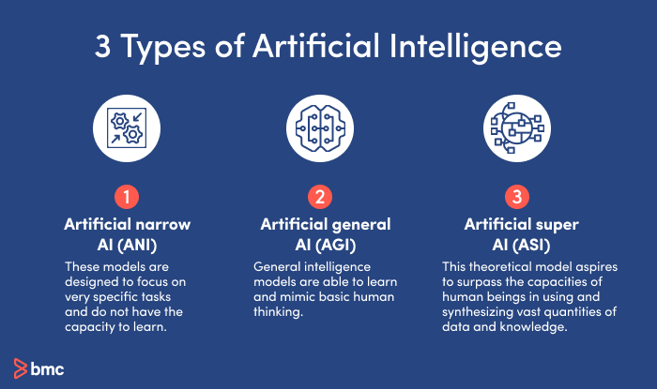
- Narrow AI (Weak AI)
Definition: AI systems designed to perform specific, limited tasks
Characteristics:
- Operates within a narrow domain
- Cannot generalize beyond its specific function
- Uses rule-based decision making
Examples:
  - Chess-playing programs
  - Voice assistants (Siri, Alexa)
  - Recommendation systems
  - Image recognition software.
- General AI (Strong AI)
Definition: AI systems with human-level cognitive abilities across all domains
Characteristics:
- Can understand, learn, and apply knowledge across various fields
- Exhibits consciousness and self-awareness (theoretical)
- Capable of rule-following decision making and creating its own rules
Current Status: Theoretical; not yet achieved
Goal: Multi-step reasoning, natural language understanding, innovative design, novel planning

- Artificial Superintelligence (ASI)
Definition: AI that surpasses human intelligence in all aspects
Characteristics:
- Superior to humans in creativity, general wisdom, and problem-solving
- Self-improving capabilities
Current Status: Speculative; subject of ongoing research and debate
2.2 Classification by Functionality
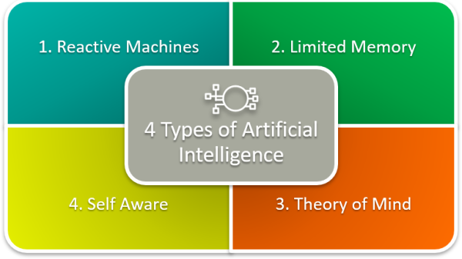

- Reactive Machines
No memory of past events
Responds to current situations only
Example: Deep Blue (IBM's chess computer)
- Limited Memory
Can use past experiences to inform current decisions
Short-term memory capabilities
Example: Self-driving cars, chatbots
- Theory of Mind
Understanding that others have beliefs, desires, and intentions
Can predict behavior based on mental states
Current Status: Research phase
- Self-Aware AI
Consciousness and self-understanding
Awareness of its own mental state
Current Status: Theoretical
2.3 Classification by Approach
- Symbolic AI
Uses symbolic representations and logic
Rule-based systems
Expert systems
Focus on high-level reasoning

- Connectionist AI
Based on neural networks
Learning through pattern recognition
Mimics brain structure and function
Examples: Deep learning, machine learning

- Evolutionary AI
Uses evolutionary algorithms
Genetic programming
Natural selection principles
Optimization through iteration
3. Historical Development of AI
AI has a history much longer than is commonly understood, in fields from science and philosophy ranging all the way back to ancient Greece (Dennehy, 2020), but its modern iteration owes much to Alan Turing (Turing, 1950) and conference in Dartmouth College in 1956 (McCorduck, 2004), where the term “Artificial Intelligence” was officially coined and defined by John McCarthy at the time as “the science and engineering of making intelligent machines”. Russel and Norvig (2020) referred to it as the “the birth of artificial intelligence.” One of the initial paradigms of AI was that it revolved around high-level cognition. Not the ability to recognise concepts, perceive objects, or execute complex motor skills shared by most animals, but the potential to engage in multi-step reasoning, to understand the meaning of natural language, to design innovative artefacts, to generate novel plans that achieve goals, and even to reason about their own reasoning (Langley, 2011). This general human-like intelligence was referred to as strong AI (Kurzweil, 2005). For strong AI, the primary approach has centred on symbolic reasoning, that computers are not simply numeric calculators but rather general symbol manipulators. As noted by Newell and Simon (1976) in their physical symbol system hypothesis, intelligent behaviour appears to require the ability to interpret and manipulate symbolic structures. While this approach showed promise initially (Newell & Simon, 1963), many branches of AI have retreated from this approach due its difficulty and the lack of progress coming in to the 21st century. It remains yet uncertain on when and if strong AI will be made a reality. The distinction between weak AI and strong AI is also concerned with rule adherence, i.e., the way machines interact with rules. Wolfe (1991) distinguishes rule-based decision making in which machines strictly respect the rules set by developers from rule following decision making which machines follow rules that have not been strictly specified to them. Rule-based decision-making matches weak AI, while rule-following decision making is an attempt that tends towards strong AI. An example of rule-following decision making is neural networks (NN), which allow algorithms to learn from themselves. Strong AI would be machines making their own rules and then follow them, which is not possible at the stage of right now (Wolfe, 1991). AI has gone through many peaks and troughs since its early inception in the 1950s, usually referred to as AI “summers and winters” (Russel and Norvig, 2020). Since 2010, however, AI can be said to have once again entered a summer period, mainly due to considerable improvements in the computing power of computers and the access to massive amounts of data (PWC, 2019).This resurgence in AI research is the result of three breakthroughs: (1) the introduction of a much more sophisticated class of algorithms; (2) the arrival on the market of low-cost graphics processors capable of performing large amounts of calculations in a few milliseconds; and (3) the availability of very large, correctly annotated databases allowing for more sophisticated learning of intelligent systems (Jain et al., 2004, Khashman, 2009, PWC, 2019). Despite the length of time the field has existed, there is still no commonly accepted definition (Allen, 1998, Bhatnagar et al., 2018, Brachman, 2006, Hearst and Hirsh, 2000, Nilsson, 2009). This is not considered a problem yet, as many scientific concepts only get true definitions after they have matured enough, rather than at their conception, and given the complexity and breadth of AI, it may not be feasible to expect AI to have a set definition yet. Still, this doesn’t mean that the topic should be ignored, especially with the recent advancements and advancements relating to the field (LeCun et al., 2015, Silver et al., 2016). However, without a clear definition of the term, “it is difficult for policymakers to assess what AI systems will be able to do in the near future, and how the field may get there. There is no common framework to determine which kinds of AI systems are even desirable” (Bhatnagar et al., 2018). A similar concern has been echoed by Monett and Lewis (2018), that “theories of intelligence and the goal of Artificial Intelligence (A.I.) have been the source of much confusion both within the field and among the general public”. In the years immediately preceding and after the 1956 Dartmouth conference where the term was coined, when the concept for AI was first brewing in academic consciousness, many researchers (would later become famous for their contributions to AI) formulated many theories and proposals that focused on the common features of mind and (McCulloch and Pitts, 1943, Turing, 1950, von Neumann, 1958, Wiener, 1948). While these thought leaders were influential, the field of AI as we know it owes more to McCarthy, Minsky, Newell, and Simon. While this is partly due to their own attendance of the famous 1951 Dartmouth conference, it is likely more since they went on to establish three leading research centres which shaped the stream of thought regarding AI for years. Their own opinion on AI was as follows; “By ‘general intelligent action’ we wish to indicate the same scope of intelligence as we see in human action: that in any real situation behaviour appropriate to the ends of the system and adaptive to the demands of the environment can occur, within some limits of speed and complexity” (Newell & Simon, Computer science as empirical enquiry: Symbols and search, 1976). Intelligence usually means “the ability to solve hard problems” (Minsky, 1958). “AI is concerned with methods of achieving goals in situations in which the information available has a certain complex character. The methods that have to be used are related to the problem presented by the situation and are similar whether the problem solver is human, a Martian, or a computer program” (McCarthy, 1988). With the variety of separate opinions on what AI is, lacking agreement on a standard evaluation (i.e., criteria, benchmark tests, milestones) makes it extremely challenging for the field to maintain healthy growth (Hern´andez-Orallo, 2017).
4. Current Applications and Examples
- Perception and Recognition
  - Computer vision
  - Speech recognition
  - Natural language processing
  - Facial recognition
- Decision Making and Planning
  - Autonomous vehicles
  - Game playing (AlphaGo, GPT models)
  - Financial trading systems
  - Route optimization
- Learning and Adaptation
  - Recommendation systems
  - Personalized learning platforms
  - Adaptive user interfaces
  - Predictive maintenance
- Communication and Interaction
  - Chatbots and virtual assistants
  - Language translation
  - Content generation
  - Human-computer interaction
5. Challenges in AI Definition and Evaluation
5.1 Definition Challenges
- Lack of consensus: No universally accepted definition
- Complexity and breadth: AI encompasses many different approaches and applications
- Moving goalposts: As AI achieves certain capabilities, the definition of intelligence evolves
- Policy implications: Unclear definitions make regulation and policy-making difficult
5.2 Evaluation Challenges
- No standard benchmarks: Difficulty in measuring AI progress consistently
- Subjective criteria: Intelligence assessment often involves subjective judgment
- Domain specificity: Performance varies significantly across different domains
- Anthropocentric bias: Tendency to measure AI against human capabilities
6. Fundamental Concepts and Terminology
6.1 Key Terms
- Algorithm: Step-by-step procedure for solving problems
- Machine Learning: AI systems that improve through experience
- Neural Networks: Computing systems inspired by biological neural networks
- Deep Learning: ML using neural networks with multiple layers
- Natural Language Processing (NLP): AI focused on language understanding
- Computer Vision: AI focused on image and visual data interpretation
- Robotics: AI applied to physical systems and automation
6.2 Important Distinctions
- AI vs. Machine Learning: AI is the broader field; ML is a subset.
- Automation vs. Intelligence: Automation follows pre-programmed rules; intelligence adapts and learns.
- Simulation vs. Intelligence: Appearing intelligent vs. being intelligent.
7. Philosophical and Ethical Considerations
7.1 The Turing Test
- Proposed test for machine intelligence
- Based on indistinguishability from human responses
- Limitations and criticisms
7.2 The Chinese Room Argument
- John Searle's thought experiment
- Questions about understanding vs. simulation
- Syntax vs. semantics debate
7.3 Ethical Implications
- Privacy and surveillance
- Job displacement
- Algorithmic bias
- Autonomous decision-making responsibility
8. Future Directions and Research Areas
8.1 Current Research Focus
- Explainable AI (XAI)
- AI safety and alignment
- Quantum computing and AI
- Neuromorphic computing
- Artificial General Intelligence (AGI)
8.2 Emerging Application of AI
- Healthcare and medical diagnosis
- Climate change and environmental monitoring
- Scientific discovery and research acceleration
- Creative AI (art, music, writing)
- Space exploration and robotics
PRACTICAL LAB SESSION
Lab 1: Setting Up Your AI Development Environment (30 minutes)
#Step 1: Python Installation and Setup
# Check Python version (should be 3.8 or higher)
python --version

# Install required packages
pip install numpy pandas matplotlib scikit-learn jupyter

# Verify installations
import numpy as np
import pandas as pd
import matplotlib.pyplot as plt
print("Environment setup complete!")

#Step 2: Jupyter Notebook Setup
# Start Jupyter Notebook
jupyter notebook

# Create a new notebook called "AI_Module1_Lab"
# Test with a simple program:
print("Welcome to AI Programming!")
Lab 2: Basic AI Concepts with Python (45 minutes)
Exercise 1: Simple Rule-Based Expert System
Create a basic medical diagnosis system:
class SimpleExpertSystem:
def __init__(self):
self.knowledge_base = {
'fever_headache': 'Possible flu - recommend rest and fluids',
'cough_fever': 'Possible respiratory infection - see doctor',
'headache_nausea': 'Possible migraine - avoid bright lights',
'fever_rash': 'Possible allergic reaction - see doctor immediately'
}

def diagnose(self, symptoms):
symptom_key = '_'.join(sorted(symptoms))
return self.knowledge_base.get(symptom_key, 'Consult a healthcare professional')

# Test the expert system
expert = SimpleExpertSystem()
print(expert.diagnose(['fever', 'headache']))
print(expert.diagnose(['cough', 'fever']))
print(expert.diagnose(['unknown', 'symptom']))

Exercise 2: Intelligent Agent Simulation
Create a simple thermostat agent:
class ThermostatAgent:/home/whatisnatus-27/Desktop/CSC 411 - Artificial Intelligence
def __init__(self, target_temp=22):
self.target_temp = target_temp
self.current_temp = 20
self.heating = False
self.cooling = False

def sense_environment(self, room_temp):
self.current_temp = room_temp
print(f"Current temperature: {self.current_temp}°C")

def decide_action(self):
if self.current_temp < self.target_temp - 1:
return "heat"
elif self.current_temp > self.target_temp + 1:
return "cool"
else:
return "maintain"

def act(self, action):
if action == "heat":
self.heating = True
self.cooling = False
print("🔥 Heating turned ON")
elif action == "cool":
self.heating = False
self.cooling = True
print("❄️ Cooling turned ON")
else:
self.heating = False
self.cooling = False
print("✅ Temperature maintained")

# Simulate the agent
thermostat = ThermostatAgent(target_temp=23)
room_temperatures = [18, 20, 22, 24, 26, 23]

for temp in room_temperatures:
thermostat.sense_environment(temp)
action = thermostat.decide_action()
thermostat.act(action)
print("-" * 30)

Lab 3: Data Manipulation for AI (30 minutes)
Exercise 3: Working with AI Data using NumPy and Pandas
import numpy as np
import pandas as pd

# Create sample AI training data
np.random.seed(42)
data = {
'temperature': np.random.normal(25, 5, 100),
'humidity': np.random.normal(60, 10, 100),
'pressure': np.random.normal(1013, 20, 100)
}

# Convert to DataFrame
df = pd.DataFrame(data)
print("Dataset shape:", df.shape)
print("\nFirst 5 rows:")
print(df.head())

# Basic statistical analysis
print("\nDataset statistics:")
print(df.describe())

# Simple classification based on conditions
def classify_weather(row):
if row['temperature'] > 30 and row['humidity'] > 70:
return 'Hot and Humid'
elif row['temperature'] < 15 and row['pressure'] < 1000:
return 'Cold and Low Pressure'/home/whatisnatus-27/Desktop/CSC 411 - Artificial Intelligence
elif row['temperature'] > 25 and row['humidity'] < 50:
return 'Warm and Dry'
else:
return 'Normal'

df['weather_type'] = df.apply(classify_weather, axis=1)
print("\nWeather classification counts:")
print(df['weather_type'].value_counts())
Lab 4: AI Problem Solving Example (15 minutes)
Exercise 4: Simple AI Game - Number Guessing
import random

class AIGuesser:
def __init__(self, min_num=1, max_num=100):
self.min_num = min_num
self.max_num = max_num
self.guesses = 0
self.history = []

def make_guess(self):
# AI uses binary search strategy
guess = (self.min_num + self.max_num) // 2
self.guesses += 1
self.history.append(guess)
return guess

def receive_feedback(self, feedback, guess):
if feedback == "higher":
self.min_num = guess + 1
elif feedback == "lower":
self.max_num = guess - 1
# If correct, no adjustment needed

def reset(self):
self.guesses = 0
self.history = []

# Simulate AI playing the guessing game
def play_guessing_game():
ai = AIGuesser(1, 100)
target = random.randint(1, 100)
print(f"AI is trying to guess the number: {target}")

while True:
guess = ai.make_guess()/home/whatisnatus-27/Desktop/CSC 411 - Artificial Intelligence
print(f"AI guess #{ai.guesses}: {guess}")

if guess == target:
print(f"🎉 AI won in {ai.guesses} guesses!")
break
elif guess < target:
ai.receive_feedback("higher", guess)
print("Feedback: Higher")
else:
ai.receive_feedback("lower", guess)
print("Feedback: Lower")
# Run the game
play_guessing_game()

Lab Assignment (Take Home)
Create a simple Recommendation System:
# Starter code for students to complete
class SimpleRecommendationSystem:
def __init__(self):
self.users = {}
self.items = {}

def add_user_rating(self, user, item, rating):
# TODO: Implement this method
pass

def recommend_items(self, user, num_recommendations=3):
# TODO: Implement recommendation logic
# Hint: Use collaborative filtering or content-based approach
pass/home/whatisnatus-27/Desktop/CSC 411 - Artificial Intelligence

# Test case (students should make this work)
recommender = SimpleRecommendationSystem()
# Add sample data and test recommendations

Lab Deliverables
Students must submit:
- Screenshot of successful environment setup
- Working code for all 4 exercises
- Completed recommendation system assignment
- Brief report (1-2 pages) explaining what they learned
Week 1 Assessment
Short Answer Questions (10 marks each):
- Compare weak AI and strong AI with real-world examples
- Explain the significance of the 1956 Dartmouth Conference
- Describe three factors that led to the current AI renaissance
- What are the main challenges in defining AI? Provide solutions.
Resources for Further Learning
- Essential Python Libraries Documentation
- NumPy: https://numpy.org/doc/stable/
- Pandas: https://pandas.pydata.org/docs/
- Matplotlib: https://matplotlib.org/stable/contents.html
Online Tutorials
- Python for AI Beginners: Python.org tutorial
- Jupyter Notebook Guide: Official Jupyter documentation
- AI Programming Examples: GitHub repositories with starter code
Recommended Readings
- Russell & Norvig, Chapter 1-2 (Foundations and Intelligent Agents)
- Mitchell, Chapter 1 (Introduction to Machine Learning)
- Online articles on current AI applications and ethics
Preparation for Next Module
- Module 2 Preview: Problem Solving and Search Algorithms
- Review basic algorithms and data structures
- Understand graph theory basics
- Practice Python functions and classes
- Read Russell & Norvig Chapter 3 (Problem Solving by Searching)
Conclusion
AI is a broad field with no single accepted definition, but generally involves creating systems that perform tasks requiring human-like intelligence.
AI can be classified by capability (narrow vs. general), functionality (reactive to self-awareness), and approach (symbolic, connectionist, evolutionary).
The field has experienced cycles of optimism and disappointment ("AI summers and winters").
Current AI success is driven by increased computing power, big data, and advanced algorithms
Defining and evaluating AI progress remains challenging due to the subjective nature of intelligence.
Modern AI focuses primarily on narrow applications rather than general intelligence
Module Questions
- Compare and contrast weak AI and strong AI. Provide examples of each.
- Explain why there is no universally accepted definition of AI and discuss the implications.
- What are the main challenges in evaluating AI systems and measuring progress in the field?
- Discuss the difference between rule-based and rule-following decision making in AI systems.
- How has the focus of AI research changed since its inception in 1956?

