**Exercise 1：**

**1.** the IP address of the website [www.koala.com.au](http://www.koala.com.au) is 129.94.242.2.

The remaining IP is a non-authoritative answer, indicating that it was read directly from the local DNS cache, not the name server that is actually responsible for the domain name that asks for it. This is because the more commonly used domains are cached for quick resolution.

**2.** 127.0.0.1 is the Loopback Address. is used for network software testing and communication between local processes

**Exercise 2：**

The next two hosts are not accessible and cannot be accessed from a browser, probably because the name of the target is not registered in DNS at all

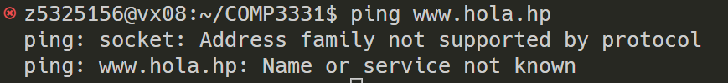

This host is not accessible by ping, but it is accessible from the browser. The reason may be because the packet I sent did not reach its destination, or the host I trying to access is not connected or offline for some reason.文本

**Exercise 3：**

**1.** 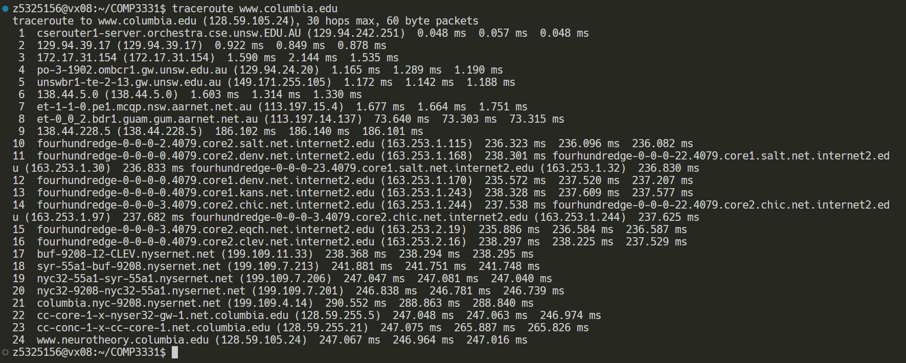

There are 22 routers are there between UNSW workstation and [www.columbia.edu](http://www.columbia.edu/).

There are 5 routers along the path are part of the UNSW network.

Packets cross the Pacific Ocean between the 9th and 10th routers

**

The paths to these three destinations fork on router 138.44.5.0, The Asia Pacific Network Information Centre (APNIC).

physical distance(miles)/number of jumps

[www.ucla.edu](http://www.ucla.edu): 10392/22=472

[www.u-tokyo.ac.jp](http://www.u-tokyo.ac.jp/): 5120/14=365

[www.lancaster.ac.uk](http://www.lancaster.ac.uk/): 10519/13=809

The number of jumps on each path is not proportional to the physical distance.

**

I chose the servers 202.150.221.170 and 129.94.242.251.

I did not observe exactly the same two IP addresses, but there are many IP's that have the same network address for the first three segments. Only the last part that has a different address. The reason for this may be because the addresses are dynamically assigned, which is for load balancing. Or the server has multiple outlets for automatic routing.

**Exercise 4：**

**1.**

**Brisbane:**

shortest possible time T = 740km / light per second = 0.002468

ratio between RTT and T = 0.016903 / 0.002468 = 6.8

**Serdang:**

shortest possible time T = 6650km / light per second = 0.022182

ratio between RTT and T = 0.022182 / 0.100042 = 4.5

**Berlin:**

shortest possible time T = 16100km / light per second = 0.053704

ratio between RTT and T = 0.053704 / 0.053704 = 5.1

**2.**

The delay in reaching the destination is time-varying, as there are times when longer queuing delays are encountered. as can be seen in destination_delay.pdf, the lines are not smooth, but occasionally packages encounter longer delays.

**3.**

Propagation delay, processing delay and queuing delay do not depend on packet size

Only transmission latency depends on packet size. It is a combination of packet size and link transmission rate

**All graphs:**

[www.uq.edu.au](http://www.uq.edu.au):

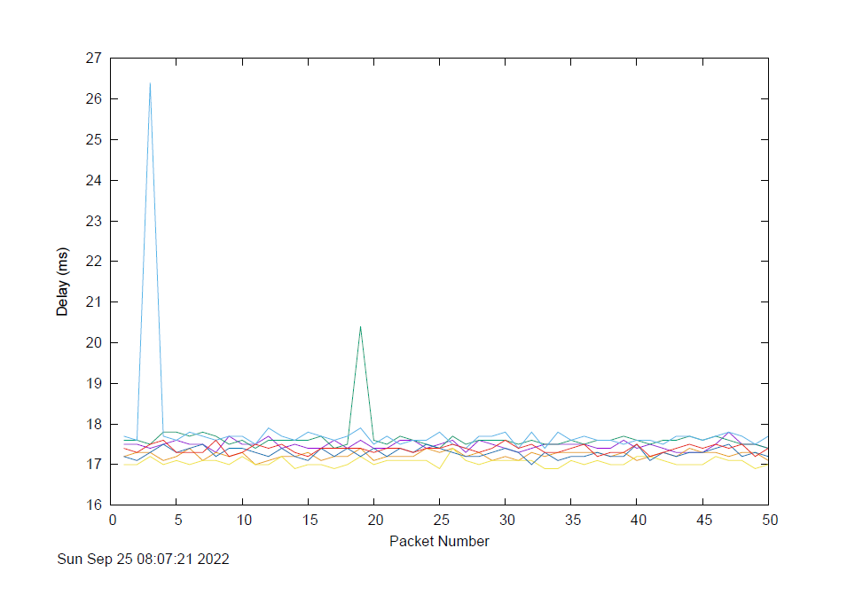

[www.upm.edu.my](http://www.upm.edu.my):

[www.tu-berlin.de](http://www.tu-berlin.de):

