**Exercise 3**

**Q1:**

**23.185.0.1, type A query**

**Q2:**

**www.eecs.berkeley.edu is an alias for live-eecs.pantheonsite.io.**

**live-eecs.pantheonsite.io is an alias for fe1.edge.pantheon.io.**



**Using CNAME records makes it easy to change IP addresses. If a server has 100 websites and they all make aliases, when that server changes its IP, it only needs to change the A record of the alias.**

**Q3:**

**AUTHORITY SECTION returns the authoritative DNS name servers for the ANSWER SECTION.**

**ADDITIONAL SECTION lists the IP addresses of these authorized DNS servers. Type AAAA stands for IPv6 addresses.**

图形用户界面

**Q4:**

**On the cse server, the local nameserver’s IP is this.**

**图形用户界面

**

**My local machine, which I won't screenshot because it's in Chinese, is 192.168.0.1**

**Q5:**

**ns.CS.berkeley.edu. -- 169.229.60.61**

**ns.eecs.berkeley.edu. -- 169.229.60.153**

**adns1.berkeley.edu. -- 128.32.136.3**

**adns2.berkeley.edu. -- 128.32.136.14**

**adns3.berkeley.edu. -- 192.107.102.142**

文本

**Q6:**

**dig -x 111.68.101.54 +short**

**Type PTR query**

**Q7:**

**No authoritative answer was obtained because the flags did not contain the aa tag. This means that the CSE server may not have access to the yahoo domain.**

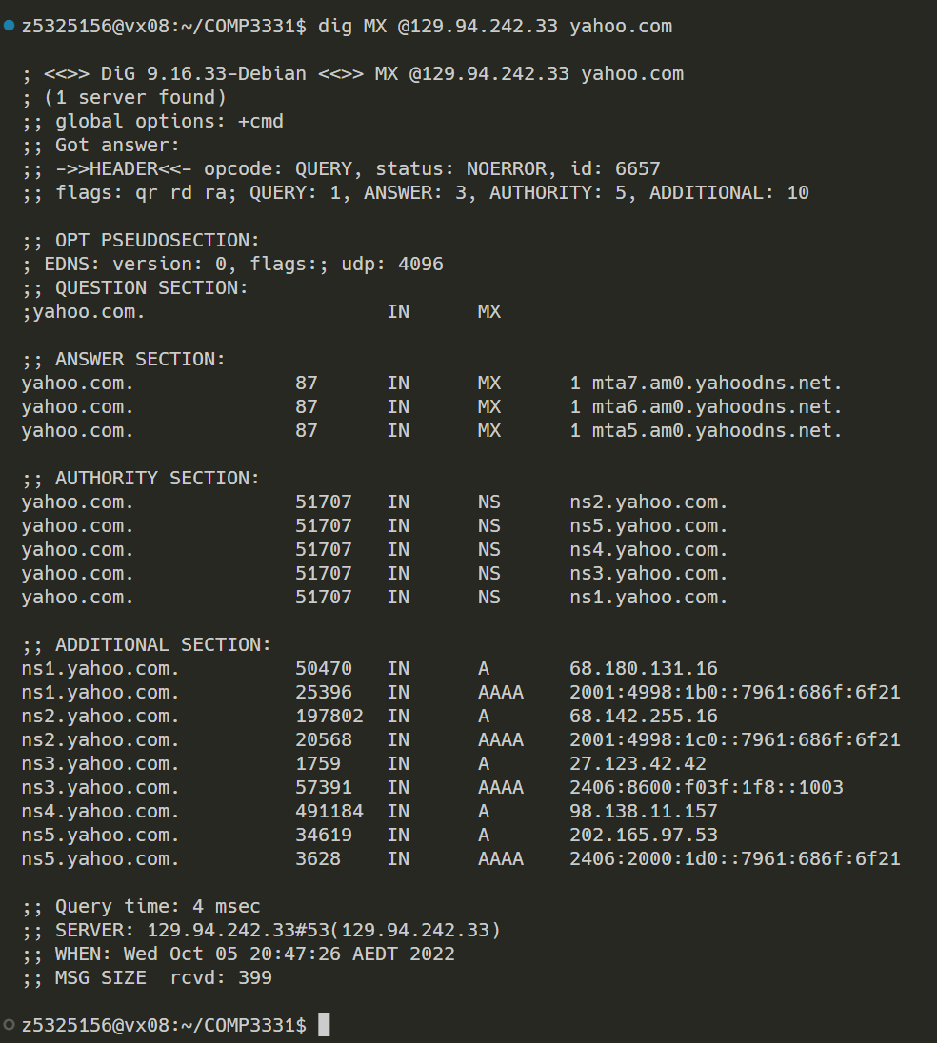

**Q8:**

**I get REFUSED. no other response, probably because the selected nameservers do not answer queries from devices that are not part of their network. It should be some kind of security measure.**

**Q9:**

**Type MX**

**Q10:**

**Need 5 DNS servers to query to get the authoritative answer.**

**(a.root-servers.net, d.au, q.au, unsw.edu.au, beethoven.orchestra.cse.unsw.edu.au)**

电脑萤幕



**Q11:**

**Yes, a machine has many network interfaces, any of which can be associated with multiple ip addresses, and these ip addresses can be associated with even more different hostnames.**

**Exercise 4**

文本

