**Exercise 1**

**1.**

* The IP address of gaia.cs.umass.edu is 128.119.245.12.
* On port 80 is it sending and receiving TCP segments for this connection.
* The IP address and TCP port numbers used by the client computer (source) is 192.168.1.102:1161.

**2.**

* The sequence number of the TCP segment containing the HTTP POST command is 232129013.

**3.**

|  |  |  |  |  |  |
| --- | --- | --- | --- | --- | --- |
| **No.** | **Seq#** | **Time Sent** | **Time Received** | **RTT** | *Estimated RTT* |
| 1 | 232129013 | 0.026477 | 0.053937 | 0.02746 | 0.02746 |
| 2 | 232129578 | 0.041737 | 0.77294 | 0.035557 | 0.028472125 |
| 3 | 232131038 | 0.054026 | 0.124085 | 0.070059 | 0.033670484375 |
| 4 | 232132498 | 0.05469 | 0.169118 | 0.114428 | 0.043765173828125 |
| 5 | 232133958 | 0.077405 | 0.217299 | 0.139894 | 0.05578127709960937 |
| 6 | 232135418 | 0.078157 | 0.267802 | 0.189465 | 0.0724917424621582 |

**4.**

|  |  |  |  |  |  |  |
| --- | --- | --- | --- | --- | --- | --- |
| **No.** | 1 | 2 | 3 | 4 | 5 | 6 |
| **Length** | 565 | 1460 | 1460 | 1460 | 1460 | 1460 |

**PS: Does not include the 20-byte TCP header.**

**5.**

* The minimum amount of available buffer space advertised at the receiver for the entire trace is 5840 bytes. It is advertised in the SYNACK segment of No. 2.
* The lack of receiver buffer space did not throttle the sender. Because the available buffer space advertised subsequently continues to get larger, even reaching 62780 bytes (No. 51). The sender seems to be limited by the congestion window rather than the flow control window. As you can also see from the graph below, the green is the cache size and the blue is the size of the bytes sent by the sender. You can see that the sender's speed is definitely not limited by the receiver's cache size.

图形用户界面, 图表, 应用程序

**6.**

* There are no retransmitted segments in the trace file. In the Time-Sequence-Graph (Stevens) from the source (192.168.1.102) to the destination (128.119.245.12) we can visually see that the sequence number is growing over time. If a retransmission occurs, there should be a sequence number that is smaller than the sequence number of the adjacent segment.

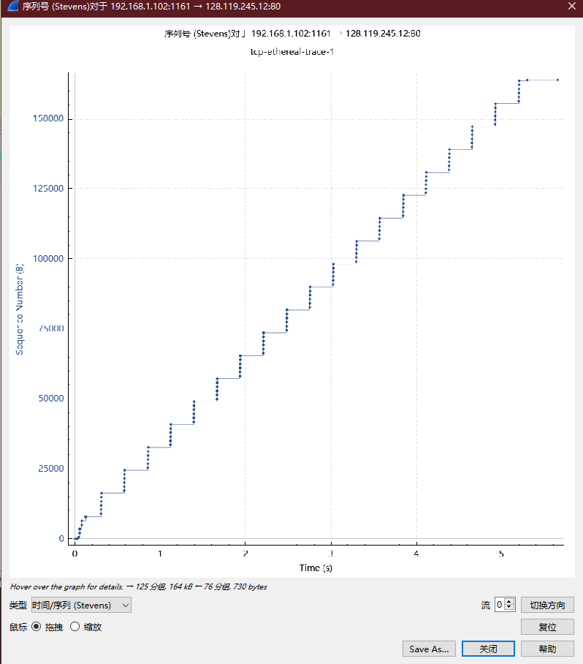

**7.**

* As you can see in the figure below, in the early part, each packet is acked separately by the receiver. For example, in the purple box. The sender sent 5 packets and the receiver responded with 5 ack.  
  But you can see in the red box that the sender sent 5 packets, but the receiver responded with 4 ack.  
  To be more specific we can see that at the 60th packet, the receiver responded with an ack (232166981) to two packets. (sequence numbers 232164061 and 232165521).  
  This is because the receiver has switched to or triggered a delayed ACK strategy, where the receiver waits up to 500ms for the next segment. if no next segment, send ACK.

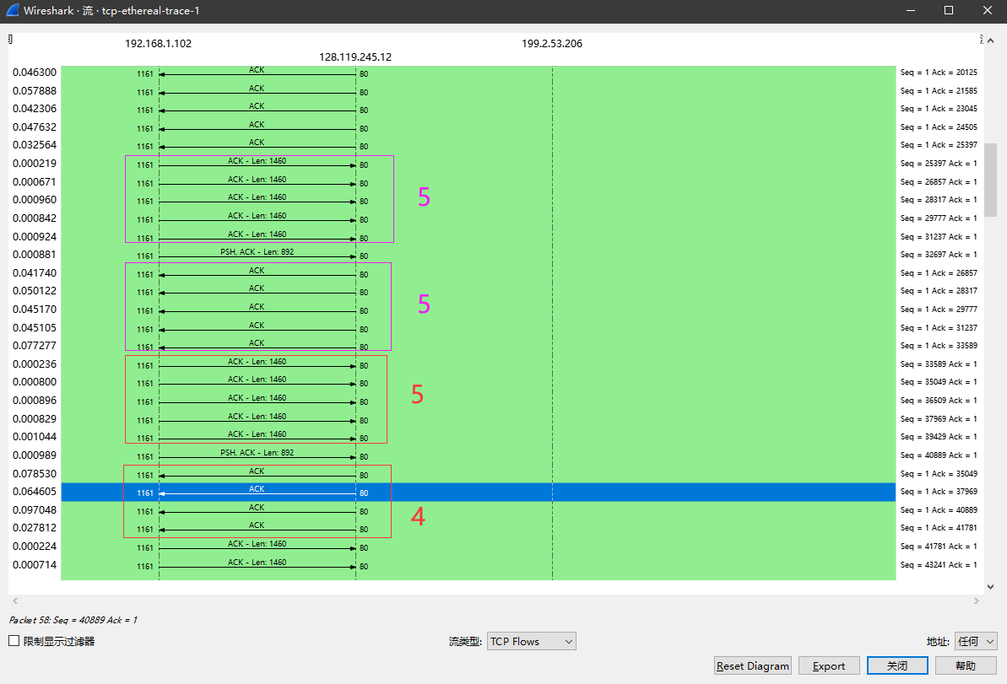

**8.**

* I calculate the average time period throughput. First we can get the total data volume by subtracting the sequence number of the first TCP segment from the acknowledged sequence number of the last ACK:

**(No. 202 segment: 232293103) - (No. 4 segment: 232129013) = 164090 bytes**

* Then subtract the timestamps of the first TCP segment from the timestamps of the last ACK to get the total transmission time:  
  **(No. 202 segment: 5.455830 sec) - (No. 4 segment: 0.026477 sec) = 5.4294 sec**
* Finally, divide the total data volume by the total transmission time to get the throughput of the TCP connection:  
  **164090/5.4294 = 30.222 Kbyte/sec**

**Exercise 2**

**1.**

* The TCP SYN segment that is used to initiate the TCP connection between the client computer and server is 2818463618.

**2.**

* The sequence number of the SYNACK segment sent by the server is 1247095790, the ACK No is 2818463619.
* The Server has added 1 in the ISN from the client to arrive at the ACK number.
* Add 1 to the ISN of the client to get the ACK number.

**3.**

* The sequence number of the ACK segment sent by the client computer in response to the SYNACK is 2818463619, and ACK = 1247095791.
* There is no data in this segment. It can be confirmed by looking at the 298 segments that follow, as it uses the same Seq No.

**4.**

* The conversation ends with a synchronous close. Both the client and server initiated a FIN, but did not receive a FIN from the other side.
* It can be seen from their seq and ack numbers, which are crossed. Normally it would be +1
  + 304's seq=2818463652, 305's ack=2818463652.
  + 305's seq=1247095831, 304's ack=1247095831.

**5.**

* **Client:** 
  + ISN = 2818463618, last ACK received has ACK No = 2818463653
  + Data transferred = last ACK received - ISN - 1 (SYN) - 1 (FIN) = 2818463653 – 2818463618 – 2 = 33 Bytes
* **Server:** 
  + ISN = 1247095790, last ACK received = 1247095832
  + Data transferred = last ACK received - ISN - 1 (SYN) - 1 (FIN) = 1247095832 - 1247095790 - 2 = 40 Bytes