Branching:

A great way to work on different versions of a project/file/repository. When we create a repository, we are, by default, creating only branch called “master”. We can create other branches and make edits to them and then can merge these to main branch “master”.

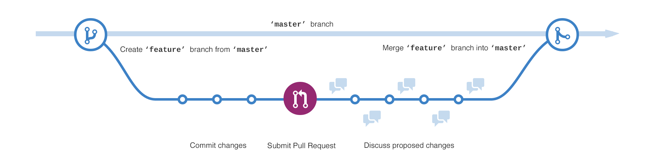

Pull Request:

When we make edits to a document in branch, we use “pull request” to allow others to review the changes and make some comments. Others can then merge these changes in main master document. This whole process of reviewing and merging can be done by yourself.

Merge: