**BUDT702: Database Management System**

**Section 0501: Project Team 06- Insight Harbor**

Ariz Shaikh, Palak Tandel, Sneha Murali, Zeba Karkhanawala

Date: 12/10/2023

**Project analysis and design**

## **Brand Name**

Insight Harbor

## **Mission Statement**

To thoroughly investigate the Smith School of Business's program rank, faculty composition, and curriculum to create a useful database for the school's records and insights.

## **Mission Objectives**

* To determine the total number of faculties possessing a PhD degree.
* To ascertain the details of the faculty who are alumni of the University of Maryland.
* To find out the total number of alumni for each program.
* To identify the rank sources, ranks, program names, program types, and program years for the Business Analytics program.
* To find the average number of years of work experience for all the faculties in each program.
* To determine how many faculties from MSQF and MS in Finance have a PhD in Finance.
* To find out all the details of the faculties in the MSMA program having a PhD in Marketing.
* To discover the new courses offered for Batch of Fall 2023 which were not a part of the curriculum for the Batch of Fall 2022.
* To find out which professor teaches how many courses in 2022 and 2023.
* To find the total number of alumni for each program as per the year and batch.
* To find out which and how many Smith school programs were ranked under the top 10 over the years.
* To determine the employers of the Smith School of Business.
* To determine the tuition fee for the courses offered in Fall 2023.

## **Business Transactions**

1. What is the total number of faculty members possessing a PhD degree?
2. What are the name, education, work experience, and contact details of the faculty members who are alumni of the University of Maryland?
3. What is the total number of alumni for each program?
4. What are the rank sources, ranks, program names, program types, and program years for the Business Analytics program?
5. What is the average number of years of work experience for faculties in each program?
6. What is the name and education of the faculties in the MS in Quantitative Finance and MS in Finance programs having a PhD in Finance?
7. What are the details of the faculties in the MSMA program having a PhD in Marketing?
8. What are the new courses in the MSIS program offered for the Fall 2023 Batch that were not part of the curriculum for the Fall 2022 Batch?
9. Which professor teaches how many courses in 2022 and 2023?
10. What is the total number of alumni for each program as per the year and batch?
11. Which Smith school programs were ranked under the top 10 over the years?
12. Who are the employers of the Smith School of Business?
13. What is the tuition fee for the courses offered in Fall 2023?

## **Describe business terms, facts, attributes, and identifiers in sentences**

Insight Harbor is a consultancy firm with an efficient team of information system analysts, database designers, database developers, and application developers who help an institution analyze its database and draw meaningful observations to help make effective decisions. The database belongs to the Robert H. Smith School of Business at the University of Maryland and it contains different tables encompassing the ecosystem of the programs offered by the school.

The Smith School offers multiple programs for different types of students to their convenience. Each program has its own Program Director. Each program has different attributes such as the type of program, the year the program was offered, its duration, and the minimum TOEFL score required from students. There are also financial details of programs such as in-state and out-of-state tuition fees.

The courses are identified using unique course IDs and have data such as the number of credits, the course semester, and the year the course was offered. Apart from course IDs, there are also course codes that are used for each course. Each course is taught by only one faculty but one faculty can teach multiple courses.

There are various faculties in the school for each program. Each faculty member has a unique identifier ID, with other details such as their name, years of work experience, and their education. They also have contact details such as their phone number and email address.

There are multiple alumni from each program. AlumniIDs are specific identifiers assigned to each alumnus. For every alumnus we have information about their current employer, their job role and the year they graduated.

The database contains programs offered by only the Robert H. Smith School of Business which has several attributes such as its location, and the year it was established. The school also has one dean who takes care of the administration and ensures smooth workflow of the school.

Each program is ranked by multiple rank sources every year. The rank sources have a unique identifier ID assigned to them.

## **Perform database analysis on entities and relationships, i.e., ER schema (Identify at least three entities.)**

### Identify at least three entities

Course ( **courseID**, courseName, courseCode, courseSemester, courseYear, courseCredits )

Faculty ( **facultyID,** facultyName, -facultyFirstName, -facultyLastName, facultyWorkExperience, facultyEducation, facultyPhoneNumber, facultyEmailAddress )

Program ( **programID,** programName, programType, programYear, programDirector, programDuration, programInStateTuition, programOutStateTuition, programMinimumTOEFL )

Alumni ( **alumniID**, alumniName, -alumniFirstName, -alumniLastName, alumniJobRole, alumniEmployer, alumniGraduationYear )

School ( **schoollD,** schoolName, schoolLocation, schoolDeanName, schoolEstablishedYear )

Rank Source ( **sourceID,** sourceName )

### **Identify relationships including at least one many-to-many or higher-degree**

Provide: Binary Relationship

1 School to 1 or more Programs

1 Program to only 1 School

Offer: Binary Relationship

1 Program to 1 or more Course

1 Course to only 1 Program

Complete: Binary Relationship

1 Program to 1 or more Alumni

1 Alumni to only 1 Program

Teach: Binary Relationship

1 Faculty to 1 or more Course

1 Course to only 1 Faculty

Rank (programRank): Binary Relationship

1 Program to 1 or more Rank Source

1 Rank Source to 1 or more Program

## 

## **ER Diagram**

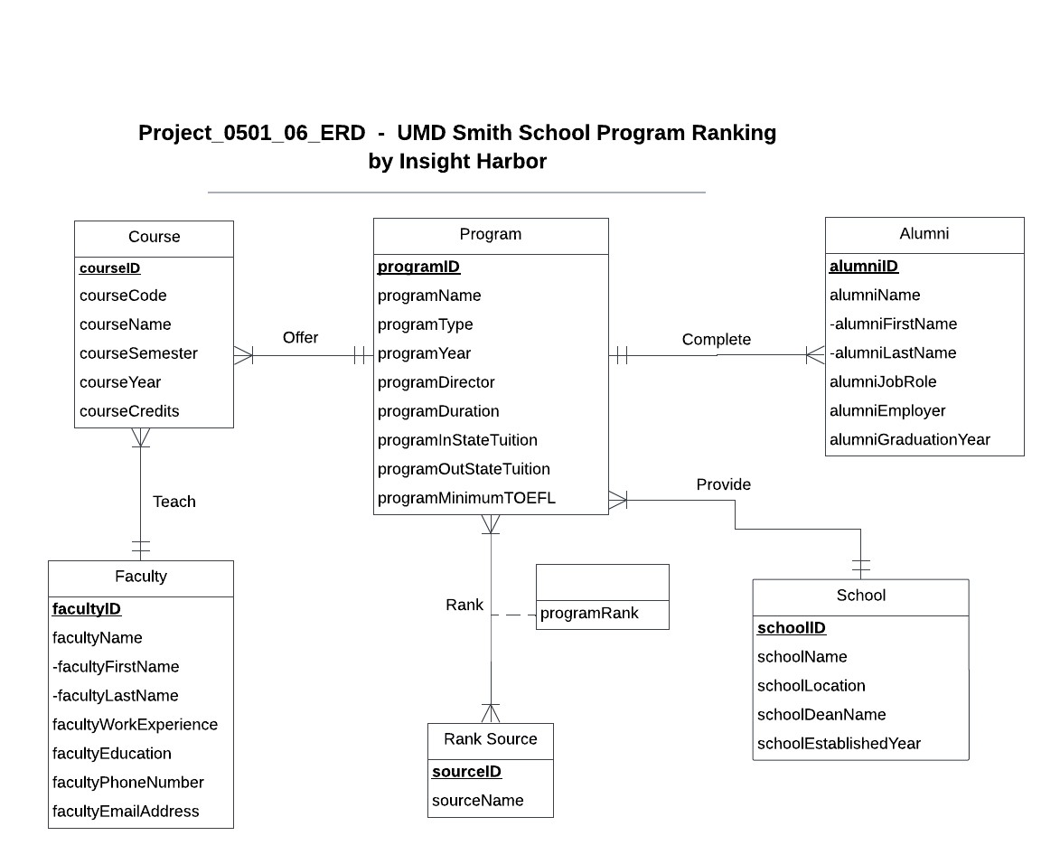

## **Relational Schema**

School (**schoolID**, schoolName, schoolLocation, schoolDeanName, schoolEstablishedYear)

Program (**programID**, programName, programType, programYear, programDirector, programDuration, programInStateTuition, programOutStateTuition, programMinimumTOEFL, *schoolID*)

Faculty (**facultyID**, facultyFirstName, facultyLastName, facultyWorkExperience, facultyEducation, facultyPhoneNumber, facultyEmailAddress)

Course (**courseID**, courseCode, courseName, courseCredits, courseSemester, courseYear, *programID*, *facultyID*)

Alumni (**alumniID**, alumniFirstName, alumniLastName, alumniJobRole, alumniEmployer, alumniGraduationYear, *programID*)

Rank Source (**sourceID**, sourceName)

Rank (***sourceID***, ***programID***, programRank)

**Functional Dependencies in 3NF**

schoolID → schoolName, schoolLocation, schoolDeanName, schoolEstablishedYear

programID → programName, programType, programYear, programDirector, programDuration, programInStateTuition, programOutStateTuition, programMinimumTOEFL, *schoolID*

facultyID →facultyFirstName, facultyLastName, facultyWorkExperience, facultyEducation, facultyPhoneNumber, facultyEmailAddress

courseID → courseCode, courseName, courseCredits, courseSemester, courseYear, *programID*, *facultyID*

alumniID → alumniFirstName, alumniLastName, alumniJobRole, alumniEmployer, alumniGraduationYear, *programID*

sourceID → sourceName

sourceID, programID → programRank

### 

### **3NF**

School (**schoolID**, schoolName, schoolLocation, schoolDeanName, schoolEstablishedYear)

Program (**programID**, programName, programType, programYear, programDirector, programDuration, programInStateTuition, programOutStateTuition, programMinimumTOEFL, *schoolID*)

Faculty (**facultyID**, facultyFirstName, facultyLastName, facultyWorkExperience, facultyEducation, facultyPhoneNumber, facultyEmailAddress)

Course (**courseID**, courseCode, courseName, courseCredits, courseSemester, courseYear, *programID*, *facultyID*)

Alumni (**alumniID**, alumniFirstName, alumniLastName, alumniJobRole, alumniEmployer, alumniGraduationYear, *programID*)

Rank Source (**sourceID**, sourceName)

Rank (***sourceID***, ***programID***, programRank)

## **Business Rules**

[R1] When a school is discontinued or deleted from the database, its program details should not be deleted from the database.

[R2] When a school’s details are updated in the database, its program’s details should be updated in the database.

[R3] When a program is discontinued or deleted from the database, the corresponding courses of this program should not be deleted.

[R4] When a program’s details are updated in the database, the corresponding courses should be accordingly updated.

[R5] When a faculty resigns or is deleted from the database, the course details of the courses that the faculty taught should not be deleted from the database.

[R6] When a faculty’s details are updated in the database, their details should be updated correspondingly in the course.

[R7] When a program is discontinued or is deleted from the database, the corresponding alumni details should not be deleted.

[R8] When a program’s details are updated in the database, the corresponding alumni details should also be updated respectively.

[R9] When the source stops ranking a program, the corresponding rank details should not be deleted.

[R10] When the source details are updated in the database, the corresponding rank details should also be updated.

[R11] When the program is discontinued or is deleted from the database, the corresponding rank data should not be deleted.

[R12] When the program details are updated in the database, the corresponding rank should also be updated.

## **Referential Integrity**

| **Relation** | **Foreign Key** | **Base Relation** | **Primary Key** | **Business Rule** | **Constraint: ON DELETE** | **Business Rule** | **Constraint: ON UPDATE** |
| --- | --- | --- | --- | --- | --- | --- | --- |
| **Program** | **schoolID** | **School** | **schoolID** | **R1** | **NO ACTION** | **R2** | **CASCADE** |
| **Course** | **programID** | **Program** | **programID** | **R3** | **NO ACTION** | **R4** | **CASCADE** |
| **Course** | **facultyID** | **Faculty** | **facultyID** | **R5** | **NO ACTION** | **R6** | **CASCADE** |
| **Alumni** | **programID** | **Program** | **programID** | **R7** | **NO ACTION** | **R8** | **CASCADE** |
| **Rank** | **sourceID** | **Rank Source** | **sourceID** | **R9** | **NO ACTION** | **R10** | **CASCADE** |
| **Rank** | **programID** | **Program** | **programID** | **R11** | **NO ACTION** | **R12** | **CASCADE** |

## **Sample Data**

School (**schoolID**, schoolName, schoolLocation, schoolDeanName, schoolEstablishedYear)



Program (**programID**, programName, programType, programYear, programDirector, programDuration, programInStateTuition, programOutStateTuition, programMinimumTOEFL, *schoolID*)

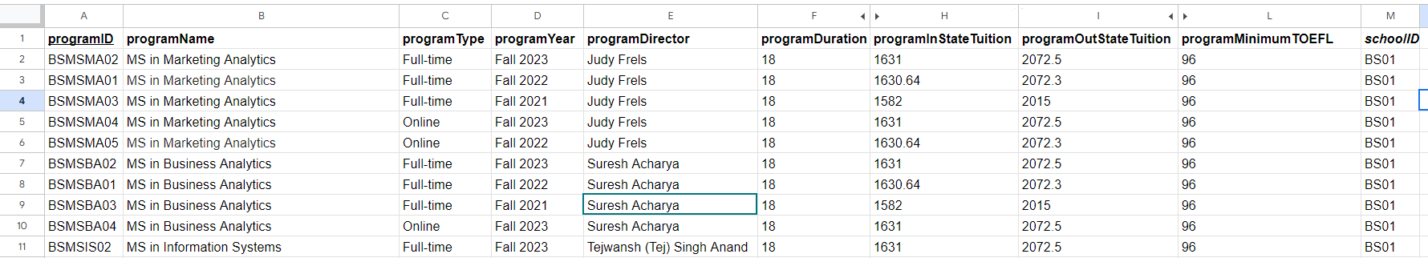

Faculty (**facultyID**, facultyFirstName, facultyLastName, facultyWorkExperience, facultyEducation, facultyPhoneNumber, facultyEmailAddress)

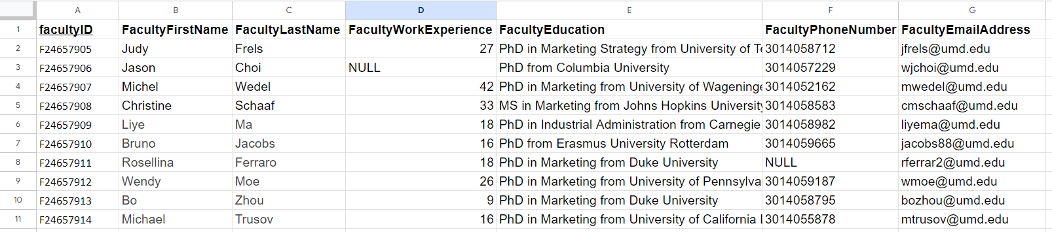

Course (**courseID**, courseCode, courseName, courseCredits, courseSemester, courseYear, *programID*, *facultyID*)

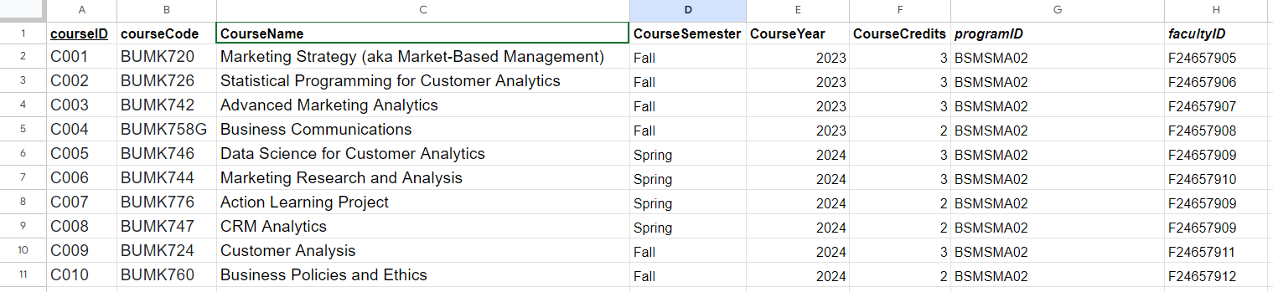

Alumni (**alumniID**, alumniFirstName, alumniLastName, alumniJobRole, alumniEmployer, alumniGraduationYear, *programID*)

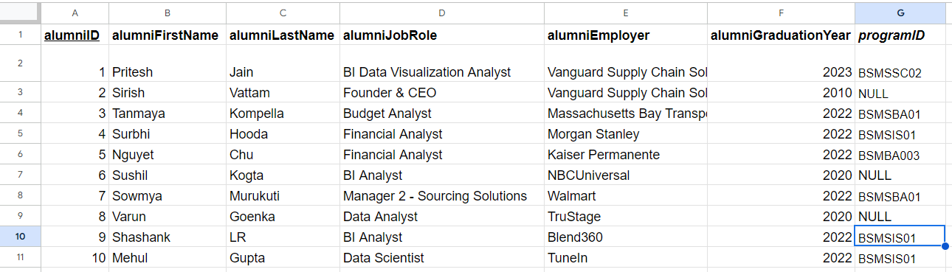

Rank Source (**sourceID**, sourceName)

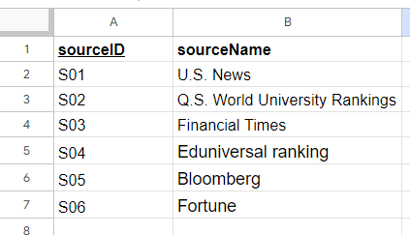

Rank (***sourceID***, ***programID***, programRank)

