

Search

[Write](https://medium.com/new-story?source=---two_column_layout_nav----------------------------------)

Zeba Roohi

Get unlimited access to the best of Medium for less than $1/week.

[Become a member](https://medium.com/plans?source=upgrade_membership---post_top_nav_upsell----------------------------------)

**JavaScript and ReactJs Interview Questions**

[[](https://bhagirathi694.medium.com/?source=post_page-----5e92869ae9e1--------------------------------)](https://bhagirathi694.medium.com/?source=post_page-----5e92869ae9e1--------------------------------)

[Bhagirathi Rohidas](https://bhagirathi694.medium.com/?source=post_page-----5e92869ae9e1--------------------------------)

·

Follow

2 min read

·

Aug 27

2

I had given more than 5+ company interviews while I was switching. Here are the most asked JavaScript and ReactJs Interview Questions. Most of them were startup companies.

**JavaScript**

* **What is Destructuring?**
* **Rest VS Spread operators?**
* **What do you mean by Arrow function?**
* **What is Closures?**
* **What do you mean by Promise? Promise.all vs Promise.allSettled.**
* **What is Deep cloning and Shallow cloning?**
* **What do you mean by callback function?**
* **Differences between async and await?**
* **What is event loop and how it work?**
* **What do you mean by Hoisting?**
* **Differentiate between synchronous and asynchronous?**
* **call, apply and bind functions**
* **new features of ES6?**
* **debouncing VS throttling?**
* **What is a higher-order function?**
* **How JavaScript works and what is global execution context?**
* **Global object and window?**
* **currying vs compose?**
* **async differ and delay load?**
* **first class function?**
* **map, filter, and reduce function?**
* **what is event bubbling and capturing?**
* **what is pure function?**
* **what is critical rendering path?**
* **splice and slice?**
* **async vs await**
* **this keyword**
* **local storage vs session storage vs cookies**

**ReactJs**

* **life cycle methods of react?**
* **lazy loading?**
* **what is reconciliation?**
* **how react work?**
* **what do you mean by hooks?**
* **can you please tell me about props?**
* **differentiate between stateless and stateful components?**
* **controlled VS uncontrolled component?**
* **what is context API?**
* **pure Vs impure component?**
* **what is jsx?**
* **what is react-redux and its 3 core concepts?**
* **advantages of react and drawbacks of react?**
* **what is Babel?**
* **react strict mode?**
* **can the browser understand JSX?**
* **what all the hooks available in react?**
* **React vs Angular**
* **Error Boundary**
* **How to implement react life cycle methods in functional component?**
* **useMemo vs useCallback**
* **useRef (use cases)**
* **react re-rendering(parent comp hold the state. pass setState to child)**
* **Lazy loading and code splitting**
* **What do you mean by lifting the state up?**
* **what is fragment?**
* **Class component Vs functional component**

Thanks For Reading Have a Good Day!

[JavaScript](https://medium.com/tag/javascript?source=post_page-----5e92869ae9e1---------------javascript-----------------)

[Reactjs](https://medium.com/tag/reactjs?source=post_page-----5e92869ae9e1---------------reactjs-----------------)

2

[[](https://bhagirathi694.medium.com/?source=post_page-----5e92869ae9e1--------------------------------)](https://bhagirathi694.medium.com/?source=post_page-----5e92869ae9e1--------------------------------)

[Written by Bhagirathi Rohidas](https://bhagirathi694.medium.com/?source=post_page-----5e92869ae9e1--------------------------------)

[3 Followers](https://bhagirathi694.medium.com/followers?source=post_page-----5e92869ae9e1--------------------------------)

Tech Enthusiast. Explorer. Learner.

Follow

More from Bhagirathi Rohidas

[[](https://bhagirathi694.medium.com/theming-using-styled-components-dark-mode-f673533a0995?source=author_recirc-----5e92869ae9e1----0---------------------130c5536_93e7_4e00_acca_a4ce7ea9c5a6-------)](https://bhagirathi694.medium.com/theming-using-styled-components-dark-mode-f673533a0995?source=author_recirc-----5e92869ae9e1----0---------------------130c5536_93e7_4e00_acca_a4ce7ea9c5a6-------)

[[Bhagirathi Rohidas](https://bhagirathi694.medium.com/?source=author_recirc-----5e92869ae9e1----0---------------------130c5536_93e7_4e00_acca_a4ce7ea9c5a6-------)](https://bhagirathi694.medium.com/?source=author_recirc-----5e92869ae9e1----0---------------------130c5536_93e7_4e00_acca_a4ce7ea9c5a6-------)

[Bhagirathi Rohidas](https://bhagirathi694.medium.com/?source=author_recirc-----5e92869ae9e1----0---------------------130c5536_93e7_4e00_acca_a4ce7ea9c5a6-------)

**[Theming Using Styled-Components(Dark Mode)](https://bhagirathi694.medium.com/theming-using-styled-components-dark-mode-f673533a0995?source=author_recirc-----5e92869ae9e1----0---------------------130c5536_93e7_4e00_acca_a4ce7ea9c5a6-------)**

[Dark Mode is Love for most of the developers out there. I’m going to implement theming using styled-components in my NextJs application. I…](https://bhagirathi694.medium.com/theming-using-styled-components-dark-mode-f673533a0995?source=author_recirc-----5e92869ae9e1----0---------------------130c5536_93e7_4e00_acca_a4ce7ea9c5a6-------)

[2 min read·Sep 3](https://bhagirathi694.medium.com/theming-using-styled-components-dark-mode-f673533a0995?source=author_recirc-----5e92869ae9e1----0---------------------130c5536_93e7_4e00_acca_a4ce7ea9c5a6-------)

[[](https://bhagirathi694.medium.com/storybook-with-nextjs-8493c9a6f4d?source=author_recirc-----5e92869ae9e1----1---------------------130c5536_93e7_4e00_acca_a4ce7ea9c5a6-------)](https://bhagirathi694.medium.com/storybook-with-nextjs-8493c9a6f4d?source=author_recirc-----5e92869ae9e1----1---------------------130c5536_93e7_4e00_acca_a4ce7ea9c5a6-------)

[[Bhagirathi Rohidas](https://bhagirathi694.medium.com/?source=author_recirc-----5e92869ae9e1----1---------------------130c5536_93e7_4e00_acca_a4ce7ea9c5a6-------)](https://bhagirathi694.medium.com/?source=author_recirc-----5e92869ae9e1----1---------------------130c5536_93e7_4e00_acca_a4ce7ea9c5a6-------)

[Bhagirathi Rohidas](https://bhagirathi694.medium.com/?source=author_recirc-----5e92869ae9e1----1---------------------130c5536_93e7_4e00_acca_a4ce7ea9c5a6-------)

**[Storybook with NextJs](https://bhagirathi694.medium.com/storybook-with-nextjs-8493c9a6f4d?source=author_recirc-----5e92869ae9e1----1---------------------130c5536_93e7_4e00_acca_a4ce7ea9c5a6-------)**

[You might have come across with the term Reusable Component yes I’m talking about React Reusable Component and We know that it can have…](https://bhagirathi694.medium.com/storybook-with-nextjs-8493c9a6f4d?source=author_recirc-----5e92869ae9e1----1---------------------130c5536_93e7_4e00_acca_a4ce7ea9c5a6-------)

[2 min read·Aug 20](https://bhagirathi694.medium.com/storybook-with-nextjs-8493c9a6f4d?source=author_recirc-----5e92869ae9e1----1---------------------130c5536_93e7_4e00_acca_a4ce7ea9c5a6-------)

[[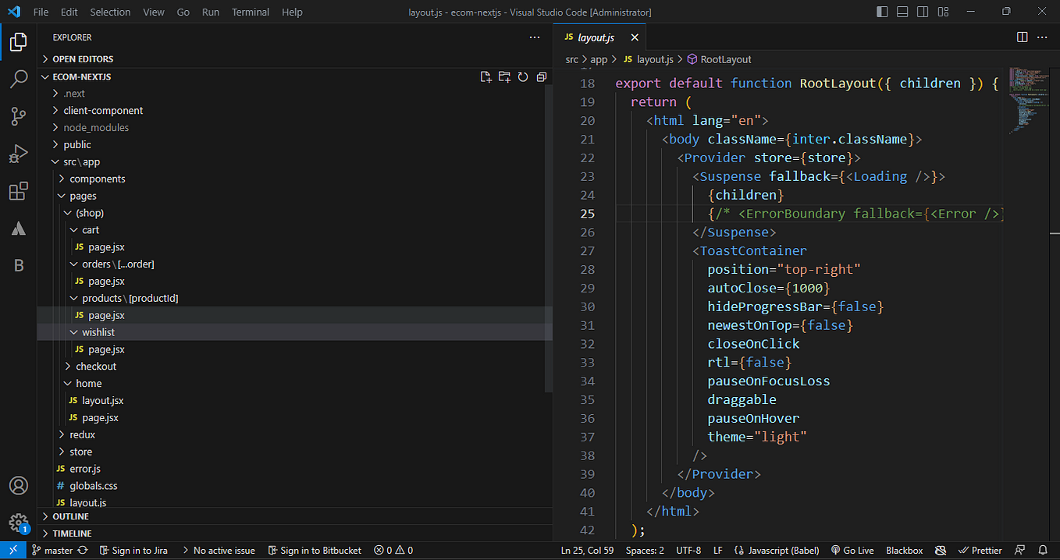](https://bhagirathi694.medium.com/nextjs-13-app-router-9aeca2917b39?source=author_recirc-----5e92869ae9e1----2---------------------130c5536_93e7_4e00_acca_a4ce7ea9c5a6-------)](https://bhagirathi694.medium.com/nextjs-13-app-router-9aeca2917b39?source=author_recirc-----5e92869ae9e1----2---------------------130c5536_93e7_4e00_acca_a4ce7ea9c5a6-------)

[[Bhagirathi Rohidas](https://bhagirathi694.medium.com/?source=author_recirc-----5e92869ae9e1----2---------------------130c5536_93e7_4e00_acca_a4ce7ea9c5a6-------)](https://bhagirathi694.medium.com/?source=author_recirc-----5e92869ae9e1----2---------------------130c5536_93e7_4e00_acca_a4ce7ea9c5a6-------)

[Bhagirathi Rohidas](https://bhagirathi694.medium.com/?source=author_recirc-----5e92869ae9e1----2---------------------130c5536_93e7_4e00_acca_a4ce7ea9c5a6-------)

**[NextJs 13 App Router](https://bhagirathi694.medium.com/nextjs-13-app-router-9aeca2917b39?source=author_recirc-----5e92869ae9e1----2---------------------130c5536_93e7_4e00_acca_a4ce7ea9c5a6-------)**

[A couple of days back I was exploring the nextjs 13 App router. It has both pages and an app router. App router offers better file…](https://bhagirathi694.medium.com/nextjs-13-app-router-9aeca2917b39?source=author_recirc-----5e92869ae9e1----2---------------------130c5536_93e7_4e00_acca_a4ce7ea9c5a6-------)

[2 min read·Aug 13](https://bhagirathi694.medium.com/nextjs-13-app-router-9aeca2917b39?source=author_recirc-----5e92869ae9e1----2---------------------130c5536_93e7_4e00_acca_a4ce7ea9c5a6-------)

[See all from Bhagirathi Rohidas](https://bhagirathi694.medium.com/?source=post_page-----5e92869ae9e1--------------------------------)

Recommended from Medium

[[](https://codeculturepro.medium.com/implementing-google-login-in-a-node-js-application-b6fbd98ce5e?source=read_next_recirc-----5e92869ae9e1----0---------------------573d9783_197f_4b35_ae0c_7b1437f0c92b-------)](https://codeculturepro.medium.com/implementing-google-login-in-a-node-js-application-b6fbd98ce5e?source=read_next_recirc-----5e92869ae9e1----0---------------------573d9783_197f_4b35_ae0c_7b1437f0c92b-------)

[[Tasadduq Ali](https://codeculturepro.medium.com/?source=read_next_recirc-----5e92869ae9e1----0---------------------573d9783_197f_4b35_ae0c_7b1437f0c92b-------)](https://codeculturepro.medium.com/?source=read_next_recirc-----5e92869ae9e1----0---------------------573d9783_197f_4b35_ae0c_7b1437f0c92b-------)

[Tasadduq Ali](https://codeculturepro.medium.com/?source=read_next_recirc-----5e92869ae9e1----0---------------------573d9783_197f_4b35_ae0c_7b1437f0c92b-------)

**[Implementing Google Login in a Node.js Application](https://codeculturepro.medium.com/implementing-google-login-in-a-node-js-application-b6fbd98ce5e?source=read_next_recirc-----5e92869ae9e1----0---------------------573d9783_197f_4b35_ae0c_7b1437f0c92b-------)**

[To implement Google Login, you need to set up a Google API project. Follow these steps:](https://codeculturepro.medium.com/implementing-google-login-in-a-node-js-application-b6fbd98ce5e?source=read_next_recirc-----5e92869ae9e1----0---------------------573d9783_197f_4b35_ae0c_7b1437f0c92b-------)

[3 min read·Jul 12](https://codeculturepro.medium.com/implementing-google-login-in-a-node-js-application-b6fbd98ce5e?source=read_next_recirc-----5e92869ae9e1----0---------------------573d9783_197f_4b35_ae0c_7b1437f0c92b-------)

5

[2](https://codeculturepro.medium.com/implementing-google-login-in-a-node-js-application-b6fbd98ce5e?responsesOpen=true&sortBy=REVERSE_CHRON&source=read_next_recirc-----5e92869ae9e1----0---------------------573d9783_197f_4b35_ae0c_7b1437f0c92b-------)

[[](https://rahuulmiishra.medium.com/deciphering-this-in-javascript-5-rules-every-developer-should-know-b655d8604ce8?source=read_next_recirc-----5e92869ae9e1----1---------------------573d9783_197f_4b35_ae0c_7b1437f0c92b-------)](https://rahuulmiishra.medium.com/deciphering-this-in-javascript-5-rules-every-developer-should-know-b655d8604ce8?source=read_next_recirc-----5e92869ae9e1----1---------------------573d9783_197f_4b35_ae0c_7b1437f0c92b-------)

[[राहुल मिश्रा](https://rahuulmiishra.medium.com/?source=read_next_recirc-----5e92869ae9e1----1---------------------573d9783_197f_4b35_ae0c_7b1437f0c92b-------)](https://rahuulmiishra.medium.com/?source=read_next_recirc-----5e92869ae9e1----1---------------------573d9783_197f_4b35_ae0c_7b1437f0c92b-------)

[राहुल मिश्रा](https://rahuulmiishra.medium.com/?source=read_next_recirc-----5e92869ae9e1----1---------------------573d9783_197f_4b35_ae0c_7b1437f0c92b-------)

**[Deciphering ‘this’ in JavaScript: 5 Rules Every Developer Should Know](https://rahuulmiishra.medium.com/deciphering-this-in-javascript-5-rules-every-developer-should-know-b655d8604ce8?source=read_next_recirc-----5e92869ae9e1----1---------------------573d9783_197f_4b35_ae0c_7b1437f0c92b-------)**

[Essential Rules for ‘this’ Mastery: Enhance Your JavaScript Development](https://rahuulmiishra.medium.com/deciphering-this-in-javascript-5-rules-every-developer-should-know-b655d8604ce8?source=read_next_recirc-----5e92869ae9e1----1---------------------573d9783_197f_4b35_ae0c_7b1437f0c92b-------)

[3 min read·4 days ago](https://rahuulmiishra.medium.com/deciphering-this-in-javascript-5-rules-every-developer-should-know-b655d8604ce8?source=read_next_recirc-----5e92869ae9e1----1---------------------573d9783_197f_4b35_ae0c_7b1437f0c92b-------)

10

Lists

[[](https://medium.com/@MediumStaff/list/stories-to-help-you-grow-as-a-software-developer-b1d913188c20?source=read_next_recirc-----5e92869ae9e1--------------------------------)](https://medium.com/@MediumStaff/list/stories-to-help-you-grow-as-a-software-developer-b1d913188c20?source=read_next_recirc-----5e92869ae9e1--------------------------------)

[[](https://medium.com/@MediumStaff/list/stories-to-help-you-grow-as-a-software-developer-b1d913188c20?source=read_next_recirc-----5e92869ae9e1--------------------------------)](https://medium.com/@MediumStaff/list/stories-to-help-you-grow-as-a-software-developer-b1d913188c20?source=read_next_recirc-----5e92869ae9e1--------------------------------)

[Stories to Help You Grow as a Software Developer](https://medium.com/@MediumStaff/list/stories-to-help-you-grow-as-a-software-developer-b1d913188c20?source=read_next_recirc-----5e92869ae9e1--------------------------------)

[19 stories·598 saves](https://medium.com/@MediumStaff/list/stories-to-help-you-grow-as-a-software-developer-b1d913188c20?source=read_next_recirc-----5e92869ae9e1--------------------------------)

[[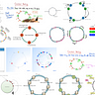](https://eddiebarth.medium.com/list/general-coding-knowledge-f2d429d4f0cd?source=read_next_recirc-----5e92869ae9e1--------------------------------)](https://eddiebarth.medium.com/list/general-coding-knowledge-f2d429d4f0cd?source=read_next_recirc-----5e92869ae9e1--------------------------------)

[[](https://eddiebarth.medium.com/list/general-coding-knowledge-f2d429d4f0cd?source=read_next_recirc-----5e92869ae9e1--------------------------------)](https://eddiebarth.medium.com/list/general-coding-knowledge-f2d429d4f0cd?source=read_next_recirc-----5e92869ae9e1--------------------------------)

[[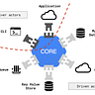](https://eddiebarth.medium.com/list/general-coding-knowledge-f2d429d4f0cd?source=read_next_recirc-----5e92869ae9e1--------------------------------)](https://eddiebarth.medium.com/list/general-coding-knowledge-f2d429d4f0cd?source=read_next_recirc-----5e92869ae9e1--------------------------------)

[General Coding Knowledge](https://eddiebarth.medium.com/list/general-coding-knowledge-f2d429d4f0cd?source=read_next_recirc-----5e92869ae9e1--------------------------------)

[20 stories·634 saves](https://eddiebarth.medium.com/list/general-coding-knowledge-f2d429d4f0cd?source=read_next_recirc-----5e92869ae9e1--------------------------------)

[[](https://medium.com/@walterbonnett71/list/modern-marketing-ef96a341a034?source=read_next_recirc-----5e92869ae9e1--------------------------------)](https://medium.com/@walterbonnett71/list/modern-marketing-ef96a341a034?source=read_next_recirc-----5e92869ae9e1--------------------------------)

[[](https://medium.com/@walterbonnett71/list/modern-marketing-ef96a341a034?source=read_next_recirc-----5e92869ae9e1--------------------------------)](https://medium.com/@walterbonnett71/list/modern-marketing-ef96a341a034?source=read_next_recirc-----5e92869ae9e1--------------------------------)

[[](https://medium.com/@walterbonnett71/list/modern-marketing-ef96a341a034?source=read_next_recirc-----5e92869ae9e1--------------------------------)](https://medium.com/@walterbonnett71/list/modern-marketing-ef96a341a034?source=read_next_recirc-----5e92869ae9e1--------------------------------)

[Modern Marketing](https://medium.com/@walterbonnett71/list/modern-marketing-ef96a341a034?source=read_next_recirc-----5e92869ae9e1--------------------------------)

[46 stories·280 saves](https://medium.com/@walterbonnett71/list/modern-marketing-ef96a341a034?source=read_next_recirc-----5e92869ae9e1--------------------------------)

[[](https://medium.com/@MediumStaff/list/medium-publications-accepting-story-submissions-7c0ec8037e61?source=read_next_recirc-----5e92869ae9e1--------------------------------)](https://medium.com/@MediumStaff/list/medium-publications-accepting-story-submissions-7c0ec8037e61?source=read_next_recirc-----5e92869ae9e1--------------------------------)

[[](https://medium.com/@MediumStaff/list/medium-publications-accepting-story-submissions-7c0ec8037e61?source=read_next_recirc-----5e92869ae9e1--------------------------------)](https://medium.com/@MediumStaff/list/medium-publications-accepting-story-submissions-7c0ec8037e61?source=read_next_recirc-----5e92869ae9e1--------------------------------)

[[](https://medium.com/@MediumStaff/list/medium-publications-accepting-story-submissions-7c0ec8037e61?source=read_next_recirc-----5e92869ae9e1--------------------------------)](https://medium.com/@MediumStaff/list/medium-publications-accepting-story-submissions-7c0ec8037e61?source=read_next_recirc-----5e92869ae9e1--------------------------------)

[Medium Publications Accepting Story Submissions](https://medium.com/@MediumStaff/list/medium-publications-accepting-story-submissions-7c0ec8037e61?source=read_next_recirc-----5e92869ae9e1--------------------------------)

[154 stories·1163 saves](https://medium.com/@MediumStaff/list/medium-publications-accepting-story-submissions-7c0ec8037e61?source=read_next_recirc-----5e92869ae9e1--------------------------------)

[[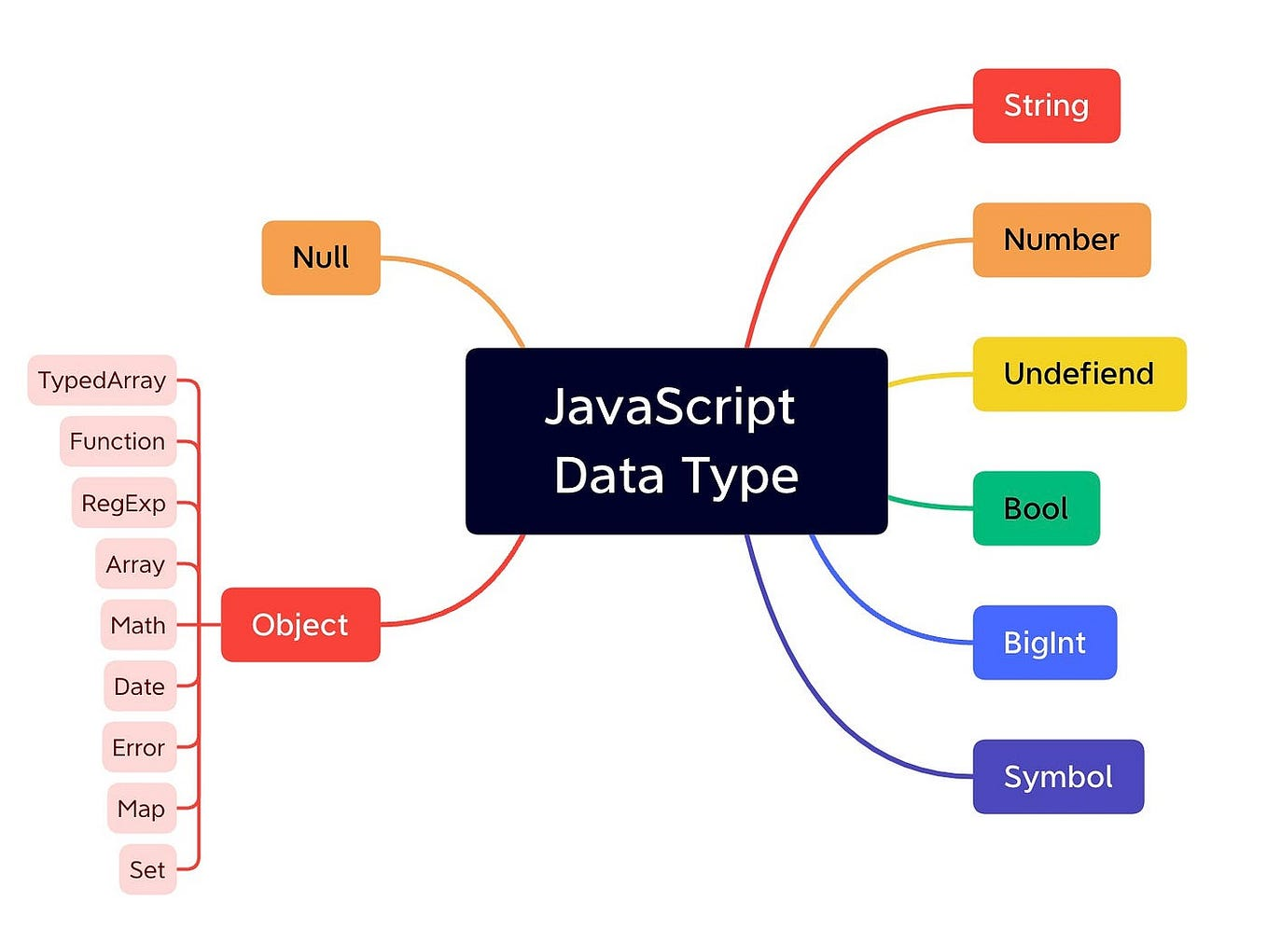](https://medium.com/@elfrmkr98/javascript-fundamentals-questions-that-i-encountered-during-interviews-part-1-5e613502b624?source=read_next_recirc-----5e92869ae9e1----0---------------------573d9783_197f_4b35_ae0c_7b1437f0c92b-------)](https://medium.com/@elfrmkr98/javascript-fundamentals-questions-that-i-encountered-during-interviews-part-1-5e613502b624?source=read_next_recirc-----5e92869ae9e1----0---------------------573d9783_197f_4b35_ae0c_7b1437f0c92b-------)

[[Elif İrem Kara Kadyrov](https://medium.com/@elfrmkr98?source=read_next_recirc-----5e92869ae9e1----0---------------------573d9783_197f_4b35_ae0c_7b1437f0c92b-------)](https://medium.com/@elfrmkr98?source=read_next_recirc-----5e92869ae9e1----0---------------------573d9783_197f_4b35_ae0c_7b1437f0c92b-------)

[Elif İrem Kara Kadyrov](https://medium.com/@elfrmkr98?source=read_next_recirc-----5e92869ae9e1----0---------------------573d9783_197f_4b35_ae0c_7b1437f0c92b-------)

**[JavaScript Fundamentals: Questions That I Encountered During Interviews (Part-1)](https://medium.com/@elfrmkr98/javascript-fundamentals-questions-that-i-encountered-during-interviews-part-1-5e613502b624?source=read_next_recirc-----5e92869ae9e1----0---------------------573d9783_197f_4b35_ae0c_7b1437f0c92b-------)**

[Studying for an interview always makes me feel like an imposter, nearly all the time.](https://medium.com/@elfrmkr98/javascript-fundamentals-questions-that-i-encountered-during-interviews-part-1-5e613502b624?source=read_next_recirc-----5e92869ae9e1----0---------------------573d9783_197f_4b35_ae0c_7b1437f0c92b-------)

[6 min read·Nov 6](https://medium.com/@elfrmkr98/javascript-fundamentals-questions-that-i-encountered-during-interviews-part-1-5e613502b624?source=read_next_recirc-----5e92869ae9e1----0---------------------573d9783_197f_4b35_ae0c_7b1437f0c92b-------)

51

[[](https://medium.com/@yash_sharma0409/mastering-advanced-concepts-in-react-js-a-comprehensive-guide-37fdba2db135?source=read_next_recirc-----5e92869ae9e1----1---------------------573d9783_197f_4b35_ae0c_7b1437f0c92b-------)](https://medium.com/@yash_sharma0409/mastering-advanced-concepts-in-react-js-a-comprehensive-guide-37fdba2db135?source=read_next_recirc-----5e92869ae9e1----1---------------------573d9783_197f_4b35_ae0c_7b1437f0c92b-------)

[[avg_programmer](https://medium.com/@yash_sharma0409?source=read_next_recirc-----5e92869ae9e1----1---------------------573d9783_197f_4b35_ae0c_7b1437f0c92b-------)](https://medium.com/@yash_sharma0409?source=read_next_recirc-----5e92869ae9e1----1---------------------573d9783_197f_4b35_ae0c_7b1437f0c92b-------)

[avg_programmer](https://medium.com/@yash_sharma0409?source=read_next_recirc-----5e92869ae9e1----1---------------------573d9783_197f_4b35_ae0c_7b1437f0c92b-------)

**[Mastering Advanced Concepts in React.js: A Comprehensive Guide](https://medium.com/@yash_sharma0409/mastering-advanced-concepts-in-react-js-a-comprehensive-guide-37fdba2db135?source=read_next_recirc-----5e92869ae9e1----1---------------------573d9783_197f_4b35_ae0c_7b1437f0c92b-------)**

[Introduction: React.js has emerged as one of the most popular and powerful JavaScript libraries for building user interfaces. While many…](https://medium.com/@yash_sharma0409/mastering-advanced-concepts-in-react-js-a-comprehensive-guide-37fdba2db135?source=read_next_recirc-----5e92869ae9e1----1---------------------573d9783_197f_4b35_ae0c_7b1437f0c92b-------)

[4 min read·Jun 26](https://medium.com/@yash_sharma0409/mastering-advanced-concepts-in-react-js-a-comprehensive-guide-37fdba2db135?source=read_next_recirc-----5e92869ae9e1----1---------------------573d9783_197f_4b35_ae0c_7b1437f0c92b-------)

18

[[](https://medium.com/@Evelyn.Taylor/10-common-javascript-interview-questions-and-how-to-answer-them-28eac15ab88?source=read_next_recirc-----5e92869ae9e1----2---------------------573d9783_197f_4b35_ae0c_7b1437f0c92b-------)](https://medium.com/@Evelyn.Taylor/10-common-javascript-interview-questions-and-how-to-answer-them-28eac15ab88?source=read_next_recirc-----5e92869ae9e1----2---------------------573d9783_197f_4b35_ae0c_7b1437f0c92b-------)

[[Evelyn Taylor](https://medium.com/@Evelyn.Taylor?source=read_next_recirc-----5e92869ae9e1----2---------------------573d9783_197f_4b35_ae0c_7b1437f0c92b-------)](https://medium.com/@Evelyn.Taylor?source=read_next_recirc-----5e92869ae9e1----2---------------------573d9783_197f_4b35_ae0c_7b1437f0c92b-------)

[Evelyn Taylor](https://medium.com/@Evelyn.Taylor?source=read_next_recirc-----5e92869ae9e1----2---------------------573d9783_197f_4b35_ae0c_7b1437f0c92b-------)

**[10 Common JavaScript Interview Questions and How to Answer Them](https://medium.com/@Evelyn.Taylor/10-common-javascript-interview-questions-and-how-to-answer-them-28eac15ab88?source=read_next_recirc-----5e92869ae9e1----2---------------------573d9783_197f_4b35_ae0c_7b1437f0c92b-------)**

[JavaScript is an essential programming language for web development, and proficiency in it is often a prerequisite for landing a job as a…](https://medium.com/@Evelyn.Taylor/10-common-javascript-interview-questions-and-how-to-answer-them-28eac15ab88?source=read_next_recirc-----5e92869ae9e1----2---------------------573d9783_197f_4b35_ae0c_7b1437f0c92b-------)

[10 min read·Jun 16](https://medium.com/@Evelyn.Taylor/10-common-javascript-interview-questions-and-how-to-answer-them-28eac15ab88?source=read_next_recirc-----5e92869ae9e1----2---------------------573d9783_197f_4b35_ae0c_7b1437f0c92b-------)

288

[1](https://medium.com/@Evelyn.Taylor/10-common-javascript-interview-questions-and-how-to-answer-them-28eac15ab88?responsesOpen=true&sortBy=REVERSE_CHRON&source=read_next_recirc-----5e92869ae9e1----2---------------------573d9783_197f_4b35_ae0c_7b1437f0c92b-------)

[[](https://medium.com/@Harshit_Raj_14/mastering-javascript-for-frontend-interviews-a-comprehensive-preparation-guide-f4266f1d39b2?source=read_next_recirc-----5e92869ae9e1----3---------------------573d9783_197f_4b35_ae0c_7b1437f0c92b-------)](https://medium.com/@Harshit_Raj_14/mastering-javascript-for-frontend-interviews-a-comprehensive-preparation-guide-f4266f1d39b2?source=read_next_recirc-----5e92869ae9e1----3---------------------573d9783_197f_4b35_ae0c_7b1437f0c92b-------)

[[Harshit Raj](https://medium.com/@Harshit_Raj_14?source=read_next_recirc-----5e92869ae9e1----3---------------------573d9783_197f_4b35_ae0c_7b1437f0c92b-------)](https://medium.com/@Harshit_Raj_14?source=read_next_recirc-----5e92869ae9e1----3---------------------573d9783_197f_4b35_ae0c_7b1437f0c92b-------)

[Harshit Raj](https://medium.com/@Harshit_Raj_14?source=read_next_recirc-----5e92869ae9e1----3---------------------573d9783_197f_4b35_ae0c_7b1437f0c92b-------)

**[Mastering JavaScript for Frontend Interviews: A Comprehensive Preparation Guide](https://medium.com/@Harshit_Raj_14/mastering-javascript-for-frontend-interviews-a-comprehensive-preparation-guide-f4266f1d39b2?source=read_next_recirc-----5e92869ae9e1----3---------------------573d9783_197f_4b35_ae0c_7b1437f0c92b-------)**

[Preparing for frontend interviews can be a daunting task, but with a well-structured approach, you can increase your chances of success. In…](https://medium.com/@Harshit_Raj_14/mastering-javascript-for-frontend-interviews-a-comprehensive-preparation-guide-f4266f1d39b2?source=read_next_recirc-----5e92869ae9e1----3---------------------573d9783_197f_4b35_ae0c_7b1437f0c92b-------)

[3 min read·Jun 29](https://medium.com/@Harshit_Raj_14/mastering-javascript-for-frontend-interviews-a-comprehensive-preparation-guide-f4266f1d39b2?source=read_next_recirc-----5e92869ae9e1----3---------------------573d9783_197f_4b35_ae0c_7b1437f0c92b-------)

4

[1](https://medium.com/@Harshit_Raj_14/mastering-javascript-for-frontend-interviews-a-comprehensive-preparation-guide-f4266f1d39b2?responsesOpen=true&sortBy=REVERSE_CHRON&source=read_next_recirc-----5e92869ae9e1----3---------------------573d9783_197f_4b35_ae0c_7b1437f0c92b-------)

[See more recommendations](https://medium.com/?source=post_page-----5e92869ae9e1--------------------------------)

[Help](https://help.medium.com/hc/en-us?source=post_page-----5e92869ae9e1--------------------------------)

[Status](https://medium.statuspage.io/?source=post_page-----5e92869ae9e1--------------------------------)

[About](https://medium.com/about?autoplay=1&source=post_page-----5e92869ae9e1--------------------------------)

[Careers](https://medium.com/jobs-at-medium/work-at-medium-959d1a85284e?source=post_page-----5e92869ae9e1--------------------------------)

[Blog](https://blog.medium.com/?source=post_page-----5e92869ae9e1--------------------------------)

[Privacy](https://policy.medium.com/medium-privacy-policy-f03bf92035c9?source=post_page-----5e92869ae9e1--------------------------------)

[Terms](https://policy.medium.com/medium-terms-of-service-9db0094a1e0f?source=post_page-----5e92869ae9e1--------------------------------)

[Text to speech](https://speechify.com/medium?source=post_page-----5e92869ae9e1--------------------------------)

[Teams](https://medium.com/business?source=post_page-----5e92869ae9e1--------------------------------)