**Assignmnet-3**

1.Create a program to give dynamic rating with JS

2.Create a program of BMI Mass calculation.Use this formula for calculation.

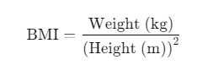

3.Create a program on FAQ page with js

4.Create a program to toggle light and dark theme with js