***Food Photography Beauty Shots & Styling by***[***Louise Mellor***](http://www.louisemellor.com/)

[image: https://toriavey.com/images/2011/01/ToriAvey.com-1.jpg](https://toriavey.com/images/2011/01/ToriAvey.com-1.jpg)

[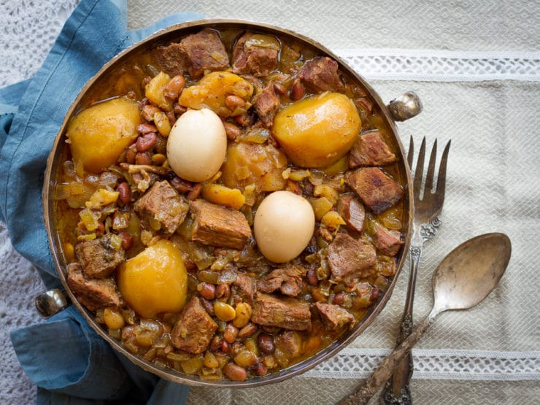](https://toriavey.com/images/2011/01/ToriAvey.com-1.jpg)

image: https://toriavey.com/images/2011/01/ToriAvey.com-2-1-200x150.jpg

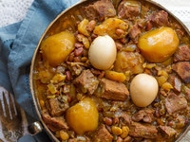

**Cholent**

from 25 votes

Servings  
 servings

Prep Time  
20 minutes

Cook Time  
17 hours

Kosher Key  
Meat

Print Recipe

**Description**

A savory slow-cooked stew for Shabbat with meat, potatoes, and beans. Also known as chamin, dafina, or skhina.

**Ingredients**

* 2 1/2 lbs large red potatoes, peeled and halved (for a smaller slow cooker, use 2 lbs)
* 2 whole onions, chopped
* 2 1/2 lbs beef stew meat or brisket, cut into chunks (for a smaller slow cooker, use 2 lbs)
* 2 marrow bones
* 1 cup dried beans - lima, pinto, chickpeas, red beans (not kidney), or a mixture
* 1/2 cup pearl barley or coarse-grain kasha (optional - for gluten free, do not use pearl barley)
* 3 whole garlic cloves
* 6 eggs (optional)
* 1/2 tsp black pepper (if spice sensitive use 1/4 tsp)
* 1 quart low sodium chicken broth
* 1 tbsp kosher salt
* 1 1/2 tsp paprika
* 1 1/2 tsp turmeric
* 1 tsp cumin
* 1/4 tsp cayenne (if spice sensitive use just a pinch)
* 1 kishke (optional - we never add this, but many families like it)
* Water (varies)

[**US Customary**](https://toriavey.com/toris-kitchen/cholent/) - [Metric](https://toriavey.com/toris-kitchen/cholent/)

**Recipe Notes**

You will also need: 6-8 quart slow cooker

**Instructions**

1. Note: The beans in this recipe will soften without any pre-soaking due to the long slow cooking process, however they will be easier to digest with a simple quick soak prior to cooking. To do this, place the beans into the bottom of a large pot and cover with water. The beans will expand to over double their size, so make sure you cover by several inches of water to allow for expansion. Bring the beans to a boil for 5 minutes, then remove from heat. Let them soak in the cooking water for 1 hour, then drain and rinse well before proceeding with the recipe. Also note that it is not recommended to slow-cook kidney beans.
2. In a large slow cooker (the larger the better!), place the potatoes in a single layer on the bottom of the cooking vessel.

image: https://toriavey.com/images/2011/01/IMG_4331.jpg

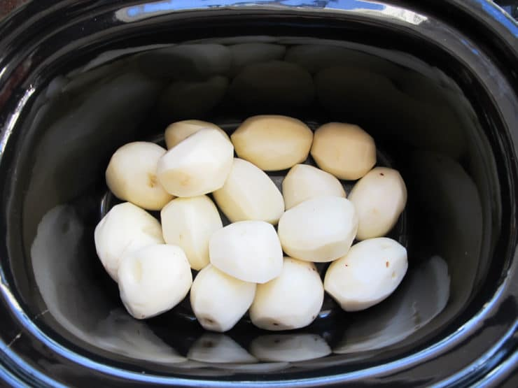

1. Sprinkle the onions over the potatoes.

image: https://toriavey.com/images/2011/01/IMG_4334.jpg

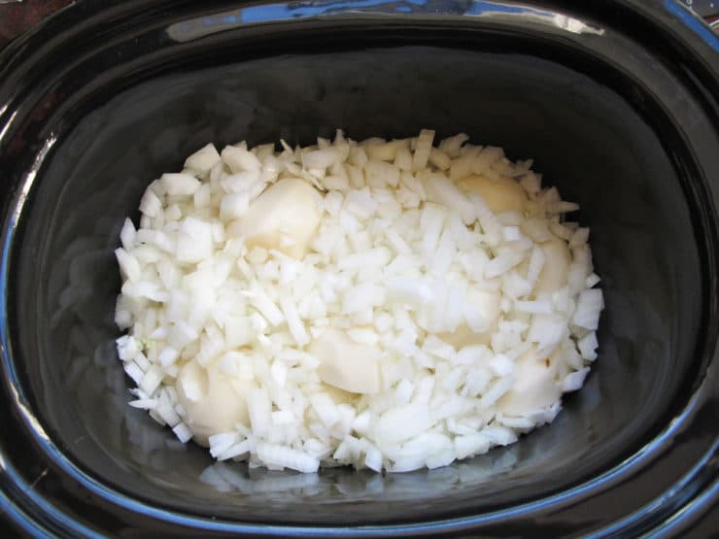

1. Place the beef in a single layer on top of the onions and potatoes. Place the two marrow bones in the meat. If you're adding a kishke, now would be the time to put it in the cooker.

image: https://toriavey.com/images/2011/01/IMG_4337.jpg

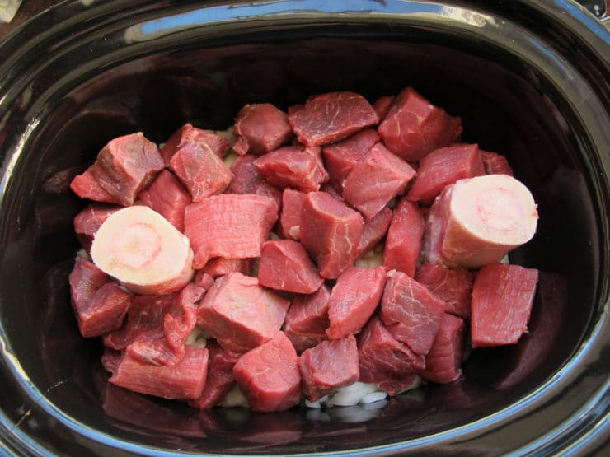

1. Rinse the beans clean, checking for any stones or impurities. If using barley or kasha, do the same with the grains. Sprinkle the beans (raw or pre-soaked) and optional grains over the top of the meat. Place the three whole garlic cloves into the meat, evenly spaced. Sprinkle the whole mixture with the black pepper.

image: https://toriavey.com/images/2011/01/IMG_4343.jpg

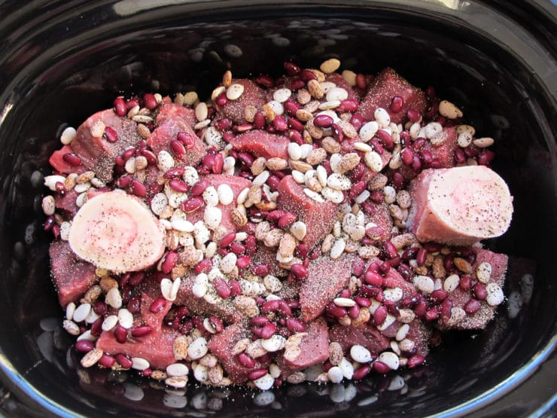

1. If using eggs, rinse them well and then tuck them into the meat. In a 4-cup container, whisk together the low sodium chicken broth, kosher salt, paprika, turmeric, cumin and cayenne.

image: https://toriavey.com/images/2011/01/IMG_4348.jpg

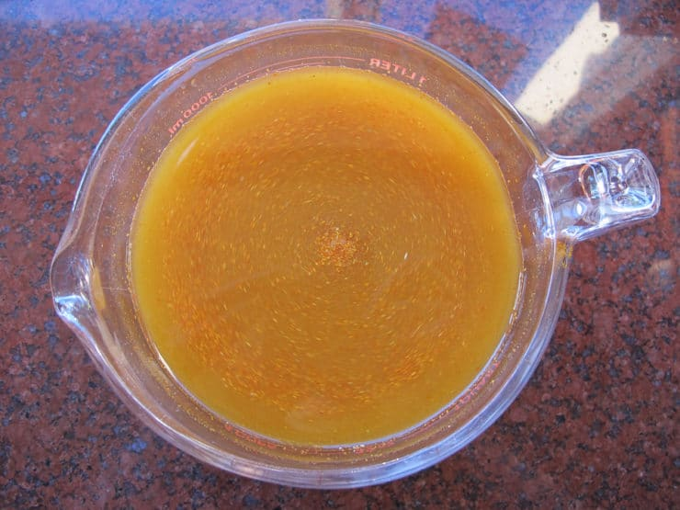

1. Pour the liquid over the cholent. Add additional water until all of the beans and pieces of meat are covered. For us, it's usually another 1-2 cups of water in our slow cooker-- it will vary; I usually add a bit more liquid if using grains, because they will soak it up.

image: https://toriavey.com/images/2011/01/IMG_4350.jpg

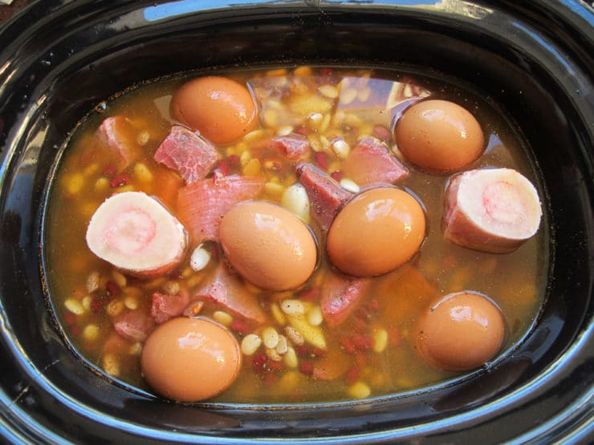

1. Cover the slow cooker. Cook on low heat for 16 hours. Check occasionally as it's cooking; add additional water and stir a bit if it's looking too dry. Most cookers will auto-switch to warm when the cooking is complete. If yours doesn’t, set it to warm until ready to serve.

image: https://toriavey.com/images/2011/01/IMG_4354.jpg

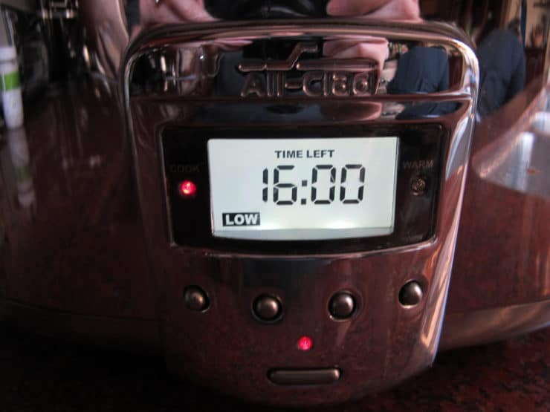

1. It will look a bit medieval when it's done cooking! Don't worry, just dig in and you'll see that it's perfectly cooked below the surface. Peel the eggs before serving the cholent.

image: https://toriavey.com/images/2011/01/IMG_4455.jpg

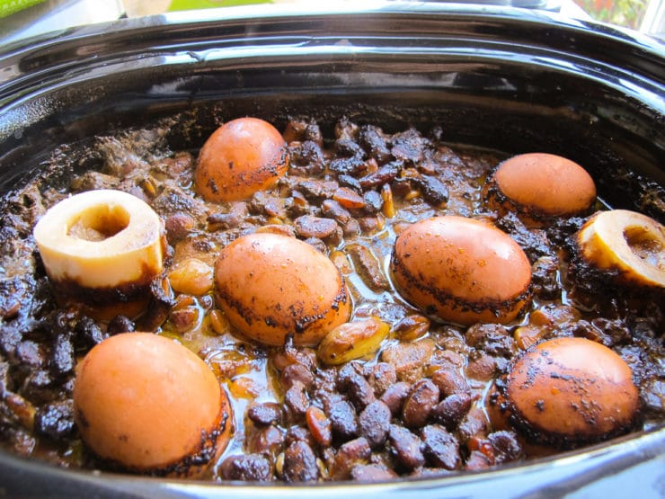

1. To cook this recipe in the oven, layer the ingredients in a large heavy 7-8 quart Dutch oven. Make sure you have enough liquid to just cover all ingredients. Cover with lid and cook cholent at 200 degrees F for 12-16 hours.

image: https://toriavey.com/images/2011/01/ToriAvey.com-1.jpg



See the full post:https://toriavey.com/toris-kitchen/cholent/#DcMgDrQiPqIcHI1m.99