OCR Labeler User Guide

OcrLabeler.exe is an OCR labeling tool. The tool was developed for internal needs and is made available as-is to the AIL user community. This version is compatible with AIL 11.
This is the recommended way to launch the tool:
- Ensure that AIL 11 is installed on your PC.
- Create a new folder as your working directory. Download the executable and place it in this directory.
- Create two new folders inside this new directory: “source_directory” and “destination_directory”.
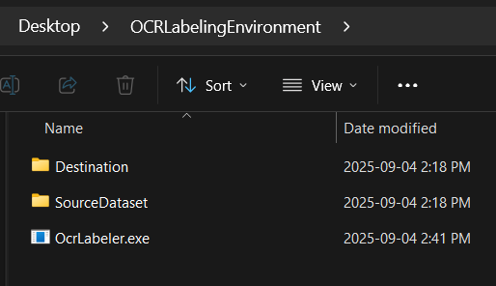
- Copy the images that need to be labeled into a folder named “Images” within the “source_directory”. If you have annotations to load, you can optionally put them in the same source folder.
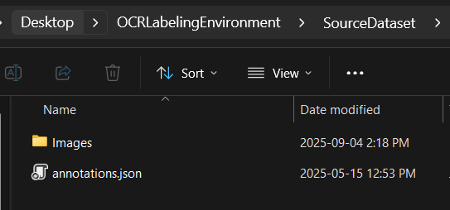

- Launch the Windows Command Prompt and navigate to your working directory, using the following command:
cd /d path_to_working_directory
- From the Windows Command Prompt, run the following command to start OcrLabeler.exe:
OcrLabeler.exe source_directory destination_directory -json path_to_annotation_file
- The source directory is the directory where the images that need to be labeled are stored.
- The destination directory is the directory where the annotation file will be stored. This directory can be empty when you first launch the tool.
- The path to the annotation file is an optional parameter and is used when you want to load an existing annotation file to modify or continue the labeling process.
- Once you launch the application, the following keymap will appear:
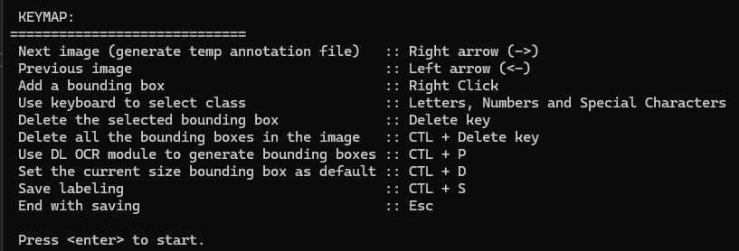
Take a moment to familiarize yourself with it.
- Press “Enter” and start labeling.

Additional details
- Images in the source directory can vary in size, however this feature has not been thoroughly tested.
- Subfolders are supported when loading images from the source directory, however this feature has not been thoroughly tested.
- Ensure all bounding boxes are assigned to a class. The DL OCR module only supports class assigned-bounding boxes.
- To ensure the labeling process is behaving as you expect, you should frequently validate that your labels are saved properly by inspecting the destination folder. It is also advised to back up your annotations every time you want to relaunch the tool.
- The DL OCR model used to facilitate the labeling is “M_OCR_NET1_BALANCED_V1”.
- Note that these characters are supported by DL OCR but not by the labeling tool: €, £, ¥, ¢, `

