**Group 4 Project: Milestone 3**

**Outland Adventures Case Study**

Kevin Meza, Dominique Monroe, Shane Tinsley

Bellevue University

CSD 310: Database Development and Use

Dr. Joseph Issa

December 8, 2023

**Group 4 Project: Milestone 3**

Milestone 3 required additional data and table parameters to encompass the scope of the reports we identified. Attached is an updated copy of the TravelAgencyFinal.py script to create the database.

**Report 1 - Equipment Sales Report:**

Based on the Equipment Sales Rule-

*Assumption: Equipment sales are a significant revenue contributor.*

*Rule: If equipment sales contribute less than 40% of the total revenue for two consecutive quarters, reevaluate the marketing strategy, consider e-commerce expansion, or adjust inventory levels to optimize sales.*

This Python script connects to a database, retrieves sales data for two quarters in 2022, calculates equipment sales percentages for each quarter, and provides recommendations based on the sales criteria.

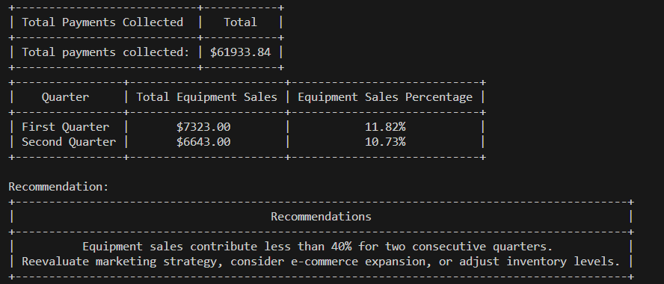

**Report 2 – Booking Trends:**

Based on the Booking Trends - Locations Rule

*Assumption: Monitoring booking trends helps in optimizing resources and identifying popular destinations.*

*Rule: If bookings for any specific location show a consistent downward trend over three consecutive quarters, conduct a detailed analysis to consider adjusting trip schedules, exploring new locations, or revising marketing strategies for those locations.*

This Python script connects to a MySQL database representing a travel agency's system. It retrieves booking data by “Continent” for the fiscal year 2022, analyzes quarterly downward booking trends, and then displays the results using tabulated formats. The code consists of functions to handle database connections, fetch booking data, display table results, analyze trends, and present the analysis.

**Report 3 – Equipment Condition Report:**

Based on the Inventory Age Rule:

*Assumption: Maintaining updated inventory is crucial for quality and safety.*

*Rule: Conduct an annual inspection of inventory items, identifying and replacing items over five years old or those failing to meet safety standards, ensuring quality and customer safety.*

This Python script performs an annual inspection of equipment in the database. Queries the database to find items with specific condition descriptions indicating items aged 5 years and older in addition to items that have been damaged. A report of all items meeting criteria displays the results and then automatically updates 'Out of Order' in the database.