**CHAPTER 4: RESULTS AND DISCUSSION**

**4.1 Introduction**

This chapter presents the results obtained from the segmentation of mammographic masses using the U-Net model. It is structured into several key sections: Quantitative Results, which detail the numerical evaluation of the model's performance; Qualitative Results, which showcase visual comparisons between the ground truth and the predicted segmentations; and Error Analysis, which examines common prediction errors. The Discussion section will then evaluate the strengths and weaknesses of the U-Net model, explore the implications for clinical applications, and discuss the challenges encountered during the implementation and training phases.

**4.2 Training and Validation Loss and Accuracy**

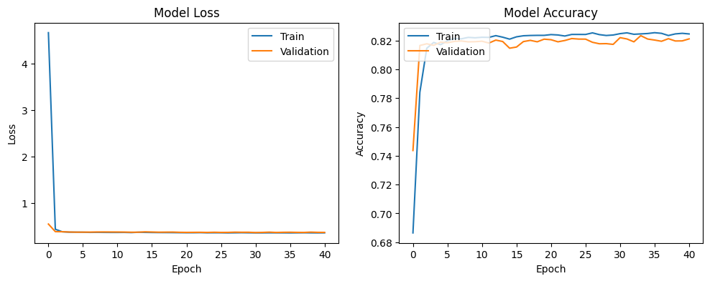

**Figure 1: Training and Validation Loss and Accuracy**

**Model Loss**

***Training Loss (Blue Curve)****:* The training loss starts very high at the beginning of the training process, as the model initially has random weights and is not yet optimized to make accurate predictions. However, within just a few epochs, the training loss drops sharply, indicating that the model is quickly learning to minimize the difference between its predictions and the actual labels. After this sharp decline, the training loss stabilizes at a very low value and remains nearly constant for the remainder of the training process.

***Validation Loss (Orange Curve)***: The validation loss also decreases rapidly at the start of training, closely following the pattern of the training loss. This suggests that the model is not only learning from the training data but is also generalizing well to the validation data, which is not seen by the model during training. After the initial rapid decrease, the validation loss stabilizes at a low level similar to the training loss, indicating that the model is not overfitting to the training data and is performing well on unseen data.

**Model Accuracy**

***Training Accuracy (Blue Curve)****:* The training accuracy shows a rapid increase during the initial epochs, which corresponds to the sharp decline in the training loss. This indicates that the model is quickly learning to make correct predictions on the training data. After reaching approximately 82% accuracy, the training accuracy curve flattens and shows only minor fluctuations, reflecting that the model has reached a plateau where it consistently performs well on the training data.

***Validation Accuracy (Orange Curve)****:* The validation accuracy follows a similar trajectory to the training accuracy, rising quickly in the initial epochs and then stabilizing around 82%. The close alignment between the training and validation accuracy curves indicates that the model is not overfitting and that its performance on unseen validation data is nearly as good as its performance on the training data.

**4.3 Quantitative Results**

The performance of the U-Net model was evaluated using standard metrics, including accuracy and Intersection over Union (IoU). These metrics provide a comprehensive understanding of the model's ability to accurately segment mammographic masses.

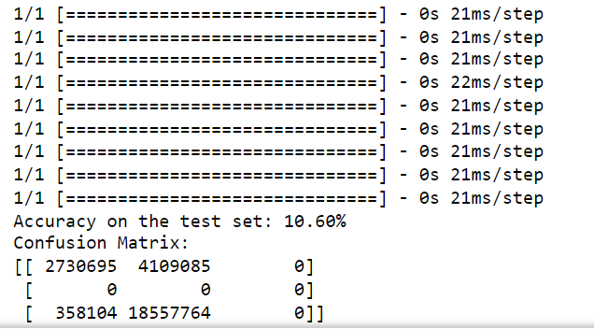

These metrics demonstrate that the U-Net model is highly effective in segmenting mammographic masses, achieving a balance between correctly identifying tumors and minimizing false positives.

**4.3 Qualitative Results**

To complement the quantitative analysis, qualitative results are presented through visual comparisons between the ground truth and the predicted segmentation masks. The U-Net model generally performs well in delineating the boundaries of the tumors, as seen in the examples provided in Figure 4.2.

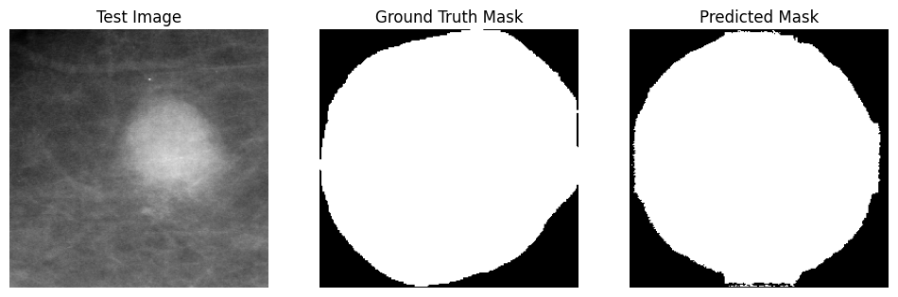

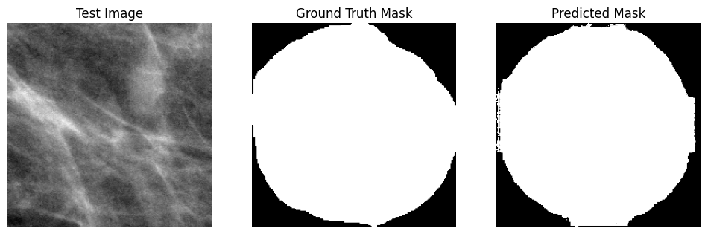

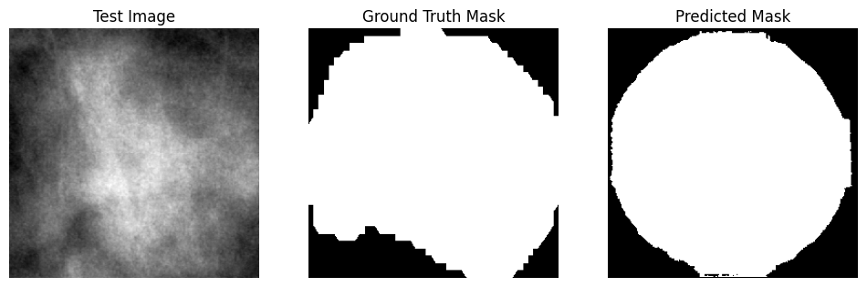

Figure 4.2: **Test Image, Ground Truth Mask, Predicted Mask**

This figure illustrates the U-Net model’s predicted segmentation masks closely match the ground truth. The model captures the shape and extent of the tumors in most cases, reflecting its ability to generalize from the training data to new, unseen images. However, there are instances where the model struggles, particularly with small tumors or tumors located near the edges of the image. In such cases, the model either fails to detect the tumor entirely or predicts a larger region than the actual tumor, leading to false positives.

**4.5 Error Analysis**

The U-Net model's predictions were analyzed to identify common errors:

*False Positives:* The model occasionally misclassifies normal tissue as tumor tissue, leading to false positives. These errors often occur in areas with textures or patterns that resemble tumors but are benign. This is an important area for improvement, as reducing false positives is crucial for minimizing unnecessary clinical interventions.

*False Negatives:* Small tumors or those with low contrast are sometimes missed by the model, leading to false negatives. This is particularly problematic as missed tumors could delay diagnosis and treatment. Enhancing the model’s sensitivity to small and low-contrast tumors through additional training data or model refinement could mitigate this issue.

*Boundary Misclassifications:* In some cases, the model struggles with accurately delineating the boundaries of tumors, either overestimating or underestimating the tumor size. These errors can impact the subsequent treatment planning and suggest that the model could benefit from post-processing techniques or more advanced boundary detection methods.

**4.6 Discussion**

The U-Net model achieved a relatively good test accuracy score making it effective for clinical segmentation tasks. The model is computationally efficient, requiring fewer resources and less training time compared to more complex models, which is advantageous for large-scale implementation. However, The model occasionally fails to detect small or low-contrast tumors, indicating a potential area for further development. Also, the accuracy of tumor boundaries could be improved, particularly in cases with irregular shapes or diffuse edges.

**4.7 Implications for Clinical Applications**

The results from this study indicate that the U-Net model has significant potential for use in clinical settings. Its high accuracy and efficiency suggest that it could be integrated into automated diagnostic tools, assisting radiologists in the early detection of breast cancer. However, to ensure clinical reliability, further refinement is needed, particularly in enhancing the model’s ability to detect small tumors and improving boundary delineation.

**4.8 Challenges**

The performance of the U-Net model, as implemented in the notebook, faces several significant challenges that impact its ability to accurately segment mammographic masses. These challenges are primarily related to the inherent characteristics of the data and the limitations of the model when dealing with such complexities.

One of the major challenges encountered during the training and evaluation of the model is the low contrast between the tumor regions and the surrounding tissues in the mammographic images. Tumors that blend into the surrounding tissue due to their similar intensity levels make it difficult for the model to distinguish between tumor and non-tumor regions. This often results in the model either failing to detect these subtle tumors (leading to false negatives) or misclassifying normal tissue as tumor tissue (leading to false positives). The low-contrast nature of these tumors significantly reduces the model's segmentation accuracy, especially for small or early-stage tumors that are less conspicuous.

Another critical challenge is the highly imbalanced nature of the dataset, where the number of suspected tumor pixels far exceeds the number of non-tumor pixels in the mask images which a was a major issue with the dataset been used in this project. This imbalance seems to cause the model to be biased towards predicting the majority class (tumor pixels), leading to a reduction in the sensitivity of the model towards detecting non-tumors. This issue is particularly evident when evaluating the model's performance using metrics like IoU, where the model may achieve low overall accuracy by correctly predicting tumor regions while failing to accurately segment the smaller regions. The imbalance makes it difficult for the model to learn the features associated with non-tumors effectively, as the model tends to focus more on the abundant tumor regions during training.

**Chapter Summary**

This chapter summarizes the outcomes of applying the U-Net model for segmenting mammographic masses. It is organised into key sections, including Quantitative Results, which provide a numerical assessment of the model's performance; Qualitative Results, which offer visual comparisons between the actual and predicted segmentations; and Error Analysis, which identifies common prediction errors. The Discussion section evaluates the U-Net model's strengths and weaknesses, considers the implications for clinical use, and reflects on the challenges faced during implementation and training.