跨文化与国际交流  
**Intercultural and International Communication**

**授课教师**殷之光 教授（[zyin@fudan.edu.cn](mailto:zyin@fudan.edu.cn)）

**助教**赵莉生、闫梦迪

**目录**

Lecture 1 - Introduction 2

Lecture 2 – Hegemony 2

Lecture 3 – Mass Communication 3

Lecture 4 – Agenda Building and Political Public Relations 4

I. Walter Lippmann and *Public Opinion* 4

II. Agenda-Setting 4

**Lecture 1 - Introduction**

2025.9.8

‘Intercultural communication’ in this module implies ‘international political communication’. The rationale of political communication is not only to convey information; it’s about **establishing social relationship**, in which we the human live. This broadest definition is where ‘communication’ of the module lies in. In term of communication as a strategy, the module will focus on the actors, regulations, methods, process, institutional structure, rhetoric, etc. about communication.

The major objective of the module is to familiarise with socio-economic analysis of political communication. We will also learn about different theoretical frameworks, and cultivate communication skills. One of the purposes of the module is to introduce strategies, ways and formats to make messaging more convincing.

Though communication aims to encourage the theory to speak to the reality, there is no permanent or absolute coherence between theory and reality; theorisation is always in process. Then, when the coherence breaks, it’s recommended to question the theory rather than to question the reality.

Charles Tilly thought that war demands technological advancement, which consequently drives social development. However, a question remains: what drives wars?

In summary,

* Politics is fundamentally human interactions.
* All human interactions require some forms of communication.
* Communication is essentially political.
* So the study of communication is about “who/says what/ in which channel/to whom/ with what effect” (Lasswell, 1948)
* Also, when (time) and for what purpose (intent)
* Communication is ‘a constitutive process that produces and reproduces shared meaning’ (Craig 1999; Pearce 1989)

**Lecture 2 – Hegemony**

2025.9.15

Hegemony fundamentally means guidance, dominance or leadership. An industrialised society is a modern society, which is largely different from an agricultural society. The fact that northern Italy, which was an industrialised society, had a great division with southern Italy, which was an agricultural society, motivated Antonio Gramsci to consider the ideology and its economic substance.

Gramsci thought that competing for hegemony was the main task for intellectuals, particularly the communists. He pointed out that “hegemony of the proletariat” was the strategic goal of winning the majority of the peasantry to the cause of the working class for the Italian party. Hegemony could be achieved with the combination of coerce and consent.

Hegemony is about consent, which not only means adhesion of allies in a common cause, but also refers to submission of adversaries to an order inimical to them. Gramsci argued that the dominator (ruling class) exerted strong influence on values, norms, ideas, expectations, worldview, and behaviour of the rest of society. To Gramsci, it was important to unite the previously segregated proletariat to form an institutional force to reshape the socio-political structure of the nation.

Gramsci suggested that dominant group should spread worldview – “common sense” ideas through schools, media, religion, and entertainment, and then normalize them. The ultimate goal is that people from all walks of life are consenting to this system voluntarily, rather than forced. Consent is the unspoken agreement from the masses that keeps the system stable without constant crackdowns.

Nowadays, we are witnessing the crisis of hegemony, or crisis of authority in Gramsci’s word.

**Lecture 3 – Mass Communication**

2025.9.22

Noam Chomsky mentioned an analytical model for manufacturing consent, which includes five layers.

* **Communicator:** Who initiates the communication?
* **Message:** What message does the person intend to deliver?
* **Medium:** What media platform is the media delivered on?
* **Receiver:** Who receives the message?
* **Effect:** What effect does the communicator want to achieve? Does it serve to its purpose?

If a communicator focuses only on the result of communication, the so-called “propaganda” inevitably emerges.

However, nearly all structuralism approaches in social science lack dialectics, including the model above.

Taylorism, raised by Frederick W. Taylor, is a scientific management (methodology) for manufacturing industry. It intends to determine the best way for the worker to do the job, provide incentives for good performance, and provide the proper tools and training.

**Lecture 4 – Agenda Building and Political Public Relations**

2025.10.13

I. Walter Lippmann and *Public Opinion*

Walter Lippmann tried to systematically examined public opinion and understand the nature and formation of it in his *Public Opinion*.

Lippmann mentioned Stereotype in this book. Stereotype is the mental images people hold about the world. Individual needs it to navigate a complex and information-rich environment and to simplify reality. However, stereotype leads to biases and distortions.

There are limitations of the public. Lippmann was very sceptical about the public’s ability to engage deeply with complex issues. He thought that most individuals lack the expertise and information needed to make informed decisions. Therefore, he appreciated an expert-driven approach to governance, where knowledgeable elites play a significant role. The challenge to democracy is that the ideal of an informed and engaged citizenry is unattainable.

Lippmann pointed out that it is the media that interprets the reality. Media influence how audiences perceive and understand events through selectively presents information and frames stories. They shape public opinion through editorial choices, headlines, and storytelling techniques (emphasizing some and downplaying others). Media also manufacture consent by controlling the information individuals receive, setting the public agenda by deciding which issues and events receive attention. Journalists and editors bring their own biases and perspectives to their works, as well.

II. Agenda-Setting

To define Agenda-setting, it is required to explore the powerful role of the media in influencing the topics and issues that occupy public attention, and to examine how media outlets (newspapers, television, online news sources, etc.) can determine which subjects are seen as important by the public through their news coverage decisions.

The core premise of the mechanism of Agenda-setting is that every organization desiring to influence the public politically must attempt to control what ideas become dominant in the public sphere. Therefore, the model is displayed below.

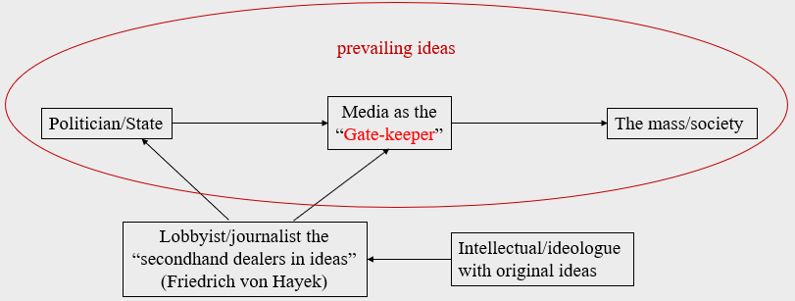

**Lecture 5 – Political Communication and Cultural Production in the Digital Age**

2025.10.20

An Era means transformation.

To a society having the digital capacity, the digital age means digital technologies, information accessibility, and global connectivity. Digital technologies including computers, smartphones, tablets, and the Internet, enable the storage, processing, and transmission of information in digital form. Information accessibility has made things easier (at least for some people); People can access vast amounts of information and data with the click of a button, which transforms the way we learn, work and communicate. Global connectivity enables people to communicate, collaborate, and conduct business across geographical boundaries. This has transformed the way we interact with others and access global markets.

The transformation of tools or material impacts the society and human life. According to Marxism, the mode of production is made up of productivity (the forces of production) and social and technical relations of production (who controls what and how). The former element consists of means of production and labour power.