**1. Introduction**

In this project, we develop a robust solution for image classification and disease detection using Convolutional Neural Networks (CNN). The project integrates various tools, frameworks, and libraries, each playing a significant role in delivering highquality results.

**2. Technologies Used**

Programming Language

Python: Python was chosen as the main programming language due to its simplicity and strong support for data science and machine learning libraries. Its wide adoption in the data science community ensures availability of extensive documentation and thirdparty resources.

Framework

Streamlit: Streamlit was used to create the webbased interface of the application. It is an opensource Python framework designed for data science projects, allowing rapid deployment of machine learning models with an interactive and userfriendly interface.

Libraries

Pillow (PIL): This library was used for handling and processing images. It allows for basic image manipulation tasks such as cropping, resizing, and format conversions, which are essential for preparing the data before classification.

NumPy: A powerful library for numerical computing in Python, NumPy was used to perform fast and efficient matrix operations. Its ability to handle multidimensional arrays is crucial when working with image data, especially in the context of deep learning models.

BytesIO: This module was used for inmemory binary streams, particularly to handle image input and output without the need to write the image files to disk, improving performance and workflow efficiency.

TensorFlow: The core library for implementing the CNN model. TensorFlow provides comprehensive tools for building, training, and deploying machine learning models. In this project, it was used to construct the CNN architecture, train the model on plant image datasets, and perform classification tasks.

**3. Use Case diagram**

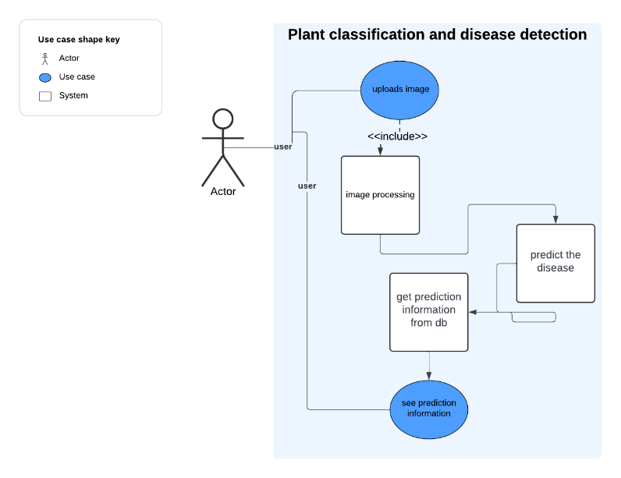

**4. Flowchart**

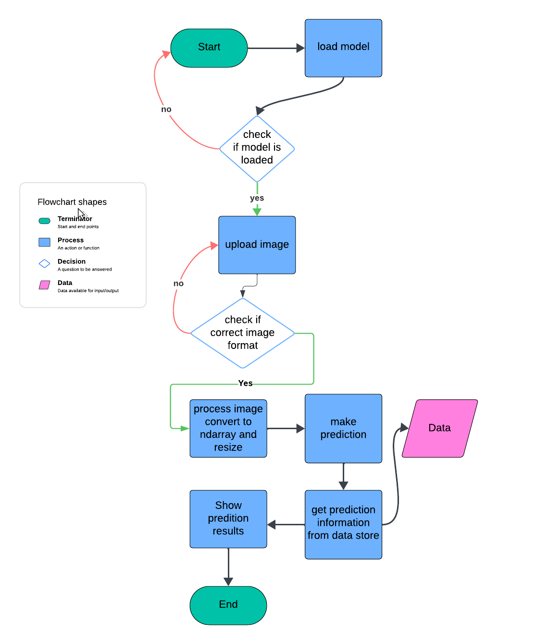

6. Application results

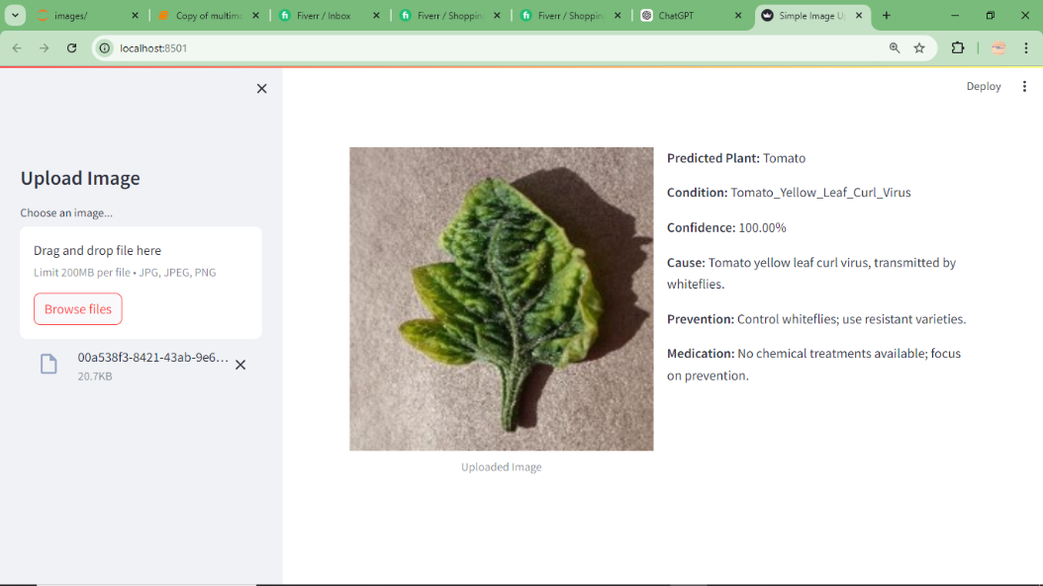

The image above shows the application interface

The application allows user to upload a leaf of a plant and get the following

1. Predicted plant
2. Condition of the predicted plant
3. Confidence score
4. The cause of the condition
5. Prevention of the condition
6. Medication of the condition

We can see the app is very effective in assisting farmers know the condition of the plants and also help them learn the cause, prevention and how to treat the condition