ENEL4187

MECHATRONICS – ULTRASONIC KEYBOARD MONITOR

ZEDDICIAUS PEARSON (SERJEANT) – 1261476

# Introduction

This document outlines the specifications, design and construction of an ultrasonic keyboard monitor. This is a device designed to sit idle next to a keyboard with a “heartbeat” LED flashing slowly to indicate the system is on. When motion occurs upon the keyboard, ultrasonic waves detect this and the LED blinks faster to indicate the system is working.

This process took the following steps:

1. Understand how to program a PIC12F675
2. Enable the flashing of the LED
3. Enable the sending of a signal via the ultrasound
4. Understand what is necessary to process the signal returned to the second transducer
5. Implement capturing of this signal using the ADC
6. Tweak until the system matched the specification

# Specification and Methods

A “Heartbeat” was implemented to indicate being on and, separately, detection. “On” but nothing detected is represented by an LED: ON period of 40ms, OFF period of 960ms. This corresponds to 1Hz with a duty cycle of 41%. Detection was represented with an ON period of 40ms, OFF period of 160ms, corresponding to 5Hz, 20%. To implement these timings, along with those necessary for a 40KHz transducer signal, Timer0 was used.

Processing of the ultrasound signal began by taking two ADC points in quadrature (360 $°$ +90 $°$) a few milliseconds after a signal is sent from the transducer to obtain the magnitude of the signal echoed back. Another calculation is made, and if the two magnitudes differ by a significant degree, motion has been detected. This set of measurements is then repeated over the distance of the keyboard by increasing the time between the send signal and the processing.

This were the most important processes to implement, *Figure 2.1* presents the entire flow of processing.

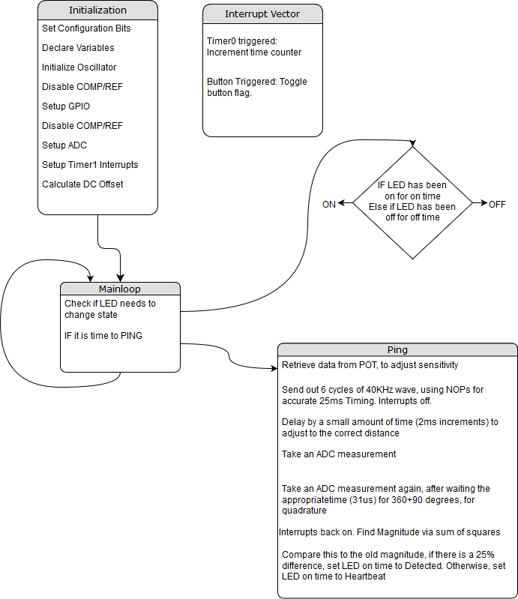

Figure . - Flowchart of Process

# Results

The timing of the system was implemented correctly, as can be seen in *Figure 3.1*. This shows the LED in resting state, when a detection hasn’t been made.

Figure . - Resting Heartbeat of LED

*Figure 3.2* shows the signal as transmitted from the transducer.

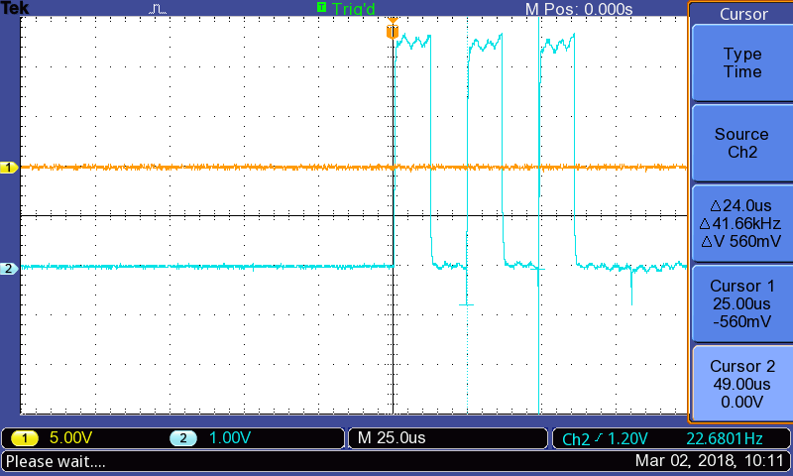

Figure . - Transmitted Signal

This is not perfectly 40KHz, due to the difficulty of timing, however this was not considered a problem. 40KHz is only the nominal resonant frequency of the transducer; it is likely to vary considerably, though tests to confirm the true resonant frequency were not conducted.

*Figure 3.3* shows the initial attempt at measuring the ADC in quadrature, with No NOPs to correct timing.

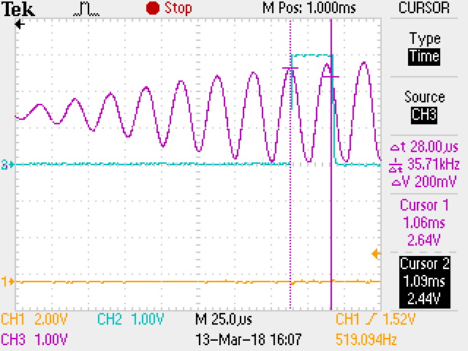

Figure . - Quadrature Refinement

Finally, to show the complete project, *Figure 3.4* will show the transmitted signal, the received signal, and ADC measure points.

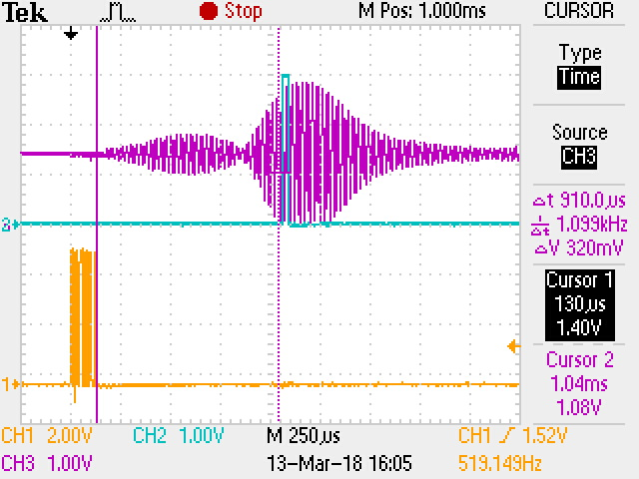

Figure . - System Functionality

# Problems

The graphs shown in S*ection 3* indicate a functional system, however there are goals that were not achieved as, unsurprisingly, the vast amount of time was spent in stage six adjusting variables such as timing and the sensitivity of the magnitude threshold.

Notably, to ensure motion is detected across the entire keyboard, the delay in row three of the flowchart ping block needs to adjust across several values. The best way to display this occurring would be a line spread in the time axis of *Figure 3.4*, however this feature was not implemented correctly at the time of presentation.

Secondly, this device was intended to detect motion, however achieving a sensitivity enough for movement of fingers and not a hand at rest was found to be difficult. The potential reason for this may be an incorrect implementation of the timing such that the sample point was not consistent, leading to motion detected erroneously. This issue may also be at fault for the inability for range detection.

# Appendix I - Code

1. /* PIC functionality Attempts*/
2. //#pragma config WDTE = OFF // Watchdog Timer Enable bit (WDT enabled)
3. // #include <pic.h>
4. #include <xc.h>
5. // #include <stdlib.h>
6. // Config
7. #pragma config FOSC = INTRCIO // Oscillator Selection bits (INTOSC oscillator: I/O function on GP4/OSC2/CLKOUT pin, I/O function on GP5/OSC1/CLKIN)
8. #pragma config WDTE = OFF // Watchdog Timer Enable bit (WDT disabled)
9. #pragma config PWRTE = OFF // Power-Up Timer Enable bit (PWRT disabled)
10. #pragma config MCLRE = OFF // GP3/MCLR pin function select (GP3/MCLR pin function is digital I/O, MCLR internally tied to VDD)
11. #pragma config BOREN = OFF // Brown-out Detect Enable bit (BOD disabled)
12. #pragma config CP = OFF // Code Protection bit (Program Memory code protection is disabled)
13. #pragma config CPD = OFF // Data Code Protection bit (Data memory code protection is disabled)
14. #define LED GPIO5
15. #define POT GPIO4 // the potentiometer. This is purely to get a value into the system. //AN3?
16. #define SWITCH GPIO3 // on-off switch
17. // time defines
18. #define n_time_on 40 // time for led to spend on
19. #define n_time_heartbeat 960 // time for led rest
20. #define n_time_detected 160 // time for led detected
21. #define ping_time_top 100 // time to take for each ping
22. // unsigned volatile short int rtmr1 @0x0E;
23. bit flag_button **=** 0**;** // represents a flag set by the button
24. bit led_on **=** 0**;**
25. char led_counter **=** 0**;**
26. // time counting variables 1tick = 1/(1MHz/4/256)~=1ms
27. int n_time_off **=** n_time_heartbeat**;** // time for led to spend off. This changes depending on signal detection to one of the above 2 variables
28. volatile int time_count **=** 0**;** // the counter that is compared to the above two variables
29. signed short int dc_offset **=** 0**;**
30. volatile char ping_time_count **=** 0**;** // counting to the top
31. char n_pings **=** 6**;** // the number of cycles of a ping to broadcast at once
32. char delay_time **=** 0**;** // allows a delay to occur, by setting this higher than 0
33. char tmp_GPIO **=** 0**;** // Used to save the GPIO State between Ultrasound pulses, otherwise wrong pins are changed
34. unsigned short long int temp **=** 0**;** // used for temporary calculations
35. unsigned short long int old_mag **=** 0**;**
36. unsigned short long int mag **=** 0**;**
37. short int pulse_sensitivity **=** 0**;** // difference in phase before something is considered movement. we don't need degrees, so absolute divisions work
38. const char n_bins **=** 4**;**
39. // char measurement_delay[n_bins] = {2, 2, 3, 3}; // XXX to modify
40. // char measurement_index = 0;
41. char new_measured **=** 0**;**
42. bit measured **=** 0**;**
43. // union ADC_STORE // allows chars to overlap in memory into a 16bit int
44. // {
45. // unsigned short int value; // final 16bit value that combines the two bytes
46. // char bytes[2]; // left and right bytes
47. // } q1, q2; // two points minimum for data capture
48. char h1**,** h2**;**
49. signed short int a1**,** a2**;**
50. void main**()**
51. **{**
52. char i**;**
53. // Initialize XXX convert to C eventually
54. asm**(**"call 0x3FF"**);**
55. asm**(**"bsf STATUS,5"**);**
56. //RP0=1; // use Bank 1 for registers // asm("bsf STATUS,5");
57. asm**(**"movwf OSCCAL"**);**
58. VRCON **=** 0X00**;** // turn off voltage reference
59. CMCON **=** 0X07**;** // disable comparator
60. //interrupts
61. INTCON **=** 0x00**;** // disable all interrupts
62. T0IE **=** 1**;** // enable timer0 interrupt
63. //PEIE = 1; // enable peripheral interrupts (ADC is a peripheral)
64. //ADIE = 1; // enables ADC interruptrs
65. TRISIO **=** 0b00011100**;** // Set all Set all except GP4(AN3), GP3(Switch), GP2(Transducer) to be outputs
66. GPIO **=** 0x00**;** // set all GPIO to low
67. IOC3 **=** 1**;** // enable interrupts on change for GPIO3
68. //ADC
69. ADFM **=** 1**;** // RIGHT justified registers (2MSB in ADRESH, 8LSB in ADRESL)
70. VCFG **=** 0**;** // Use Vdd as reference
71. CHS1 **=** 1**;** CHS0 **=** 0**;**// (AN3,POT)CHS=0b11; (AN2,Receive)CHS=0b10;
72. //ADCS = 0b001; // Set ADC to Fosc/16 1us (XXX Check this)
73. ADCS2 **=** 0**;**
74. ADCS1 **=** 0**;**
75. ADCS0 **=** 1**;**
76. ANS3 **=** 1**;** // Set AN3 as an analogue input
77. ANS2 **=** 1**;** // Set AN2 as an analogue input
78. ADON **=** 1**;** // enable the ADC, GO=1 starts a conversion
80. //timer0
81. T0CS **=** 0**;** // Use internal clock for the timer
82. PSA **=** 0**;** // prescaler is used by Timer0
83. //set the prescaler to be 1:4
84. PS2 **=** 0**;**
85. PS1 **=** 0**;**
86. PS0 **=** 1**;**
87. GIE **=** 1**;** // enable all interrupts
88. //sample to find DC offset
89. GO **=** 1**;** // fire ADC
90. **while** **(**GO**);** // wait until the ADC has a value
91. dc_offset **=** **(**ADRESH**<<**8**)** **|** ADRESL**;**
92. **while** **(**1**)** // flash LED
93. **{**
94. **if** **(**led_on**)** // && (led_counter < start_counter)
95. **{**
96. LED **=** 1**;** // turn on the LED
97. **if** **(**time_count **>** n_time_on**)** // check to see if we are finished being on
98. **{**
99. time_count **=** 0**;**
100. led_on **=** 0**;**
101. **}**
102. **}**
103. **else**
104. **{**
105. LED **=** 0**;**
106. **if** **(**time_count **>** n_time_off**)**
107. **{**
108. time_count **=** 0**;**
109. led_on **=** 1**;**
110. **}**
111. **}**
113. **if** **(**ping_time_count **>** ping_time_top**)**
114. **{**
115. ping_time_count **=** 0**;**
116. // if (measurement_index == n_bins)
117. // {
118. // measurement_index = 0;
119. CHS1 **=** 1**;** CHS0 **=** 1**;**// (AN3,POT)CHS=0b11; (AN2,Receive)CHS=0b10;
120. asm**(**"NOP"**);**
121. asm**(**"NOP"**);**
122. asm**(**"NOP"**);**
123. asm**(**"NOP"**);**
124. GO **=** 1**;**
125. **while** **(**GO**);**
126. // if ((temp>>3) > ((ADRESH<<8)+ADRESL))
127. // {
128. // LED = 1;
129. // }
130. // else
131. // {
132. // LED = 0;
133. // }
134. //Change ADC back
135. pulse_sensitivity **=** **(**ADRESH**<<**8**)+**ADRESL**;**
136. CHS1 **=** 1**;** CHS0 **=** 0**;**// (AN3,POT)CHS=0b11; (AN2,Receive)CHS=0b10;
137. // }
138. GIE **=** 0**;** // disable interrupts for this
139. tmp_GPIO **=** GPIO**;** // save GPIO
141. // Loop to get x cycles off the transducer
142. **for** **(**i**=**0**;** i**<**n_pings**;** i**++)**
143. **{**
144. // asm("NOP");
145. // asm("NOP");
146. // asm("NOP");
147. // asm("NOP");
148. //asm("NOP");
150. GPIO **=** 0x01**;**
151. asm**(**"NOP"**);**
152. asm**(**"NOP"**);**
153. asm**(**"NOP"**);**
154. asm**(**"NOP"**);**
155. asm**(**"NOP"**);**
156. asm**(**"NOP"**);**
157. asm**(**"NOP"**);**
158. asm**(**"NOP"**);**
159. asm**(**"NOP"**);**
160. GPIO **=** 0x02**;**
161. **}**
162. GIE **=** 1**;**
163. delay_time **=** 2**;**
164. // measurement_index++;
165. **while** **(**delay_time**);** // delay for 3 ticks to give time for the ping to reflect back, ignoring transmit echo
166. GIE **=** 0**;**
167. GO **=** 1**;** // fire ADC
168. **while** **(**GO**);** // wait until the ADC has a value
169. // LED = 1;
170. asm**(**"NOP"**);**
171. asm**(**"NOP"**);**
172. // LED = 0;
173. GO **=** 1**;** // Once it has a value, tell it to fetch another value. This doesn't overwrite current value, and this is done for speed
174. h1 **=** ADRESH**;**
175. h2 **=** ADRESL**;**
176. **while** **(**GO**);** // wait for current conversion to finish now.
177. GPIO **=** tmp_GPIO**;** // restore GPIO
178. GIE **=** 1**;** // reenable interrupts
179. a1 **=** **((**signed short int**)(((**h1**<<**8**)+**h2**)** **-** dc_offset**));**
180. a2 **=** **((**signed short int**)(((**ADRESH**<<**8**)+**ADRESL**)** **-** dc_offset**));**
181. old_mag **=** mag**;**
182. mag **=** **((**a1**\***a1**)** **+** **(**a2**\***a2**));**
183. // if (measurement_index == 0)
184. // {
185. // continue;
186. // }
187. **if** **(**old_mag **>** mag**)**
188. **{**
189. temp **=** old_mag **-** mag**;**
190. **}**
191. **else** **if** **(**old_mag **<** mag**)**
192. **{**
193. temp **=** mag **-** old_mag**;**
194. **}**
195. **else**
196. **{**
197. temp **=** 0**;**
198. **}**
199. **if** **((**temp**>>**4**)** **>** **(**pulse_sensitivity**))** // if the magnitude with sqrt is larger than 70mV, this is a point worth considering, and for now this will just active
200. **{**
201. n_time_off **=** n_time_detected**;**
202. **}**
203. **else**
204. **{**
205. n_time_off **=** n_time_heartbeat**;**
206. **}**
207. **}**
208. **}**
209. **}**
210. void interrupt ISR**()**
211. **{**
212. **if** **(**T0IF**)** // timer0 triggered
213. **{**
214. T0IF **=** 0**;** //clear the overflow bit
215. TMR0 **=** 0**;** // set the counter back to 0 (XXX maybe not strictly necessary?)
216. time_count**++;**
217. ping_time_count**++;**
218. **if** **(**delay_time **>** 0**)**
219. **{**
220. delay_time**--;**
221. **}**
222. **}**
223. // if (ADIF) // adc triggered
224. // {
225. // ADIF = 0; // clear the interrupt flag
226. // if (ADRESH > 125)
227. // {
228. // LED = 1;
229. // }
230. // else
231. // {
232. // LED = 0;
233. // }
234. // }
235. **if** **(**GPIF**)** // pin change
236. **{**
237. **if** **(**GPIO3**)**
238. **{**
239. flag_button **^=** 1**;**
240. **}**
241. GPIF **=** 0**;**
242. **}**
243. // return;
244. **}**