Addis DemandFlow — Comprehensive Model Report
Addis DemandFlow · team_demandflow · Developer: Zedingil Zelalem · clock Africa/Addis_Ababa (EAT, UTC+3)

1. Headline
Best model: Ensemble: CatBoost + MLP (blended)
Models compared: 14 on the leaderboard + extended grid: 79 cells (13 families × 2 encoders × 3 scalers = 78, plus CatBoost native = 79).
Features used: 57 leakage-safe features (events: 17, history: 15, calendar: 11, weather: 11, trend: 2, zone: 1).
Rolling-origin folds: 4 (expanding, 14-day windows).
Validation: raw RMSE 8.352, MAE 5.738, R² 0.904; trimmed RMSE 8.352, R² 0.904.

2. Feature engineering
57 model features. Category counts: events: 17, history: 15, calendar: 11, weather: 11, trend: 2, zone: 1.

2.1 Lags (forecast-safe same-slot)
2 lag features: lag_336h (14-day same-slot lag), lag_672h (28-day same-slot lag). lag_336h = 14 days earlier; lag_672h = 28 days earlier (same zone & hour).

2.2 Rolling / recent windows
Rain rolling sums: rain_3h_sum, rain_6h_sum, rain_24h_sum. Trailing zone windows (days): hist_zone_recent_7d, hist_zone_recent_14d, hist_zone_recent_28d, hist_zone_recent_56d.

2.3 Full feature audit
feature | category | formula | rationale | known_at_forecast_time
zone_id | zone | dim_zone.zone_id | zone identity 1-12 | yes
hour | calendar | pickup_datetime.dt.hour | diurnal demand cycle | yes
dayofweek | calendar | pickup_datetime.dt.dayofweek | weekday pattern | yes
day | calendar | day of month | pay-period effects | yes
month | calendar | month | seasonal trend | yes
weekofyear | calendar | iso week | within-year seasonality | yes
is_weekend | calendar | dayofweek>=5 | weekend leisure demand | yes
is_payday | calendar | day in 1-3,28-31 | salary spending pulse | yes
hour_sin | calendar | sin(2*pi*hour/24) | smooth time-of-day | yes
hour_cos | calendar | cos(2*pi*hour/24) | smooth time-of-day | yes
dow_sin | calendar | sin(2*pi*dow/7) | smooth day-of-week | yes
dow_cos | calendar | cos(2*pi*dow/7) | smooth day-of-week | yes
days_since_start | trend | date - 2025-01-01 | captures growth trend | yes
temp_c | weather | weather temp (F fixed) | heat/comfort effect | yes
rain_mm | weather | previous-hour rain | rain demand effect | yes
is_raining | weather | rain_mm>0.05 | rain yes/no | yes
heavy_rain | weather | rain_mm>7.6 | heavy-rain flag | yes
rain_class | weather | cut(rain_mm) | non-linear rain response | yes
rain_3h_sum | weather | rolling 3h rain | sustained-rain effect | yes
rain_6h_sum | weather | rolling 6h rain | wet-spell effect | yes
rain_24h_sum | weather | rolling 24h rain | all-day wetness | yes
rain_is_raining_x_hour | weather | is_raining*hour | rain x time-of-day | yes
humidity_pct | weather | weather humidity | comfort | yes
wind_kmh | weather | weather wind | minor comfort | yes
has_event | events | interval join | event demand uplift | yes
event_count | events | overlap count | crowd of events | yes
has_sports | events | event_type | stadium match uplift | yes
has_concert | events | event_type | concert uplift | yes
has_conference | events | event_type | conference demand | yes
has_road_closure | events | event_type | detours/supply | yes
has_public_holiday | events | event_type | holiday demand shift | yes
has_school_break | events | event_type | school-holiday pattern | yes
has_exhibition | events | event_type | exhibition demand | yes
event_attendance | events | parsed crowd size | event size | yes
event_before | events | 2h before | pre-event inflow | yes
event_during | events | during | in-event demand | yes
event_after | events | 2h after | post-event dispersal | yes
has_sports_evening | events | has_sports * (hour>=17) | evening match uplift | yes
event_after_evening | events | event_after * (hour>=17) | evening dispersal peak | yes
hours_to_event | events | hours to next start | anticipation | yes
hours_since_event | events | hours since last end | dispersal decay | yes
lag_336h | history | trips 14 days ago | same slot last fortnight | yes
lag_672h | history | trips 28 days ago | same slot last month | yes
hist_zone_dow_hour_mean | history | expanding mean by zone/dow/hour | seasonal baseline | yes
hist_zone_hour_mean | history | expanding mean by zone/hour | diurnal baseline | yes
hist_zone_dow_mean | history | expanding mean by zone/dow | weekly baseline | yes
hist_zone_mean | history | expanding mean by zone | zone level | yes
hist_zdh_recent8w | history | 8-week zone/dow/hour mean before cutoff | current regime profile | yes
hist_zh_recent8w | history | 8-week zone/hour mean before cutoff | current regime diurnal | yes
hist_zone_recent_7d | history | mean last 7 days of history | recent level | yes
hist_zone_recent_14d | history | mean last 14 days of history | recent level | yes
hist_zone_recent_28d | history | mean last 28 days of history | recent level | yes
hist_zone_recent_56d | history | mean last 56 days of history | recent level | yes
rel_recent_7d | history | recent_7d / zone/dow/hour mean | recent-vs-profile level | yes
rel_recent_14d | history | recent_14d / zone/dow/hour mean | recent-vs-profile level | yes
rel_recent_28d | history | recent_28d / zone/dow/hour mean | recent-vs-profile level | yes
trend_index | trend | trailing city level, capped extrapolation | extrapolates growth | yes
active_drivers | operational | trip log | NOT available at forecast time | NO
avg_wait_min | operational | trip log | consequence of demand | NO
avg_fare_birr | operational | trip log | surge consequence | NO

3. Baselines (D1)
Model | train_time_s | RMSE | MAE | R2 | MAPE_% | robust_RMSE | robust_R2
Seasonal-naive (zone/dow/hour mean) | 0.0 | 11.2985 | 7.36 | 0.8252 | 26.43 | 11.2985 | 0.8252
Mean predictor (baseline) | 0.0 | 27.5381 | 20.6891 | -0.0381 | 163.89 | 27.5381 | -0.0381

4. Model comparison (D2)
16 ranked rows (14 families + 2 baselines). Winner: Ensemble: CatBoost + MLP (blended).
Model | train_time_s | RMSE | MAE | R2 | MAPE_% | robust_RMSE | robust_R2
Ensemble: CatBoost + MLP (blended) | 35.07 | 8.3523 | 5.7383 | 0.9045 | 28.82 | 8.3523 | 0.9045
CatBoostRegressor (tuned) | 24.98 | 8.5079 | 5.7789 | 0.9009 | 26.8 | 8.5079 | 0.9009
CatBoost | 34.67 | 8.5218 | 5.7861 | 0.9006 | 26.78 | 8.5218 | 0.9006
MLP | 35.07 | 8.5849 | 5.9726 | 0.8991 | 31.9 | 8.5849 | 0.8991
ExtraTrees | 21.44 | 8.699 | 5.8518 | 0.8964 | 26.13 | 8.699 | 0.8964
RandomForest | 45.11 | 8.7285 | 5.8905 | 0.8957 | 26.42 | 8.7285 | 0.8957
HistGradientBoosting | 21.38 | 8.7581 | 5.9391 | 0.895 | 26.95 | 8.7581 | 0.895
GradientBoosting | 161.91 | 8.7749 | 5.9185 | 0.8946 | 27.01 | 8.7749 | 0.8946
XGBoost | 35.39 | 8.8274 | 5.9624 | 0.8933 | 27.15 | 8.8274 | 0.8933
LightGBM | 16.15 | 8.837 | 5.9854 | 0.8931 | 26.94 | 8.837 | 0.8931
Ridge | 0.87 | 9.2087 | 6.4142 | 0.8839 | 38.77 | 9.2087 | 0.8839
Lasso | 3.44 | 9.3731 | 6.4391 | 0.8797 | 37.68 | 9.3731 | 0.8797
KNN | 3.21 | 9.7012 | 6.407 | 0.8712 | 28.76 | 9.7012 | 0.8712
DecisionTree | 3.58 | 10.193 | 6.8528 | 0.8578 | 29.67 | 10.193 | 0.8578
Seasonal-naive (zone/dow/hour mean) | 0.0 | 11.2985 | 7.36 | 0.8252 | 26.43 | 11.2985 | 0.8252
Mean predictor (baseline) | 0.0 | 27.5381 | 20.6891 | -0.0381 | 163.89 | 27.5381 | -0.0381

4.1 Extended grid
79 cells (13 families × 2 encoders × 3 scalers = 78, plus CatBoost native = 79). Best: MLP / onehot / minmax.

5. Rolling-origin validation (D3)
4 folds; model RMSE 8.926 ± 0.660 vs naive 11.782.
fold | val_window | model_RMSE | model_MAE | model_R2 | model_robust_RMSE | model_robust_R2 | naive_RMSE
2025-07-01 | 2025-07-01..2025-07-14 | 8.8696 | 6.0285 | 0.8718 | 8.8696 | 0.8718 | 10.727
2025-08-05 | 2025-08-05..2025-08-18 | 8.6809 | 5.7358 | 0.8864 | 8.6809 | 0.8864 | 11.4292
2025-09-10 | 2025-09-10..2025-09-23 | 9.8507 | 6.1848 | 0.8693 | 9.8507 | 0.8693 | 13.8674
2025-10-17 | 2025-10-17..2025-10-30 | 8.3038 | 5.7013 | 0.9043 | 8.3038 | 0.9043 | 11.105

6. Ablation (D5)
configuration | RMSE | MAE | R2 | MAPE_% | robust_RMSE | robust_R2
calendar+zone+trend | 9.663 | 6.3641 | 0.8722 | 28.41 | 9.663 | 0.8722
calendar+zone+trend+weather | 9.2829 | 6.1732 | 0.882 | 28.56 | 9.2829 | 0.882
calendar+zone+trend+events | 8.7197 | 5.9062 | 0.8959 | 27.2 | 8.7197 | 0.8959
calendar+zone+trend+weather+events | 8.3858 | 5.7391 | 0.9037 | 27.86 | 8.3858 | 0.9037

7. Leakage audit (D4)
Audit covers 60 features; operational columns excluded.

8. Figures

fig10_model_comparison.png
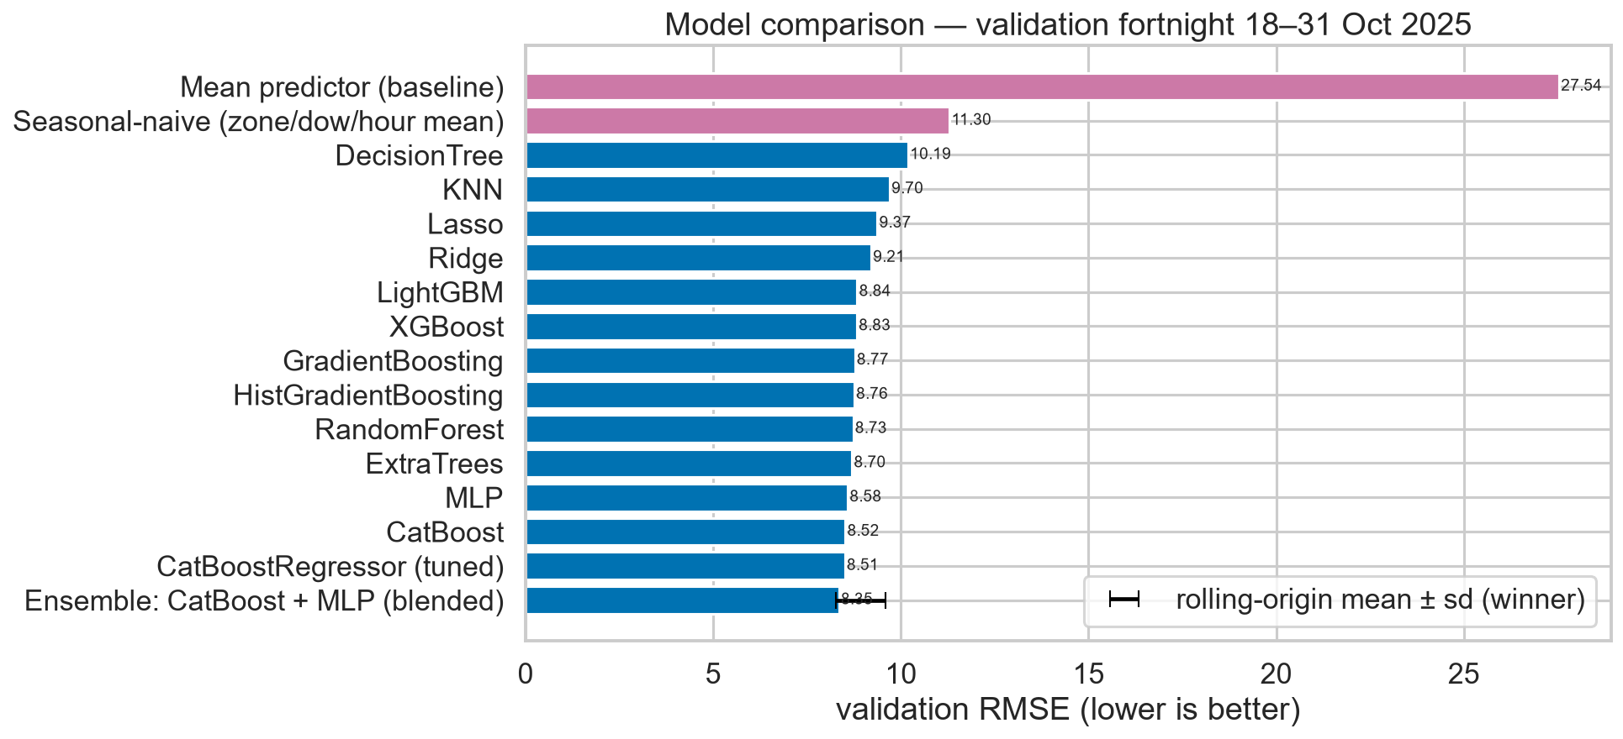
Validation RMSE of every model vs baselines.

fig12_feature_importance.png
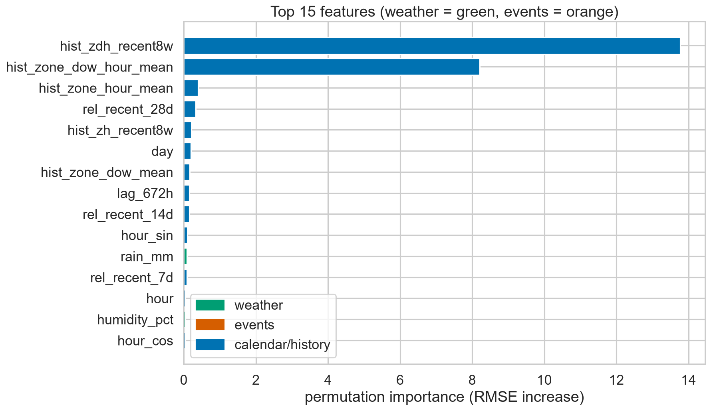
Top-15 permutation importances.

fig11_forecast_vs_actual.png
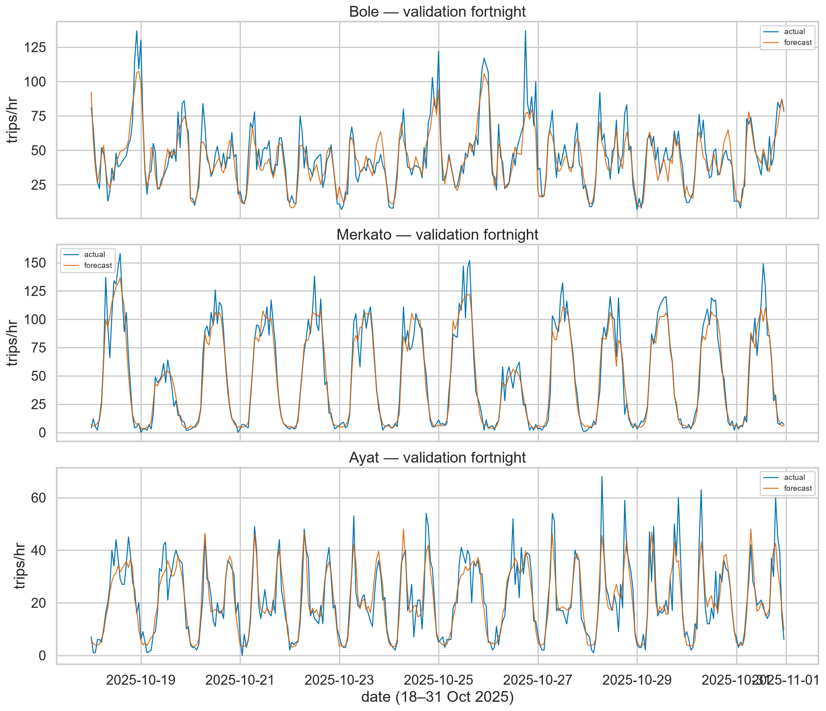
Forecast vs actual, 3 zones, full fortnight.

fig03_demand_trend_with_holidays.png
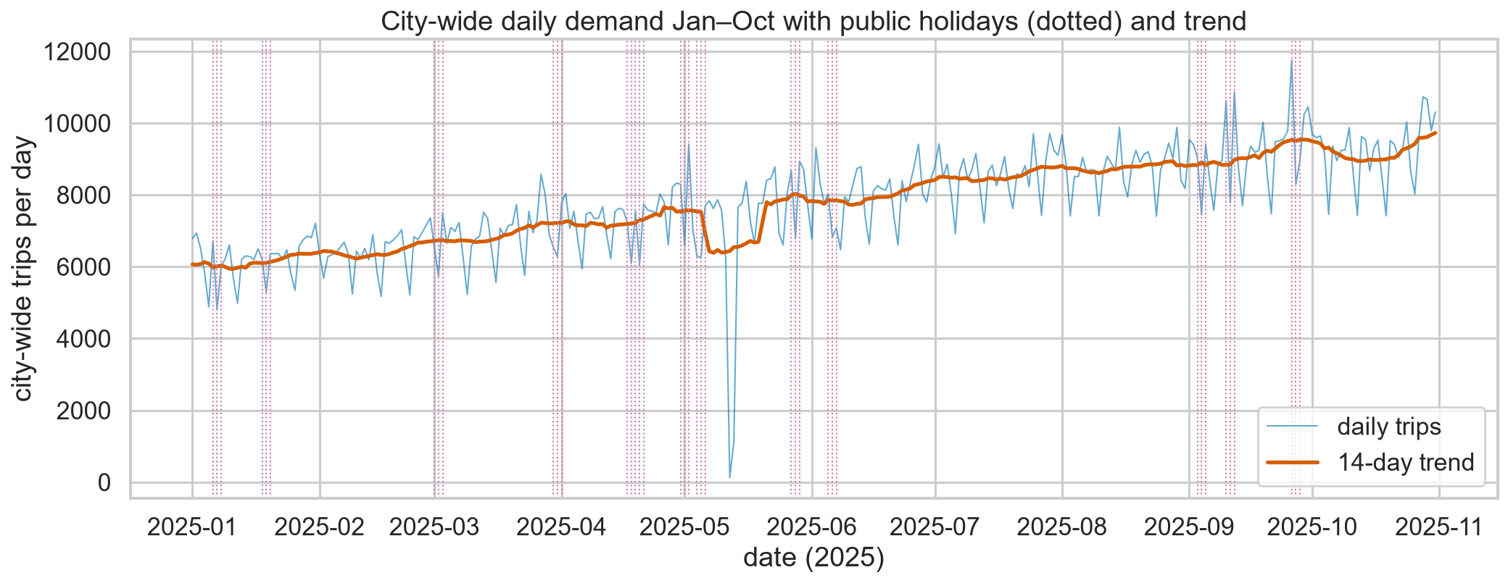
City demand trend with holidays.

fig07_rain_effect.png
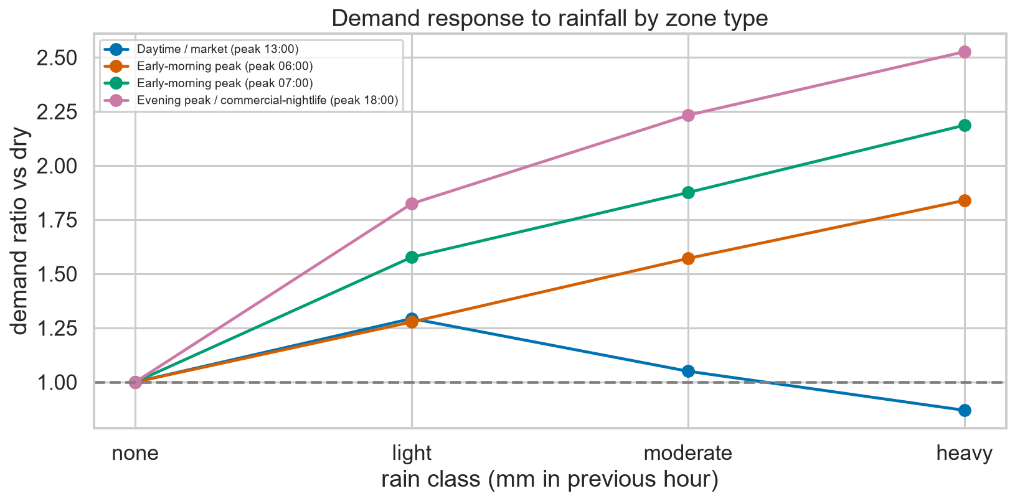
Rain dose-response by zone type.

fig08_event_study.png
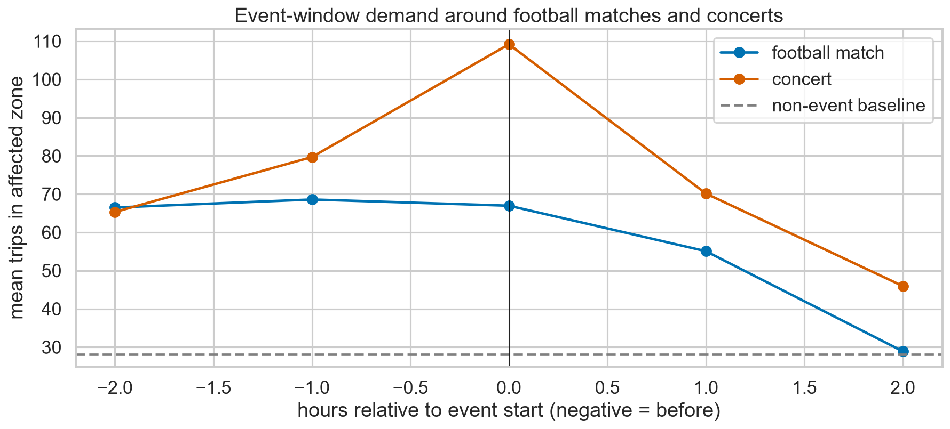
Event-window demand around events.

