Open Titan UART

IP Block Documentation
Version 2.0, December 2025

1 Overview
The UART IP block provides a full duplex hardware-based serial communication interface that enables:
- Asynchronous serial data transmission and reception.
- Communication with external devices.
- Software-configurable operation through register interface.
- Independent TX and RX FIFO data handling.
This version includes some customizations:
- Original uart_reg_top rtl file from Opentitan has been replaced with custom codes.
- Removed the prim_intr_hw rtl which handles interrupts.

1.1 Features
Summary of features:
- Programmable frame format: 8 data bits, optional parity bit, 1 stop bit.
- Programmable baud rate generation using Numerically Controlled Oscillator(NCO).
- Independent transmits(TX) and receive(RX) data paths with dedicated FIFO’s.
- 32-bit register interface compatible with Opentitan register conventions.
- Status flags for operational monitoring: TX empty, RX Full, frame errors, and more.

1.3 Block Diagram
The UART IP consists of several functional blocks:
- Register Interface: Software-configurable register interface.
- Baud Rate Generator: NCO-based clock generation for precise timing.
- FIFO: Data storage for both TX and RX.
- State Machine: Controls serial transmission and reception.

1.4 Data flow

1.4.1 Transmit Path
The transmit data flow operates as follows:
- Software writes data to the WDATA register.
- Data is stored in the TX FIFO.
- TX state machine retrieves data from FIFO when ready.
- Serial transmission begins: start bit, 8 data bits, optional parity, stop bit.
- TX line returns to idle state after transmission.

3.2.2 Receive Path
The receive data flow operates as follows:
- RX state machine monitors the RX line for a start bit (low).
- Data bits are sampled at the center of each bit period.
- Parity checking is performed if enabled.
- Stop bit is verified.
- Received byte is stored in the RX FIFO.
- Software reads data from the RDATA register.

2 Programmer’s Guide / Usage Examples

2.1 Initialization
The UART IP implements a 32-bit register interface following Opentitan conventions. For UART IP to be active for transmission baud rate needs to be programmed. Configuring the registers right is crucial. The NCO value can be achieved through the equation:
NCO = (NCO × f_clk) / 2^NCO_WIDTH
where NCO is the baud-rate to be used, f_clk is the system clock, and NCO_WIDTH is typically 16 bits.

Notice: It’s important to program to baud-rate first before anything else.

2.2 Register Map
All registers are aligned on 32-bit boundaries and accessed through the uart_reg_pkg interface. Below is a few registers and their offset.
Table 1: Register Map
Name | Offset | Type | Width | Description
UART.CTRL | 0x10 | rw | 32 | UART control register
UART.STATUS | 0x14 | ro | 32 | UART live status register
UART.RDATA | 0x18 | ro | 32 | UART read register
UART.WDATA | 0x1c | wo | 32 | UART write register
UART.FIFO_CTRL | 0x20 | rw/wo | 32 | UART FIFO control register
UART.FIFO_STATUS | 0x24 | ro | 32 | UART FIFO status register
UART.TIMEOUT_CTRL | 0x30 | rw | 32 | UART RX timeout control
UART.VAL | 0x2c | ro | 32 | UART oversampled values
The above registers are the only once that have been implemented. For in depth registers visit this link uart registers

2.2 Register Descriptions

2.2.1 CTRL Register (0x10)
Control register for enabling UART operation and configuring operational modes. Bits position that are crucial for UART to be operational are show below, rest can be checked out a this link uart registers. Setting 1 enables and 0 disables.
- Bit[0] TX_ENABLE: Enable transmitter.
- Bit[1] RX_ENABLE: Enable receiver.
- Bit[2] NF: Noise filter can either be enabled or not.
- Bit[6] PARITY_EN: Parity bit can either be enable for parity checking or not.
- Bit[7] PARITY_ODD: If parity bit is enabled, parity type can be selected as either even(1) or odd(0).
- Bit[31:16] NCO: Baud clock rate control.

2.2.2 STATUS Register (0x14)
Status register providing operational state information. All bits are read-only.
- Bit[0] TXFULL: TX buffer full.
- Bit[1] RXFULL: RX buffer full.
- Bit[2] TXEMPTY: TX FIFO empty.
- Bit[3] TXIDLE: TX FIFO empty and all bits transmitter.
- Bit[4] RXIDLE: RX is idle.
- Bit[5] RXEMPTY: RX FIFO empty.

2.2.3 RDATA Register (0x18)
Read-only data register for receiving data. Reading from this register pops a byte from the RX FIFO. Only bits [7:0] contain valid data, upper bits read as zero.

2.2.4 WDATA Register (0x1c)
Write-only data register for transmitting data. Writing to this register pushes a byte into the TX FIFO. Only bits [7:0] are used, upper bits are ignored.

2.2.5 FIFO Control Register (0x20)
This register can be read/write and write only. Only bits [7:0] are used up.
- Bit[1] TXRST: TX fifo reset, write-only
- Bit[0] RXRST: RX fifo reset, write-only
- Bit[4:2] RXILVL: Triggers RX interrupt, read/write
- Bit[7:5] TXILVL: Triggers TX interrupt, read/write
- Bit[31:8] Reserved
Note that bits [4:2] & [7:5] should used since no interrupts implemented.

2.2.6 FIFO Status Register (0x24)
This is a read-only register. Only bits [7:0] & [23:16] can be read.
- Bits[7:0] RXLVL, current fill level of RX fifo.
- Bits[23:16] TXLVL, current fill level of TX fifo.

2.2.7 TIMEOUT_CTRL Register (0x30)
UART RX timeout control is a read/write register.
- Bits[23:0] VAL, RX timeout value in UART bit times.
- Bit [31] EN, Enable RX timeout feature.

2.2.8 VAL Register (0x2c)
UART oversampled values is a read-only register.
- Bits[15:0] RX, Last 16 oversampled values of RX. Most recent bit is bit 0, oldest 15.

2.3 Pin Interface
The UART IP exposes the following external pins:
- uart_rx: Serial receive input.
- uart_tx: Serial transmit output.
These signals connect directly to external UART connectors.

2.4 Integration
Within the testchip2, UART IP serves these purposes:
- Primary communication interface for the 6-byte command protocol.
- Peripheral function accessible through IP select code.
- Common clock and reset is distributed to all IP’s in the testchip2.
In regards to the 6-byte command protocol structure for all IP block transactions.

Protocol Structure
Byte 0: Command/Control byte (IP select + Read/Write flag).
Byte 1: Register address to write to or read from.
Byte 2-5: Data to write(32-bit data).

Control Byte (Byte 0)
First byte is used to identify the IP. Also to indicate if the IP transaction is going to be a read or write.
Bit position of the byte 0:
- Bit 7: Read/Write flag(1 = Read, 0 = Write)
- Bits 6-0: IP select code

IP select codes are:
- 0x10 - GPIO
- 0x02 - PWM
- 0x03 - I2C
- 0x7F – UART
By default the IP select codes are in the write state since 7th bit is 0.

Register Address(Offset)
Offset of IP to be writing to or reading from. Some IP offset are read-only, write only, or both.

Data Format (32-bit)
Data to be transmitted is in MSB format.
- Byte 2: Bits [31:24]
- Byte 3: Bits [23:16]
- Byte 4: Bits [15:8]
- Byte 5: Bits [7:0]
When a read command is done, the response back is a 4 byte.

NOTE:
Default NCO baud-rate is 115200 upon startup. A time delay can be given for chip to setup.

3 Verification & Testing
The verification and testing of UART IP were done on different environments. Two strategies were used to do the verification:
- Icarus verilog strategy
- DE10-Lite strategy

3.1 Icarus Verilog Strategy
The testbench only did test on UART IP internal registers. A task to write and read.

Write Task
//=========================================
// UART TX Task - Send one byte to DUT
//=========================================
task uart_send_byte(input [7:0] data);
integer i;
begin
// Start bit
uart_rx_i = 1'b0;
#(BIT_PERIOD_NS);
// Data bits
for (i = 0; i < 8; i = i + 1) begin
uart_rx_i = data[i];
#(BIT_PERIOD_NS);
end
// Stop bi
uart_rx_i = 1'b1;
#(BIT_PERIOD_NS);
end
endtask

//=========================================
// Send 6-byte Command Packet
//==================================
task send_command(
input [6:0] ip_select,
input [7:0] addr,
input [31:0] data,
input is_read
);
logic [7:0] cmd_byte;
begin
// command byte: [7]=R/W, [6:0]=IP Select
cmd_byte = {is_read, ip_select};
$display("[TX] CMD=0x%02X ADDR=0x%02X DATA=0x%08X (%s)",
cmd_byte, addr, data, is_read ? "READ" : "WRITE");
// Send 6 bytes: CMD, ADDR, DATA[31:24..7:0]
uart_send_byte(cmd_byte);
uart_send_byte(addr);
uart_send_byte(data[31:24]);
uart_send_byte(data[23:16]);
uart_send_byte(data[15:8]);
uart_send_byte(data[7:0]);
end
endtask

Read Task
//=========================================
// UART RX Task - Receive one byte from DUT
//====================================
task uart_recv_byte(output [7:0] data);
integer i;
begin
data = 8'h00;
// Wait for start bit
@(negedge uart_tx_o);
// Wait half bit period to sample in middle
#(BIT_PERIOD_NS / 2);
// Verify start bit is LOW
if (uart_tx_o !== 1'b0) begin
$display("[ERROR] Invalid start bit detected!");
end
// Sample 8 data bits
for (i = 0; i < 8; i = i + 1) begin
#(BIT_PERIOD_NS);
data[i] = uart_tx_o;
end
// Wait through stop bit
#(BIT_PERIOD_NS);
end
endtask

//=========================================
// Receive 4-byte Response
//=================================
task recv_response(output [31:0] data);
logic [7:0] byte0, byte1, byte2, byte3;
begin
uart_recv_byte(byte0); // MSB
uart_recv_byte(byte1);
uart_recv_byte(byte2);
uart_recv_byte(byte3); // LSB
data = {byte0, byte1, byte2, byte3};
$display("[RX] Response = 0x%08X", data);
end
endtask
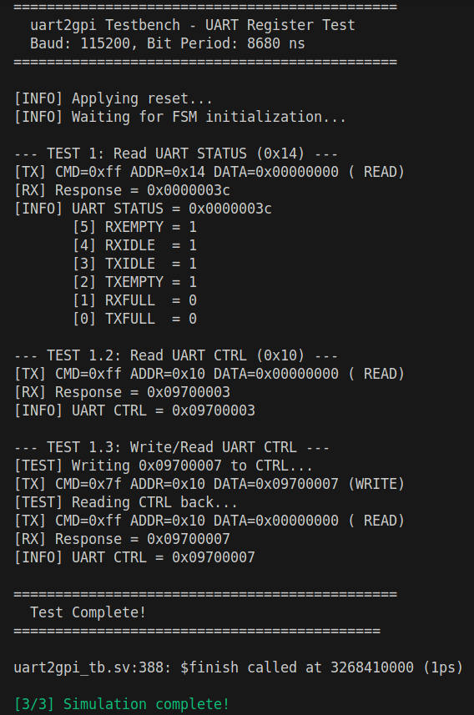Figure 1: Simulation log

3.2 DE-Lite Strategy
The purpose of these tests is to validate that the UART IP behaves consistently in real hardware,
confirming reliable serial communication under practical conditions.

Testing Setup
The DE-Lite board hosts the synthesized UART IP design. It provides the TX and RX signals through its I/O. Where in the DE10-Lite, GPIO[0] is set for RX and GPIO[4] for TX;

RS232 TTY cable will be used to facilitate UART data exchange, enabling serial communication via software.

Oscilloscope probes can be attached to TX and RX lines to visualize waveforms.

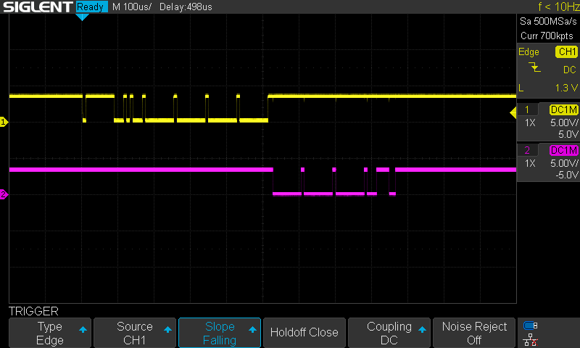Figure 2: Read from UART STATUS Register

Reading from UART STATUS (0x14) register offset. Signal yellow is RX and purple is TX.

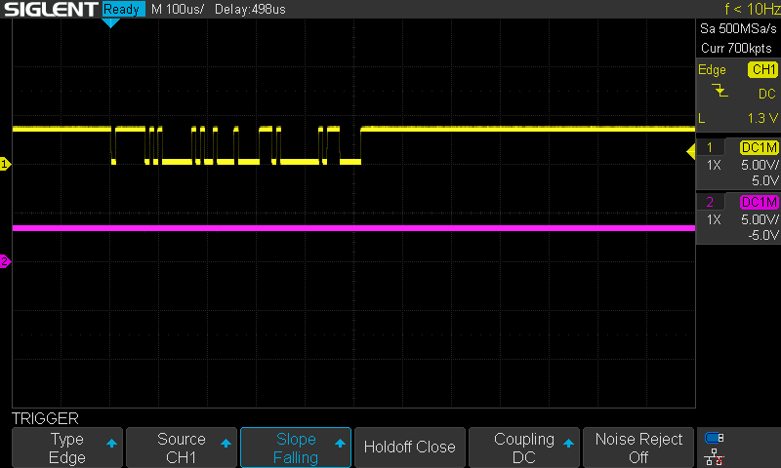Figure 3: Write to UART CTRL Register
Writing to UART CTRL (0x10) register offset. As can be seen, when only a WRITE is done TX line is idle.

4 Limitations and Future Works
Current UART IP does not support hardware control flow RTS/CTS, interrupt capabilities.
Future improvements may include extended FIFO depth, additional flow control, and interrupts.

5 Revision History
Version | Date | Author | Changes
V1.0 | October, 2025 | Samuel Napaa | Initial version
V2.0 | December, 2025 | Samuel Napaa | Current version

