Open Titan SPI HOST IP Block Documentation
Version 1.0, October 2025

1 Overview
The SPI Host IP block provides a basis for both half duplex and full duplex serial communication between a Host (Master) and any number of Devices (Slaves).
- It’s purpose is to interface with serial NOR flash devices, Analogue-to-Digital Controllers (ADCs), and Digital-to-Analogue Controllers (DACs).
- This implementation of the Open Titan SPI Host IP block aims for a relatively standalone, compact design; hence data fifos, command fifos, command windows, remote accesss control and external interrupts were replaced with lightweight design logic.

1.1 Features
Summary of main capabilities:
- Real-time monitoring of Host state via “awake_o” & “idle_o” output pins.
- Stale input signal filtering; allows linking the active high “write_i” & “read_i” inputs to push buttons.
- Drives core modules with clear pulses and de-bounced input signals to reduce electrical noise.
- Automated control of Open Titan’s “spi_host_core” to perform Writes &/ Reads when triggered.
- Seamless data transfer even at speeds over 32KB/s per data line using a 50 MHz input clock.
- Supports both half duplex and full duplex data transfer with Standard SPI Mode 3.

1.2 Ports
Port | Purpose
clk_i | Input; clock signal. Used in scheduling SPI Host tasks.
rst_ni | Input; Active low reset. Powers on the SPI Host and (re)sets configuration to default.
tx_byte_i | Input; 8-bit buffer. Sets the byte to be sent via “mosi_o” when the next Write is triggered.
write_i | Input; Active high. Used in triggering the start of a Write transaction.
read_i | Input; Active high. Used in triggering the start of a Read transaction.
miso_i | Input; Used to receive data from an SPI Device during a Read.
rx_byte_o | Output; 8-bit buffer. Holds the byte received via “miso_i” when the last Read was triggered.
awake_o | Output; Goes high to indicate when the host has been powered on.
idle_o | Output; Goes high to indicate when the host is ready and waiting for the next Write &/ Read trigger.
mosi_o | Output; Used to send data to an SPI Device during a Write.
sck_o | Output; clock signal. For scheduling SPI Device tasks.
csb_o | Output; Active low chip select signal. For indicating when a specific directly connected SPI Device is being interacted with.

2 Programmer’s Guide / Usage Examples
GPIO Output Logic
In the setup and use of the SPI Host IP for communication, Follow these instructions:
- Deactivate all inputs (this is just to avoid accidental Writes / Reads when the Host awakens).
- Feed an input clock signal to “clk_i”.
- Pulse “rst_ni” low for 1 clock cycle to power on the Host. If this is done properly, “awake_o” will go high.
- Whenever “idle_o” goes high the Host will be waiting for the next Write &/ Read triggers.
- To trigger a Write, Pulse “write_i” high for 2 clock cycles.
- To trigger a Read, Pulse “read_i” high for 2 clock cycles.
- To perform a half duplex SPI transaction trigger either a Write or a Read but not both.
- To perform a full duplex SPI transaction trigger Write & Read simultaneously.

3 Verification & Test

3.1 Simulation Environment
The “iverilog” (“Icarus Verilog”) simulator was used for verification of the design in simulation. With the exception of logging statements, all non-synthesize-able logic was kept within the test bench modules for a clear separation of concerns.

3.2 Test bench Strategy
- The test bench in “targets/iverilog/tb_smoke.sv” simulates the manual setup and use of the SPI Host Core module. This test bench was used to determine the best way to manage I/O timing and handshaking for the core modules of the Open Titan SPI Host IP during setup, Writes and Reads.
- The test bench in “targets/iverilog/tb.sv” simulates the setup and extended use of SPI Host for both consecutive half duplex transactions and full duplex transactions. The SPI Host was connected to a purpose built SPI Device to verify data transfer timing. Within the test bench, the expected response from the slave is algorithmically determined at the start of each new Write or Read transaction. See targets/iverilog/tb.sv for details.

3.3 Field Programmable Gate Array (FPGA) Targets
Two FPGA targets have been used to separately verify the timing, speed and stability of SPI Host data transfer. These are:
- DE10-Lite MAX 10 FPGA.
- T-Core MAX 10 FPGA.
Here are a couple of test results for half duplex and full duplex communication:

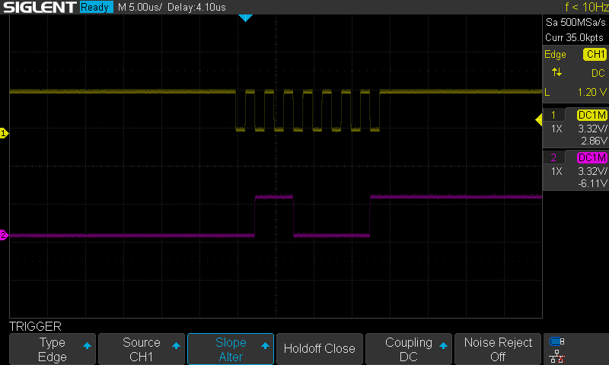Figure 1: half duplex transaction: Host sends 097(‘a’) via “mosi” whiles “sck_o”(in yellow) is toggled

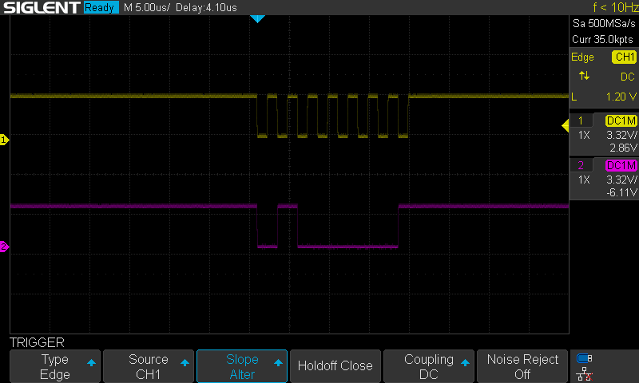Figure 2: half duplex transaction: Host receives 065(‘A’) via “miso_o”whiles “sck_o”(in yellow) is toggled

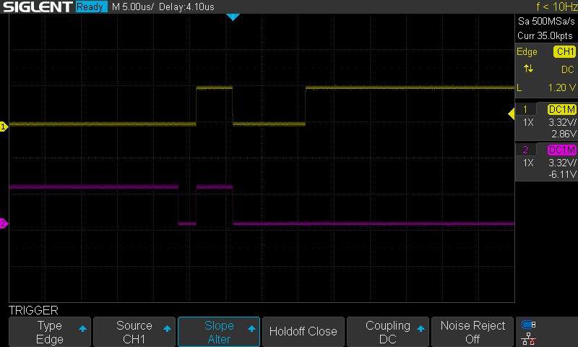Figure 3: full duplex transaction: Host sends 097(‘a’) via “mosi_i”(in yellow) simultaneously receiving 096(‘`’) via “miso_o”

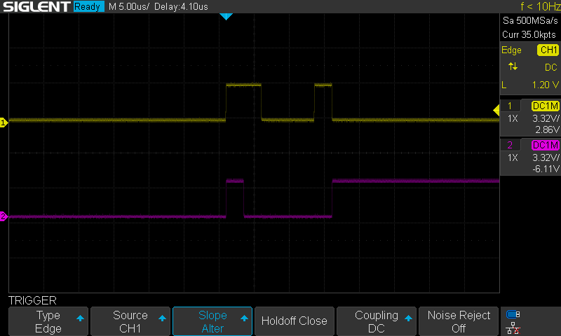Figure 4: full duplex transaction: Host sends 098(‘b’) via “mosi_i”(in yellow) simultaneously receiving 065(‘A’) via “miso_o”

4 Limitations & Future Work
- All SPI Host output signals are easily destabilized by external connections (oscilloscope probes) ( are noisy and continuous) at very high speeds (i.e above 260416.666666667 kHz which is equivalent to about 32.6 KB/s).
- Use shorter wires or even better use an actual PCB.

5 Revision History

Version | Date | Author | Changes
V1.0 | October, 2025 | Zedulo, jopoku | Initial version

