Open Titan UART

IP Block Documentation
Version 1.0, October 2025

1 Overview
The UART (Universal Asynchronous Receiver/Transmitter) IP is a serial-to-parallel receive (RX) and parallel-to-serial (TX) full duplex design intended to communicate to an external device, typically for basic terminal-style communication. It is programmed to run at a particular baud rate and contains only a transmit and receive signal to the outside world, i.e. no synchronizing clock.
This version includes the following tweaks/customizations:
- Stripped away UART_reg_config, place all configurations codes in the top module
- New top module which includes finite state machine (FSM)
- Removed prim_intr_hw instantiations from uart_core.sv

1.1 Features
This version of the UART IP block provides the following features:
- 8-bit data word, optional even or odd parity bit per byte
- 1 stop bit
- 64 x 8b RX buffer
- 32 x 8b TX buffer
- Programmable baud rate
- 2-pin full duplex external interface
- Interrupt for transmit empty, receive overflow, frame error, parity error, break error, receive timeout.

1.2 Features
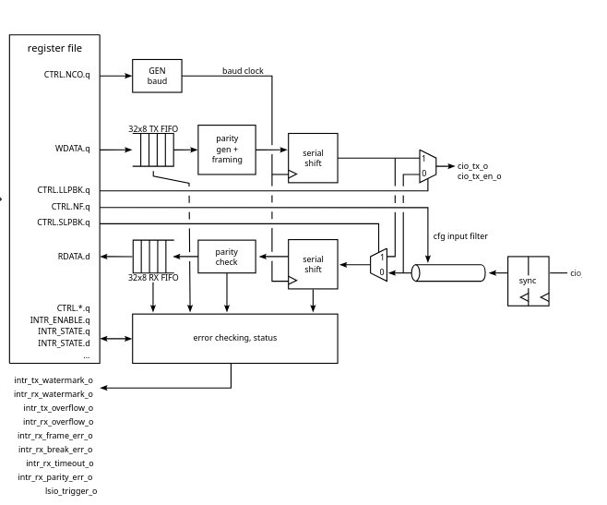Figure 1: UART IP Block structure

Figure 1-1 shows how the OpenTitan IP block is structured.

The baudrate is set by writing to CTRL.NCO.q register field. It shows two deep FIFO’s which can be written to and read from. Also has serial shift registers which shifts a frame bit by bit.

(Image Credit: OpenTitan)
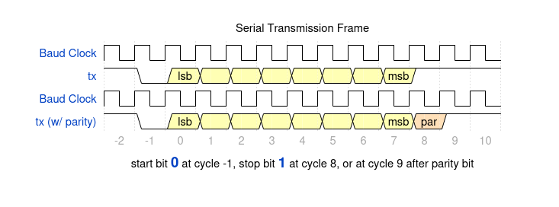Figure 2: Serial Interface
The TX/RX serial lines are high when idle. Data starts with a START bit (high idle state de-asserts, 1–>0) followed by 8 data bits. The least significant bit is sent first. If the parity feature is turned on then an odd or even parity bit follows after the data bits. Finally a STOP (1) bit completes one byte of data transfer.

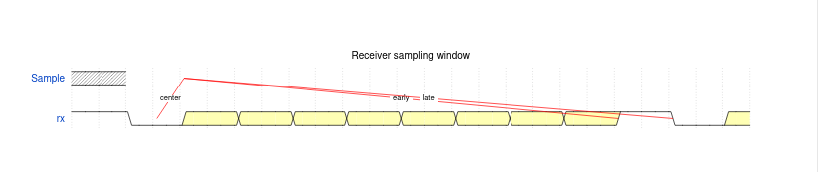Figure 3: Receiver Sampling Window
Figure 1-3 shows the receiver sampling window
The RX module over-samples the RX input pin at 16x the requested baud clock. When the input is detected low the receiver will check half a bit-time later if the line is still low before detecting the START bit.

GPIO Output Logic

2 Programmer’s Model / Usage Examples

2.1 uart_core.sv
uart_core implements the main transmit (TX) and receive (RX) data-paths, as well as control logic for serial communication. It is the engine of the UART IP, responsible for converting between parallel data (used by the SoC) and serial data (on TX/RX lines).

It also manages FIFO buffering for smooth data flow, interfaces with the NCO for accurate baud timing, and connects to the register interface (reg2hw/hw2reg) for configuration, status reporting, and seamless integration with the OpenTitan style verification framework.

Table 1: Key Signals for uart_core.sv
Signals | Type | Description
clk_i | input | Main system clock input for synchronizing
rst_ni | input | Active-low reset
reg2hw | input | Software-to-hardware control
hw2reg | output | Hardware-to-software status
rx | input | Serial receive line
tx | output | Serial transmit line

The code below shows one of the many things the uart_core does. The code depicts how the accurate baud ticks for proper timing for bit sampling and shifting is achieved.

// NCO 16x Baud Generator
// output clock rate is:
// Fin * (NCO/2**NcoWidth)
logic [NcoWidth:0] nco_sum_q; // extra bit to get the carry

always_ff @(posedge clk_i or negedge rst_ni) begin
if (!rst_ni) begin
nco_sum_q <= 17'h0;
end else if (tx_enable || rx_enable) begin
nco_sum_q <= {1'b0,nco_sum_q[NcoWidth-1:0]} +
{1'b0,reg2hw.ctrl.nco.q[NcoWidth- 1:0]}; //op
end
end
assign tick_baud_x16 = nco_sum_q[NcoWidth];

On reset, ctrl.tx.q and ctrl.rx.q are set to zero and so as other register fields. Now after reset, ctrl.tx.q(transmitter) and ctrl.rx.q(receiver) are set to logic one which enables the TX and RX ready to operate.

2.2 uart_tx.sv
uart_tx handles the serial transmission of data bytes from the UART core to the external TX line. Takes a byte from the reg2hw interface (software side), frames it according to UART protocol (start bit, data bits, optional parity, and stop bit), and then shifts it out bit by bit at the configured baud rate. The table below shows key signals for the transmitter to be have to work.

Table 2: Key Signals for uart_tx.sv
Signals | Type | Description
clk_i | input | Main system clock input for synchronizing
rst_ni | input | Active-low reset
tx_enable | input | Enables the transmitter
tick_baud_x16 | input | 16x baudrate tick used for precise bit timing.
wr | Input | Write strobe, triggers loading of new byte
parity_enable | input | Enable parity bit to be set and transmitted
wr_parity | input | Parity bit value to be transmitter if enabled
wr_data[7:0] | input | 8-bit parallel-serial data sent via tx line
idle | output | Indicates transmitter is idle
tx | output | Serial transmit line

2.3 uart_rx.sv
uart_rx is responsible for receiving and decoding serial data from the RX line. It samples incoming serial data on the rx line for a start bit, then samples each bit at the correct baud timing (using the 16× baud tick).
It reconstructs the received bits into a parallel byte, optionally checks for parity correctness, and verifies the stop bit to detect framing errors. The received data, along with any error flags, is then passed to the higher-level UART control logic or stored in the RX FIFO.

Table 3: Key Signals for uart_rx.sv
Signals | Type | Description
clk_i | input | Main system clock input for synchronizing
rst_ni | input | Active-low reset
rx_enable | input | Enables the receiver
tick_baud_x16 | input | 16x baudrate tick used for precise bit timing.
parity_odd | input | Selects odd or even mode when parity enable
parity_enable | input | Enable parity checking if set
tick_baud | input | Single baudrate tick derived from x16 clock for timing reference
rx_valid | output | Indicates byte received and valid
rx_data[7:0] | output | 8-bit serial-to-parallel data
idle | output | Indicates receiver idle
frame_err | output | Asserted when a framing error encounters
rx | input | Serial input line

2.4 nco_config.sv
To generate accurate UART baud timing, the Numerically Controlled Oscillator (NCO) increment value must be calculated based on the desired baud rate and system clock frequency. The relationship between these parameters is defined by the following equation:

The nco_config module implements this equation in hardware to compute the NCO increment value used for baud rate generation.

// Computes NCO value at elaboration time (64-bit safe).
module nco_config #(
parameter int BAUD_RATE,
parameter int CLK_FREQ_HZ,
parameter int NCO_WIDTH = 16
) (
output logic [15:0] nco
);

// Using 64-bit to avoid overflow
localparam logic [63:0] POW2 = 64'd1 << NCO_WIDTH; // 2^NCO_WIDTH

// wide numerator
localparam logic [63:0] NUMERATOR = BAUD_RATE * 16 * POW2;
// rounded division
localparam int NCO_VALUE = (NUMERATOR + (CLK_FREQ_HZ/2)) / CLK_FREQ_HZ;

assign nco = NCO_VALUE[NCO_WIDTH-1:0];
endmodule

Table 4: Register Map
Name | Offset | Length | Description
UART.INTR_STATE | 0x0 | 4 | Interrupt State Register
UART.INTR_ENABLE | 0x4 | 4 | Interrupt Enable Register
UART.INTR_TEST | 0x8 | 4 | Interrupt Test Register
UART.ALERT_TEST | 0xc | 4 | Alert Test Register
UART.CTRL | 0x10 | 4 | UART control register
UART.STATUS | 0x14 | 4 | UART live status register
UART.RDATA | 0x18 | 4 | UART read register
UART.WDATA | 0x1c | 4 | UART write register
UART.FIFO_CTRL | 0x20 | 4 | UART FIFO control register
UART.FIFO_STATUS | 0x24 | 4 | UART FIFO status register
UART.OVRD | 0x28 | 4 | TX pin override control. Gives direct SW control over TX pin state
UART.VAL | 0x2c | 4 | UART oversampled values
UART.TIMEOUT_CTRL | 0x30 | 4 | UART RX timeout control

2.5 Functional Description
Configure Pins:
Two pins are configured for UART operation. One as input (RX) and the other as output (TX).
Input Mode:
When configured as an input, the RX pin captures serial data bits, which are sampled and reconstructed into bytes. The received data is stored in the RX FIFO and made available to software through the register interface.
Output Mode:
When configured as an output, the TX pin transmits serialized data bytes loaded from the TX FIFO. Each frame includes a start bit, data bits, optional parity, and stop bit generated inline with UART protocol.
Baud Rate Generator:
A Numerically Controlled Oscillator (NCO) or divider derives the baud clock from the system clock, ensuring accurate bit timing for both transmission and reception. The baud rate is programmable through configuration registers, allowing flexible communication speeds.
Interrupts:
The UART IP generates interrupts on key events such as when new data is received (RX valid), when the transmitter becomes idle or FIFO empty (TX done), or when errors occur (parity or framing error).

2.6 Integration Notes
For standalone testing and verification, the TileLink Uncached Lightweight (TL-UL) bus interface and the RACL (Register Access Control Layer) were temporarily removed from the UART IP.
To enable full system integration, the TL-UL interface must be reintroduced, and corresponding modifications made to reconnect the UART IP with the system bus and register framework.

3 Verification & Test
The verification and testing of UART IP were done on different environments. Three strategies were used to do the verification and there are:
- Icarus verilog strategy
- T-Core strategy
- DE10-Lite strategy

3.1 Icarus Verilog Testbench Strategy
During the iverilog simulation, various tests where done to enable the UART IP work as intended. A task to write into the rx line. Below is the structure if the task to write into RX line

Write Task
task UART_send_byte_exact(input [7:0] data);
int i;
begin
// start bit
rx_i = 0;
repeat (16) @(posedge dut.UART_core.tick_baud_x16);

// data bits
for (i = 0; i < 8; i++) begin
rx_i = data[i];
repeat (16) @(posedge dut.UART_core.tick_baud_x16);
end

// stop bit
rx_i = 1;
repeat (16) @(posedge dut.UART_core.tick_baud_x16);

$display("[%0t] TB: Sent byte 0x%02h '%c'\n", $time, data, data);
end
endtask

The uart_send_byte_exact task simulates sending a single UART frame by driving the rx_i line with a start bit, eight data bits, and a stop bit, each held for one baud period (16 clock ticks), to emulate accurate serial transmission timing in the testbench.

Simulation Results
Below is a snapshot of the iverilog simulation results and waveform output.

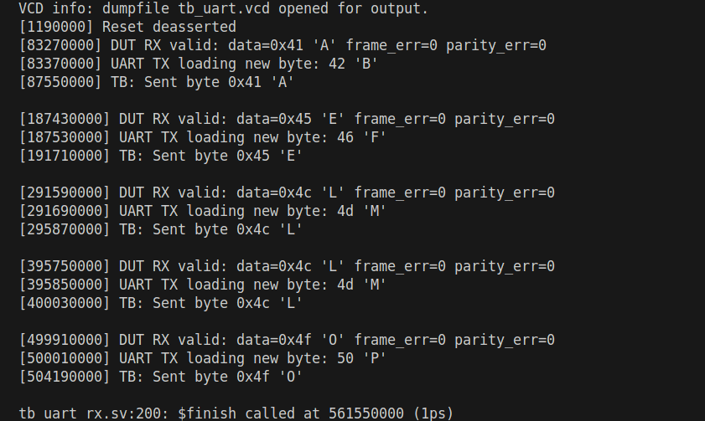Figure 4: Simulation output log

Simulation confirms that the UART IP is operating correctly and is ready for FPGA deployment
testing.

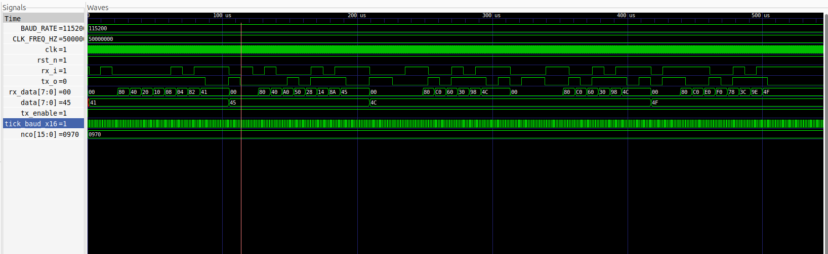Figure 5: Waveform output from GTKwave

3.2 FPGA TESTING
After verifying the UART IP in simulation strategy, hardware testing was performed on two FPGA
platforms:
• T-CORE FPGA
• DE10-LITE FPGA
The purpose of these tests is to validate that the UART IP behaves consistently in real hardware,
confirming reliable serial communication under practical conditions.

Testing Setup

FPGA Board
The FPGA hosts the synthesized UART IP design. It provides the TX and RX signals through its I/O. Where in the T-Core, TMD_D[0] is set for RX and TMD_D[1] for TX. Whereas in the DE10-Lite, GPIO[0] is set for RX and GPIO[4] for TX;

Breadboard Interface
The breadboard acts as an interconnection platform, allowing routing signal lines between the FPGA boards, the RS232-to-TTL cable, and oscilloscope probes.

Signal Connections
Yellow wires represent the RX (Receiver) signal path. This line captures incoming serial data sent via software such as Minicom.

Red wires represent the TX (Transmitter) signal path. This line carries outgoing serial data to the software.

Black and brown wires used as ground (GND) connections to ensure a common reference between all connected components (FPGA, RS232 adapter, and oscilloscope).

RS232–TTL Cable
Connected between the breadboard and the PC, this cable facilitates UART data exchange, enabling serial communication via software such as Minicom.

Oscilloscope Probes
Two oscilloscope probes are attached to the TX and RX lines respectively. These probes are used to visually monitor the waveform of transmitted and received UART signals, ensuring proper baud rate, frame structure, and signal integrity.

3.2.1 T-Core Strategy
With the Terasic T-Core FPGA, using QUARTUS as the programming software, the clk_i, rst_ni were hooked to MAX10_CLK1_50 and KEY[0] respectively. Following the testing setup stated previously can help to validate the performance of the UART IP.

3.2.2 DE10-LITE Strategy
Just as it was with the Terasic T-Core FPGA, using QUARTUS as the programming software, the clk_i, rst_ni were hooked to MAX10_CLK1_50 and KEY[0] respectively to the DE10-LITE FPGA. Following the testing setup stated previously can help to validate the performance of the UART IP.

3.3 Minicom Output
The minicom interface shows the bytes sent and echoed back. The echoed back byte has been
manipulated. So if you send A, B gets transmitted back.

3.4 Oscilloscope Capture
The yellow signal is the receiver and the purple is the transmitter. Upon observing the oscilloscope, there’s a delay after a full frame(start bit, 8 bits data, stop bit) is received and when a frame transmitted.

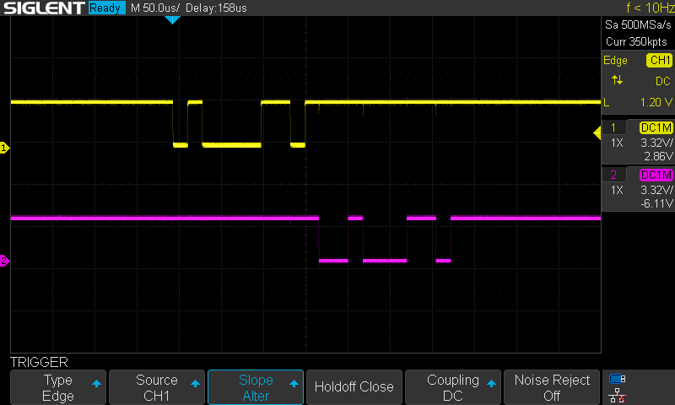Figure 6: Oscilloscope visual monitoring of signals

4 Limitations & Future Work
Currently state of UART IP is a standalone IP that works seamless both on simulation and on FPGA boards. It’s ability to interact with other IP’s is not possible at the current state.

To enable full system integration with other IP’s, the TL-UL interface bus must be reintroduced, and corresponding modifications made to reconnect the UART IP with the system bus and register framework.

5 Revision History

Version | Date | Author | Changes
V1.0 | October, 2025 | Zedulo | Initial version

