**Semester Project**

**Project Proposal**

**_______________________________________**

**Hospital Management System**

**Group Members**

**Muhammad Zeeshan (213013)**

**Rana Aazib Qayyum (213035)**

**Advisor:** Mam Aatka Ali

**Hospital Management System**

**Project Proposal**

**Introduction:**

Creating a Hospital management system involves various components such as information of patient, doctor, receptionist. To begin implementing the Data Operations functionality for your project, you can follow these steps:

* **Database Setup**

Choose a database system (MySQL, PostgreSQL, MongoDB, etc.) and create the necessary tables or collections to store supermarket-related data. Tables might include:

Patient: Store information about Patient (ID, name etc.).

Doctor: Track sales transactions (ID, product sold, quantity, total price, date, etc.).

Receptionist: Store user information for authentication (ID, username, password, role, etc.).

* **Backend Development**

Develop a backend using a programming language (Python, Node.js, Java, etc.) and a framework (Flask, Express.js, Spring Boot, etc.) to create RESTful APIs for CRUD (Create, Read, Update, Delete) operations.

**Example API Endpoints:**

/products (GET, POST, PUT, DELETE): Manage products in the inventory.

/sales (GET, POST): Handle sales transactions.

/users (POST): User authentication and creation.

Ensure proper authentication and authorization mechanisms to restrict access based on user roles.

* **Frontend Development**

Create a user-friendly web interface using HTML, CSS, and JavaScript frameworks (React, Angular, Vue.js, etc.) that consumes the backend APIs.

Design the front to allow users to:

View patients and their details.

Add, update, or remove patients from the system.

Authenticate as different users with varying levels of access.

* **Testing**

Thoroughly test your application to ensure data operations work as expected test CRUD operations on products, sales transactions, and user authentication.

### **Lab Management**

Maintain accurate accounts of tests, payments received, report generation dates, patient information, customized reports, timely notifications to patients and laboratory staff, and detailed MIS reports – all through one Hospital Management System.

### **Patient Management**

With faster, secure, and easy data retrieval, a hospital facility would be able to provide better and efficient care to the patients. With every department interconnected and integrated into the HMS, the quality of patient care can be enhanced, leading to greater customer satisfaction and lowered turnovers. Today there is severe competition even in the realm of healthcare, and patients and their kin prefer to visit a facility that is efficient, cost-effective, and secure.

### **Billing Management**

Given the large numbers (in all respects) that any hospital needs to manage, a great feature of Hospital Management System is to help keep track of billing aligned with treatments, tests, and doctor fee. The system is able to send out messages for bill payment, display discounts, automatically capture patient data, provide several payment options to patients/kin, and keep a track of patient visits and payments.

## **Benefits of a Hospital Management System**

### **Improves interaction between the patient and the hospital**

With faster, secure, and easy data retrieval, a hospital/healthcare facility would be able to provide better and efficient care to the patients. With every department interconnected and integrated into the HMS, the quality of patient care can be enhanced, leading to greater customer satisfaction and lowered turnovers. Today there is severe competition even in the realm of healthcare, and patients and their kin prefer to visit a facility that is efficient, cost-effective, and secure.

* **Keep the hospital data secure**

The cloud-based medical records software in a Hospital Management System, ensures that all data remains interlinked and with high security. This translates to ease of data storage and retrieval by authorized personnel only. Faster access to accurate data has a significant impact on the speed and efficiency of the overall operational and administrative processes of a hospital/healthcare facility.

* **Demonstration**

Prepare for an in-person demonstration where the functionality of your web app will be tested to ensure that:

CRUD operations function properly.

User authentication and authorization are secure.

Group members understand the codebase and functionalities.

During the demonstration, be prepared to explain the code architecture, data flow, and how different components of your application work together.

Remember to document your code and create clear API documentation to help others understand and use your system efficiently.

Lastly, work closely with your team members to ensure everyone comprehends the project and can contribute effectively during the demonstration. Good luck!

# Conclusion

The [Hospital Management System](https://www.karexpert.com/saas/hospital-information-management-system/?utm_source=Website%20Organic&utm_medium=https://www.google.com/&referer=https://www.google.com/&origin_referer=https://www.google.com/) has today become an indispensable part of any hospital/clinic/healthcare facility. In order to create a differentiated, efficient, speedy, and thoughtful healthcare model, it would make sense to invest in a comprehensive HMS.

**Class Diagram:**

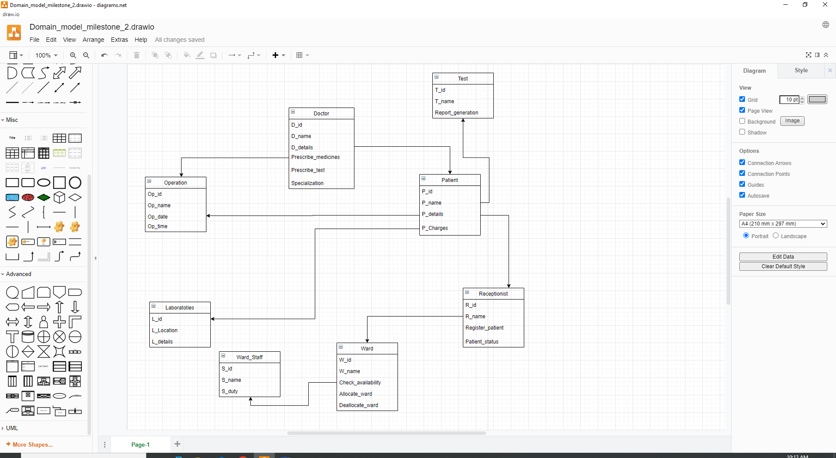

**Snippets:**

**Home Page:**

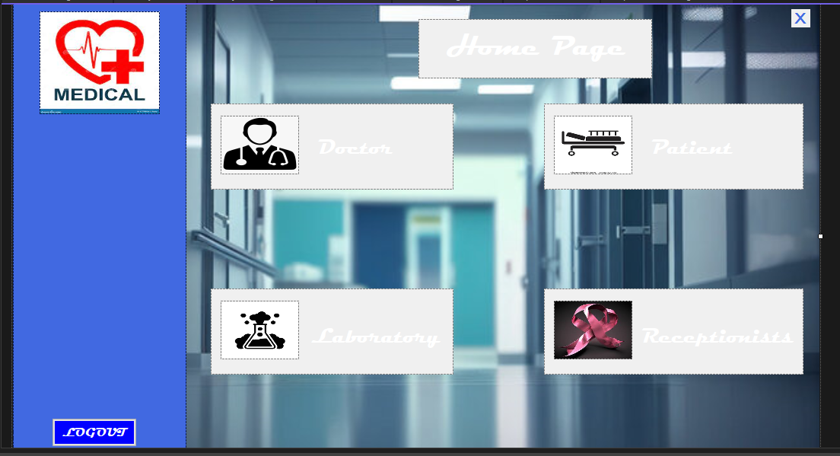

**Login Page:**

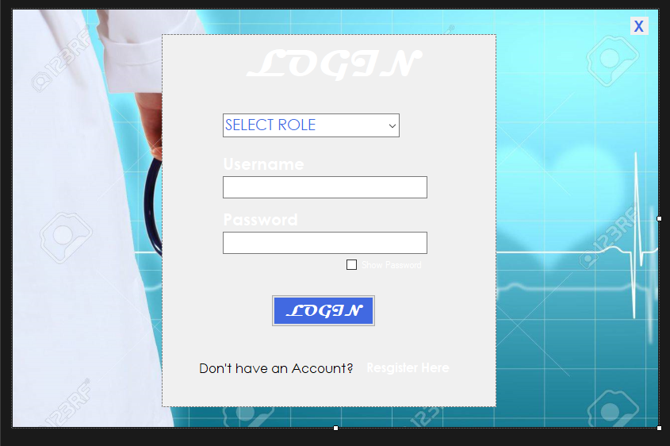

**Signup:**

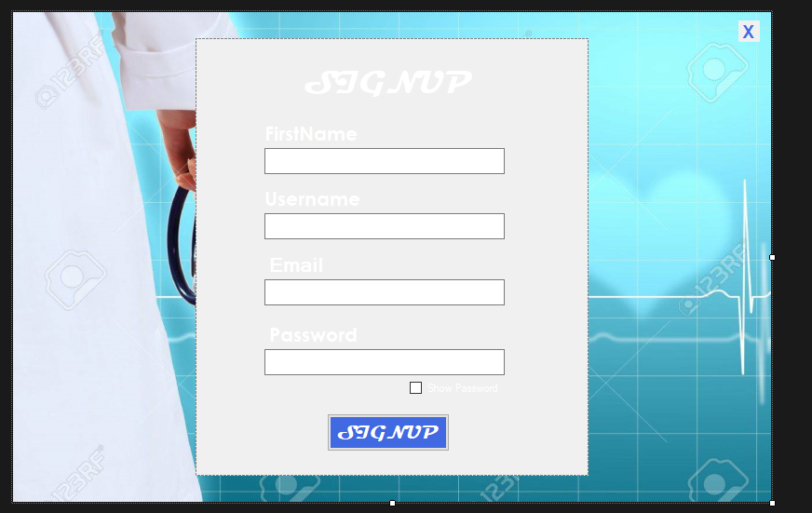

**Patient:**

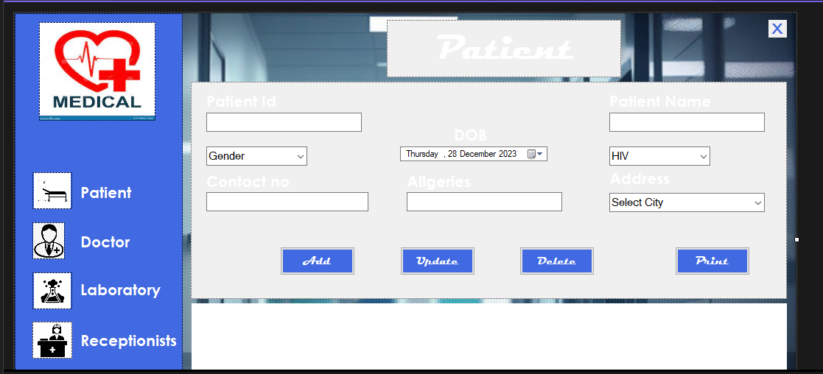

**Doctor:**

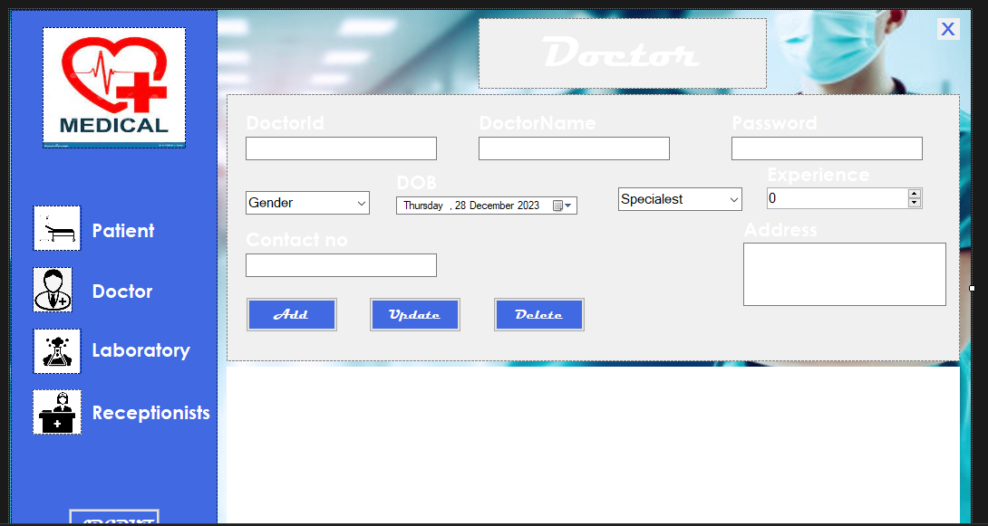

**Laboratory:**

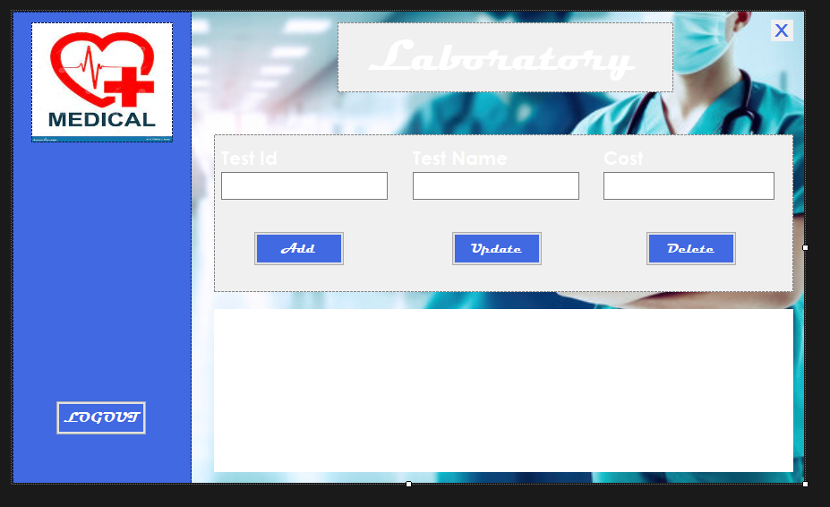

**Receptionist:**

