|  |  |
| --- | --- |
| COS10011 Assignment 3 Report | Version: 1.0 |
| Team Name: Radiance | Date: 2019-04-07 |
| Title: Snow Sports | |

# PHP

## Reuse Common Elements

To reuse common elements within the website, such as the header, navigation bar and footer, PHP files were created. The HTML structure for these elements are coded within the PHP files. To use them, they were included in pages that required these elements, by using the “include_once” function.



## Create Database Table

To create the tables within the database, a PHP file called “create_db.php” was created. This file is included within any area of the website that required access to the database. Within this file, functions that checks for existing databases and tables were written. If they do not exist, then the database or table will be created with the required specifications.

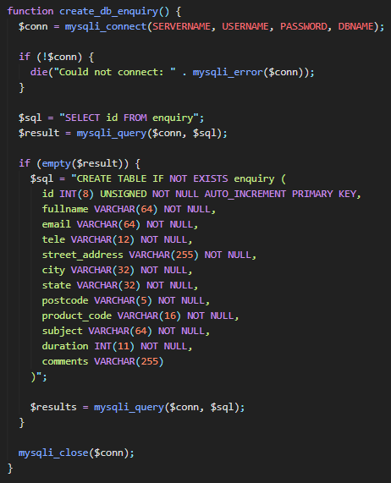

## Submitting An Enquiry

When submitting the enquiry from “enquiry.php”, the form inputs are sent to “enquiry_process.php” using the POST method. The values are then obtained by the $_POST superglobal, and then validated using various functions like “preg_match”, “str_len”, “isset” and “empty”. The values are also modified using functions like “stripslashes”, “trim” and “htmlspecialchars” in order to preserve the integrity of the database. After all the validation and modification, the values are then stored in the “enquiry” table using the “INSERT INTO” query. If successful, the user will be notified by messages from the “echo” function.

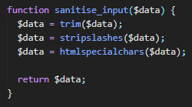 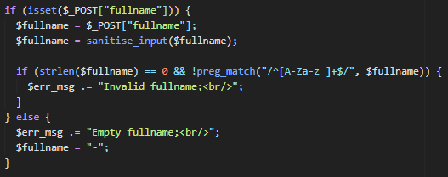

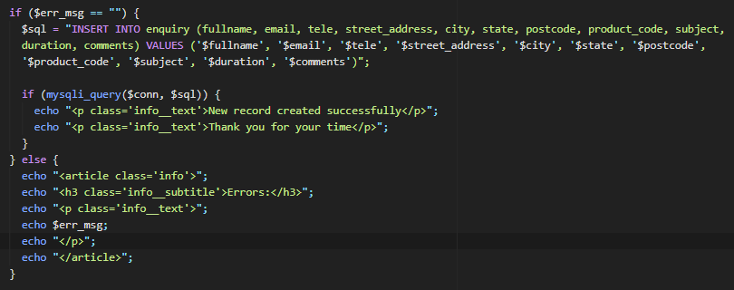

## View Enquiries

To view the enquiries within the webpage, the data within the “enquiry” table are retrieved with the “mysqli_fetch_assoc” function and then iterated through. Within each iteration, the HTML structure for each record is created. In the context of this website, since the data is presented in a table, for each record, the data is echoed in “<tr> ” tags and “<td>” tags for each column.

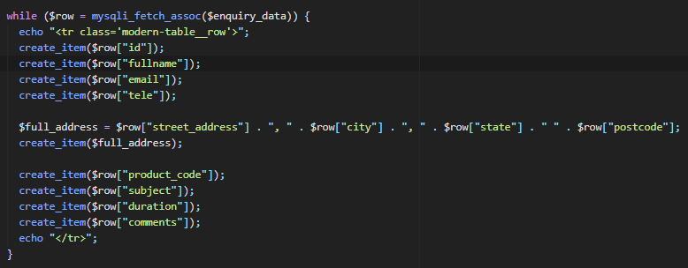

# MySQL Database

For the purpose of storing enquiries and the users information on the website, a database called “db_glacier” was created. This database contains the “enquiry” table, which is used to store the form inputs from enquiry.php. The columns within this table include the ID, fullname, email, telephone number, email address, city, state, postcode, product code, subject, rental duration, and comments given by the user in the form. All of the columns use the VARCHAR data type except for the ID and rental duration, which uses the INT data type. The ID is set to AUTO_INCREMENT and is also set as the PRIMARY_KEY of the table. Since all the values except the comments are required, they are all set to NOT NULL.

# Enhancements

## User Management Module

To create the User Management Module, a new table called "users" was created in the database. Within this table, the user’s information (id, username, password, privilege level) were stored. This table is where the user login system retrieves and sends user accounts. In register.php, the user will enter a username and password for their new account. When submitting the form, the PHP will validate the inputs and check the "users" table for any similar usernames. If the submit is successful, the account will be saved in the table with a privilege level of "0", which is for the User level. The entered password will also be hashed with the "password_hash" function so that the security of the password can be ensured.

When submitting the form in login.php, the username and password will be checked with the existing accounts within the "users" table. This is done by looping through the records after querying the database for the table. If there is a match, then login is successful, and new $_SESSION variables will be created. These variables are used to store the "logged_in" state, the id, username and the privilege level of the user. With these $_SESSION variables, other .php files are able to use the data stored in them. In the context of this assignment, the team used the data to change the links within the navigation bar. For example, if the user is logged in and is under the Admin Level(1) privilege, they will have access to additional pages that otherwise are inaccessible by User Level(0) users. To store $_SESSION variables, the “session_start” function has to be called first to initialize a session. Afterwards, by indexing the variable name and giving it a value, a $_SESSION variable will be created. For example, "$_SESSION['username'] = $username".

As an "admin", the user will be able to access and view the website database, in pages such as view_enquiries.php and view_users.php. The records within the tables are displayed on the page in a presentable format. This is done by looping through the records of the users table and creating the HTML dynamically using PHP. The user will also be able to edit the records for the accounts in the "users" table. After editing the inputs, the table will be queried with "UPDATE" in order to change the records in the table. There is also a function to delete the user records in the table with the use of the "DELETE" query. In order to edit or delete the corresponding record, the ID of the record is used as the condition during the query.

NOTE: After the creation of a new “users” table, a master user account will automatically be added into the table. The username is “master” and the password is “master”.

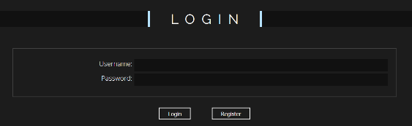 

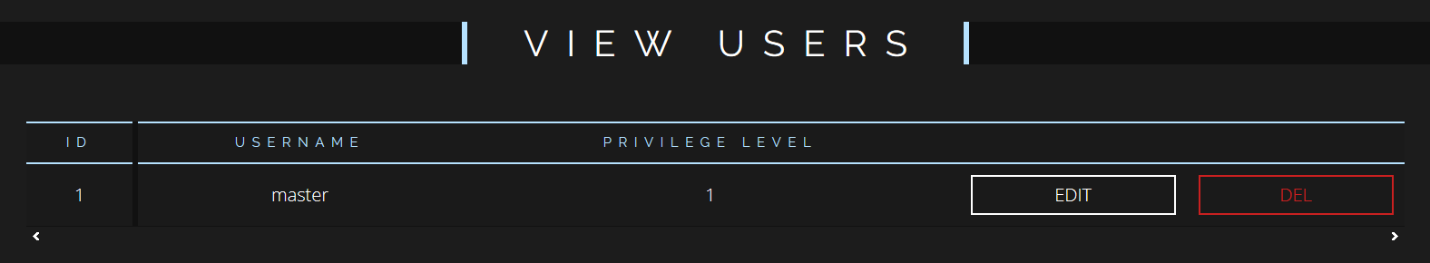

# Contributions

|  |  |
| --- | --- |
| **Team Member 1** | Ian Ong |
| **Contribution (%)** | 33% |
| **List of Contributions** | PHP for reusing common elements (header.php, footer.php)  PHP for form validation and submission (enquiry_process.php) |

|  |  |
| --- | --- |
| **Team Member 2** | Jonathan Seng |
| **Contribution (%)** | 33% |
| **List of Contributions** | PHP for database configurations (create_db.php)  PHP for user login and registration (login.php, logout.php, register.php)  PHP for editing and deleting users (edit_users.php) |

|  |  |
| --- | --- |
| **Team Member 3** | Karyn Chong |
| **Contribution (%)** | 33% |
| **List of Contributions** | PHP for viewing data (view_enquiries.php, view_users.php)  Making use of $_SESSION variables to modify the header |