Cognitive Decline Risk Factors in U.S. Older Adults
Progress Report | DATA 205 Capstone | Spring 2026 | Prof. Perine | Zivar Murphy

1. Introduction and Project Overview
The goal of this project is to explore which health, behavioral, and socioeconomic factors are most strongly associated with cognitive decline (memory loss) among older adults across U.S. states. Cognitive decline and Alzheimer’s disease are among the most significant public health challenges in the United States. This project covers adults aged 45+ across all 50 states and D.C. from 2015 to 2022.

Research Questions
RQ | Question
RQ1 | Which states have the highest and lowest cognitive decline rates?
RQ2 | Is there a relationship between depression and cognitive decline?
RQ3 | Does physical inactivity correlate with cognitive decline?
RQ4 | How does poor self-reported health relate to cognitive decline?
RQ5 | Is cognitive decline associated with disability rates?
RQ6 | Does median household income relate to cognitive decline across states?
RQ7 | Does higher educational attainment reduce cognitive decline?
RQ8 | Do cognitive decline rates differ between the 50–64 and 65+ age groups?
RQ9 | Are early-stage memory complaints linked to severe cognitive decline?
RQ10 | Which combination of variables best predicts cognitive decline?

Goals and Tools
Goal: identify which factors best predict state-level cognitive decline and provide policy-relevant insights. Tools: Python (Pandas, Matplotlib, Seaborn, Scikit-learn), Jupyter Notebook, GitHub. Both datasets are loaded via live APIs for reproducibility. Code: github.com/ZeeMurphy/Data_205_Capstone_Project.

2. Data

Primary Dataset: CDC BRFSS
The CDC BRFSS “Alzheimer’s Disease and Healthy Aging Data” (2015–2022) has 284,142 rows and 31 columns. Each row is one aggregated survey answer for one question, one location, one year, and one demographic subgroup, not one person. Loaded live via CDC SODA2 API. Source: data.cdc.gov/Healthy-Aging/hfr9-rurv.

Complimentary Dataset: U.S. Census ACS
ACS 2018–2022 5-year estimates pulled via the Census Bureau's free API. Variables: median household income (DP03_0062E) and % adults 25+ with bachelor’s degree+ (DP02_0068PE). Merged with CDC data on state abbreviation. Data pairing type: contextual. Source: api.census.gov/data/2022/acs/acs5/profile.

Data Cleaning Highlights
- Replaced blank/NA/N∕A with pd.NA; converted Data_Value and YearStart to numeric (API returns text)
- Removed rows missing target or year: 284,142 → 192,808 rows
- Filtered to 51 U.S. states + DC only. Dataset has 59 locations, including territories (PR, GU, VI excluded because not states; Puerto Rico has 60-75% SCD rate that would distort analysis) and regional rollups (Midwest, South, NE, West, excluded to avoid double-counting)
- Filtered to ‘Overall’ stratification only to avoid counting each state three times per year (originally: 45-65, 65+, Overall)
- Pivoted long → wide: 284,142 rows → 406 state-year rows. After dropping rows missing the cognitive decline target (optional BRFSS module, 57% missing), 173 usable rows remain.

Descriptive Statistics
Variable | Mean | Std Dev | Min | Max
Cognitive Decline (%) | 36.7% | 6.9% | 22.4% | 53.1%
Depression (lifetime diagnosis) | 18.2% | 3.3% | 12.2% | 28.4%
Mental Distress | 11.1% | 2.1% | 6.2% | 16.9%
Physical Inactivity | 30.3% | 5.1% | 21.3% | 45.7%
Self-reported Poor Health | 25.4% | 4.8% | 13.7% | 38.5%
Unhealthy Days (mean days/month) | 5.3 | 0.9 | 3.2 | 7.6
Disability | 37.6% | 5.4% | 27.5% | 53.5%

3. Exploratory Data Analysis

RQ1: State Variation in Cognitive Decline
Southern states have the highest average rates: Mississippi (50.3%), Tennessee (48.7%), Alabama (47.7%), Louisiana (47.3%), Illinois (46.6%), Texas (45.7%). Lowest rates are in the Midwest and New England: Iowa (27.9%), Minnesota (28.2%), Massachusetts (28.5%), Colorado (28.6%). The gap is nearly 2:1, suggesting strong regional patterns linked to socioeconomic conditions and health behaviors.
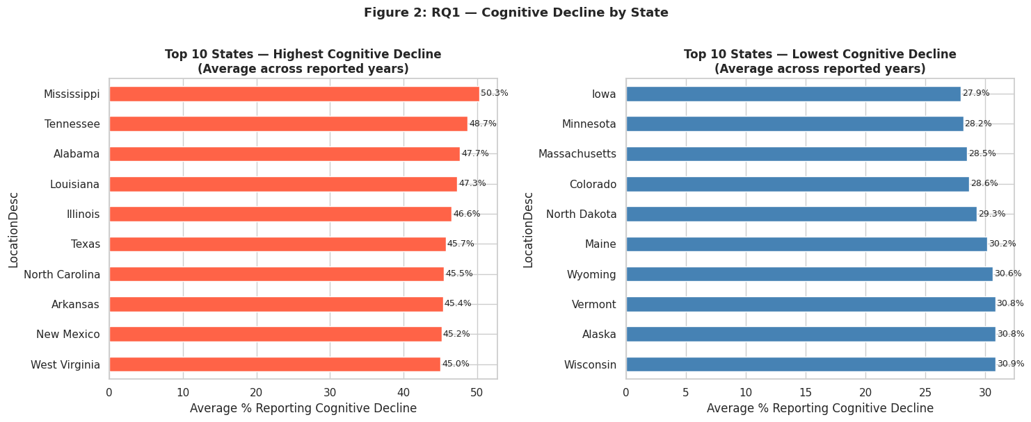
Figure 1: Average cognitive decline rate by state (2015–2022). Source: CDC BRFSS.

RQ8: Age Group Differences
The 50-64 age group reports 43.0% average cognitive decline vs 29.9% for the 65+ group, surprising since cognitive decline is typically associated with older adults. The r = 0.48 correlation between groups means states ranking high for one also tend to rank high for the other. Note: this RQ was revised from the original plan, which proposed testing the Census % aged 65+ variable; the direct age-group comparisons from the BRFSS stratification are more informative.

RQ2–RQ5: Health and Behavioral Risk Factors
All six health factors show positive correlations with cognitive decline:

Risk Factor (RQ) | r | Interpretation
Self-reported Poor Health (RQ4) | 0.54 | Strong positive — strongest predictor
Physical Inactivity (RQ3) | 0.48 | Moderate-strong positive
Mental Distress | 0.44 | Moderate positive
Disability (RQ5) | 0.43 | Moderate positive
Unhealthy Days | 0.38 | Moderate positive
Depression (RQ2) | 0.22 | Weak positive — dataset measures lifetime diagnosis, not current status
Depression is weakest because the dataset measures lifetime diagnosis rather than current status, a less precise indicator of present mental health.
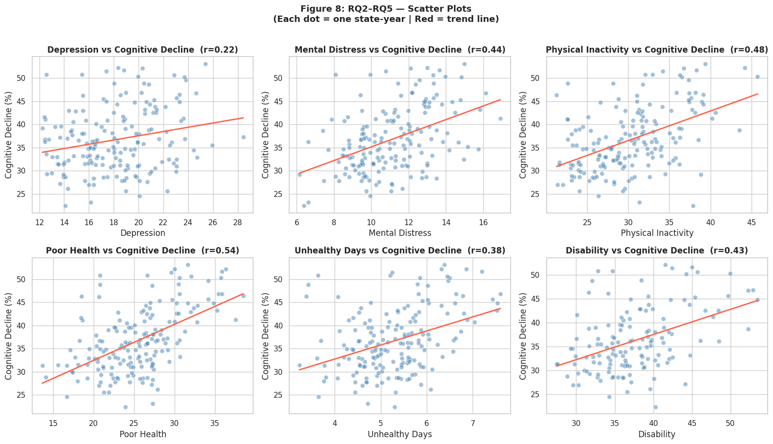
Figure 2: RQ2–RQ5. Each dot = one state-year observation. Red line = trend. Source: CDC BRFSS.

RQ6 and RQ7: Socioeconomic Factors (Census API)
Both Census variables show negative correlations, in the opposite direction from health factors. Income: r = −0.48 (moderate). Low-income states (MS, AL, LA) cluster at high cognitive decline; high-income states (MD, MA, NH) at low. Education: r = −0.29 (weak). Higher education = greater cognitive reserve. DC is an outlier, with high income and education, but high SCD, likely reflecting income inequality within the district.
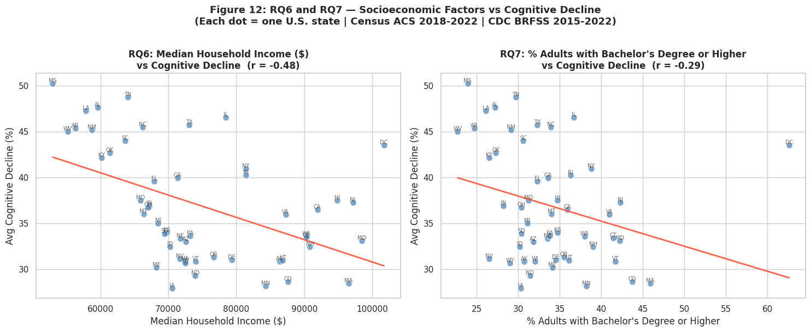
Figure 3: RQ6 (income) and RQ7 (education) vs cognitive decline. Each dot = one U.S. state. Census ACS 2018–2022.

RQ9: Early vs Severe Cognitive Decline
‘Needs assistance with daily activities’ is very strongly correlated with the main target (r = 0.85). ‘Getting worse over time’: r = 0.27. ‘Talked to a doctor’: r = 0.06. This last finding is a key public health insight: people with severe cognitive decline are not more likely to have sought medical help, suggesting gaps in awareness or healthcare access.

4. Final Data Product
Current outputs: fully documented Jupyter notebooks for ingestion and EDA; 12 visualizations covering all 9 research questions; merged CDC + Census analysis dataset; GitHub repository with organized folders and README documentation. The planned final product is an interactive U.S. choropleth map (Streamlit or Plotly Dash) where users can click any state to see its cognitive decline rate, national ranking, elevated risk factors, and links to state and national cognitive health resources. This makes the analysis accessible to policymakers and the general public, not just data analysts.

5. Summary of Data Story
The clearest story is geographic: Southern states have cognitive decline rates nearly twice those of Midwestern and New England states, and this pattern holds consistently across every dimension, health factors, socioeconomic factors, and both age groups. This convergence suggests compounding structural disadvantages rather than any single cause. The second story is about timing: the unexpectedly high rates in the 50-64 age group argue for earlier screening and intervention. The third story is actionable: strong correlations with modifiable behaviors (physical inactivity, poor health) suggest that targeted interventions could meaningfully reduce rates, while the near-zero correlation for doctor conversations points to a specific awareness and access gap worth addressing. Full details and charts: github.com/ZeeMurphy/Data_205_Capstone_Project.

6. Next Steps and Recommendations
Maintaining from the original plan: multiple linear regression (RQ10), combining all predictors; Tableau choropleth map for RQ1. Changes: RQ8 revised to an age-group comparison (more informative than the Census age-structure variable). Adding hypothesis testing: two-sample t-test (South vs Midwest) and one-way ANOVA (by region) to formally validate geographic patterns. Dashboard upgraded from Tableau-only to Streamlit/Plotly Dash for richer state-level interactivity with resource links. Future directions: individual-level microdata analysis, longitudinal tracking within states, spatial regression models.

7. Reflections

What Was Challenging
Understanding the CDC BRFSS structure took significant time; a bug in the original code caused Puerto Rico to appear as the top state because the territory filter was missing, an important lesson about validating data before drawing conclusions. Managing 57% structural missingness in the cognitive decline variable required careful decisions about what to include. Switching to the live API introduced an unexpected column-naming issue (the API returns lowercase; the code expected mixed case) that required debugging.

What Was Rewarding
The geographic story was compelling; seeing the same Southern states appear consistently at the top across every dimension creates a coherent, policy-relevant narrative about structural inequality and health outcomes. Successfully merging two live APIs and producing a fully reproducible analysis was also satisfying.

What I Would Change Next Time
Spend more time exploring the dataset structure before committing to research questions; some questions (particularly RQ8 as originally framed) turned out to be less directly answerable than assumed. Also, plan for API data type and column name differences earlier.

8. Acknowledgments
Thank you to Professor Lori Perine for detailed feedback on the project plan and progress presentations, guidance on CRISP-DM, and for emphasizing the importance of connecting EDA to research questions and documenting what is being maintained versus changed from the original plan. Thanks to the CDC BRFSS team and the U.S. Census Bureau for making these datasets publicly available via API.

