**Incoming Boogies**

Incoming Boogies is a single player wave defense game where the player takes the role of a stationary turret defending itself from incoming waves comprised of various combinations of three distinct enemies.

It is made exclusively for PC.

**Winning/Losing Condition**

The player loses the game when he runs out of lives, causing a game over.

The game cannot be won, rather the winning condition is to survive for as long as possible.

**Gameplay Elements**

**Player Character**

The **Player Character** is locked at the center of the screen, and has to defend itself via the player utilizing the mouse cursor to click at locations on the gaming area, firing shots in that direction.

**Enemies**

**Enemies** come in three distinct forms. More on these below.

They spawn at **Spawn Points** along the edge of the gaming area and will attack the **Player Character** in two different ways, shooting at and moving towards the player.

**Waves**

The game is centered around a **Wave** system, where the first **Wave** contains one of each type of **Enemy**, and successive **Waves** are made up of random combinations of these types of **Enemies**.

This will continue until the player loses via running out of lives.

If a player manages to defeat a **Wave** without taking damage, a small amount of health will be restored to the **Player Character** and all upcoming **Waves** will be containing an additional random **Enemy**.

**Gameplay Elements in Depth**

**Game layout**

Circular wall along the edges of the screen, cutting off the corners.

**Player Character** is placed at the center.

A total of 16 **Enemy** **Spawn Points** are spread out evenly along the sides of the game area.

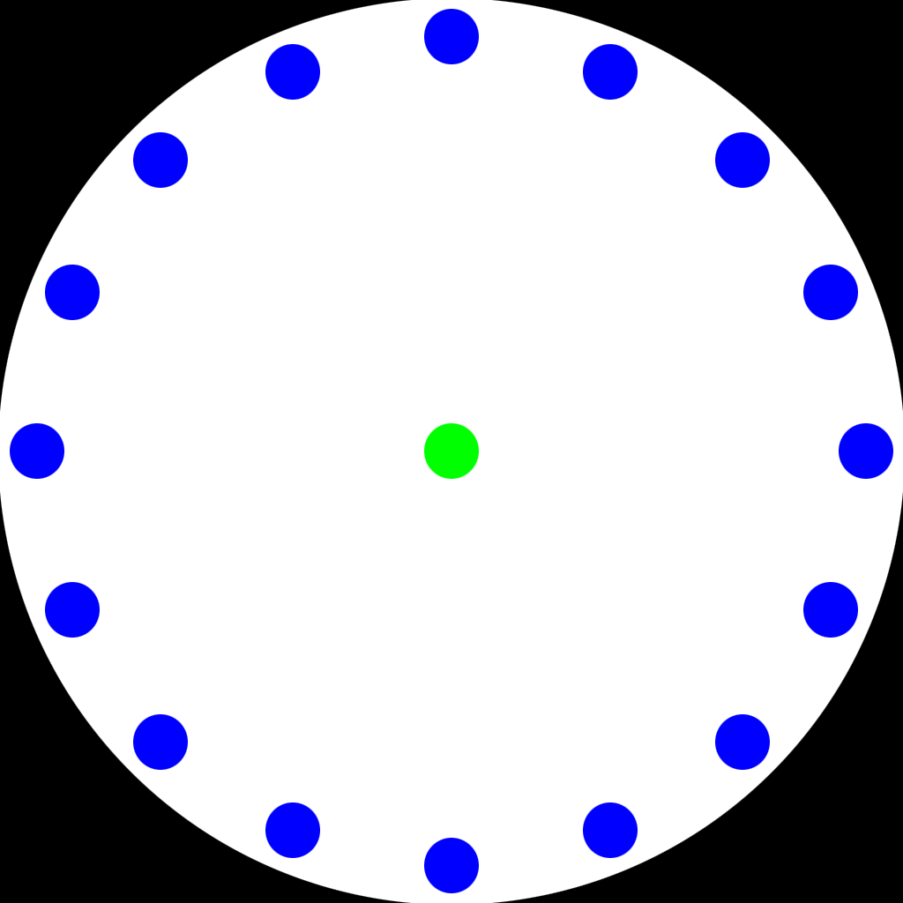

*(Mockup of gameplay area. Green is the player character. Blue are spawn points, these are invisible ingame)*

**Spawn Point**

There are sixteen (16) **Spawn Points** spread out evenly along the circular wall surrounding the playing area. These are numbered from 0 to 15.

Then have no sprite or hitbox and are merely location markers.

Whenever a **Wave** begins, each **Enemy** in that **Wave** will spawn on randomly selected separate **Spawn Points**.



**Player Character**

The **Player Character** hitbox and sprite are 32x32 pixels in size.

The starting health value of the **Player Character** is 100. Upon this value reaching 0 the player is taken to the **Game Over** screen, more on this later.

The **Player Character** is locked at the center of the screen and cannot move.

The player can, via use of the mouse cursor, click anywhere on the gaming area. Doing this will spawn and fire a **Player Projectile**, originating from the **Player Character** and moving towards the location of the cursor click.

Only one (1) of these **Player Projectiles** can be spawned at a time and only if there is no current instance of a **Player Projectile** already on the screen.

Clicking to fire while a **Player Projectile** is already on the screen will result in no new **Player Projectile** being spawned and fired.



**Player Projectile**

The **Player Projectile**’s hitbox and sprite measure 8x8 pixels and moves at a speed that reaches the wall surrounding the gaming area in 0.25 second.

Upon connecting with an **Enemy** hitbox, that **Enemy** takes 1 damage, the **Player Projectile** despawns and then if the enemy has 0 life remaining it also despawns.

If the **Player Projectile** misses and collides with the wall, it despawns.

**Enemies**

**Enemies** spawn in random combinations in every **Wave** after the initial one.

Upon spawning, **Rushers** and **Tanks** begin moving towards the **Player Character** at a speed described on their respective entries.

Upon collision between the **Player Character** and one of these **Enemies** or **Enemy Projectile**, the **Enemy** or **Projectile** disappears and the **Player Character** takes an amount of damage stated on the info regarding the **Enemy** it collided with.

**Shooters** do not move upon being spawned, instead they begin charging shots. More on this on the **Shooter** description.

Enemies have a health value. Upon taking damage from the **Player Projectile** this value is reduced by 1. Upon reaching 0 the enemy despawns.

**Enemies** do not collide with each other.



**Rusher**

Sprite and collision size is 16x16 pixels.

Has a Health value of 1.

It takes the **Rusher** 3 seconds to collide with the **Player Character** after being spawned.

Upon colliding with the **Player Character**, the **Player Character** takes 15 damage, and the **Rusher** then despawns.



**Shooter**

Sprite and collision size is 32x32 pixels.

Has a Health value of 3.

The **Shooter** does not move at all upon being spawned, instead it stays on its spawn location.

Upon being spawned, the **Shooter** begins charging a shot over 2 seconds. This is indicated by a bar above the **Shooter** filling up over the 2 seconds. Upon this charge being completed, the **Shooter** fires a **Enemy Projectile** originating at the **Shooter** straight towards the **Player Character** and begins the charging process again.

**Enemy Projectile**

The **Enemy Projectile** fired measures 8x8 pixels and takes 3 seconds to reach the **Player Character**, at which point it inflicts 5 damage to the **Player Character** and despawns.

The **Enemy Projectile** can collide with the **Player Projectile**, this cancels the two out, causing both to despawn.

**Tank**

Sprite and collision size is 64x64 pixels.

Has a Health value of 10.

It takes the **Tank** 8 seconds to reach the **Player Character** after being spawned.

Upon colliding with the **Player Character**, the **Player Character** takes 50 damage and the **Tank** despawns.

**Game Start**

After booting up the game, the player is presented with the message “Press any button to begin.”. Doing so will begin a 3 second countdown before the first **Wave**.

This first screen is black with white text.

**Waves**

**Initial Wave**

The first **Wave** always consists of three **Enemies**, one **Tank**, one **Rusher** and one **Shooter**.

**Following Waves**

Upon all the **Enemies** in the **Initial** **Wave** having been defeated (Either by being shot and killed or hitting the **Player Character** and despawning), a new 3 second countdown begins, after which a wave consisting of a random setup of the three different **Enemy** types appear on the **Spawn Points** along the sides of the gaming area.

This first random **Wave** consists of 3 **Enemies**.

Upon this first random **Wave** being completed, the game repeats the same formulae of countdown, spawn, play until the game ends.

Whenever the player defeats an entire **Wave** without taking damage, 10 health is restored to the **Player Character** and the wave size is increased by 1 for all upcoming **Waves**.

Whenever a new **Wave** is spawned, the game will check the current “wave_size” and summon that many random **Enemies** at random **Spawn Points**.

A maximum of 16 **Enemies** can be spawned per **Wave**. This is also the maximum the “wave_size” variable can reach, further perfect rounds will still grant 10 health to the player but will not cause more enemies to spawn.

**Game Over Screen**

Upon the **Player Character** being reduced to 0 health, the game switches to the **Game Over Screen**. This is a black screen with white text.

On this screen the message “Game Over” is displayed, together an assortment of with stats for the current session;

Total number of **Waves** cleared

**Waves** perfected *(Defeated without taking damage)*

**Enemies** killed

At the bottom is a “Press any key to try again” message

Pressing any key will cause the player to restart the game and begin the three second countdown for the first **Wave** as described above.

**Technical**

**Controls**

The player uses the mouse cursor to aim the shots, and left mouse button to fire.

**Screen**

1024x1024 or 512x512 pixels

At 512x512, all measurements and movement speeds are downscaled by 50% to fit the smaller screen format.

**Hud**

Indicators for;

At the top right corner of the screen.

**Player Character** current Health value

At the top left corner of the screen.

Number of **Enemies** next **Wave**.

Countdown for next **Wave**.

Total number of **Waves** defeated.

**All Text**

Text size: 48px

Text color: white with black outline

Text font: Arial