**Home Task-Solution**

**About My Test Environment:**

Minikube was installed in VirtualBox on windows 10 laptop, kubectl was also installed on windows 10 laptop as you can see in the screenshot below, minikube setup directory in my laptop was C:\kubernetes\Minikube:

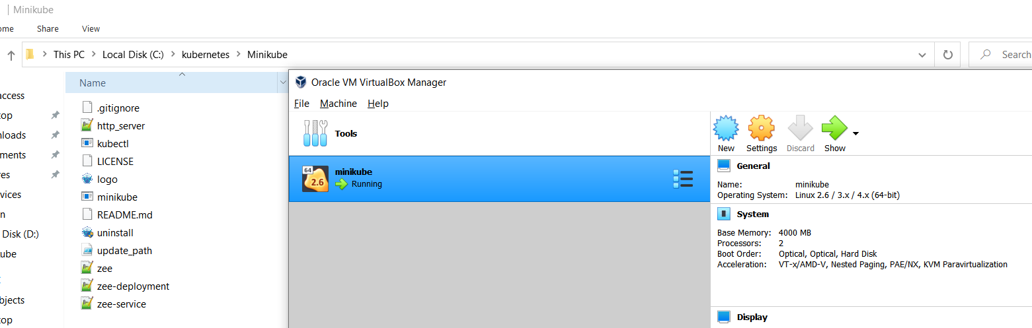

**Solution:**

First of all, clone all files using git from my git account

* **git clone** [**https://github.com/ZeeShanKhalid18/Fusion.git**](https://github.com/ZeeShanKhalid18/Fusion.git)

Then log into the minikube and build docker container there as on my windows laptop no eval commands existed to run docker commands from windows to minikube

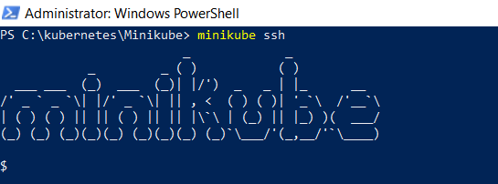

Build docker image there to run application with non-root user

* **docker build -t zee:0.0.1 -f zee.dockerfile .**

Once docker image built inside minikube then exit the minikube and run kubectl commands from windows laptop to create deployment and service

* kubectl create -f zee-deployment.yaml
* kubectl create -f zee-service.yaml

In my laptop virtualbox IP was 192.168.99.100 so try to access the website using port 32000

**Note:** Website will only be accessible in internet explorer as application supports HTTP0.9 and no other browser supports http0.9, likewise in ‘readiness’ and ‘liveness’ probes make sure it uses http 0.9 other wise container will keep crashing

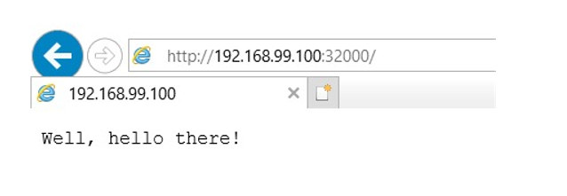

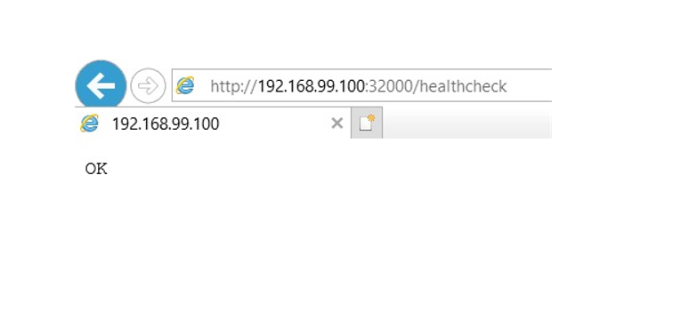

**Inline Answers of the Requirements:**

* Highly available and load balanced environment is required

*Set 2 replicas to ensure Highly available and service type to load balanced*

* Docker is the tool to support it

*Used Docker Run time*

* Ensuring the application is started before served with traffic

*To ensure this, used readinessProbe:*

readinessProbe:

httpGet:

path: /

port: 80

initialDelaySeconds: 5

periodSeconds: 5

* Enhancing availability with probes

*To ensure this, used livenessProbe*

livenessProbe:

httpGet:

path: /healthcheck

port: 80

initialDelaySeconds: 5

periodSeconds: 5

* Running application as non-root

*Used user zeeshan in docker file to ensure this*

* A README with:

*Added*

* step-by-step instructions to recreate the setup

*This is the document to recreate the setup*

* the Strategy/Architecture

*This doc contains that as well*

* Instructions on how to connect to the running application

*In my laptop virtualbox IP was 192.168.99.100 so try to access the website using port 32000*





* All the scripts, configs, playbooks, manifest etc. should be provided on a DVCs, preferably GitHub.

*Pushed to GitHub as requested*

* If your test requires a non-current version of software, please explain why.*Website will only be accessible in internet explorer as application supports HTTP0.9 and no other browser supports http0.9, likewise in ‘readiness’ and ‘liveness’ probes make sure it uses http 0.9 otherwise container will keep crashing*