**Viewport width** and **screen width**

Sites can set their **viewport** to a specific size. For example, the **definition** "**width**=320, **initial**-**scale**=**1**" can be used to fit precisely onto a small phone display in portrait mode. This can cause problems when the browser doesn't render a page at a larger size.

The **CSS margin** properties are used to create space around elements, outside of any defined borders. With **CSS**, you have full control over the **margins**. There are properties for setting the **margin** for each side of an element (top, right, bottom, and left).

The cursor property specifies the mouse cursor to be displayed when pointing over an element. .. yar mtlab jdhen mathan mouse anyun ta kehro shape ache

<https://www.w3schools.com/cssref/pr_class_cursor.asp>

The **CSS id** Selector

The **id** selector uses the **id** attribute of an HTML element to select a specific element. The **id** of an element is unique within a page, so the **id** selector is used to select one unique element! To select an element with a specific **id**, write a hash (#) character, followed by the **id** of the element.

<https://www.w3schools.com/jsref/met_tablerow_insertcell.asp>

The HTML <**span**> tag **is used** for grouping and applying styles to inline elements. There **is** a difference between the **span** tag and the div tag. The **span** tag **is used** with inline elements whilst the div tag **is used** with block-level content.

<https://www.codeandcourse.com/how-to-connect-html-form-to-mysql-database-using-php/>

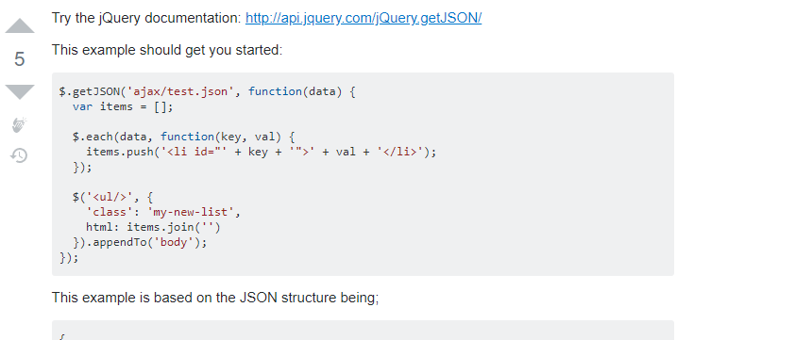

<https://api.jquery.com/jQuery.getJSON/>