ZEEBROO
CRM User Manual
A simple, step-by-step guide from A to Z
This guide shows you how to use the CRM section of the Zeebroo desktop app. Every chapter has:
- a Where to find it box that shows which buttons to click,
- a screenshot with red numbered markers, and a key that explains each number,
- easy steps to follow, and
- a real-life example.

You do not need to read it all at once. Use the contents page to jump to what you need.
Updated: October 2026

Contents
1. What is the CRM? 4
1.1 Words you will see 4
1.2 Our example in this guide 4
2. Opening the CRM 5
3. The CRM ribbon: every button explained 6
4. Setup step 1: Org Structure (admin) 7
How to set up a department 7
5. Setup step 2: Who can do what (Permissions) 9
How to change a user's access 9
6. Setup step 3: Create a sales board (Relation) 11
How to create a relation 11
7. Setup step 4: Stages (the steps of your sale) 13
How to add a stage 14
What do the standard statuses mean? 15
Pipeline Automation 15
8. Setup step 5: Web forms (get leads from your website) 16
8.1 Create a form 16
8.2 Design the form 16
8.3 Custom fields 17
9. Your sales board (Pipeline) 18
9.1 Moving a lead to the next stage 20
9.2 List view 21
9.3 Lead scores (Hot / Warm / Cold) 21
10. Adding a new lead 22
What if the customer already exists? 23
11. Marketing Inbox: checking new leads 24
How to work the inbox 24
12. Inside a lead (Lead Details) 25
12.1 Giving a lead to a team member (Assign) 26
12.2 The other tabs 26
13. Sending a quotation 29
13.1 Create the quotation 29
13.2 Send it 29
13.3 Record the customer's answer 30
14. Approving quotations (heads and admins) 31
15. Follow-ups: never forget to call back 32
16. Closing a lead: Won or Lost 34
16.1 Mark Won 34
16.2 Mark Lost 34
16.3 Put on Hold 34
16.4 Reopen a closed lead 34
17. Importing many leads at once 35
18. Tasks: your to-do list 37
How to add a task 37
19. Contacts: everyone in one list 39
Contacts of one relation 39
20. Custom Data and History 40
20.1 Custom Data 40
20.2 History 40
21. CRM Dashboard (reports) 42
21.1 Audit Log (admins) 43
22. The whole journey on one page 44
23. Questions and problems 45
Quick daily checklist for sales staff 45

1. What is the CRM?
CRM means Customer Relationship Management. In simple words, it is the place where your team keeps track of people who might buy from you, and everything you do with them until they buy (or decide not to).
Without a CRM, enquiries get lost in phone calls, WhatsApp chats and notebooks. With the CRM, every enquiry is saved, everyone can see who is handling it, and nothing is forgotten.

1.1 Words you will see
Word | What it means | Example
Relation | A group of leads that move through the same steps. Think of it as one sales board. Usually one per department. | "Sales", "Q4 Sales Pipeline"
Lead | One person or company that is interested in buying. | Kamal, who asked on Facebook
Stage | One step of the sales process. Shown as a column on the board. | New → Contacted → Quotation Sent → Won
Pipeline | The board that shows all stages side by side, with lead cards in them. | The Sales board
Quotation | A price offer you send to the lead. | QT-0011 for LKR 21,900
Follow-up | A reminder to contact the customer again after a quotation. | "Call Kamal on Monday"
Task | Any to-do item for your team. | "Send product brochure"
Form | A web form on your website. When someone fills it in, a lead is created automatically. | "Request a quote" form
Score | How hot the lead is: Hot, Warm or Cold. | Hot = very likely to buy

1.2 Our example in this guide
EXAMPLE Throughout this guide we follow one real customer from the Sales pipeline: Kamal, who contacted the business through Facebook. The team moved him from New to Contacted, Qualified and Proposal, prepared quotation QT-0011 for LKR 21,900, got it approved, emailed it, followed up, and Kamal accepted. The lead is now Won. The screenshots show his actual record, so you can see each step exactly as it looks in the app.

2. Opening the CRM
WHERE TO FIND IT Top menu bar › CRM
Click the word CRM in the top menu bar. The CRM home page (called Overview) opens.
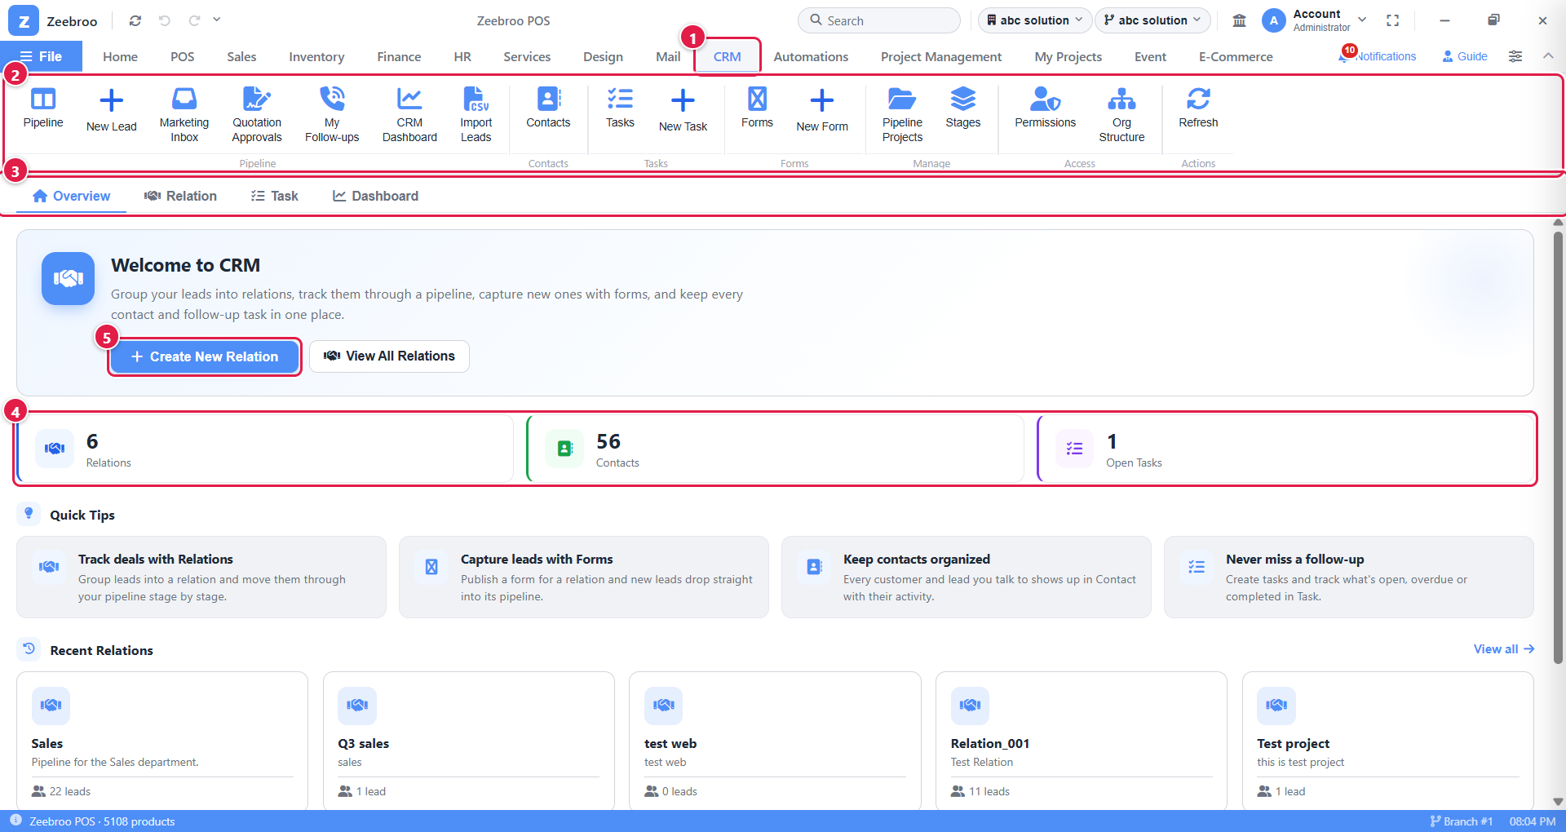
Picture 1. The CRM home page (Overview)
1 | CRM tab. Click here to open the CRM from anywhere in Zeebroo.
2 | CRM ribbon. All CRM buttons live here. Chapter 3 explains each one.
3 | Sub-tabs. Overview (home), Relation (your sales boards), Task (to-do list) and Dashboard (reports).
4 | Summary tiles. How many relations, contacts and open tasks you have right now.
5 | Create New Relation. Start a new sales board (see Chapter 6).

Further down the page you will find Quick Tips and Recent Relations. Click any relation card to open its board straight away.
TIP Some buttons may be missing on your screen. That is normal. You only see what your role allows. If you need a button you cannot see, ask your CRM administrator (see Chapter 5).

3. The CRM ribbon: every button explained
WHERE TO FIND IT CRM tab › the button bar at the top
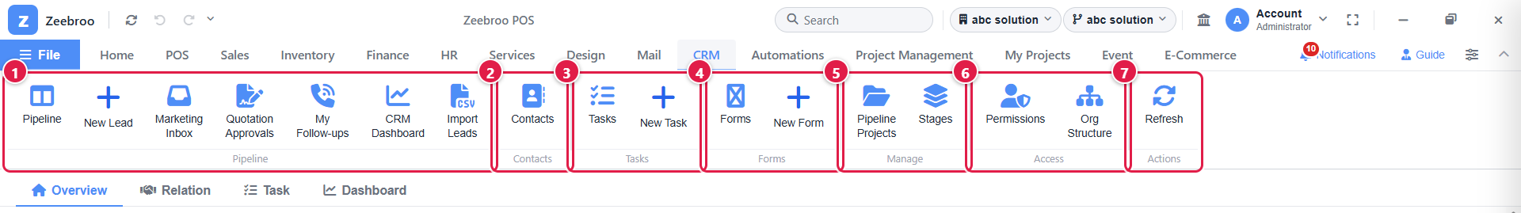
Picture 2. The CRM ribbon, split into 7 groups
1 | Pipeline group. Your daily work: open boards, add leads, inbox, approvals, follow-ups, reports and import.
2 | Contacts. A list of everyone your team has talked to.
3 | Tasks. See your to-do list or add a new task.
4 | Forms. Web forms that collect leads from your website.
5 | Manage. Create new sales boards and set up their stages.
6 | Access. Who can do what (Permissions) and how your company is organised (Org Structure). For administrators.
7 | Actions. Refresh reloads the screen with the latest data.

Button | Use it when you want to… | Chapter
Pipeline | open the list of sales boards (relations) | 9
New Lead | add a new enquiry by hand | 10
Marketing Inbox | check and clean new leads before they go to sales | 11
Quotation Approvals | approve or return quotations (heads / admins) | 14
My Follow-ups | see which customers you must call back | 15
CRM Dashboard | see sales reports and numbers | 21
Import Leads | upload many leads from an Excel / CSV file | 17
Contacts | search all people in the CRM | 19
Tasks / New Task | see or add to-do items | 18
Forms / New Form | build a web form for your website | 8
Pipeline Projects | create a new sales board (relation) | 6
Stages | add or change the steps of a board | 7
Permissions | control what each user can do | 5
Org Structure | link departments to boards and set rules | 4
Refresh | reload the latest data | n/a

4. Setup step 1: Org Structure (admin)
This is a one-time setup, done by an administrator. It tells the CRM which department owns which sales board, and sets a few rules.
WHERE TO FIND IT CRM tab › Org Structure (Access group)
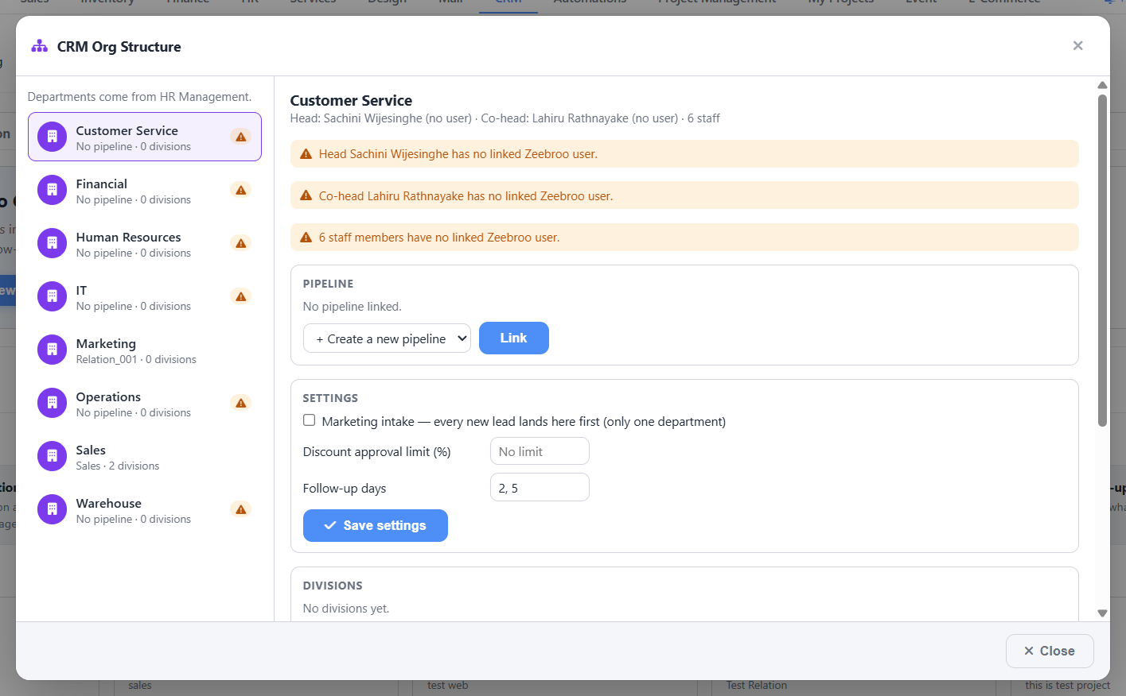
Picture 3. CRM Org Structure window
The departments on the left come from HR Management. The head of a department in HR is automatically the head of that department in the CRM.

How to set up a department
- Click a department on the left, for example Sales.
- Under Pipeline, choose an existing board or + Create a new pipeline, then click Link.
- Under Settings, fill in the rules (see the table below).
- Click Save settings.
- Optionally add Divisions (smaller teams inside the department).
- Click Close when you are done.
Setting | What it does | Example
Marketing intake | Every new lead lands in this department first, so the marketing team can check it before it goes to sales. Tick this for only one department. | Tick for "Marketing"
Discount approval limit (%) | Quotations with a discount up to this % can be sent without the head's approval. Bigger discounts need approval. | 10 = up to 10% is OK without approval
Follow-up days | After a quotation is sent, the CRM reminds staff to call the customer on these days. | 2, 5 = reminders after 2 and 5 days

BE CAREFUL If you see orange warnings such as "Head has no linked Zeebroo user", the person in HR does not have a Zeebroo login yet. Link them to a user in HR so they can use the CRM as head.

5. Setup step 2: Who can do what (Permissions)
WHERE TO FIND IT CRM tab › Permissions (Access group)
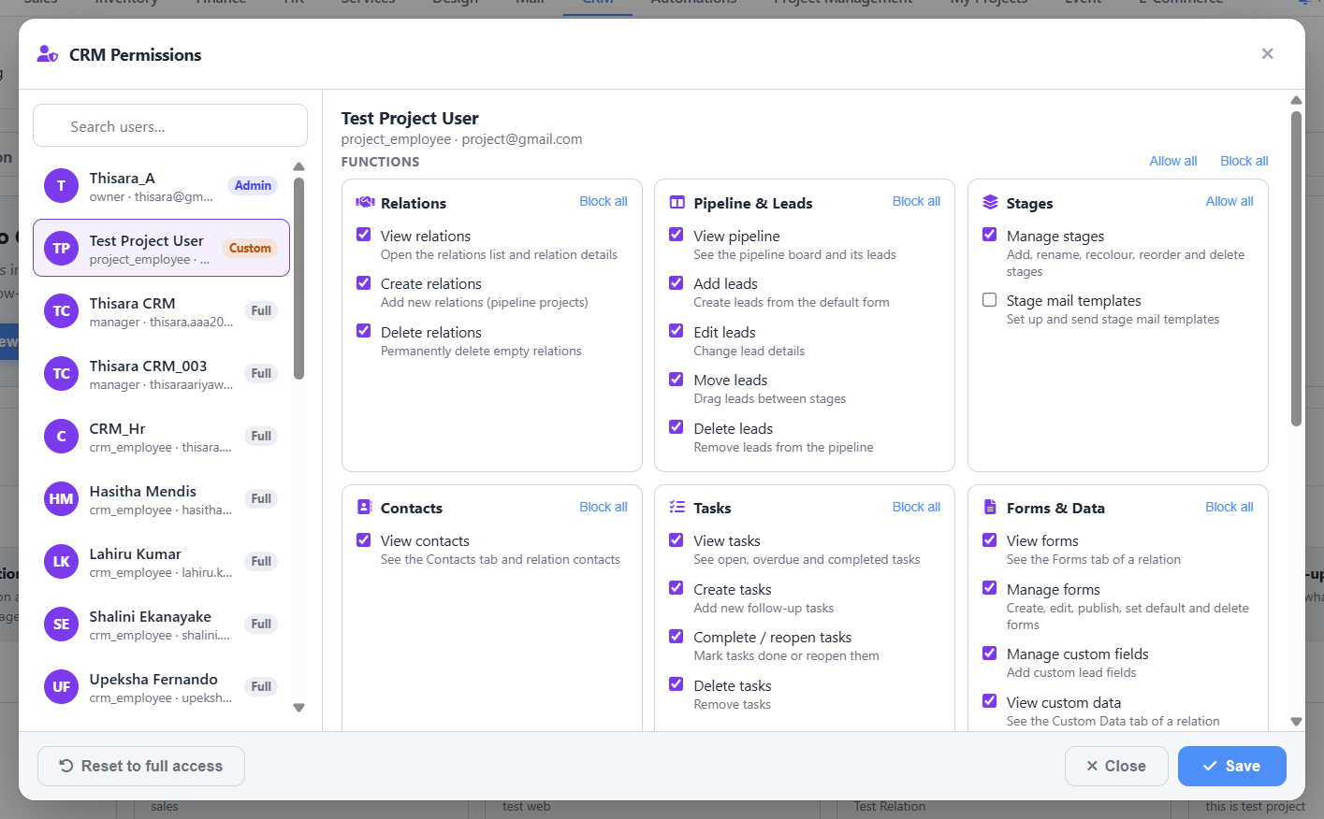
Picture 4. CRM Permissions window
Every user has a CRM role. The role decides the basic access:
Role | Who | What they can do
Admin | Owner / CRM manager | Everything.
CEO | Top management | Can look at everything, including reports, but cannot change anything.
Marketing | Marketing team | Checks new leads in the Marketing Inbox and sends them to the right department.
Department Head | Head of a sales team | Sees the whole team board, gives leads to staff, approves quotations, sees team reports.
Staff | Sales person | Sees the team board but works only on the leads given to them.

How to change a user's access
- Search for the user in the box on the left and click their name.
- On the right you see 6 groups: Relations, Pipeline & Leads, Stages, Contacts, Tasks and Forms & Data.
- Untick anything the person should not do. Use Block all or Allow all to change a whole group at once.
- Click Save.
EXAMPLE Your new trainee should see leads but not delete them. Open Permissions, click the trainee, untick Delete leads and Delete relations, then click Save. The trainee's name now shows Custom in the list.
TIP Ticks can only take away access. They can never give someone more than their role allows. To undo all changes for a user, click Reset to full access.

6. Setup step 3: Create a sales board (Relation)
A relation is a sales board. Most businesses have one per department, or one per campaign.
WHERE TO FIND IT CRM tab › Relation sub-tab (or the Pipeline button on the ribbon)
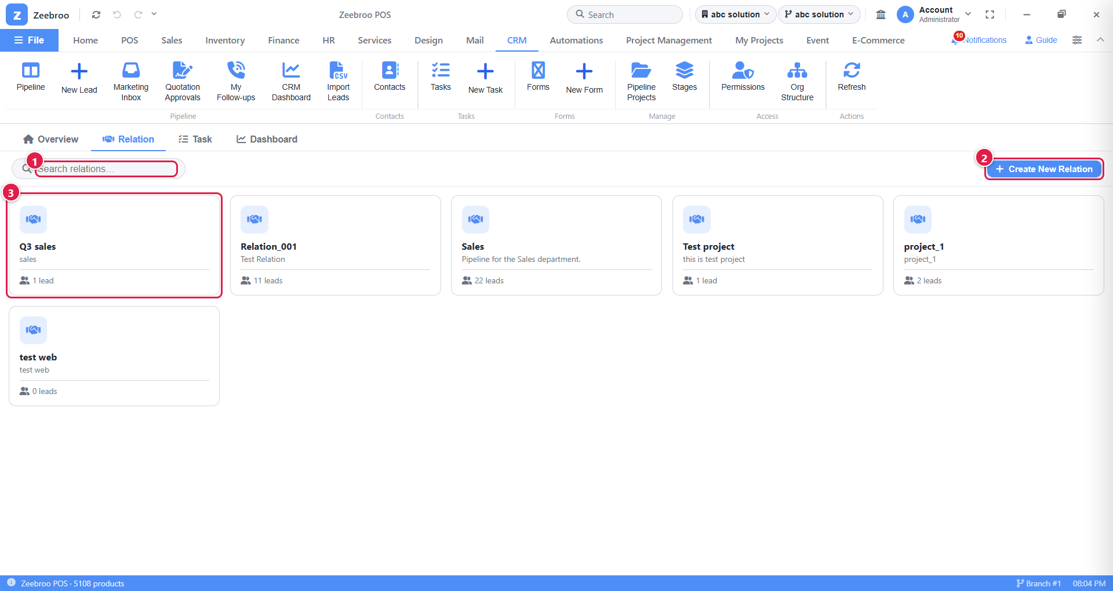
Picture 5. The list of relations
1 | Search box. Type part of a name to find a relation quickly.
2 | Create New Relation. Make a new board.
3 | Relation card. Shows the name, description and number of leads. Click it to open the board.

How to create a relation
- Click Create New Relation.
- Type a Relation Name.
- Type a short Description (optional).
- Click Create Relation.
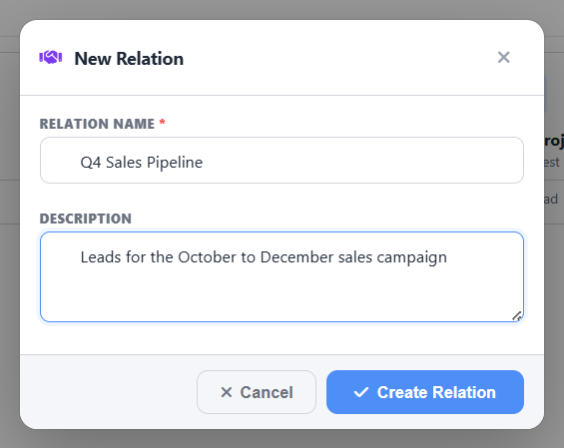
Picture 6. New Relation window, filled in
EXAMPLE Name: Q4 Sales Pipeline. Description: "Leads for the October to December sales campaign".
BE CAREFUL You can only delete a relation when it has no leads in it. Move or delete the leads first, then use Delete Relation.

7. Setup step 4: Stages (the steps of your sale)
Stages are the columns on your board. Each lead sits in one stage, and you move it to the next stage as the sale goes forward.
WHERE TO FIND IT CRM › open a relation › Pipeline tab › Manage Stages (or Stages on the ribbon)
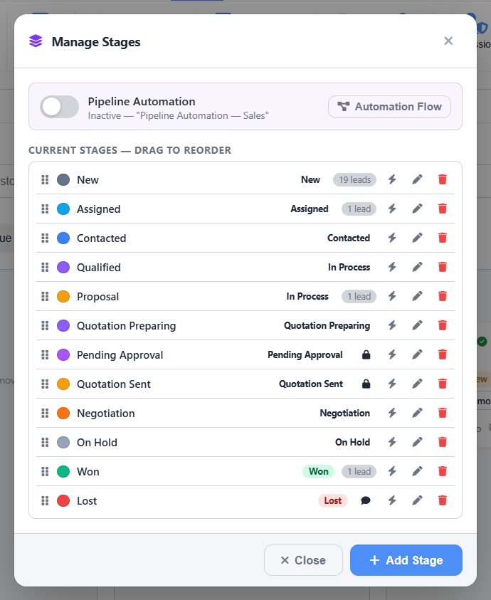
Picture 7. Manage Stages window
Each row is a stage. The coloured dot is its colour, the word on the right is its standard status, and the grey badge shows how many leads are in it.
- Drag the ⋮⋮ handle on the left to change the order.
- The pencil edits a stage. The red bin deletes it.
- The lightning icon sets up an email you can send to everyone in that stage.
- A lock means the CRM moves leads into this stage by itself (for example after a quotation is approved or sent).

How to add a stage
- Click Add Stage at the bottom.
- Type a Name and pick a Colour.
- Choose a Standard Status. This tells the CRM what the stage means (for reports).
- Tick Ask for a reason when a lead moves here if staff must explain why, for example for a "Lost" stage.
- Click Add Stage.
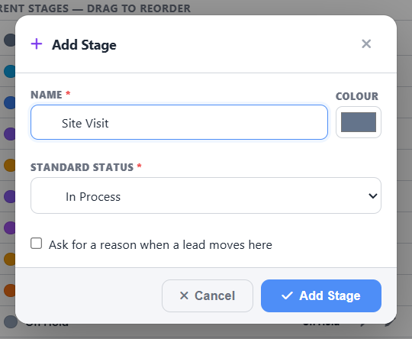
Picture 8. Add Stage window
EXAMPLE You visit customers before quoting. Add a stage called Site Visit, colour orange, standard status In Process, and drag it between Contacted and Quotation Preparing.

What do the standard statuses mean?
Status | Meaning
New | Just arrived. Nobody has looked at it yet.
Assigned | Given to a sales person.
Contacted | We have spoken to the customer.
In Process | Talking about what they need.
Quotation Preparing | A price offer is being made. (Set automatically when you create a quotation.)
Pending Approval | The quotation is waiting for the head to approve it. (Automatic.)
Quotation Sent | The customer has the quotation. (Automatic.)
Negotiation | The customer wants a better price or changes.
On Hold | Paused for now.
Won | The customer said yes.
Lost | The customer said no. A reason is needed.

Pipeline Automation
At the top of the Manage Stages window is Pipeline Automation. Turn it on and click Automation Flow to link an automation (made in the Automations tab), for example "send a WhatsApp when a lead reaches Won".

8. Setup step 5: Web forms (get leads from your website)
A form is a small page on the internet. When a customer fills it in, a new lead appears on your board automatically. No typing needed.
WHERE TO FIND IT CRM › open a relation › Forms tab (or Forms / New Form on the ribbon)

8.1 Create a form
- In the Forms tab, click New Form.
- Step 1, Details: type the Form name and choose the Form type (Customer Contact Form is the usual one). Tick Set as default form for this project if this form should also be used when staff click New Lead.
- Click Next.
- Step 2, Template: pick a ready-made template or start blank. Click Next.
- Step 3, Finish: choose which stage new leads go into and the thank-you message. Click Create Form.
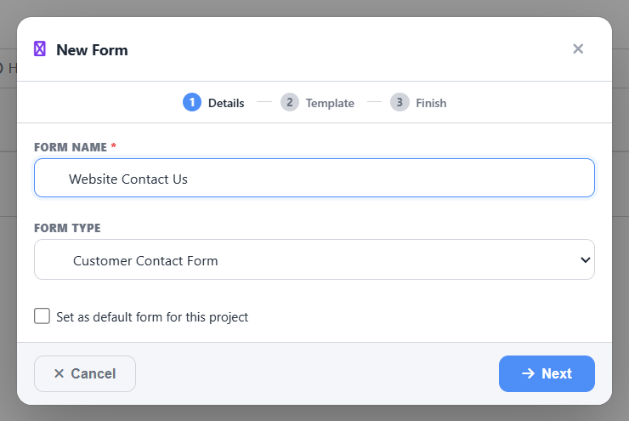
Picture 9. New Form wizard, step 1

8.2 Design the form
After creating the form, the form builder opens. You can also open it later with the pencil icon on a form in the Forms tab.
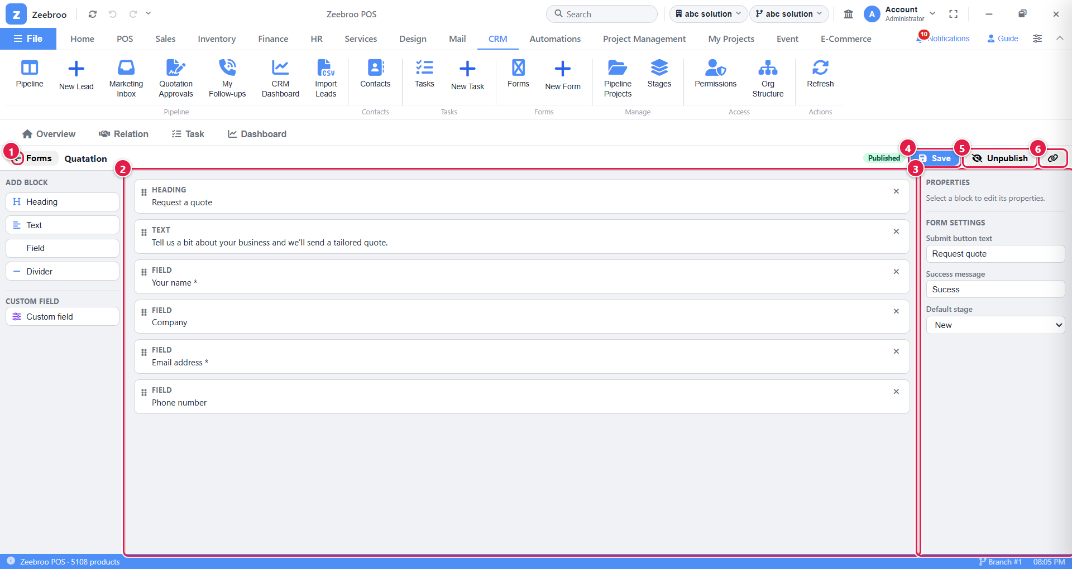
Picture 10. The form builder
1 | Back to Forms. Go back to the list of forms.
2 | Your form. The blocks in order. Drag the ⋮⋮ handle to reorder them, or click × to remove one. To add a block, click Heading, Text, Field, Divider or Custom field in the Add Block panel on the far left.
3 | Properties. Click a block to change its label or make it required. Below that, Form settings has the button text, thank-you message and default stage.
4 | Save. Saves your changes.
5 | Publish / Unpublish. Puts the form online, or takes it offline.
6 | Copy link. Copies the public web address of the form. Paste it on your website, Facebook page or WhatsApp.

EXAMPLE Create a form called Request a quote with the fields Your name, Company, Email address and Phone number. Publish it and put the link on your website's "Contact us" page. Every customer who fills it in appears in the New column of your Sales board.

8.3 Custom fields
Need extra information, like budget or preferred delivery date? Click Custom field in the builder, then fill in:
- Field name, for example "Budget".
- Field type: Text, Long text, Number, Date, Dropdown, Radio buttons, Checkboxes or a Yes/No checkbox.
- For Dropdown, Radio and Checkboxes, type one option per line (for example Small, Medium, Large).
Click Add Field. The answers appear in the Custom Data tab of the relation (Chapter 20).

9. Your sales board (Pipeline)
This is where you spend most of your day. Each column is a stage and each card is a lead.
WHERE TO FIND IT CRM › Pipeline (ribbon) › click a relation, for example Sales › Pipeline tab
When you open a relation, you first see its header and tabs:
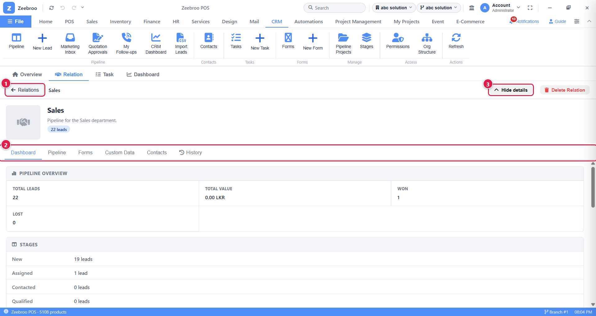
Picture 11. An open relation
1 | ← Relations. Go back to the list of relations.
2 | Tabs. Dashboard, Pipeline, Forms, Custom Data, Contacts and History.
3 | Hide details. Hides the big header to give the board more room.

Now click the Pipeline tab:
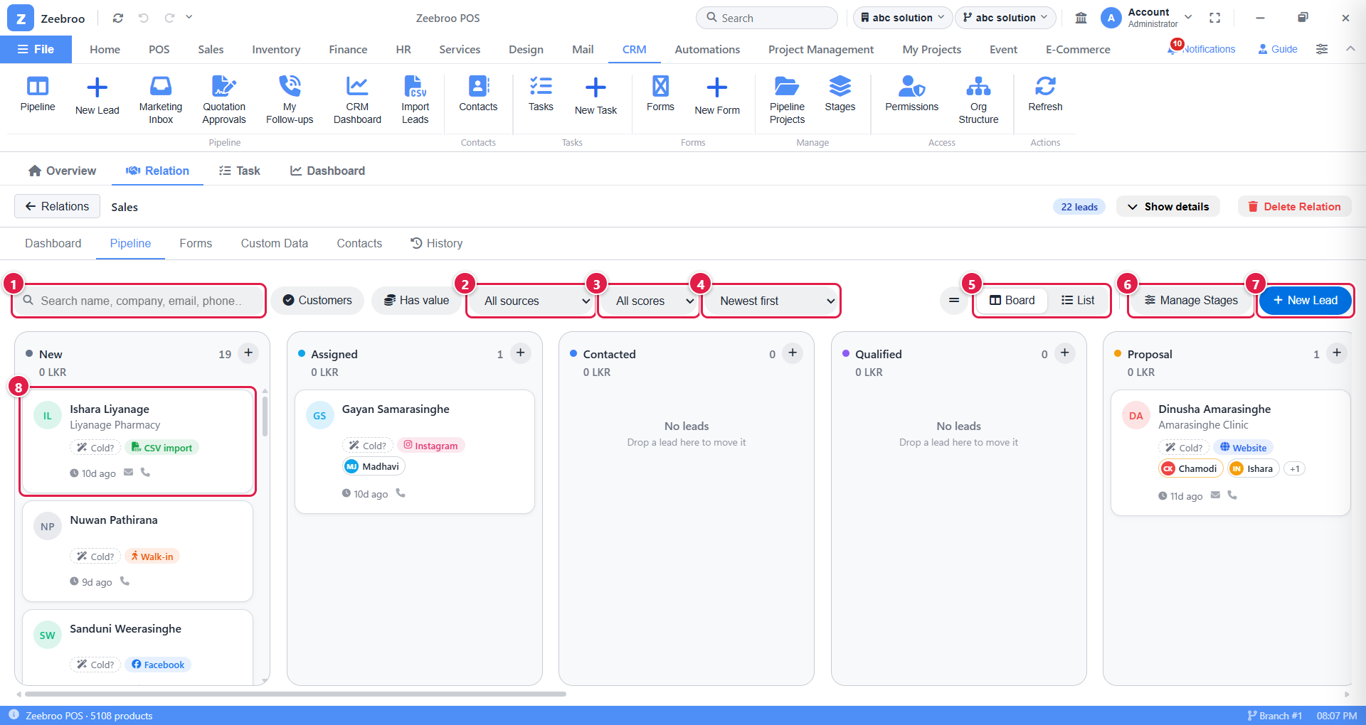
Picture 12. The Pipeline board
1 | Search. Find a lead by name, company, email or phone.
2 | Source filter. Show only leads from, for example, Facebook or Website.
3 | Score filter. Show only Hot, Warm or Cold leads.
4 | Sort. Order the cards (for example Newest first or by score).
5 | Board / List. Switch between columns (Board) and a table (List).
6 | Manage Stages. Change the columns (Chapter 7).
7 | New Lead. Add a lead to this board (Chapter 10).
8 | A lead card. Shows the name, company, score, source, who is working on it and how long ago it was updated. Click it to open the lead. Drag it to another column to move it.

The board is wider than the screen. Scroll sideways (or use the scroll bar at the bottom) to see the later stages:
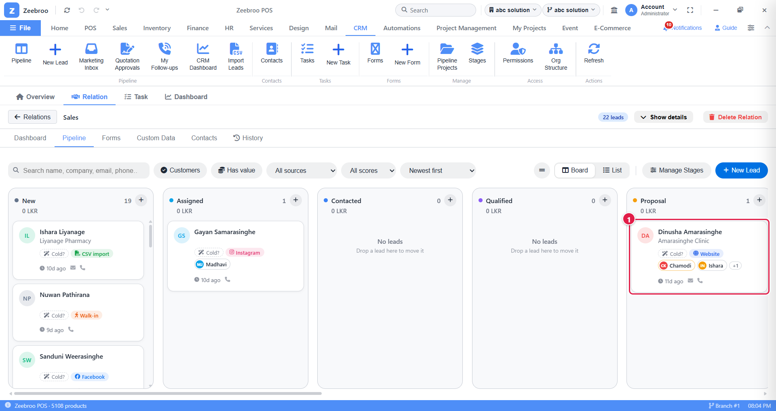
Picture 13. Later stages: Dinusha Amarasinghe is in Proposal
On each card you can see the score (here "Cold?", a suggestion), the source (Website) and the people working on it (Chamodi, Ishara and one more).
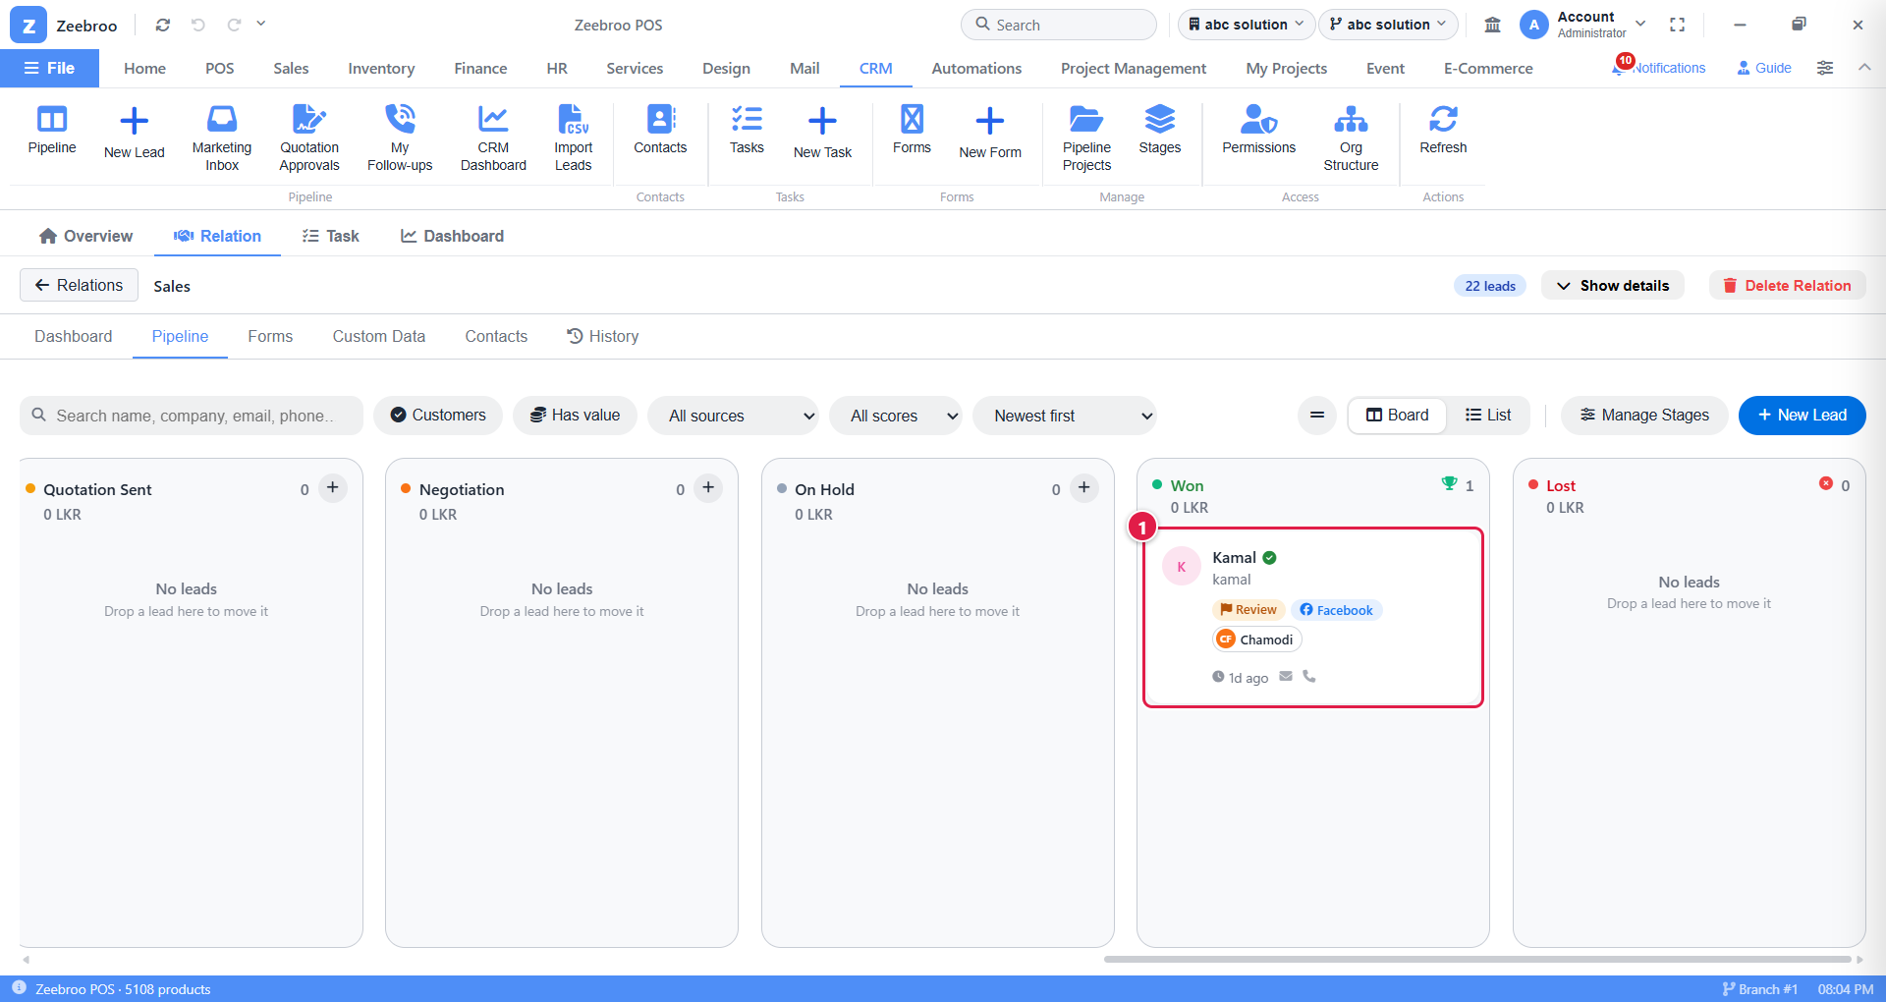
Picture 14. Kamal's card in the Won column
Kamal's card shows a green tick next to his name (he is now a customer), the Review flag (Marketing still needs to check something), his source Facebook, and Chamodi who is working on it. The trophy at the top of the Won column counts the won leads.

9.1 Moving a lead to the next stage
- Press and hold on the lead card.
- Drag it to the new column and let go.
- If the stage needs a reason (for example Lost), a small window asks for it. Choose or type the reason and click Move.
EXAMPLE You have just phoned Kamal for the first time. Drag his card from New to Contacted. The History tab will later show that he spent 1 hour 4 minutes in New.

9.2 List view
Prefer a spreadsheet look? Click List. Click any column heading to sort by it, for example by value or next follow-up.
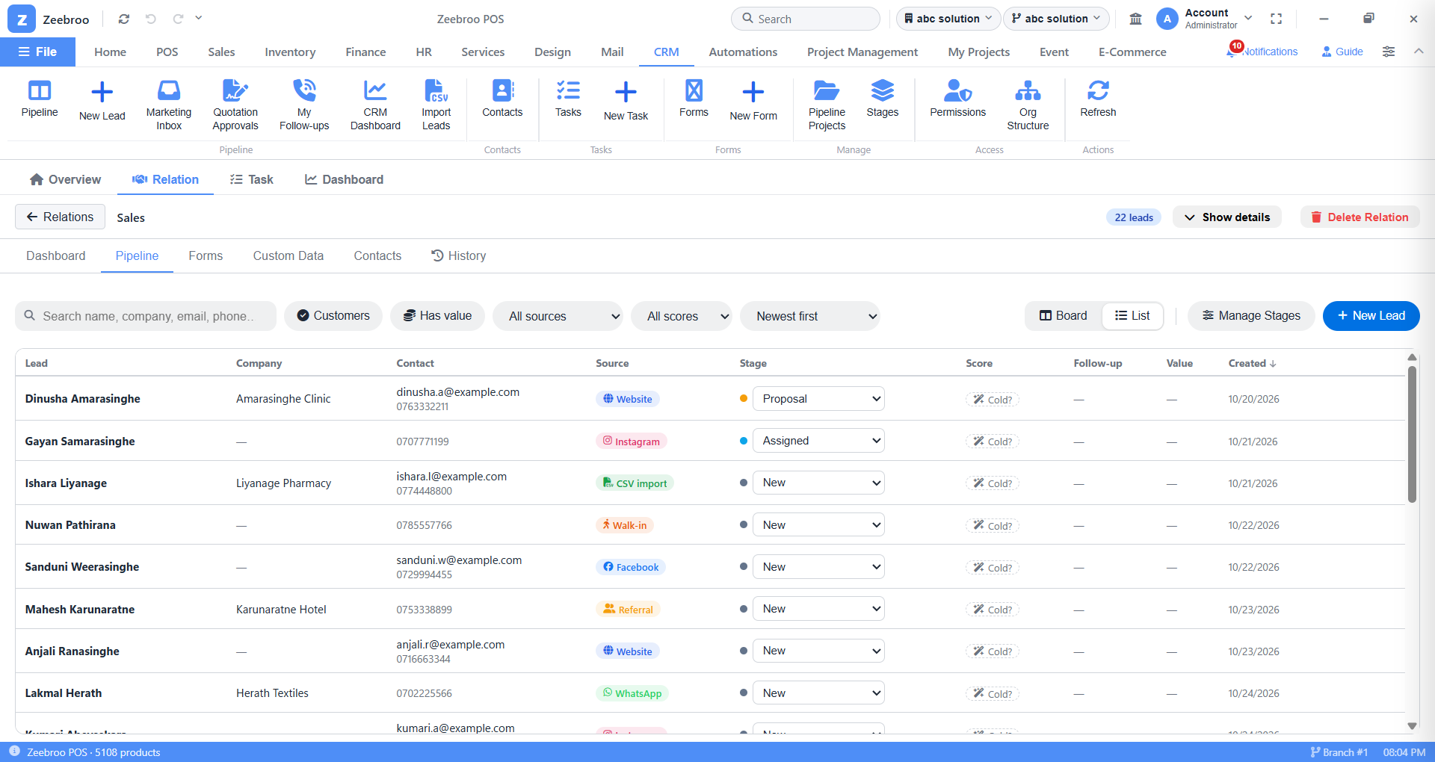
Picture 15. The same board in List view

9.3 Lead scores (Hot / Warm / Cold)
Each card can show Hot, Warm or Cold. Staff or the head choose it. When nobody has chosen yet, the card shows a suggestion with a question mark, such as "Cold?". The CRM works out the suggestion from:
- Where the lead came from. Referrals and walk-ins count most.
- How big the deal is compared with the other leads.
- How recently someone talked to them.
- Whether a quotation has been sent.
TIP Use the score filter each morning to show only Hot leads and call those first.

10. Adding a new lead
WHERE TO FIND IT CRM › New Lead (ribbon) or open a board › Pipeline tab › New Lead
- Click New Lead.
- Fill in the details. Fields marked with a red star ( * ) must be filled.
- Choose the Lead source: how did this customer find you?
- Click Save Lead. The new card appears in the first column of the board.
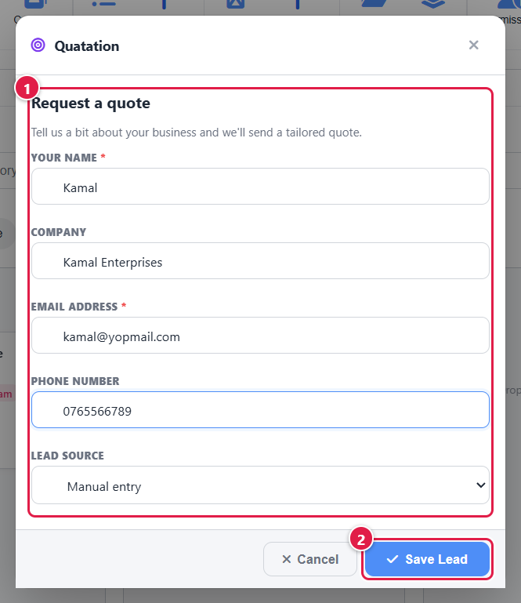
Picture 16. New Lead window, filled in with our example
1 | Lead details. These fields come from the board's default form, so they may differ on your screen.
2 | Save Lead. Saves the lead. Cancel closes without saving.

EXAMPLE Name: Kamal · Company: Kamal Enterprises · Email: kamal@yopmail.com · Phone: 0765566789 · Source: Facebook. Because Kamal already has an open lead with this phone and email, saving this form would not create a second card. Read on to see why.

What if the customer already exists?
The CRM checks the phone number and email for you. It never creates a messy double entry:
If… | Then the CRM…
the person already has an open lead | does not make a new lead. It adds this enquiry to the existing lead and flags it Needs review.
the person only has old, closed leads | makes a new lead and marks it as a possible duplicate, so Marketing can decide.
the person is already a customer | makes a new lead linked to that customer and flags it for review. The card shows Already a Customer.

11. Marketing Inbox: checking new leads
For the marketing team. New leads (and leads flagged for review) wait here. Marketing checks the details, fixes mistakes and sends each lead to the right department.
WHERE TO FIND IT CRM › Marketing Inbox (ribbon)
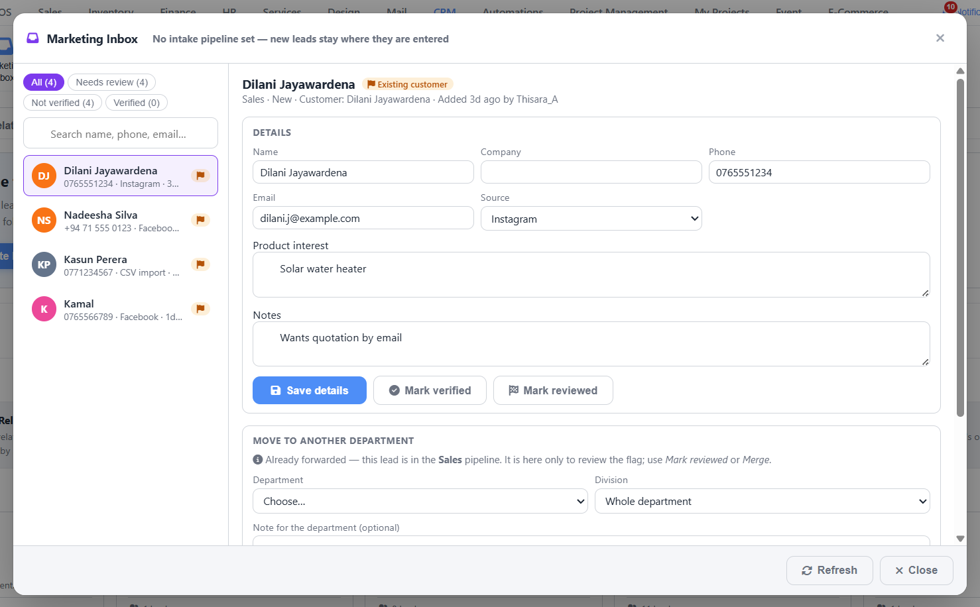
Picture 17. Marketing Inbox

How to work the inbox
- Use the filter chips at the top left: All, Needs review, Not verified or Verified.
- Click a lead in the list on the left.
- Check and correct the Details (name, phone, email, source, product interest, notes). Click Save details.
- Click Mark verified when the details are correct.
- If it was flagged, check the reason and click Mark reviewed, or merge it with the duplicate.
- Under Move to another department, choose the Department and Division, add a note if you like, and send it.
EXAMPLE Dilani Jayawardena sent an enquiry on Instagram about a solar water heater. Marketing checks her phone number, marks her verified and sends her to the Sales department.
TIP The orange flag next to a name means the lead needs review, for example because it might be a duplicate.

12. Inside a lead (Lead Details)
Click any lead card to open its Lead Details. Everything about this customer is here.
WHERE TO FIND IT CRM › open a board › Pipeline tab › click a lead card
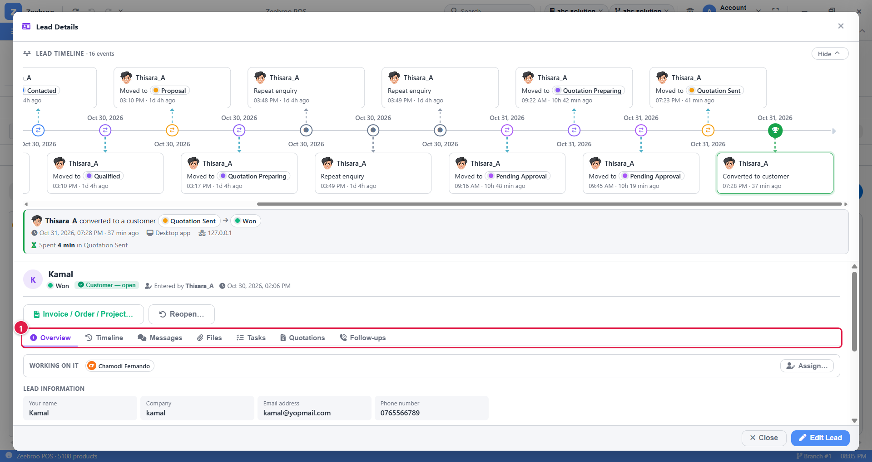
Picture 18. Lead Details, Overview tab
At the top you see the lead timeline, a picture of every stage the lead has been through. Below that:
- For an open lead you see Mark Won…, Put on Hold and Mark Lost (Chapter 16). Kamal's lead is already Won, so it shows Invoice / Order / Project… and Reopen… instead.
- The tabs (marker 1) hold all the lead's information.
- Working on it shows who is handling the lead. Click Assign… to change it.
- Edit Lead (bottom right) changes the lead's details.
Tab | What you do there
Overview | See the lead's details, who is working on it, and the record information.
Timeline | See everything that happened, in date order: calls, moves, messages, quotations.
Messages | Write notes to your team about this lead, and reply to them.
Files | Attach documents and photos, for example site photos or a signed order.
Tasks | Add to-do items for this lead.
Quotations | Create and send price offers (Chapter 13).
Follow-ups | See and record call-backs (Chapter 15).

12.1 Giving a lead to a team member (Assign)
Department heads and admins decide who works on a lead.
- In the Overview tab, click Assign….
- Choose one or more people. Mark one as the main (primary) person.
- Add a note for the team if you like.
- Click Save Assignees.
EXAMPLE Kamal's lead is assigned to Chamodi Fernando. You can see her name under Working on it. She sees the lead on her board and gets its follow-up reminders.

12.2 The other tabs
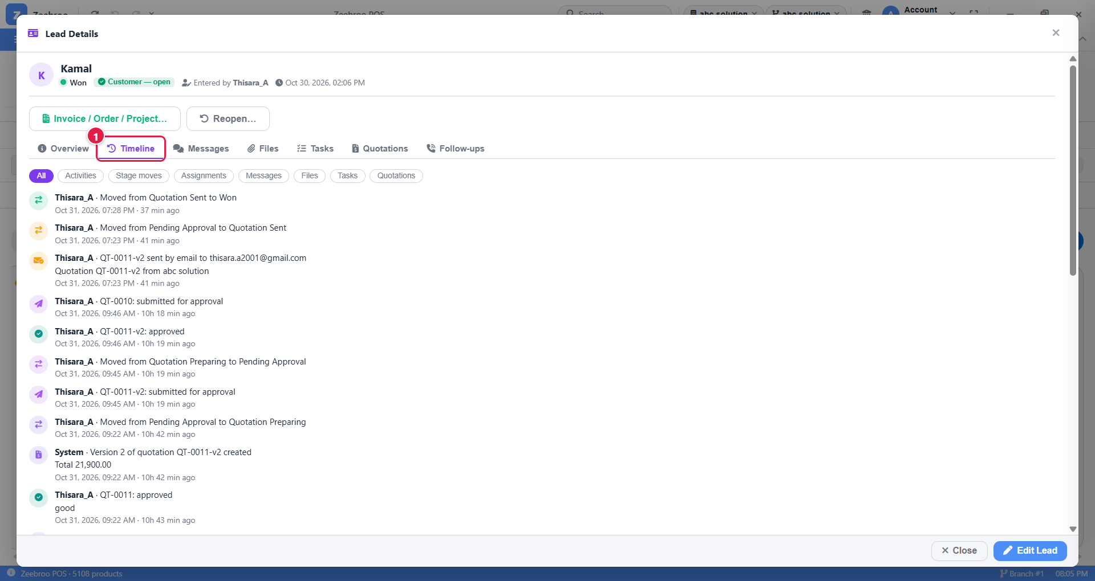
Picture 19. Timeline tab of Kamal's lead
The Timeline lists everything newest first: stage moves, quotations submitted and approved, and the quotation emailed to the customer. Click the chips (Activities, Stage moves, Assignments, Messages, Files, Tasks, Quotations) to show only one kind.
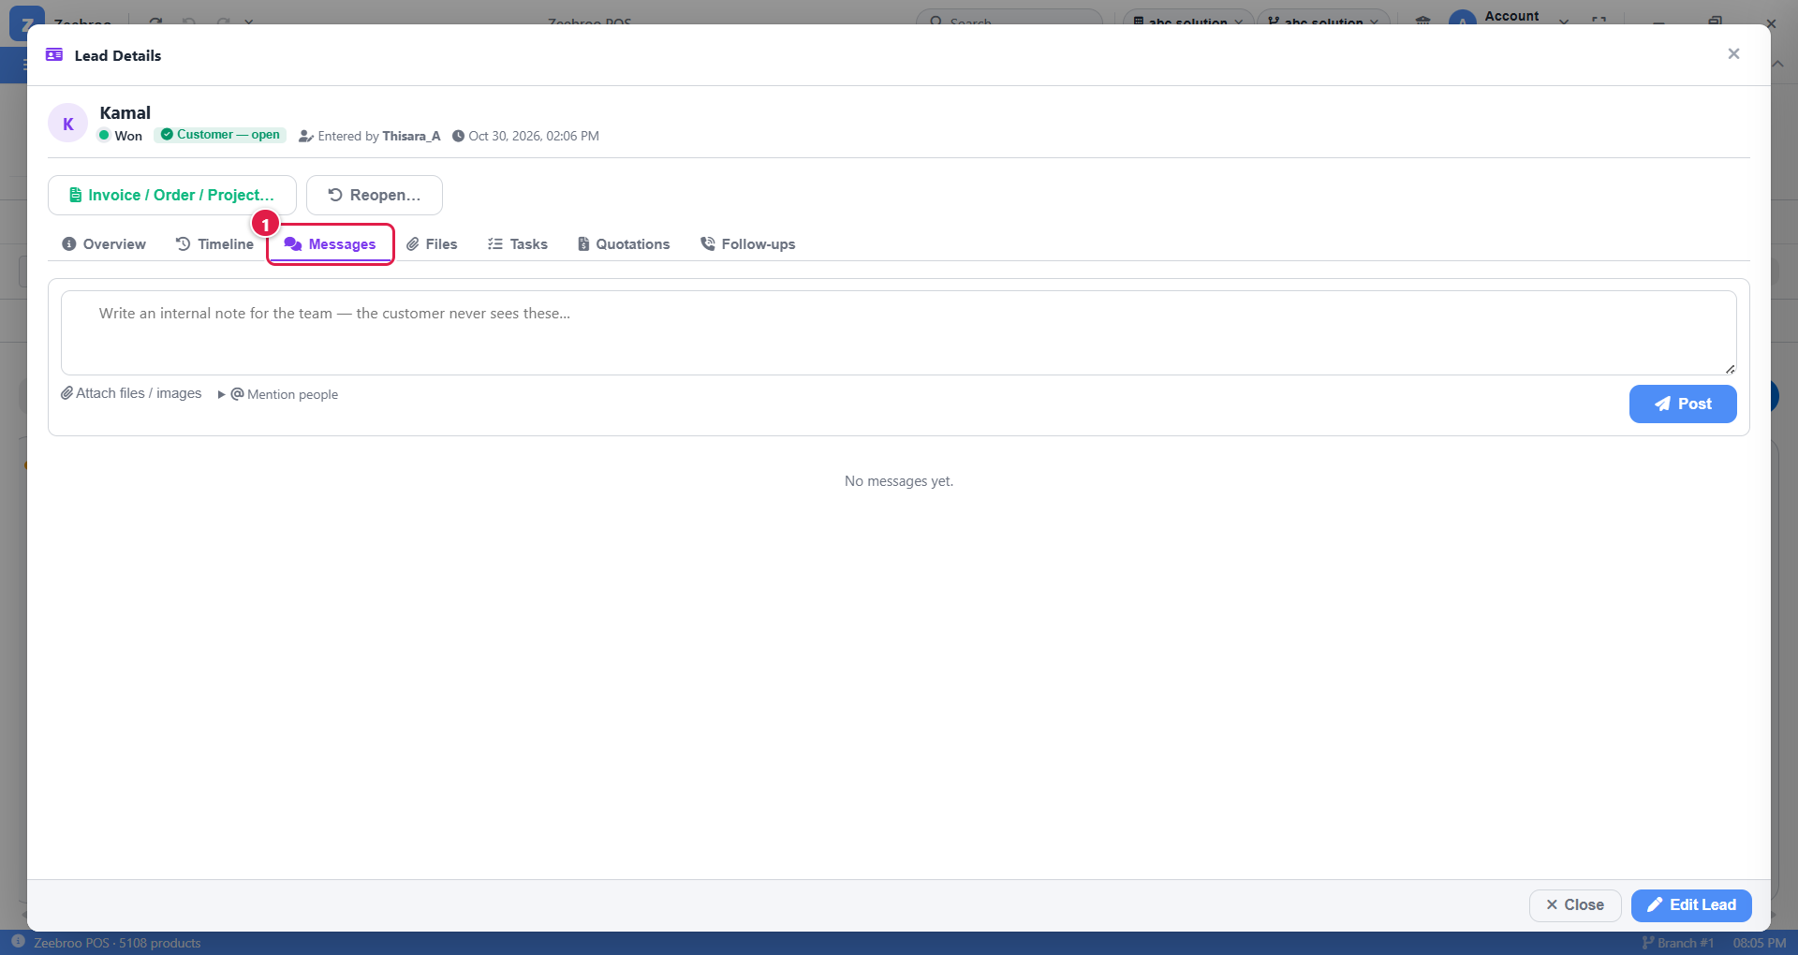
Picture 20. Messages tab
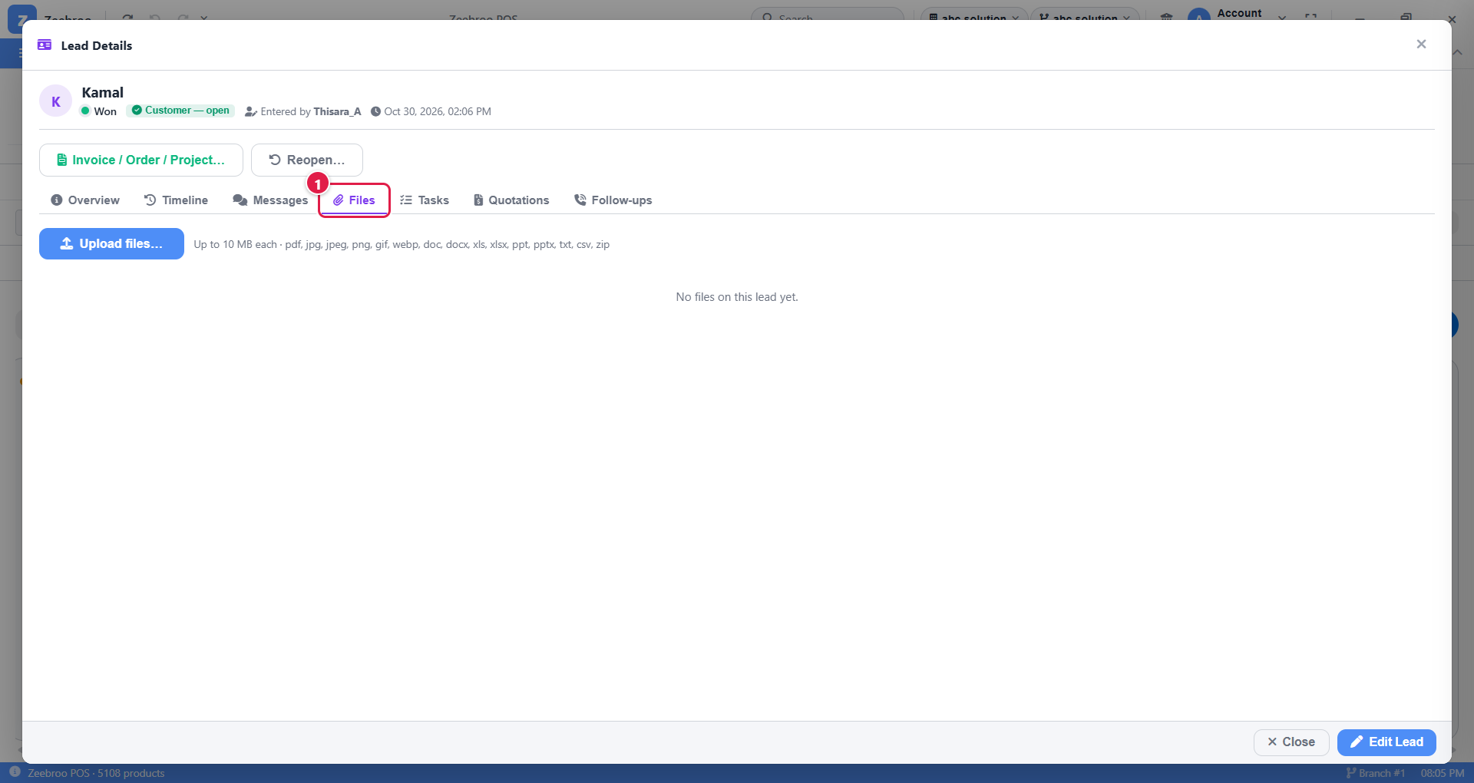
Picture 21. Files tab
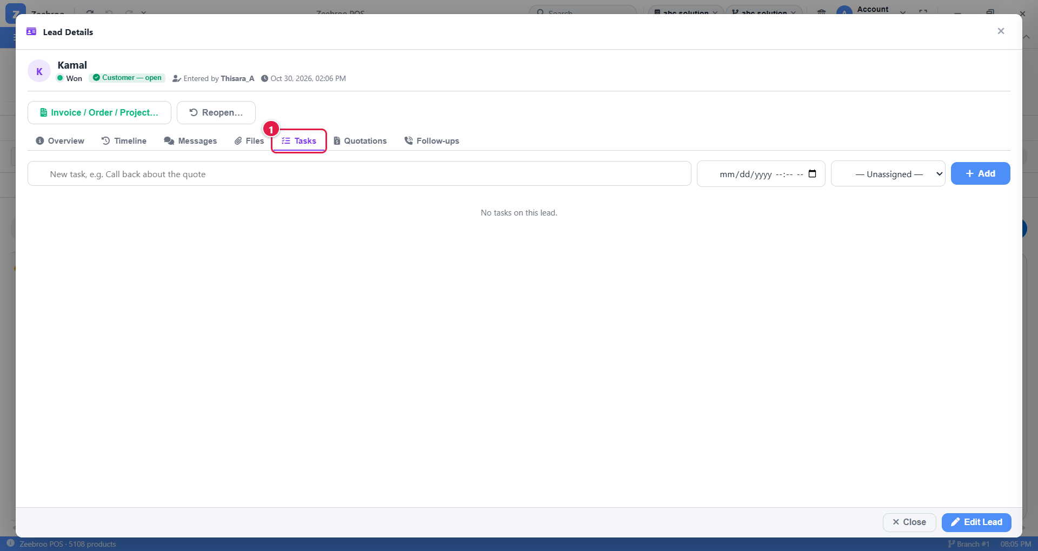
Picture 22. Tasks tab

13. Sending a quotation
WHERE TO FIND IT Open the lead › Quotations tab › Create quotation
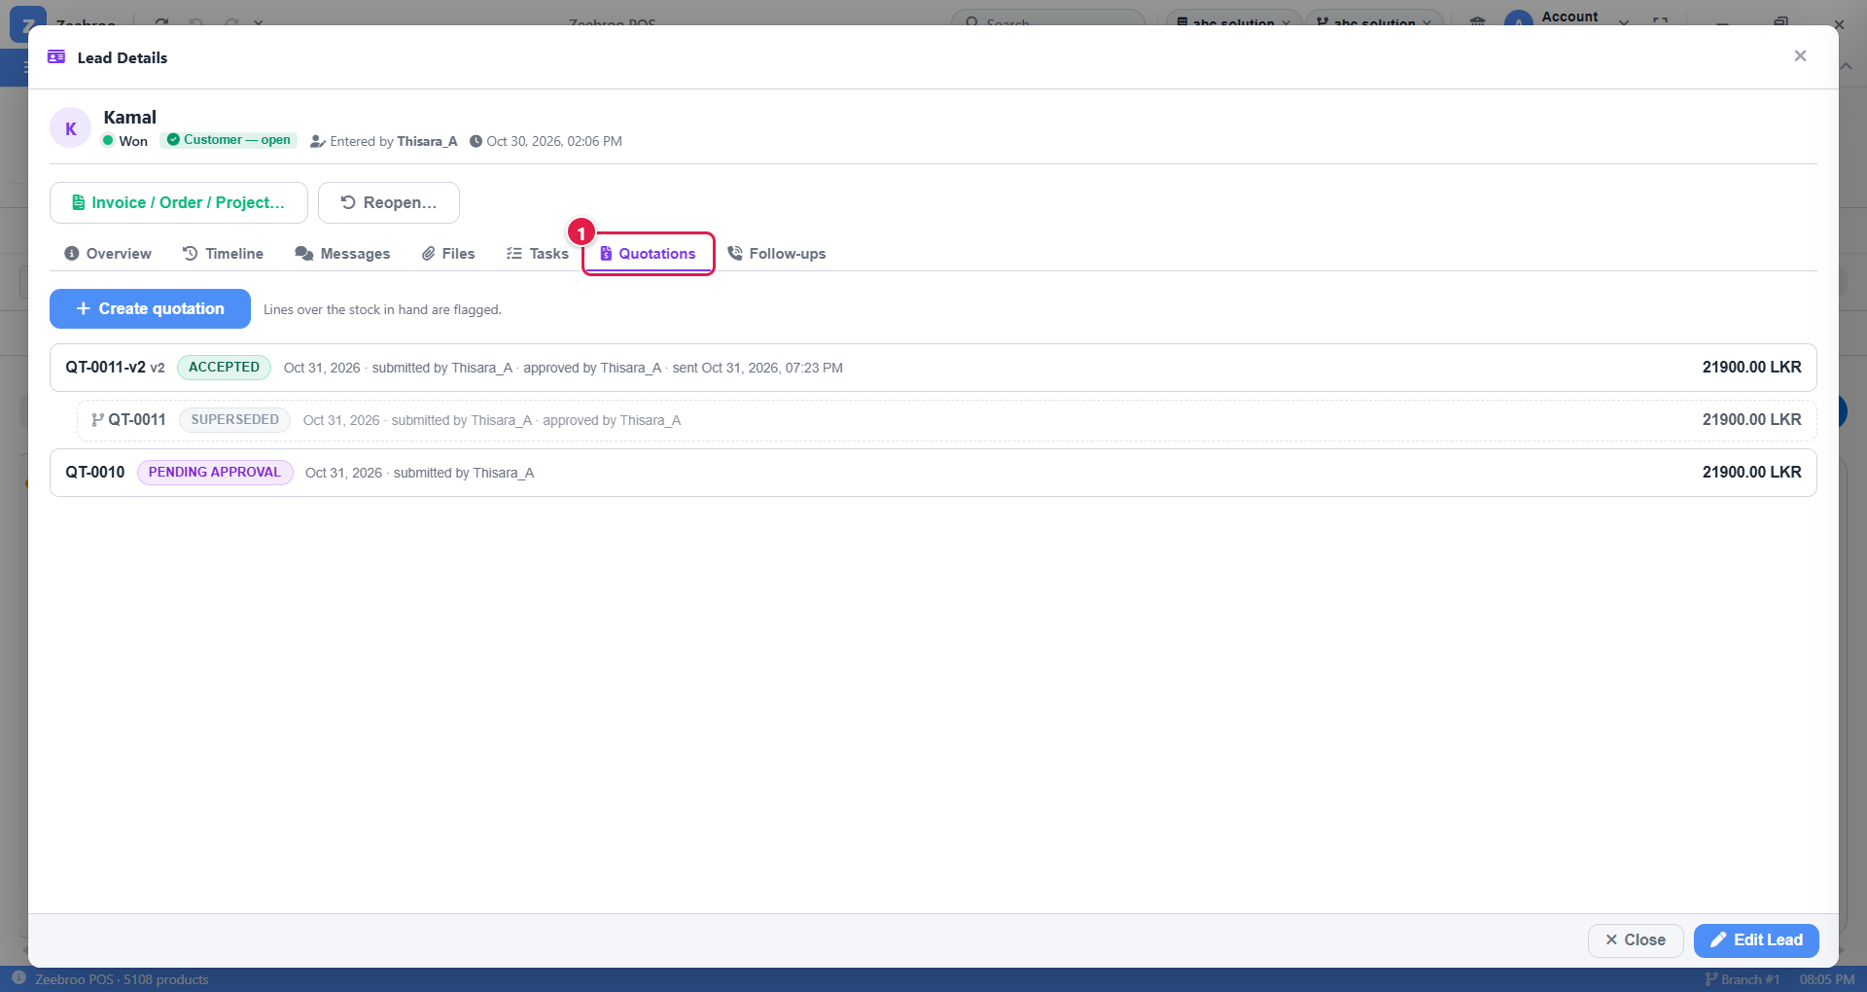
Picture 23. Quotations tab of Kamal's lead
Each quotation shows its number, status, who submitted and approved it, when it was sent, and the total. In Kamal's lead:
- QT-0011-v2 · ACCEPTED: version 2, approved, sent on Oct 31 and accepted by Kamal (LKR 21,900).
- QT-0011 · SUPERSEDED: the first version, replaced by version 2.
- QT-0010 · PENDING APPROVAL: another quotation still waiting for the head.

13.1 Create the quotation
- Open the lead and click the Quotations tab.
- Click Create quotation.
- Add the products from your inventory, with quantity, price and any discount.
- Save it. The lead moves to Quotation Preparing by itself.
TIP The CRM checks your stock. Lines asking for more than you have in stock are flagged. Depending on your settings, it only warns you, or it stops you from saving.

13.2 Send it
What happens next depends on the discount:
- Small discount (within the department's limit): you can send it straight away.
- Bigger discount: click Submit for approval. The lead moves to Pending Approval and the head is told (Chapter 14).
Once sent, the lead moves to Quotation Sent and the CRM sets follow-up reminders for you.

13.3 Record the customer's answer
Customer says… | Click… | What happens
"Yes, go ahead" | Accept | The lead becomes Won.
"No thank you" | Reject | The lead becomes Lost. You must choose a reason.
"Can you give a better price?" | Discount request | The lead moves to Negotiation. Make a new version of the quotation and send it.

EXAMPLE Kamal's quotation QT-0011 (LKR 21,900) was created, so the lead moved to Quotation Preparing. It was submitted (Pending Approval) and approved, but a change was needed, so version 2 was made. Version 2 was submitted and approved again, then emailed to Kamal (Quotation Sent). Kamal accepted it and the lead became Won.

14. Approving quotations (heads and admins)
WHERE TO FIND IT CRM › Quotation Approvals (ribbon)
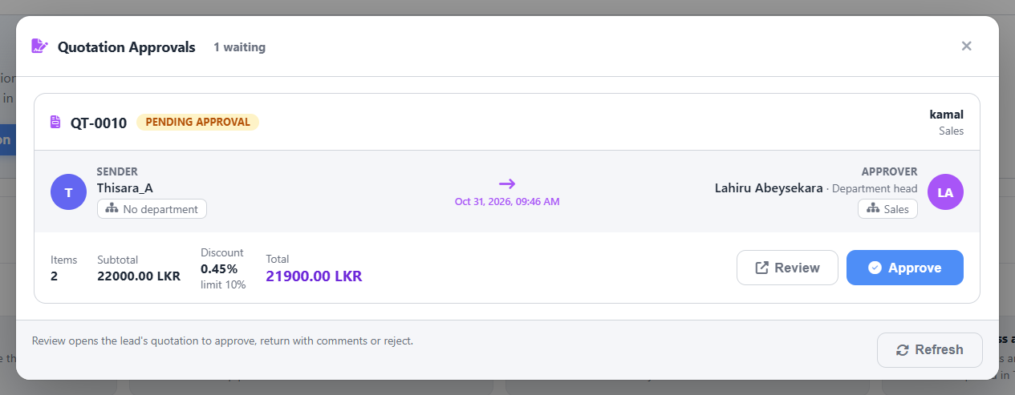
Picture 24. Quotation Approvals
- Open Quotation Approvals. Every quotation waiting for you is listed.
- Click Review to open the quotation.
- Choose one:
- Approve: the quotation PDF is created and staff can send it.
- Return: send it back with a comment, for example "Please reduce discount to 7%". The lead goes back to Quotation Preparing.
- Reject: stop it completely. The lead also goes back to Quotation Preparing.
TIP The CRM Dashboard shows the number of Pending approvals, so nothing waits too long.

15. Follow-ups: never forget to call back
After a quotation is sent, the CRM automatically creates reminders to call the customer again (by default after 2 and 5 days). You get a notification when one is due, and another one if it becomes overdue.
WHERE TO FIND IT CRM › My Follow-ups (ribbon) or open a lead › Follow-ups tab
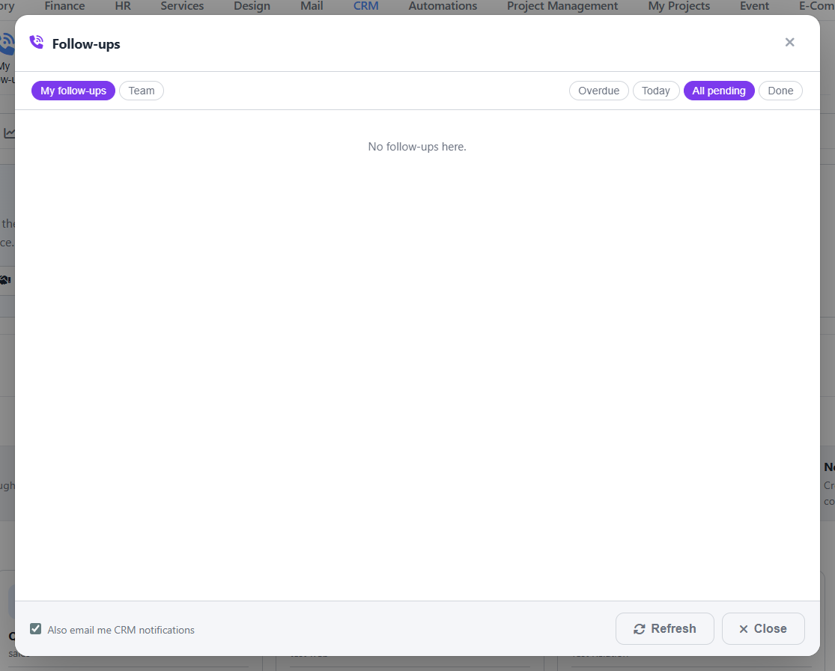
Picture 25. Follow-ups window
- Open My Follow-ups.
- Use Overdue and Today to see what you must do now. All pending shows everything planned, and Done shows finished ones.
- Heads can click Team to see everyone's follow-ups.
- Call or message the customer, then open the follow-up and log what happened. You can plan the next one at the same time.
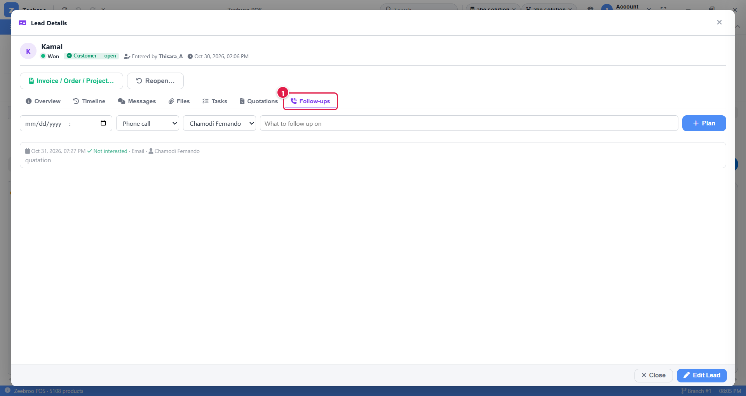
Picture 26. Follow-ups tab of Kamal's lead
To plan a follow-up yourself: pick the date and time, the type (for example Phone call), the person, type what to follow up on, and click + Plan. Below that you see past follow-ups and their result. Kamal's shows one done by email by Chamodi Fernando.
EXAMPLE Two days after the quotation is emailed, Chamodi sees Kamal under Today. She calls him; he wants to check with his partner. She logs the result and plans the next follow-up for Friday.
TIP Tick Also email me CRM notifications at the bottom to get reminders by email too.
When a lead is won or lost, its remaining follow-ups are cancelled automatically.

16. Closing a lead: Won or Lost
WHERE TO FIND IT Open the lead › Mark Won… / Put on Hold / Mark Lost (or drag the card to the Won / Lost column)

16.1 Mark Won
- Open the lead and click Mark Won….
- Choose what to create next: Nothing, an Invoice, a Sales order (both use the quotation's items), or a Project (in Project Management).
- Click Mark Won.
The lead is linked to a customer record. If the customer does not exist yet, the CRM creates one using the lead's phone or email.
EXAMPLE Kamal accepted QT-0011-v2, so his lead is Won and he is now a customer (green tick). The buttons on his lead changed to Invoice / Order / Project…: click it to create the invoice from the quotation's lines. If the lead was closed by mistake, a head or admin can click Reopen….

16.2 Mark Lost
Click Mark Lost, choose a reason (for example "Price too high" or "Bought from competitor") and add a note if you like. Open tasks and follow-ups for the lead are closed.
TIP Lost reasons are very useful. The reports show why you lose deals, so you can fix the problem.

16.3 Put on Hold
Use Put on Hold when the customer says "maybe later". The lead stays on the board in the On Hold stage.

16.4 Reopen a closed lead
Only a department head or admin can reopen a won or lost lead. They click Reopen… on the lead and must give a reason.

17. Importing many leads at once
Have a list of leads in Excel, Google Forms or Facebook? Upload them all in one go instead of typing them.
WHERE TO FIND IT CRM › Import Leads (ribbon)
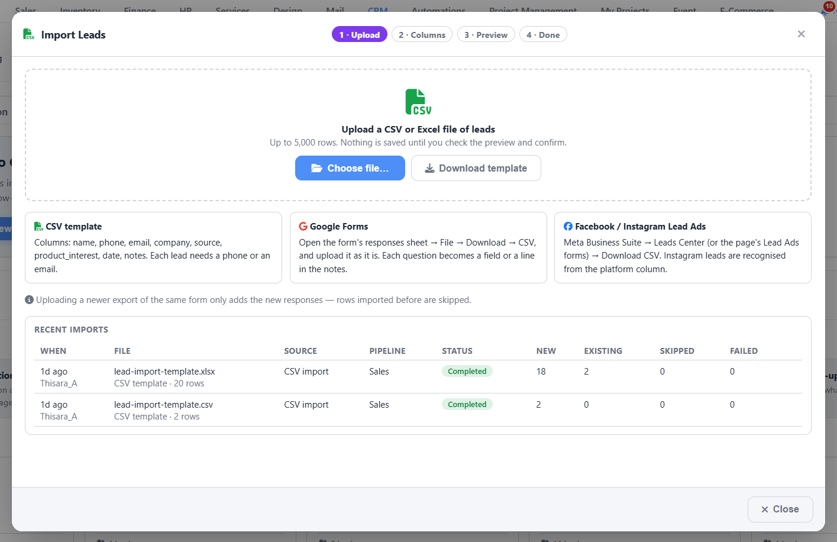
Picture 27. Import Leads, step 1 (Upload)
- 1 · Upload. Click Choose file… and pick your CSV or Excel file (up to 5,000 rows). Not sure about the format? Click Download template first and fill it in.
- 2 · Columns. The CRM guesses which column is the name, phone, email and so on. Check and fix any wrong guesses. Choose what to do with duplicates: add the row to the existing lead as a repeat enquiry, or skip it.
- 3 · Preview. Check every row. Each one shows OK, Duplicate, Error or Skipped.
- 4 · Done. Confirm. Big files import in the background and you can watch the progress.
File type | How to get it
CSV template | Click Download template. Columns: name, phone, email, company, source, product_interest, date, notes. Each lead needs a phone or an email.
Google Forms | Open the form's responses sheet › File › Download › CSV. Upload it as it is.
Facebook / Instagram Lead Ads | Meta Business Suite › Leads Center › Download CSV.

TIP Uploaded the same Google or Facebook form again next week? Only the new responses are added. Old ones are skipped automatically.
Recent imports at the bottom shows your past uploads and how many leads were new, existing, skipped or failed.

18. Tasks: your to-do list
WHERE TO FIND IT CRM › Task sub-tab (or Tasks on the ribbon)
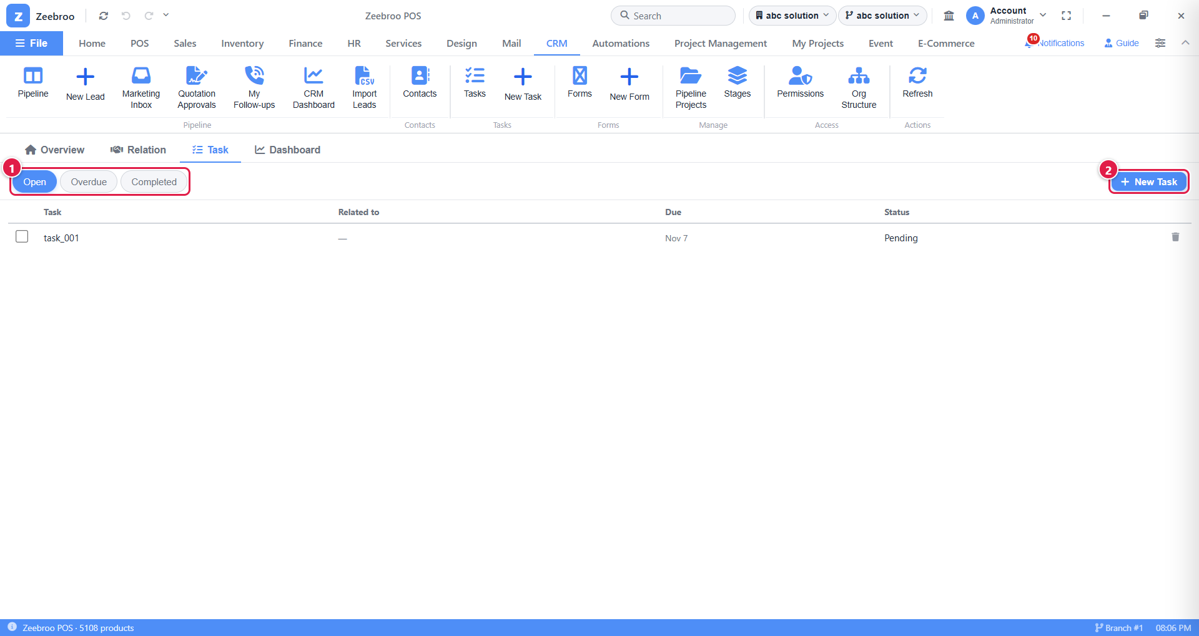
Picture 28. The task list
1 | Filter. Open (still to do), Overdue (late) or Completed (done).
2 | New Task. Add a new to-do item.

How to add a task
- Click New Task.
- Type a Title.
- Pick a Due Date and add Notes if needed.
- Click Create Task.
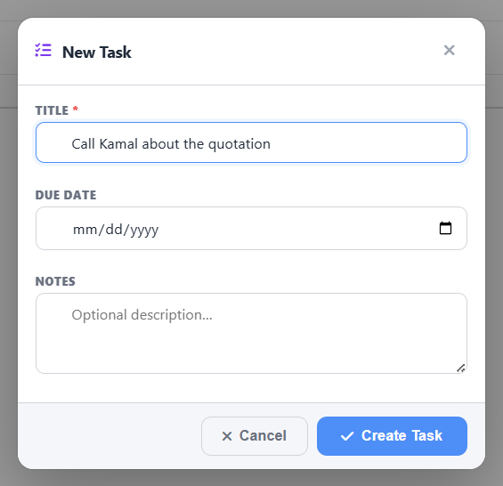
Picture 29. New Task window
Tick the box in front of a task when it is done. Click the bin icon to delete it.
EXAMPLE Title: Call Kamal about the quotation · Due: next Monday · Notes: "Ask if he wants installation too".
TIP Tasks made inside a lead (Tasks tab of the lead) are linked to that lead and show in the Related to column.

19. Contacts: everyone in one list
WHERE TO FIND IT CRM › Contacts (ribbon)
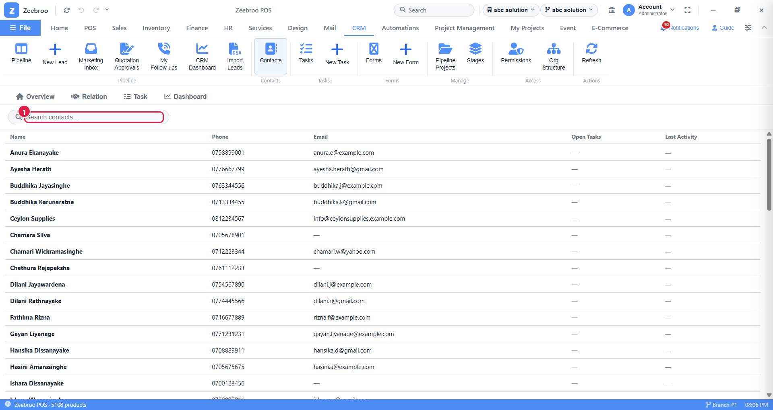
Picture 30. All contacts
Every customer and lead your team has spoken to, across all boards, with phone, email, open tasks and last activity. Type in the search box to find someone quickly.

Contacts of one relation
WHERE TO FIND IT Open a relation › Contacts tab
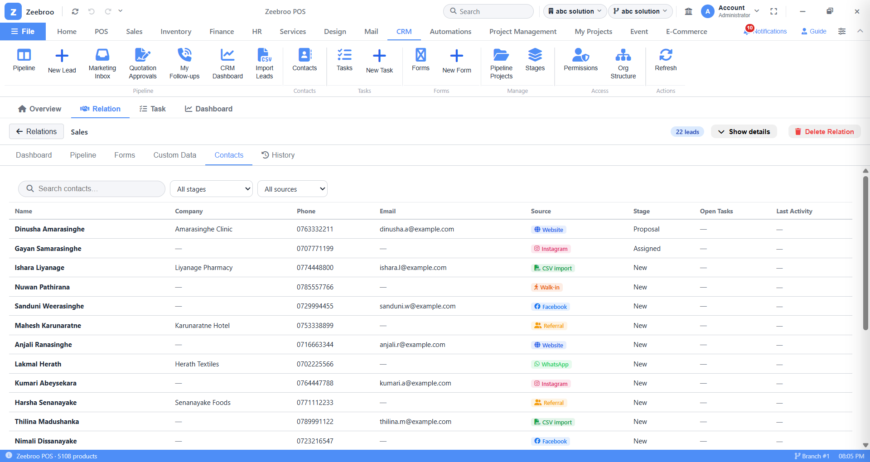
Picture 31. Contacts tab of a relation
This shows only the people on this board. You can also filter by stage and source.

20. Custom Data and History

20.1 Custom Data
WHERE TO FIND IT Open a relation › Custom Data tab
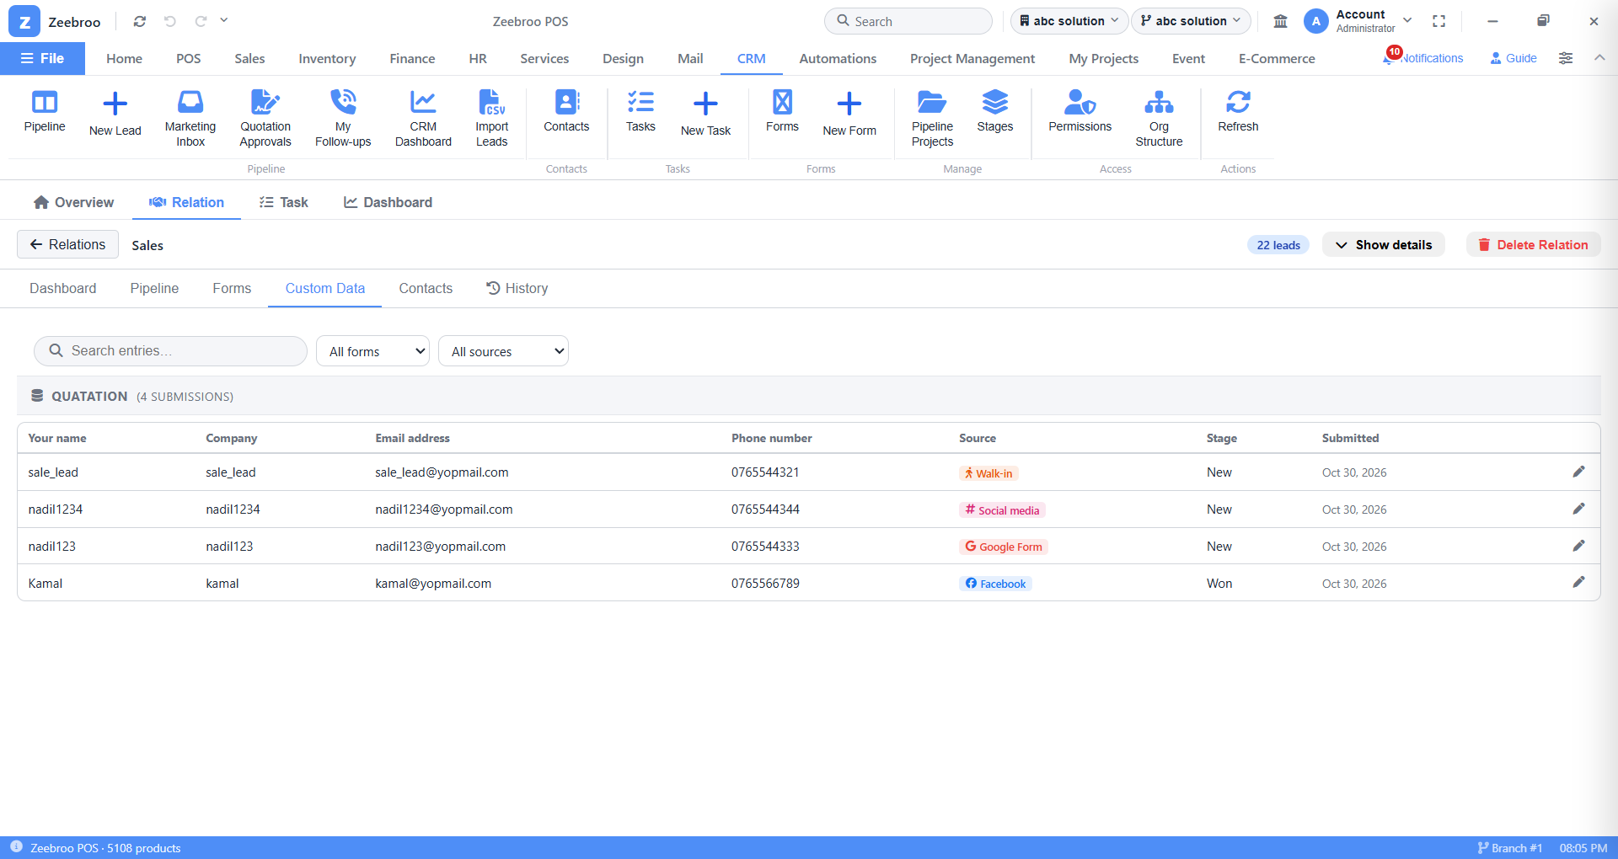
Picture 32. Custom Data tab
All the answers people gave in your forms, grouped by form. Search, or filter by form and source.

20.2 History
WHERE TO FIND IT Open a relation › History tab
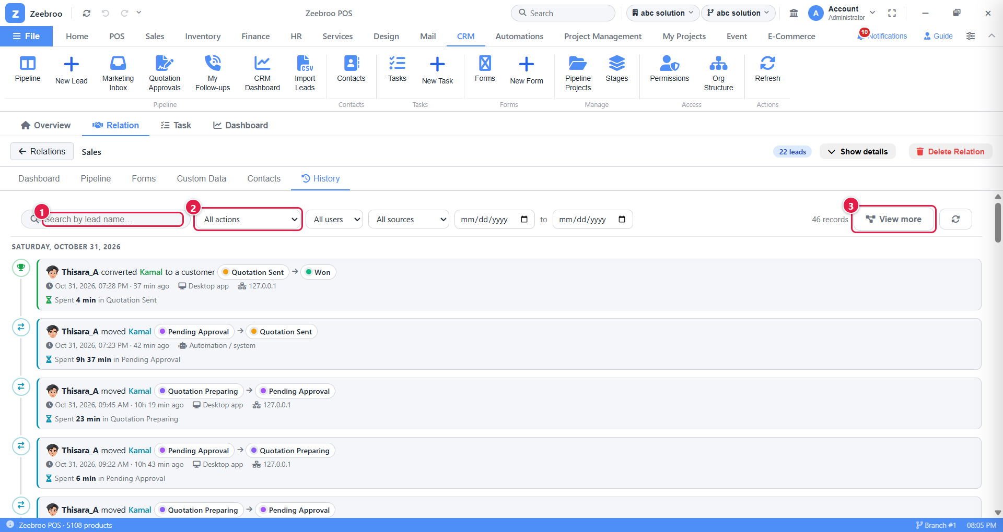
Picture 33. History tab
1 | Search by lead name.
2 | Filters: action, user, source and date range.
3 | View more opens the history as a picture (flow diagram).

History records who did what and when: every move, assignment, quotation and close. It even shows how long a lead spent in each stage.
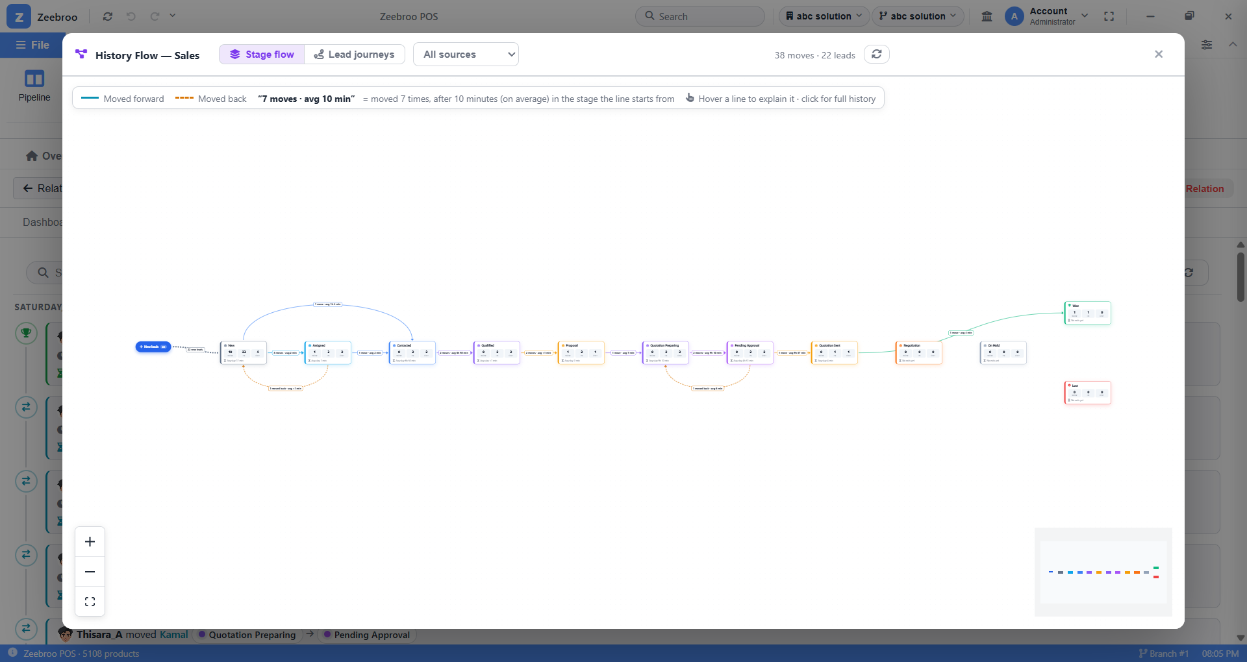
Picture 34. History Flow, Stage flow: how leads move between stages
Click Lead journeys at the top to see each lead's path, step by step. Solid lines mean the lead moved forward, and dashed orange lines mean it moved back. Each box shows when it happened, who did it, and how long the lead spent in the stage before.
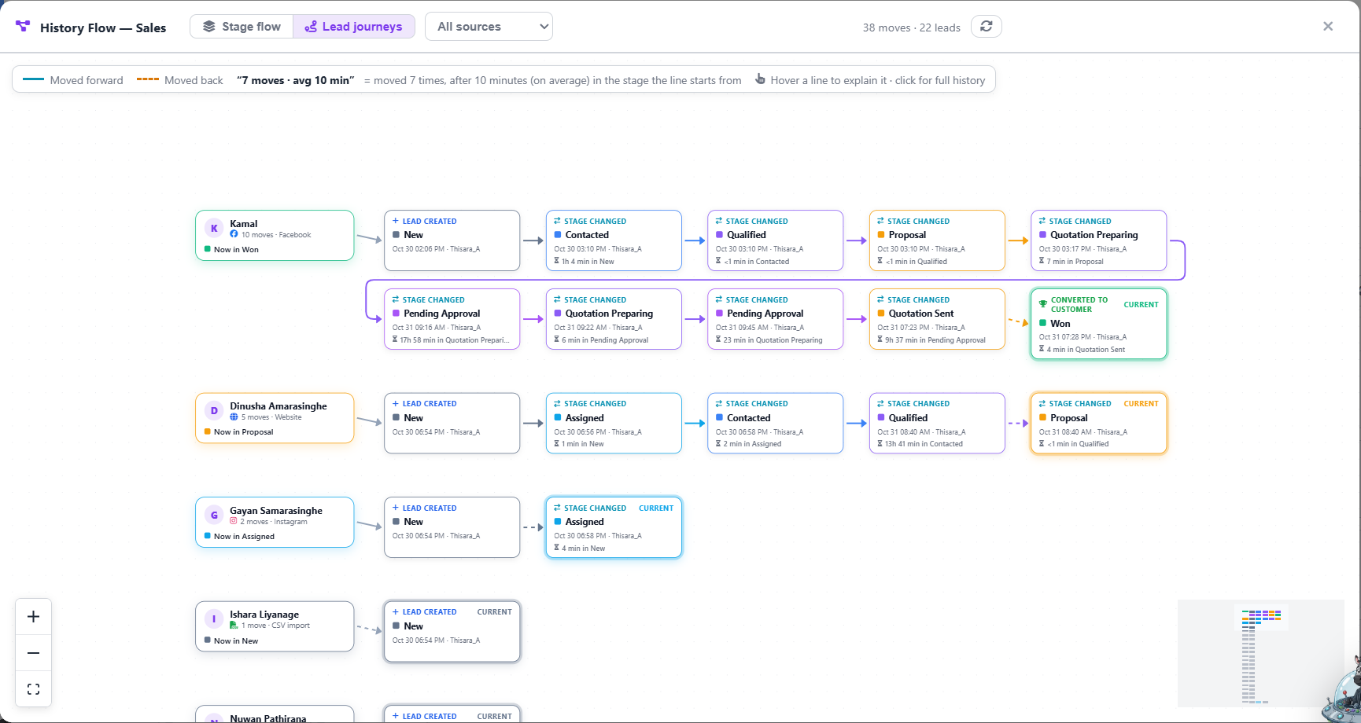
Picture 35. History Flow, Lead journeys: Kamal's 10 moves from New to Won

21. CRM Dashboard (reports)
See how your sales team is doing, in numbers and charts. Admins and the CEO see the whole business. Department heads see their own department.
WHERE TO FIND IT CRM › CRM Dashboard (ribbon) or the Dashboard sub-tab
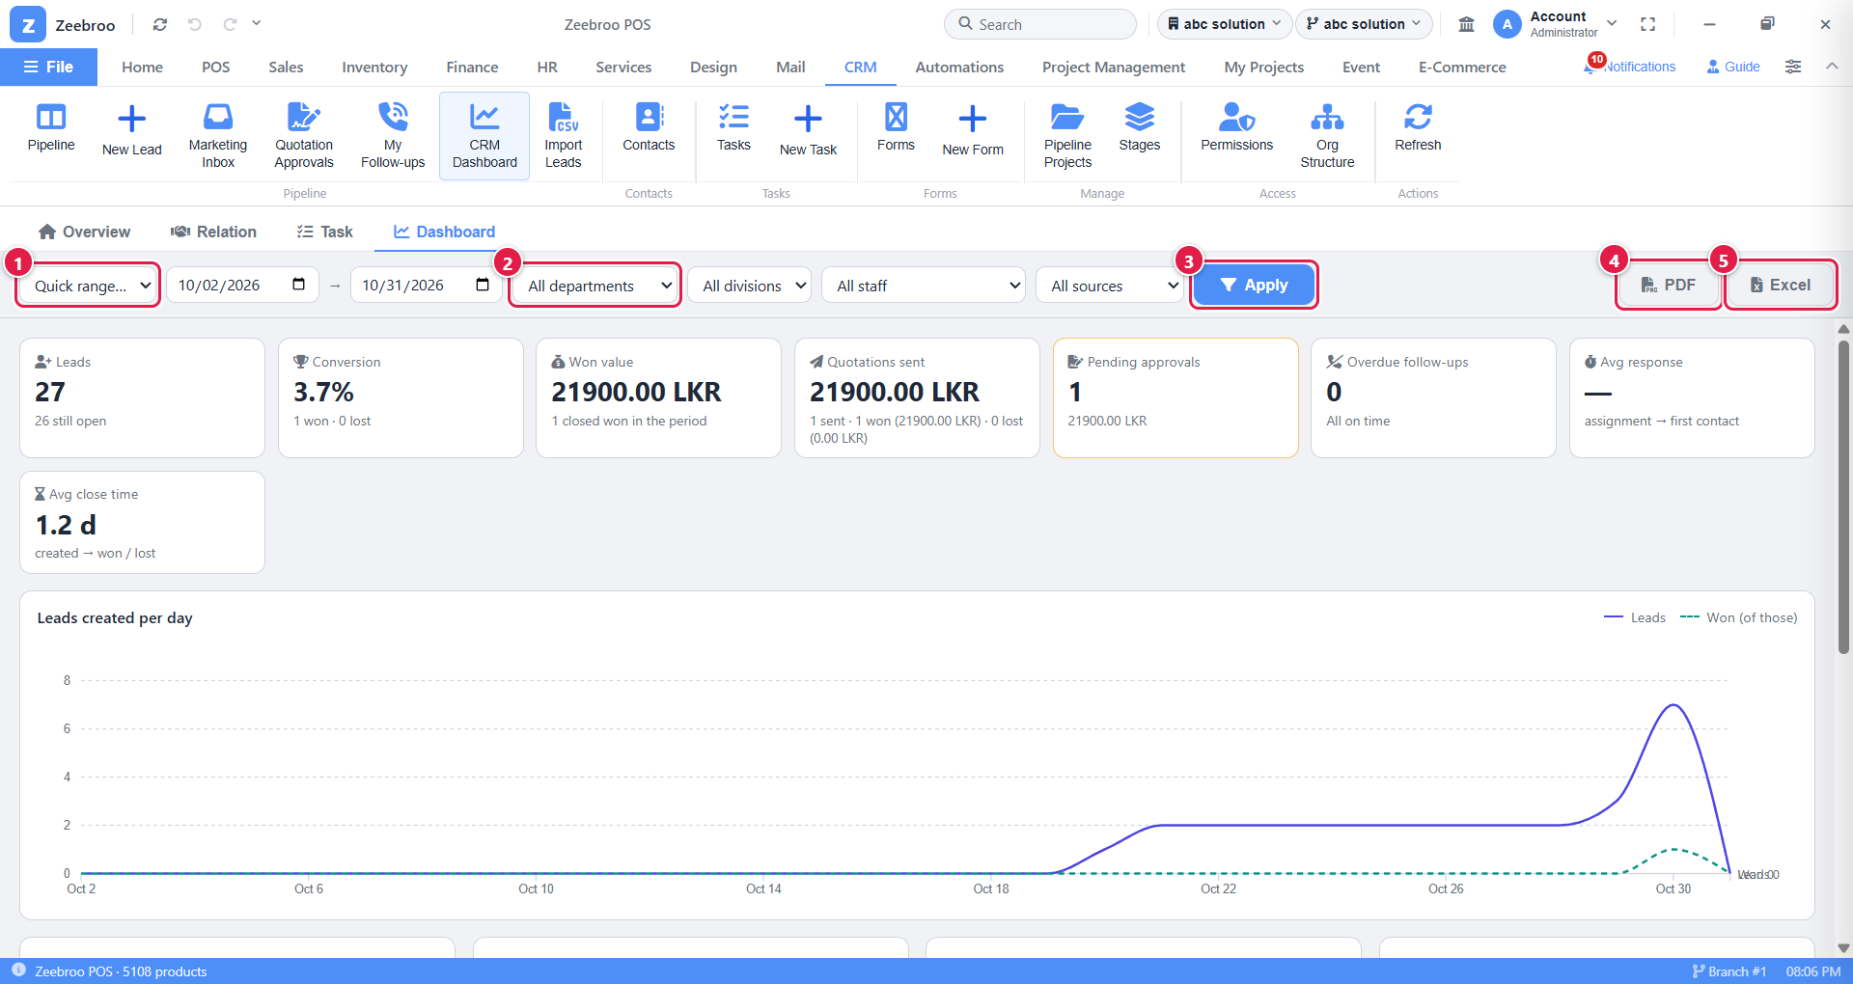
Picture 36. CRM Dashboard
1 | Quick range. Last 7 / 30 / 90 days, this month, quarter or year. Or type your own dates next to it.
2 | Filters. Department, division, staff member and lead source.
3 | Apply. Refresh the numbers with your filters.
4 | PDF. Download this report as a PDF.
5 | Excel. Download this report as an Excel file.

Tile | What it tells you
Leads | How many new leads came in, and how many are still open.
Conversion | Of the new leads, how many % became Won.
Won value | Total money from won deals.
Quotations sent | Value of quotations sent, and how much was won or lost.
Pending approvals | Quotations waiting for a head right now.
Overdue follow-ups | Call-backs that are late right now.
Avg response | How fast staff contact a lead after it is assigned.
Avg close time | How many days from new lead to won / lost.

EXAMPLE Every Monday the Sales head picks Last 7 days, department Sales, clicks Apply, then PDF, and shares the report in the weekly meeting.

21.1 Audit Log (admins)
Full administrators can also open the Audit Log, a complete record of every change in the CRM, with who made it, when, and from which computer. Filter by record, event and user.

22. The whole journey on one page
These are Kamal's real steps in the Sales pipeline (see the Lead journeys picture in Chapter 20).
# | What happened | Where | Stage
1 | Kamal enquires through Facebook. The lead is created (Oct 30, 2:06 PM). | New Lead | New
2 | The team contacts him about an hour later. | Pipeline board | Contacted
3 | His needs are confirmed and a proposal is discussed. | Pipeline board | Qualified › Proposal
4 | Quotation QT-0011 (LKR 21,900) is created. | Lead › Quotations | Quotation Preparing
5 | It is submitted and approved, then revised as version 2. | Quotation Approvals | Pending Approval › Quotation Preparing
6 | Version 2 is submitted and approved. | Quotation Approvals | Pending Approval
7 | QT-0011-v2 is emailed to Kamal (Oct 31, 7:23 PM). | Lead › Quotations | Quotation Sent
8 | Chamodi Fernando follows up. | Lead › Follow-ups | Quotation Sent
9 | Kamal accepts. He becomes a customer (7:28 PM). | Lead › Quotations | Won
10 | The invoice is created from the quotation. | Invoice / Order / Project… | Won
11 | The win shows in the management report. | CRM Dashboard | n/a

23. Questions and problems
Problem | Why it happens / what to do
I can't see a button from this guide. | Your role or permissions do not include it. Ask your CRM admin to check Permissions.
I can't move or edit a lead. | Staff can only work on leads assigned to them. Ask your head to assign it to you.
I added a lead but no new card appeared. | The person already had an open lead. Check that lead's Timeline: your enquiry was added there.
I can't delete a relation. | It still has leads. Move or delete them first.
My quotation is stuck at Pending Approval. | The discount is above your department's limit. Ask your head to open Quotation Approvals.
A quotation line is flagged red. | You don't have enough stock for that quantity. Lower the quantity or restock.
I keep forgetting to call customers back. | Open My Follow-ups every morning and tick Also email me CRM notifications.
The screen shows old information. | Click Refresh on the ribbon.
The orange flag is on a lead. | It needs review, usually a possible duplicate. Marketing should check it in the Marketing Inbox.

Quick daily checklist for sales staff
- Open My Follow-ups and clear Overdue and Today.
- Open your board, filter by Hot, and call those leads first.
- Move every card you worked on to its correct stage.
- Write a short note in Messages after every call.
- Check the Task sub-tab for anything due today.

