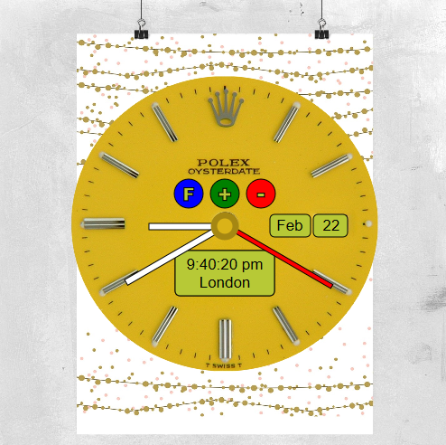

Multimedia Clock

Analogue / digital

Candidate No: 162217 | Advanced Computer Science MSc

Multimedia Design and Applications | 23/02/2017

# 1: Introduction

This report is part of project 1 of the “Multimedia Design and Applications” module. It will help to demonstrate the processes that have taken place, and give reasons for the decisions made, during the design, and creation of a multimedia clock using SVG in JavaScript.

## 2: Design and Developmenmt

The clock was designed to give the feeling of floating; it achieves this by placing an abstract poster [2] in the background that is predominately white, with gold and beige speckles, and a well-defined clock face that is bright yellow [1] in the foreground., this gives a feeling of separation. Both images complement each other and there is a sense of belonging. (Photoshop was used to merge the jpeg images of the clock face and background poster).

The creation of the clock hardware, started by using the JavaScript written [6] during the Labs, that was based on the Raphael SVG JavaScript library [3]. The code for the original clock face was deleted and the new jpeg poster clock image was inserted, the clock hands were moved to the correct position and the size and colour were changed. Because the clock had a watch face, it made sense to place the additional clock hardware accordingly. The digital clock was placed at the bottom and based on a 12-hour time, with the current time zone beneath. The Day and Month function was placed on the right. At the top of the clock three Buttons were inserted. The Blue Function Button, is used to scrolls through a list of functions, by using a switch/case statement that uses the current function name to find the next function in the list, this highlights the new Function selected by causing the screen to flash (Figure 1.0), once a function is selected, the Green and Red direction buttons are used to change the value. The decision to use three buttons was for aesthetic reasons and simplicity of use, three buttons are the minimum number that could be used, and still allow all of the actions to be perform as expected, they are also easy to understand, offer dual purpose functionality (direction and stop, start), they are pleasing on the eye, and fit perfectly in the top section of the clock.

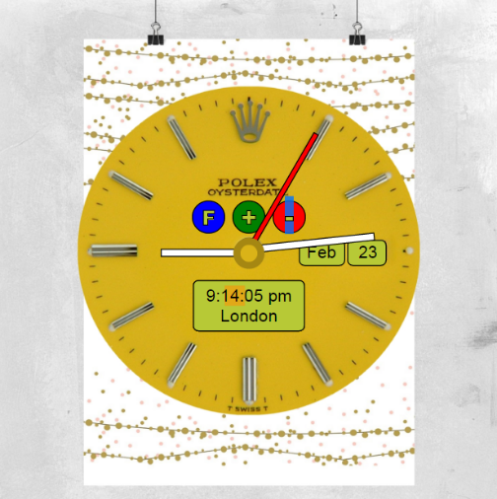

Figure 2.1. Current Function ‘Minutes’

The current date and time are acquired from the Date class, and stored as Day, Month, Hours, Minutes and Seconds; the time values are kept up to date by performing a loop every second, which in turn updates the minutes and hours fields every 60 seconds or 60 minutes.

**Time Zones Function.**

I found a JavaScript library called “moment-timezone” [7] online that helps with the implementation of time zones, it works by using a function called ‘moment’ that accepts a Date/Time, with the location that the date applies to (“Europe/London”) and then allows the creation of a new timezone by using a clone function and applying a new time zone location. After looking into it, I decided to ignore this method and control the time zone function myself by creating two arrays [4], the first to store the time zone names and the second to contain the offset in hours, this method fit the design of my clock better. When the next time zone is selected by using one of the direction keys, the next time zone in the array is selected, and the new offset in hours is applied (London to Rome Add 1 Hour), going backwards through the time zone list works slightly differently where the current offset in hours has to be subtracted from the current time before the previous time zone is selected (New York to Rome Add 6 Hours).

timeZones = ["London", "Rome", "New York", "Sydney"]

timeDiff = [ -11, 1, -6, 16 ]

**Date Function.**

The day number is taken from the current date that was stored when the clock was first displayed, it can be changed by using the direction buttons when selected. The range allowed is between 1 and 31 and currently does not check to see if the day number is valid for the selected month.

**Stop Watch Function.**

When the stop watch function is first selected, the counter is set to zero, when used it can record an action to a hundredth of a second. The green function button starts the timer, and the red button will first stop the timer, and then reset it to zero if pressed again.

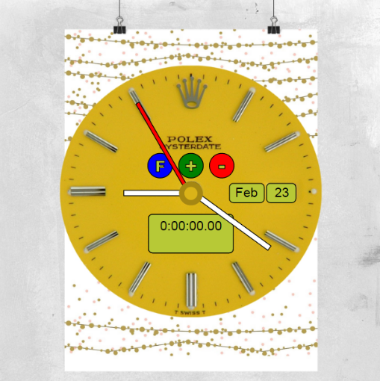

Figure 2.2. Stopwatch Function

**Alarm Clock Function.**

When the Alarm Clock function is first selected, the alarm time is set to zero. This can be changed to the correct time by using the function button to move between the hours, minutes and Am_Pm values, and the green and red direction buttons to change the values. You set the alarm by pressing the “Green Set” button underneath the Alarm Time. You can leave this function if you wish and change other Functions, this will not stop the alarm from functioning. When the current time equals the alarm time you will be taken back to the Alarm window, and the Alarm Time will flash. You can cancel the alarm by pressing the “Red Cancel” button.

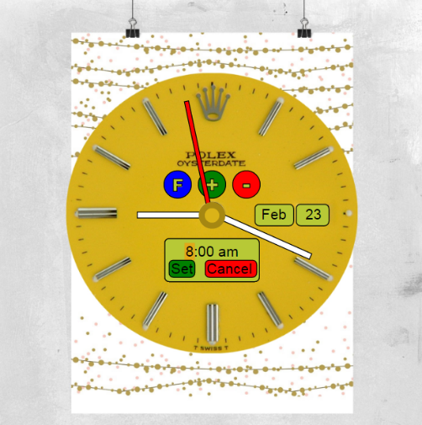

Figure 2.3 Alarm Function

## 3: CONCLUSION

I wanted to create a clock that was pleasing on the eye, had multiple features that were easily selectable but did not overly affect the simplicity of the design, and I believe I have achieved my goal. I completed all of the required tasks to meet the basic specification required and created four additional functions.

A list of additional features that would be of benefit are listed below.

1: Day number should be checked against the month to make sure that the day number is valid.

2: The stop watch feature could allow multiple times to be taken.

3: The current weather and temperature could be shown for your location.

4: Alarm Feature should indicate an alarm has been set by showing a bell to the top right hand corner of the digital clock. The alarm should make a ringing sound when it goes off.

## 4: REFERENCES

1. C & F Dial Restoration (2016) Watch Dial Guide.Available at: www.watchdialrestoration.co.uk/asp-pages/watch-dial-guide.asp (Accessed: 09 February 2017).
2. I Love Design (2014) OH LOOK IT'S WINE O'CLOCK POSTER.Available at: http://www.ilovedesign.net/oh-look-its-wine-oclock-poster-or-canvas-print-865-p.asp (Accessed: 09 February 2017).
3. Gurin, S (2012) RaphaëlJs Tutorial.Available at: http://cancerbero.mbarreneche.com/raphaeltut/#heading_toc_j_103 (Accessed: 09 February 2017).
4. Chapman, S (2016) Quick Tip.Available at: https://www.sitepoint.com/quick-tip-create-manipulate-arrays-in-javascript/ (Accessed: 19 February 2017).
5. Crowder, T (2016) Questions.Available at: http://stackoverflow.com/questions/8443151/how-to-stop-a-settimeout-loop (Accessed: 16 February 2017).
6. Sussex University (2016) *Labs*. Available at: https://studydirect.sussex.ac.uk/course/view.php?id=28104&topic=2 (Accessed: 09 February 2017).
7. MIT (2016) *Moment Timezone*. Available at: https://momentjs.com/timezone/ (Accessed: 20 February 2017).