# Task №1. Access settings and adding data to ‘country_managers’ table

-- Creatin users

**create** **user** ivan **with** **password** **'sql'**;

**create** **user** sophie **with** **password** **'sql1'**;

**create** **user** kirill **with** **password** **'sql2'**;

-- Granting permissions to planadmin

**grant** **select** **on** **all** **tables** **in** **schema** public **to** planadmin;

**grant** **select**, **update**, **insert**, **delete** **on** plan_data **to** planadmin;

**grant** **select**, **update**, **insert**, **delete** **on** plan_status **to** planadmin;

**grant** **select**, **update**, **insert**, **delete** **on** country_managers **to** planadmin;

**grant** **select** **on** v_plan_edit **to** planadmin;

**grant** **select** **on** v_plan **to** planadmin;

-- Granting permissions to planmanager

**grant** **select** **on** **all** **tables** **in** **schema** public **to** planmanager;

**grant** **select**, **update**, **insert**, **delete** **on** plan_data **to** planmanager;

**grant** **select**, **update** **on** plan_status **to** planmanager;

**grant** **select** **on** country_managers **to** planmanager;

**grant** **select**, **update** **on** v_plan_edit **to** planmanager;

**grant** **select** **on** v_plan **to** planmanager;

-- Granting roles

**grant** planadmin **to** ivan;

**grant** planmanager **to** sophie, kirill;

-- Adding managers

**INSERT** **INTO** public.country_managers

(username, country)

**VALUES**

(**'sophie'**, **'US'**), (**'sophie'**, **'CA'**),

(**'kirill'**, **'FR'**), (**'kirill'**, **'GB'**),

(**'kirill'**, **'DE'**), (**'kirill'**, **'AU'**);

# Task №2. product2 & country2 materialized views

**create** **materialized** **view** product2 **as**

**select**

pc.productcategoryid **as** pcid,

p.productid **as** productid,

pc.**"name"** **as** pcname,

p.**"name"** **as** pname

**from** public.product **as** p

**left** **join** public.productsubcategory **as** psc **using**(productsubcategoryid)

**left** **join** public.productcategory **as** pc **using**(productcategoryid)

**with** **no** **data**;

**REFRESH** **MATERIALIZED** **VIEW** product2;

**create** **materialized** **view** country2 **as**

**select** **distinct** a.countryregioncode **from** public.customeraddress **as** ca

**left** **join** public.address **as** a **using**(addressid)

**where** ca.addresstype = **'Main Office'**

**with** **no** **data**;

**REFRESH** **MATERIALIZED** **VIEW** country2;

**grant** **select** **on** product2, country2 **to** planadmin, planmanager;

# Task № 3. Loading data into the company table

**insert** **into** public.company

(cname, countrycode, city)

**select** c.companyname **as** cname,

a.countryregioncode **as** countrycode,

a.city **as** city

**from** customer **as** c

**left** **join** customeraddress **as** ca **using**(customerid)

**left** **join** address **as** a **using**(addressid)

**where** ca.addresstype = **'Main Office'**

# Task №4. Company classification

**with** **data** **as**

(**select**

**date_part**(**'y'**, soh.orderdate) **as** **"year"**,

comp.id **as** cid,

**sum**(soh.subtotal) sales_total,

**sum**(**sum**(soh.subtotal)) **over**

(**partition** **by** **date_part**(**'y'**, soh.orderdate)

**order** **by** **date_part**(**'y'**, soh.orderdate), **sum**(soh.subtotal) **desc**

) **as** sales_agg

**from** company **as** comp

**left** **join** customer **as** cust **on** comp.cname = cust.companyname

**left** **join** salesorderheader **as** soh **on** soh.customerid = cust.customerid

**where** **date_part**(**'y'**, soh.orderdate) **in** (2012, 2013)

**group** **by** comp.id, **date_part**(**'y'**, soh.orderdate)

**order** **by** **date_part**(**'y'**, soh.orderdate), sales_total **desc**

),

S_values **as**

(**select**

**"year"**,

**sum**(**data**.sales_total) **as** S,

0.8 * **sum**(**data**.sales_total) **as** S_a,

0.95 * **sum**(**data**.sales_total) **as** S_b

**from** **data**

**group** **by** **"year"**)

**insert** **into** company_abc(cid, salestotal, cls, "year")

**select**

**data**.cid,

**data**.sales_total **as** *sales_total*,

**case**

**when** **data**.sales_agg <= ***S_values***.S_a **then** **'A'**

**when** **data**.sales_agg <= ***S_values***.S_b **then** **'B'**

**else** **'C'**

**end** **as** *cls*,

**data**."year"

**from** **data**

**join** ***S_values*** **on** ***S_values***."year" = **data**."year"

**order** **by** **data**."year"

First 15 rows of ‘company_abc’ table:

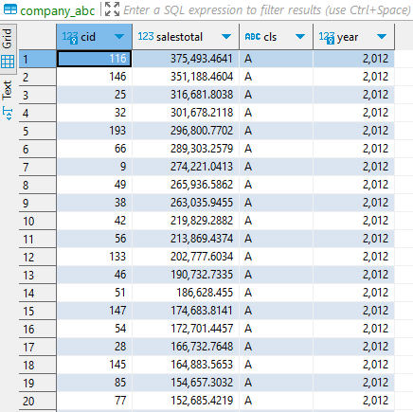

# Task №5. Finding quarterly sales amount by company, and product category

**insert** **into** company_sales (cid, salesamt, **year**, quarter_yr, qr, categoryid, ccls)

**select**

***comp***.***id*** **as** cid,

**sum**(***sod***.linetotal) **as** *salesamt*,

**extract**(**"year"** **from** ***soh***.***orderdate***) **as** **"year"**,

**extract**(**"quarter"** **from** soh.orderdate) **as** quarter_yr,

**extract**(**year** **from** soh.orderdate)||**'.'**||**extract**(**quarter** **from** soh.orderdate) **as** qr,

p2.pcid **as** categoryid,

cabc.cls **as** ccls

**from** company **as** comp

**left** **join** customer **as** cust **on** cust.companyname = comp.cname

**left** **join** salesorderheader **as** soh **using**(customerid)

**left** **join** salesorderdetail **as** sod **using**(salesorderid)

**join** product2 **as** p2 **using**(productid)

**left** **join**

company_abc cabc **on** comp.id = cabc.cid **and** **extract**(**year** **from** soh.orderdate) = cabc.**"year"**

**where**

**extract**(**year** **from** soh.orderdate) **in** (2012, 2013)

**group** **by**

comp.id,

**extract**(**year** **from** soh.orderdate),

**extract**(**"quarter"** **from** soh.orderdate), p2.pcid, cabc.cls;

# Task №6. Initial data preparation

Function:

def start_planning(year, quarter, user, pwd):

    delete_quarter_plan_data_query = """

                                delete from plan_data

                                where quarterid = %s;

                                """

    delete_quarter_plan_status_query = """

                                delete from plan_status

                                where quarterid = %s;

                                """

    add_plan_status_query = """

                            insert into plan_status

                            (quarterid, status, modifieddatetime, author, country)

                            select distinct

                            %s as quarteid, 'R' as status,

                            now() as modifieddatetime,

                            %s as author,

                            countrycode as country

                            from company;

                            """

    generate_plan_N = """

                    insert into plan_data

                    (versionid, country, quarterid, pcid, salesamt)

                    select 'N' as versionid,

                        l.country,

                        %s as quarterid,

                        l.pcid,

                        coalesce (r.salesamt, 0)

                    from

                    (select distinct

                            c.countrycode country,

                            p.productcategoryid as pcid

                        from company c

                        cross join productcategory p

                        order by c.countrycode, p.productcategoryid

                    ) as l

                    left join

                    (select distinct

                        c.countrycode as country,

                        categoryid as pcid,

                        avg(sum(salesamt))

                        over(partition by c.countrycode, quarter_yr, categoryid

                        order by c.countrycode, quarter_yr, categoryid

                        )

                        as salesamt

                    from company_sales as cs

                    join company as c on c.id=cs.cid

                    where ccls in ('A', 'B') and cs."year" in (%s, %s)

                    and quarter_yr = %s

                    group by c.countrycode, qr, categoryid, quarter_yr

                    order by c.countrycode, categoryid

                    ) as r

                    on l.country = r.country and l.pcid = r.pcid

                    order by l.country, l.pcid;

                    """

    generate_plan_P = """insert into plan_data

                        (versionid, country, quarterid, pcid, salesamt)

                        select

                        'P' as versionid, country, quarterid , pcid, salesamt

                        from plan_data pd;

                        """

    qurterid = f"{year}.{quarter}"

    con = psycopg2.connect(database="2024_plans_Melnikov",

                           user=user, password=pwd,

                           host="localhost")

    cur = con.cursor()

    try:

        cur.execute(delete_quarter_plan_data_query, [f"{year-1}.{quarter}"])

        cur.execute(delete_quarter_plan_data_query, [f"{year-2}.{quarter}"])

        cur.execute(delete_quarter_plan_status_query, [f"{year}.{quarter}"])

        cur.execute(generate_plan_N, [f"{year}.{quarter}", year-1, year-2, quarter])

        cur.execute(generate_plan_P)

        cur.execute(add_plan_status_query, [qurterid, user])

        con.commit()

    except Exception as e:

        print(e)

    con.close()

Function call:

psw = {'postgres': 'sql',

       'ivan': 'sql',

       'sophie': 'sql1',

       'kirill': 'sql2'}

user = 'ivan'

start_planning(2014, 1, user, psw[user])

plan_data table (N and P versions):

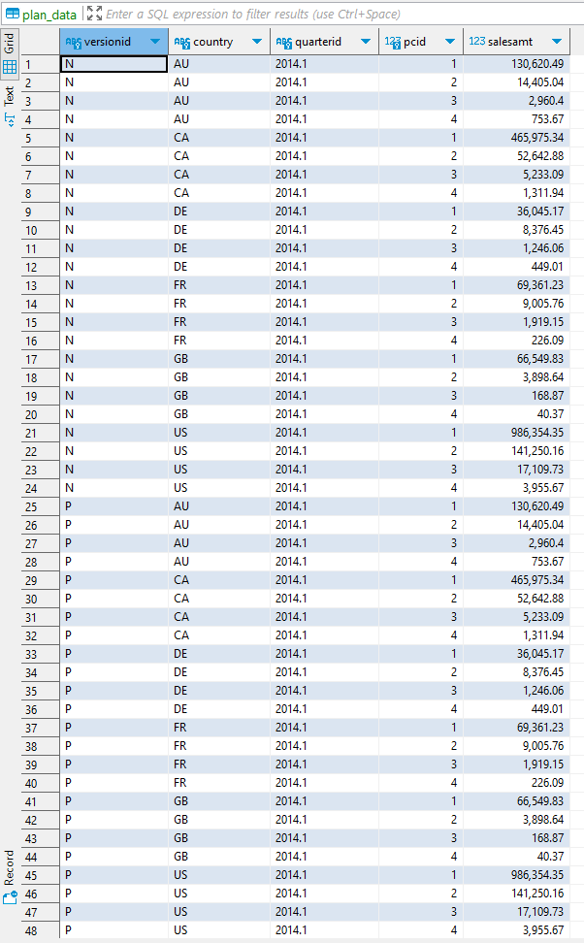

plan_status:

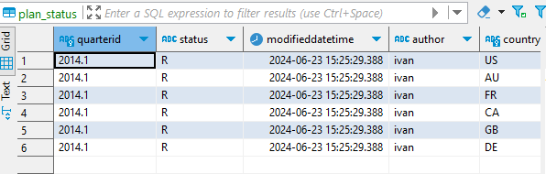

# Task № 7. Changing plan data

def set_lock(year, quarter, user, pwd):

    qurterid = f"{year}.{quarter}"

    query = """

            update plan_status

            set status = 'L',

            modifieddatetime = now(),

            author = current_user

            where quarterid = %s and

            country in

                (select country

                from country_managers cm

                where cm.username = current_user)

            """

    con = psycopg2.connect(database="2024_plans_Melnikov",

                           user=user, password=pwd,

                           host="localhost")

    cur = con.cursor()

    cur.execute(query,[qurterid])

    con.commit()

    con.close()

def remove_lock(year, quarter, user, pwd):

    qurterid = f"{year}.{quarter}"

    query = """

            update plan_status

            set status = 'R',

            modifieddatetime = now(),

            author = current_user

            where quarterid = %s and

            country in

                (select country

                from country_managers cm

                where cm.username = current_user)

            """

    con = psycopg2.connect(database="2024_plans_Melnikov",

                           user=user, password=pwd,

                           host="localhost")

    cur = con.cursor()

    cur.execute(query,[qurterid])

    con.commit()

    con.close()

v_plan_edit as ‘kirill’:

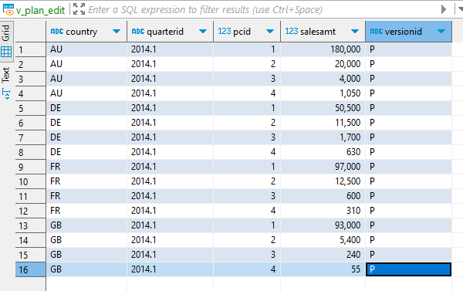

# Task №8 Plan data approval.

Function:

def accept_plan(year, quarter, user, pwd):

    remove_existing_plan_query = """

            delete from plan_data

            where versionid = 'A'

            and quarterid = %s

            and country in

                (select country

                from country_managers cm

                where cm.username = current_user)

            """

    accept_plan_query = """

            insert into plan_data

            (versionid, country, quarterid, pcid, salesamt)

            select

                'A' as versionid,

                country,

                quarterid,

                pcid,

                salesamt

            from plan_data

            where versionid = 'P'

            and quarterid = %s

            and country in

                (select country

                from country_managers cm

                where cm.username = current_user)

            """

    update_plan_status_query = """

            update plan_status

            set status = 'A',

            modifieddatetime = now(),

            author = current_user

            where status = 'R' and

            quarterid = %s and

            country in

                (select country

                from country_managers cm

                where cm.username = current_user)

            """

    qurterid = f"{year}.{quarter}"

    con = psycopg2.connect(database="2024_plans_Melnikov",

                           user=user, password=pwd,

                           host="localhost")

    cur = con.cursor()

    cur.execute(remove_existing_plan_query,[qurterid])

    con.commit()

    cur.execute(accept_plan_query,[qurterid])

    con.commit()

    cur.execute(update_plan_status_query,[qurterid])

    con.commit()

    con.close()

Function call:

user = 'kirill'

accept_plan(2014,1, user, psw[user])

user = 'sophie'

accept_plan(2014,1, user, psw[user])

‘v_plan’ from Sophie’s view:

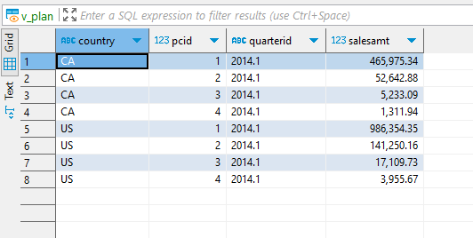

# Task № 9. Data preparation for plan-fact analysis in Q1 2014

I have chosen to load data of 2014 into the company_sales table and include it in the view.

**create** **materialized** **view** mv_plan_fact_2014_q1 **as**

**select**

pd.quarterid,

pd.country,

p.**"name"**,

pd.salesamt - **coalesce**(fact.salesamt, 0) **as** Dev,

**round**((pd.salesamt - **coalesce**(fact.salesamt, 0))/pd.salesamt * 100, 1) **as** **"Dev%"**

**from** plan_data **as** pd

**join** productcategory p **on** p.productcategoryid = pd.pcid

**left** **join**

(**select**

c.countrycode **as** country,

qr **as** quarterid,

categoryid **as** pcid,

**sum**(salesamt) **as** salesamt

**from** company_sales cs

**join** company c **on** c.id=cs.cid

**where** **year**=2014 **and**

cs.cid **in** (**select** cid **from** company_abc abc

**where** abc.**year** = 2013 **and** abc.cls **in** (**'A'**, **'B'**))

**group** **by** c.countrycode, qr, categoryid

**order** **by** c.countrycode, qr, categoryid) **as** fact

**on** pd.country = fact.country

**and** pd.quarterid = fact.quarterid

**and** pd.pcid = fact.pcid

**where** pd.versionid = **'A'**

**order** **by** 1, 2, 3

mv_plan_fact_2014_q1:

