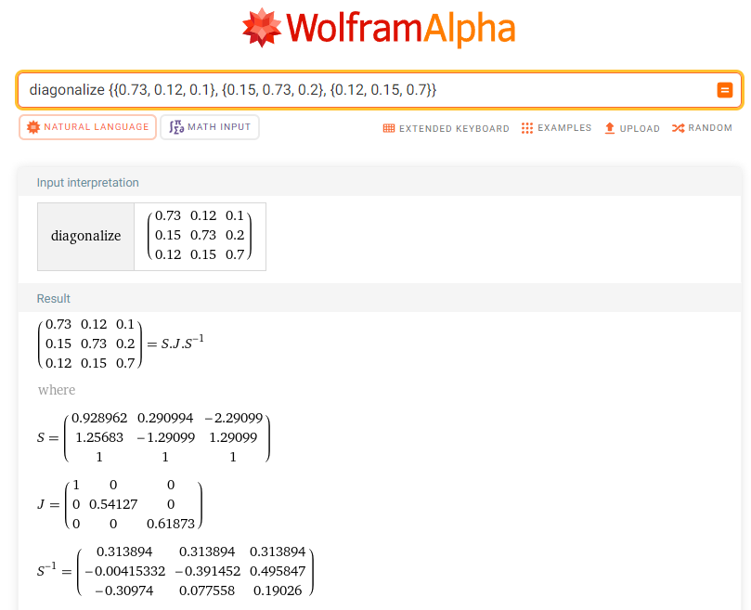

Main thing I had to compute is above.

* S is matrix of eigenvalues of matrix P from the task (in my notes it’s matrix T),
* J is matrix of eigenvalues of matrix P (in my notes it’s matrix A),
* S-1 is inverse matrix of S (in my notes it’s matrix T-1)

After that I’ve substituted A by An and multiplied all these matrices back by WolframAlpha (result is written by hand in the main paper)