# **MODULE 2**

# **Name**

# 

# **UNIVERSITY**

# 

# **Subject**

# 

# **Professor**

**Introduction**

* **Importance of Visualization:** Visualizations effectively communicate complex information, making it easier to understand patterns and trends within datasets.
* **Overview of Datasets:** This report analyzes data related to peach farms in Missouri, including the number of farms, planted acreage, and market distribution across different counties and cities.
* **Objective:** The goal is to identify patterns and insights regarding peach farm distribution, acreage, and market presence in Missouri.

**Methodology**

* **Data Collection:** Data was gathered on peach farms, planted acreage, and market distribution in Missouri.
* **Analytical Tools:** Data was visualized using various charts to illustrate relationships and trends.
* **Variable Selection:** The analysis focuses on the number of peach farms, planted acreage, and market distribution across counties and cities.

**Analysis**

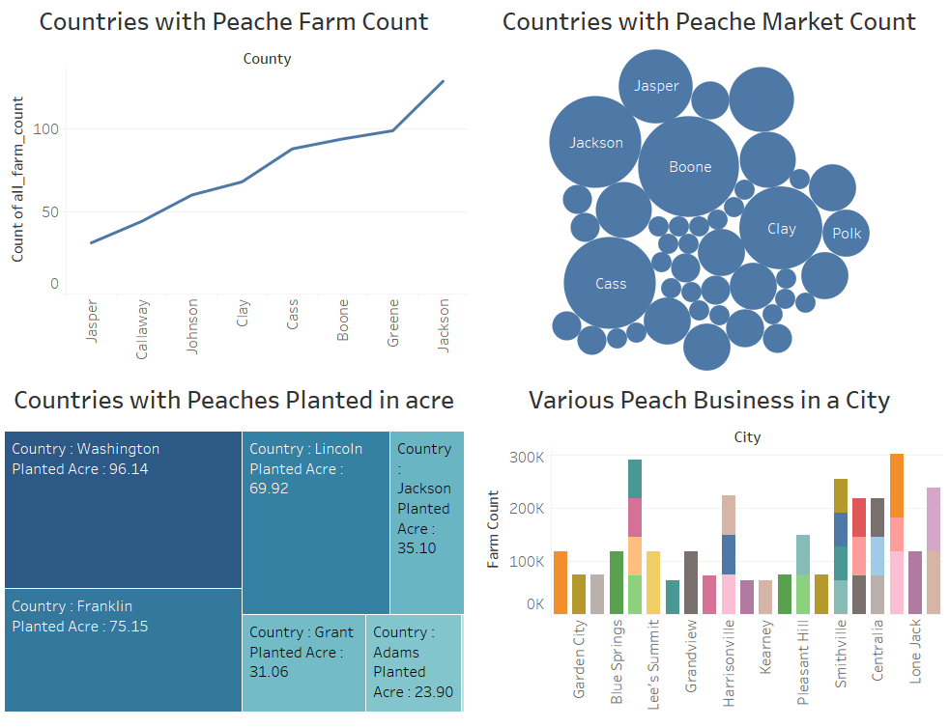

**Key Findings:**

Distribution of Peach Farms and Production:

* Jasper County has the lowest number of farms and smallest planted acreage
* Jackson County leads with the highest number of peach farms.
* Cass County has average number of farms and planted acres.

Distribution of Farmers Markets:

* The peach market count is concentrated in the Southeastern United States. This is likely due to the warm climate and fertile soil in this region, which are ideal for growing peaches.
* The counties with the highest peach market counts are Jackson, Jasper, Boone, Clay, and Polk. These counties are all located in Georgia, which is the leading producer of peaches in the United States.
* The peach market count is lower in the Northern and Western United States. This is likely due to the colder climate in these regions, which is not as suitable for growing peaches.

Distribution of Planted acre in various Countries:

* The United States has Washington as the most land dedicated to peach planting. This is likely due to the country's large size and diverse climate, which allows for peaches to be grown in many different regions.
* Other states with significant peach acreage include California, Georgia, South Carolina, and Colorado. These states also have climates that are well-suited for growing peaches.
* There is a positive correlation between the amount of land a country has dedicated to peach planting and its overall peach production. This suggests that countries with more land dedicated to peaches are able to produce more of the fruit.

Peach business analysis:

* Kansas City has the most peach businesses. There are 3 major peach businesses with 118k farm count more than any other city on the list. This suggests that Kansas City in Jackson Country has a large and thriving peach industry and is likely to have a major source of jobs and revenue for the city.
* After Kansas, Columbia and Smithville also have a wide businesses for Peaches.
* Belton has only single market for Peaches.

**Conclusion**

* **Geographical Disparities:** The distribution of peach farms, planted acreage, and market presence varies considerably across Missouri counties and cities.
* **Policy Implications:** These findings can inform agricultural policies and marketing strategies to support peach production and distribution in Missouri.
* **Future Research**: Further research could explore factors influencing these disparities, such as soil quality, climate conditions, and access to transportation infrastructure.

References

TechTarget - What is data visualization and why is it important?: https://www.techtarget.com/searchbusinessanalytics/definition/data-visualization

Tableau - What Is Data Visualization? Definition & Examples: https://www.tableau.com/learn/articles/data-visualization