Terraform

Steps to perform ACL and RBAC using Terraform:
- Create a Cloud API Key.
  - Go to Cloud API keys.
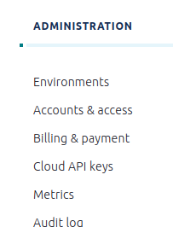
  - Click on +Add key
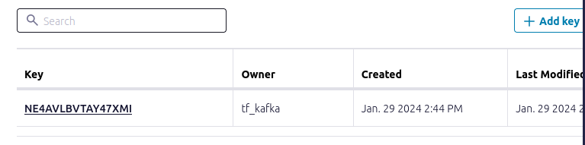
  - Choose Granular access and create the service account.
  - Assign the “OrganizationAdmin” role to the service account you have created for cloud API key.
- Create a resource on Confluent Cloud via Terraform.
  - Create ACL using Terraform
    - Write a terraform script for ACL.

resource "confluent_kafka_acl" "emp-consumer-group-read" {
kafka_cluster {
id = confluent_kafka_cluster.basic.id
}

resource_type = "GROUP"
resource_name = "confluent_cli_consumer_"
pattern_type = "LITERAL"
principal = "User:${confluent_service_account.emp-consumer.id}"
host = "*"
operation = "READ"
permission = "DENY"
rest_endpoint = confluent_kafka_cluster.basic.rest_endpoint
credentials {
key = confluent_api_key.manager-api-key.id
secret = confluent_api_key.manager-api-key.secret
}

depends_on = [
confluent_role_binding.kafka-cluster-admin
]
}
Similarly assign the ACL for other operations such as READ, WRITE.
    - Terraform code snippet for RBAC
resource "confluent_role_binding" "emp-producer-developer-write" {
principal = "User:${confluent_service_account.emp-producer-rbac.id}"
role_name = "DeveloperWrite"
crn_pattern = "${confluent_kafka_cluster.standard.rbac_crn}/kafka=${confluent_kafka_cluster.standard.id}/topic=${confluent_kafka_topic.test_rbac.topic_name}"

}
    - Download and install the providers defined in the configuration.
terraform init
OUTPUT:
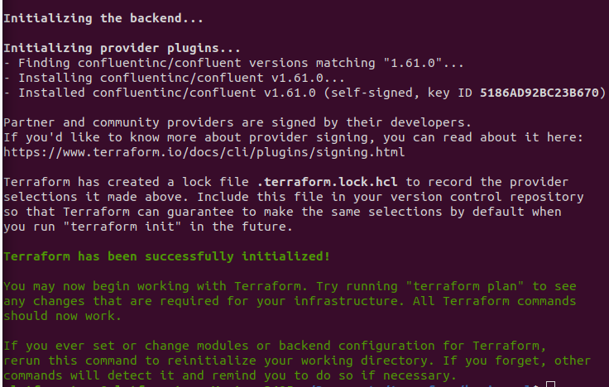
    - Validate the terraform script
terraform validate
OUTPUT:
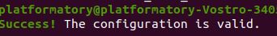
    - If you want your script to be in proper format use the following command
terraform fmt
    - To see what your script going to do, run the following command.
terraform plan
OUTPUT:
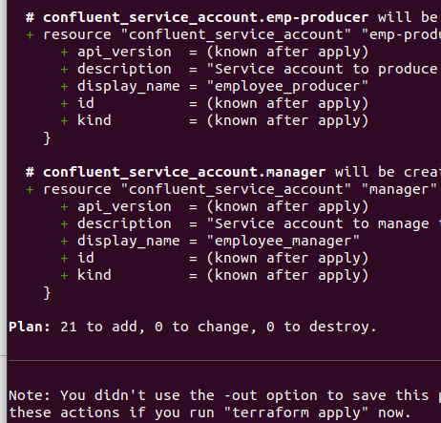
    - Run the terraform script.
terraform apply
OUTPUT:
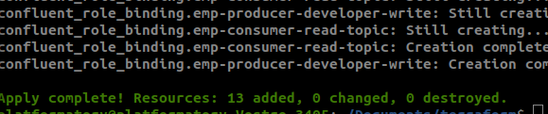

Test Cases:

- ACL
  - READ
    - Deny
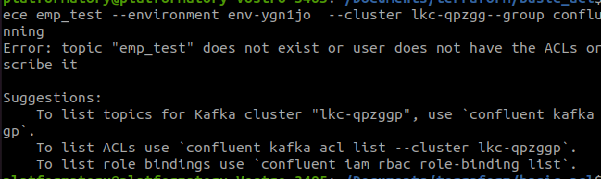
    - Allow
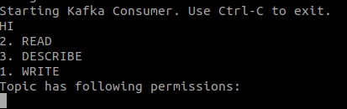
  - WRITE
    - Deny
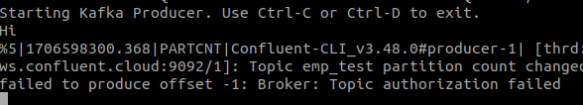
    - Allow
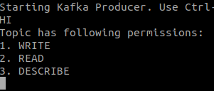
- RBAC
  - DeveloperRead
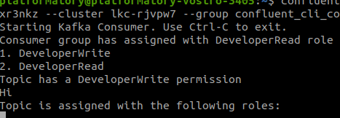
  - DeveloperWrite
