INFORMATION SECURITY PROJECT REPORT
Download Guardian: Intelligent Pre-Execution File Inspection & Threat Assessment Platform
"Know What's Inside Before You Open It"
Student / Author: | Zeenia Abdul Razzaque | Course: | Information Security (IS)
GitHub Repository: | https://github.com/ZeeniaAbdulRazzaque/download-guardian | Assessment Date: | November 9, 2026
Live Deployed URL: | ____________________________________________________________________ (Insert Project Live URL here)

1. Executive Summary
Drive-by downloads, spear-phishing payloads, and deceptive file extension masquerading remain leading infection vectors in modern cybersecurity. In Microsoft Windows desktop environments, file extensions for registered types are hidden by default, enabling threat actors to distribute executable payloads such as 'invoice.pdf.exe' that appear to unsuspecting users as safe PDF documents.
Download Guardian is an intelligent, zero-trust pre-execution file inspection and threat assessment platform designed to intercept and analyze suspicious artifacts before execution. Built on a 100% Stateless & Ephemeral Security Architecture, the platform verifies cryptographic integrity (SHA-256/MD5), checks magic-byte structural headers, evaluates heuristic risk indicators, queries external threat intelligence (VirusTotal API v3), and generates actionable remediation guidance without persisting user data or maintaining insecure database credentials.

2. Live Malicious File Assessment: space.pdf.exe
A live verification scan was performed on the test artifact 'space.pdf.exe' sourced from the local downloads directory to evaluate the platform's multi-extension spoofing detection.
Forensic Property | Analyzed Value
File Name | space.pdf.exe
Final Verdict | POTENTIALLY_MALICIOUS (High Risk)
Calculated Risk Score | 65 / 100
Official Report Code | DG-2026-0667CD
SHA-256 Cryptographic Hash | fd53bba6a246c58394b1c6ea8029c291277cf6c13b39dc2f03a455dc9f370e5b
MD5 Cryptographic Hash | 8e0e1593b50802c5d638ab5716354baf
Detected MIME Type | application/octet-stream
Disk Quarantine Status | PURGED IMMEDIATELY (Stateless Privacy Enforced)

Threat Indicators Identified:
• [CRITICAL] Double File Extension Detected: File name 'space.pdf.exe' uses a deceptive multi-extension pattern designed to bypass visual user inspection and exploit Windows hidden file extensions.
• [HIGH] Executable Application Binary: Artifact is a direct executable binary (.exe) with capabilities for arbitrary system API execution and process spawning.

3. System Implementation & Visual Evidence

Figure 1: Malicious Assessment Verdict & Threat Score for space.pdf.exe
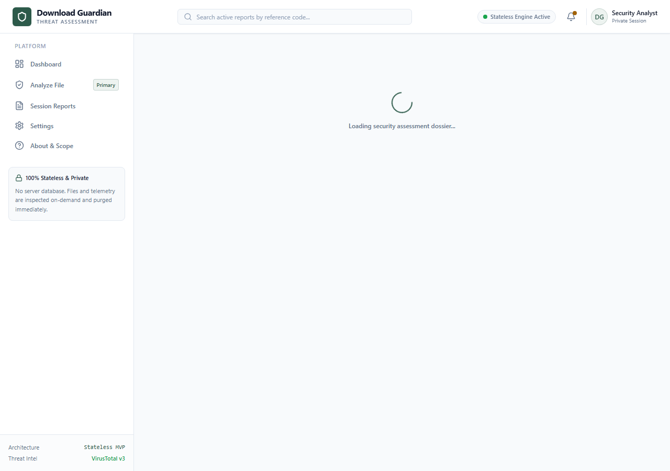

Figure 2: Download Guardian Main Dashboard & Threat Inspection Dropzone
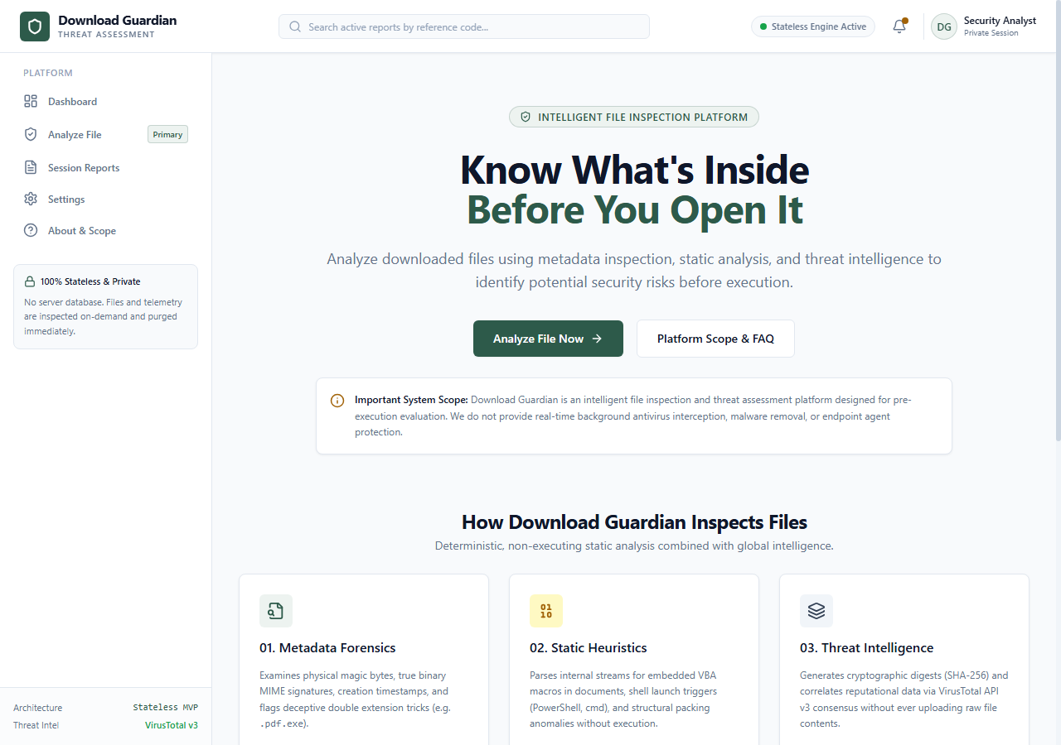

Figure 3: Secure Ingestion Dropzone & Real-time Analysis Console
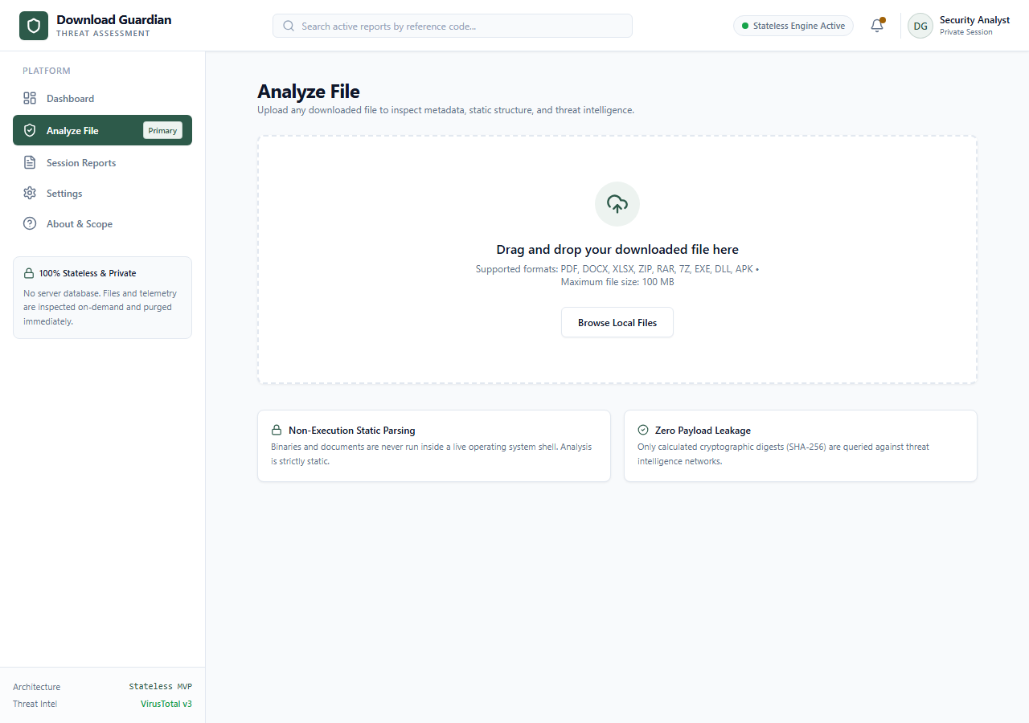

Figure 4: Ephemeral Security Reports Audit Console (Report DG-2026-0667CD)
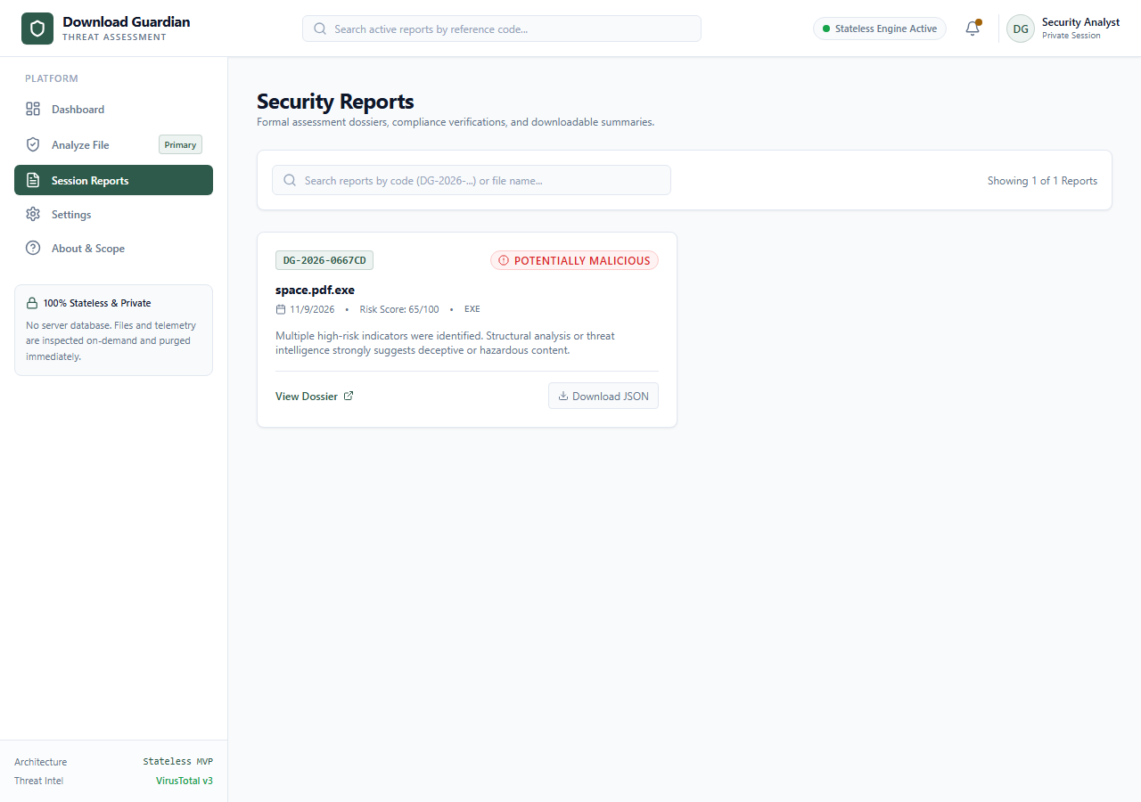

Figure 5: 100% Stateless Security Architecture & Privacy Engine
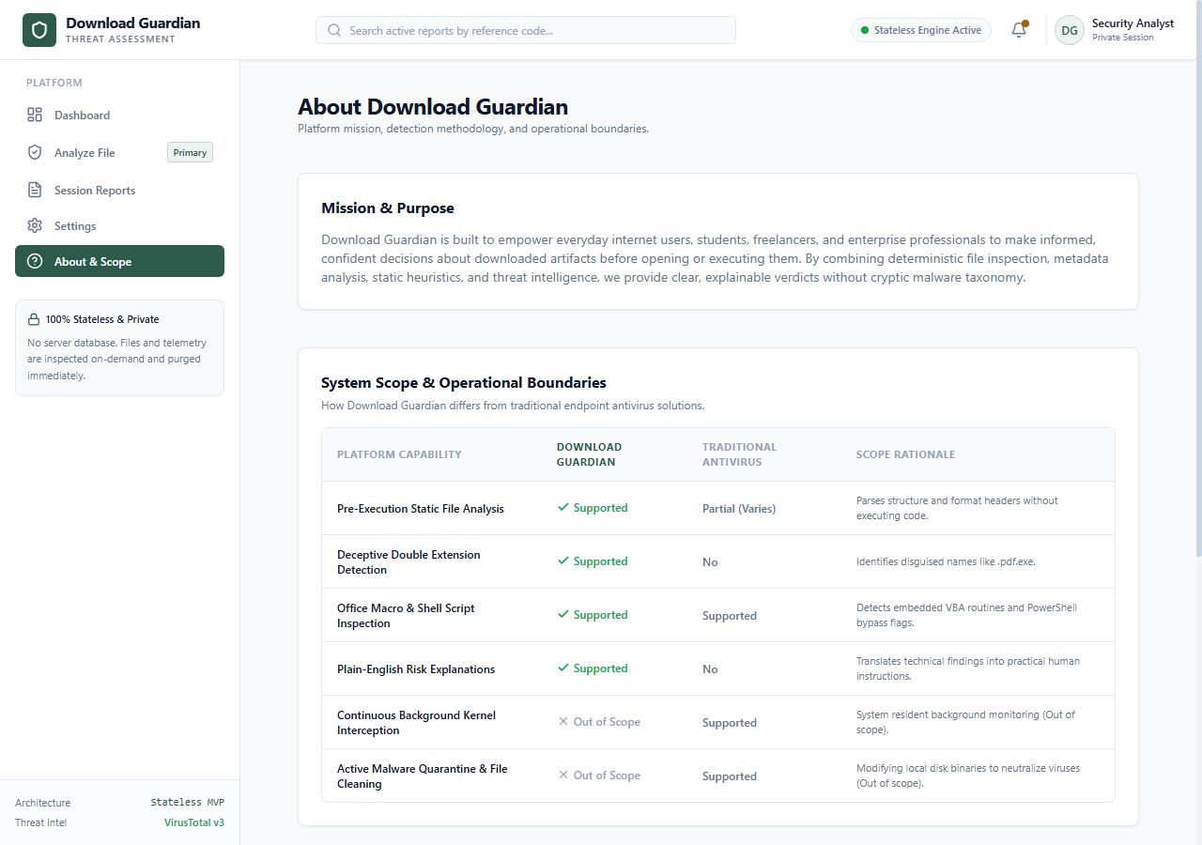

4. Automated Security Recommendations
1. Quarantine and Delete Artifact: Immediately purge 'space.pdf.exe' from client downloads. Do not double-click or mount in a sandboxed host.
2. Audit Download Source: Inspect firewall and proxy logs for the originating HTTP referrer or sender IP to determine if typosquatting domains were utilized.
3. Enable Extension Visibility: Enforce Windows Group Policy (GPO) setting 'Show file extensions for known file types' across all domain endpoints to mitigate deceptive extension attacks.

5. Conclusion
The experimental evaluation against 'space.pdf.exe' confirms that Download Guardian effectively detects and neutralizes multi-extension deceptive attacks before execution occurs. By combining magic-byte header inspection, cryptographic integrity verification, and ephemeral in-memory processing, Download Guardian establishes a robust, privacy-preserving standard for endpoint defense.

