1. **What is the expected result for each of the following test cases?**

|  | **Rule1** | **Rule2** | **Rule3** | **Rule4** |
| --- | --- | --- | --- | --- |
| **Conditions** |  |  |  |  |
| Citibank Card Member | Yes | Yes | No | No |
| Type of Room | Silver | Platinum | Silver | Platinum |
| **Actions** |  |  |  |  |
| Offer upgrade To Gold Luxury | Yes | No | No | No |
| Offer upgrade to Silver | N/A | Yes | N/A | No |

X. Citibank card member, holding a Silver room   
Y. Non Citibank-member, holding a Platinum room

A. X – Don’t offer any upgrade, Y – Don’t offer any upgrade.  
B. X – Don’t offer any upgrade, Y – Offer upgrade to Gold.  
C. X – Offer upgrade to Silver, Y – Offer upgrade to Silver.  
**D. X – Offer upgrade to Gold, Y – Don’t offer any upgrade**

1. **Given the following decision table: Which of the following test cases and expected results is VALID?**

|  | **Rule1** | **Rule2** | **Rule3** | **Rule4** |
| --- | --- | --- | --- | --- |
| **Conditions** |  |  |  |  |
| Age | **<21 Years** | **21-29 Years** | **30-50 Years** | **>50 Years** |
| Insurance Class | **A** | **A or B** | **B, C or D** | **C or D** |
| **Actions** |  |  |  |  |
| Premium | **$100** | **$90** | **$70** | **$70** |
| Excess | **$2500** | **$2500** | **$500** | **$1000** |

1. 23 year old in insurance class A Premium is 100 and excess is 500.
2. 51 year old in insurance class C Premium is 100 and excess is 00.
3. **31 year old in insurance class B Premium is 70 and excess is 500.**
4. 43 year old in insurance class C Premium is 100 and excess is 5000.
5. **In a system designed to work out the tax to be paid:**

| Where taxable income does not exceed **Rs600,000** | The tax rate is **zero** |
| --- | --- |
| Where taxable income exceeds **Rs. 600,000** but does not exceed **Rs. 1,200,000** | **2.5** per cent of the amount exceeding **Rs 600,000** |
| Where taxable income exceed **Rs1,200,000** but does not exceed **Rs2,400,000** | **Rs15,000 + 12.5** per cent of the amount exceeding **Rs1,200,000** |
| If taxable income exceeds **Rs2,400,000** but does not exceed **Rs3,600,000** | **Rs165,000 + 20%** of the amount exceeding **Rs2,400,000** |
| Where taxable income exceeds **Rs3,600,000** but does not exceed **Rs6,000,000** | **Rs405,000 + 25** per cent of the amount exceeding **Rs3,600,000** |
| If taxable income exceeds **Rs6,000,000** but does not exceed **Rs12,000,000** | **Rs1,005,000 + 32.5** per cent of the amount exceeding **Rs6,000,000** |
| Where taxable income exceeds **Rs12,000,000** | **Rs2,955,000 + 35** per cent of the amount exceeding **Rs12,000,000** |

List down all VALID and INVALID boundary values and EQUIVALENCE CLASSES for each slab

**Answer:**

| **Sr #** | **Valid Boundary** | **Invalid Boundary** | **Equivalence Classes** |
| --- | --- | --- | --- |
| 1 | 0 - 600,000 | >600,000 | 0 |
| 2 | 600,001 - 1,200,000 | >1,200,000 | 2.5% |
| 3 | 1,200,001 - 2,400,000 | >2,400,000 | 15,000 + 12.5% |
| 4 | 2,400,001 - 3,600,000 | >3,600,000 | 165,000 + 20% |
| 5 | 3,600,001 - 6,000,000 | >6,000,000 | 405,0000 + 25% |
| 6 | 6,000,001 - 12,000,000 | >12,000,000 | 1,005,000 + 32.5% |
| 7 | <12,000,000 | >12,000,000 | 2,955,000 + 35% |

1. Let’s consider the behavior of the Order **Ice Cream** Text Box Below. **Ice Cream** values 1 to 20 are considered valid. A success message is shown. While value 21 to 99 are considered invalid for order and an error message will appear, **“Maximum 20 ice cream can be ordered”**

**Ice Cream:**

**Here is the test condition**

1. Any Number greater than 20 entered in the Ice cream field (let say 21) is considered invalid.
2. Any Number less than 1 that is 0 or below, then it is considered invalid.
3. Numbers 1 to 20 are considered valid
4. Any 3 Digit Number say -100 is invalid.

**Answer:**

| **0** | **1 - 20** | **21 - 99** |
| --- | --- | --- |
| Invalid | Valid | Invalid |

**Design Test that will cover above scenario with all VALID and INVALID boundary values and Equivalence Classes.**

1. **Following password field accepts minimum 8 characters and maximum 15 characters**

**That means results for values in partitions 0-7, 8-15, 16-20 should be equivalent**

**Enter Password:** 

**Answer:**

Here we will see the Boundary Value Test Cases

| Test Scenario Description | Expected Outcome |
| --- | --- |
| Boundary Value = 0 | System should NOT accept |
| Boundary Value = 8 | **System should accept** |
| Boundary Value = 7 | System should NOT accept |
| Boundary Value = 15 | **System should accept** |
| Boundary Value = 16 | System should NOT accept |
| Boundary Value = 20 | System should NOT accept |
| Boundary Value = 6 | System should NOT accept |
| Boundary Value = 14 | **System should accept** |
| Boundary Value = 17 | System should NOT accept |
| Boundary Value = 19 | System should NOT accept |

1. **Draw Decision Table and state transition diagram of following Registration screen:**

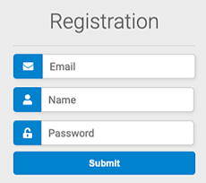

**Answer:**

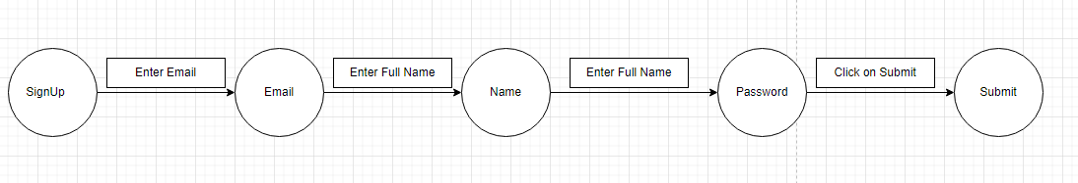

1. **Draw state transition diagram and decision table of the following scenario:**

Go to the ATM machine to withdraw RS 10,000, requires to the ATM machine and get cash. Later on, go to the ATM and give the same request at the same amount but this time ATM refuses the amount because of insufficient balance amount

**Note: ATM all default states should also be included in your answer**

**Answer:**

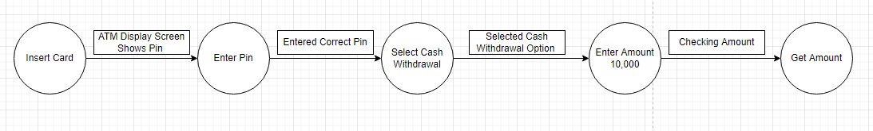

1. Suppose there is a password field which can accept letters from a-z, A-Z and numericals 1-9.  
   Now if we test this password field with a straight approach(unefficient one) then we will test this field by entering each alphabet i.e a to z then A to Z and then numericals 1 to 9 to test whether the field accepts them successfully or not. And further we will test it by some invalid values like ] (ascii value 93) or @(ascii value 64).

**How many test cases would be there to test? Show all equivalence classes and boundary values**

**Answer:**

1) First class

Digits smaller than 1 **(Invalid values)**

2)Second class

digits 1-9 **(valid values)**

3) Third class

digits greater than 9 **(invalid values)**

4) Fourth class

(characters smaller than A and greater than 9)

i.e. whose ASCII value is smaller than that of A and greater than that of 9.

**(invalid values)**

5) Fifth class

Characters A-Z **(valid values)**

6) Sixth class

characters having ascii value greater than that of Z and smaller than a(small &#39;a&#39; of next

class)

**(invalid values)**

7) Seventh class

a-z

**(valid values)**

8) Eighth Class

characters having ascii value greater than z(small)

**(invalid values)**

1. Let us consider an example of software application. There is function of software application that accepts only particular number of digits, not even greater or less than that particular number.

Consider an OTP number that contains only 6 digit number, greater and even less than six digits will not be accepted, and the application will redirect customer or user to error page. If password entered by user is less or more than six characters, that equivalence partitioning method will show an invalid OTP. If password entered is exactly six characters, then equivalence partitioning method will show valid OTP.

**Provide all equivalence and Boundary values.**

**Answer:**

| **<100000** | **100000-999999** | **>999999** |
| --- | --- | --- |
| **Invalid Boundary** | **Valid Boundary** | **Invalid Boundary** |

| **TC #** | **Enter OTP** | **Result** |
| --- | --- | --- |
| **1** | 452000 | Valid |
| **2** | 522411 | Valid |
| **3** | 44455112 | Invalid |
| **4** | 775841211 | Invalid |
| **5** | 98 | Invalid |
| **6** | 1 | Invalid |
| **7** | 456789 | Valid |
| **8** | 958552 | Valid |
| **9** | 345 | Invalid |
| **10** | 45678 | Invalid |

1. **The next-date problem**

Given a day in the format of day-month-year, you need to find the next date for the given date. Perform boundary value analysis and equivalence-class testing for this.

**Conditions :**

D: 1<Day<31

M: 1<Month<12

Y: 1950 <Year <2025

Example:

| Test Case ID | Day | Month | Year | Expected Output |
| --- | --- | --- | --- | --- |
| 1 | 1 | 6 | 2000 | 2-6-2000 |

**Answer:**

| **Test Case ID** | **Day** | **Month** | **Year** | **Expected Output** |
| --- | --- | --- | --- | --- |
| 1 | 30 | 1 | 1945 | Invalid |
| 2 | 23 | 2 | 1951 | 23-2-1951 |
| 3 | 1 | 3 | 1946 | Invalid |
| 4 | 2 | 11 | 1930 | Invalid |
| 5 | 5 | 4 | 1958 | 5-4-1958 |
| 6 | 6 | 5 | 1998 | 6–5-1998 |
| 7 | 3 | 6 | 1949 | Invalid |
| 8 | 21 | 7 | 1996 | 21-7-1996 |
| 9 | 22 | 8 | 2000 | Invalid |
| 10 | 15 | 9 | 2012 | 15-9-2012 |
| 11 | 31 | 10 | 2015 | 30-10-2015 |
| 12 | 25 | 11 | 2032 | Invalid |
| 13 | 26 | 1 | 2022 | 26-1-2022 |
| 14 | 4 | 2 | 2068 | Invalid |
| 15 | 14 | 12 | 2051 | Invalid |