[**Task1: Write an SQL query that selects records that have matching values in both tables.**](https://docs.google.com/document/d/1mUwtDWwerq0TS1xz2Lk6Wd8Hp_96PXL0-s4hgOEXeX4/edit#heading=h.2et92p0)

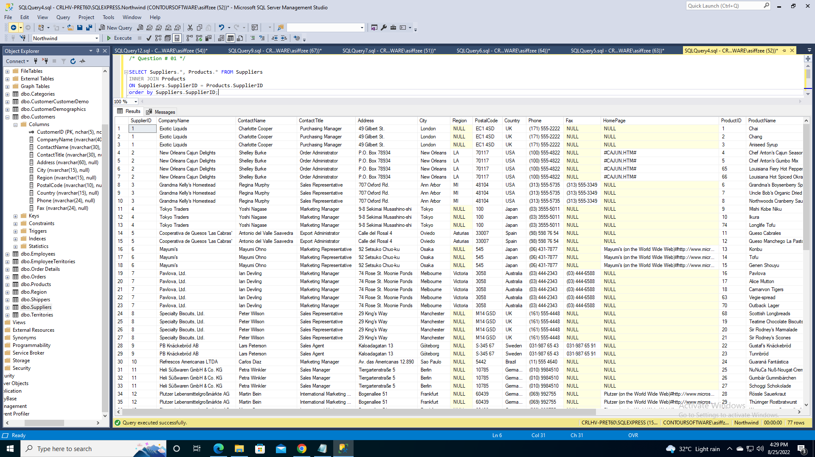

**/* Question # 01 */**

SELECT Suppliers.*, Products.* FROM Suppliers

INNER JOIN Products

ON Suppliers.SupplierID = Products.SupplierID

order by Suppliers.SupplierID;

[**Task2: Write an SQL query that selects all orders with customer information.**](https://docs.google.com/document/d/1mUwtDWwerq0TS1xz2Lk6Wd8Hp_96PXL0-s4hgOEXeX4/edit#heading=h.tyjcwt)

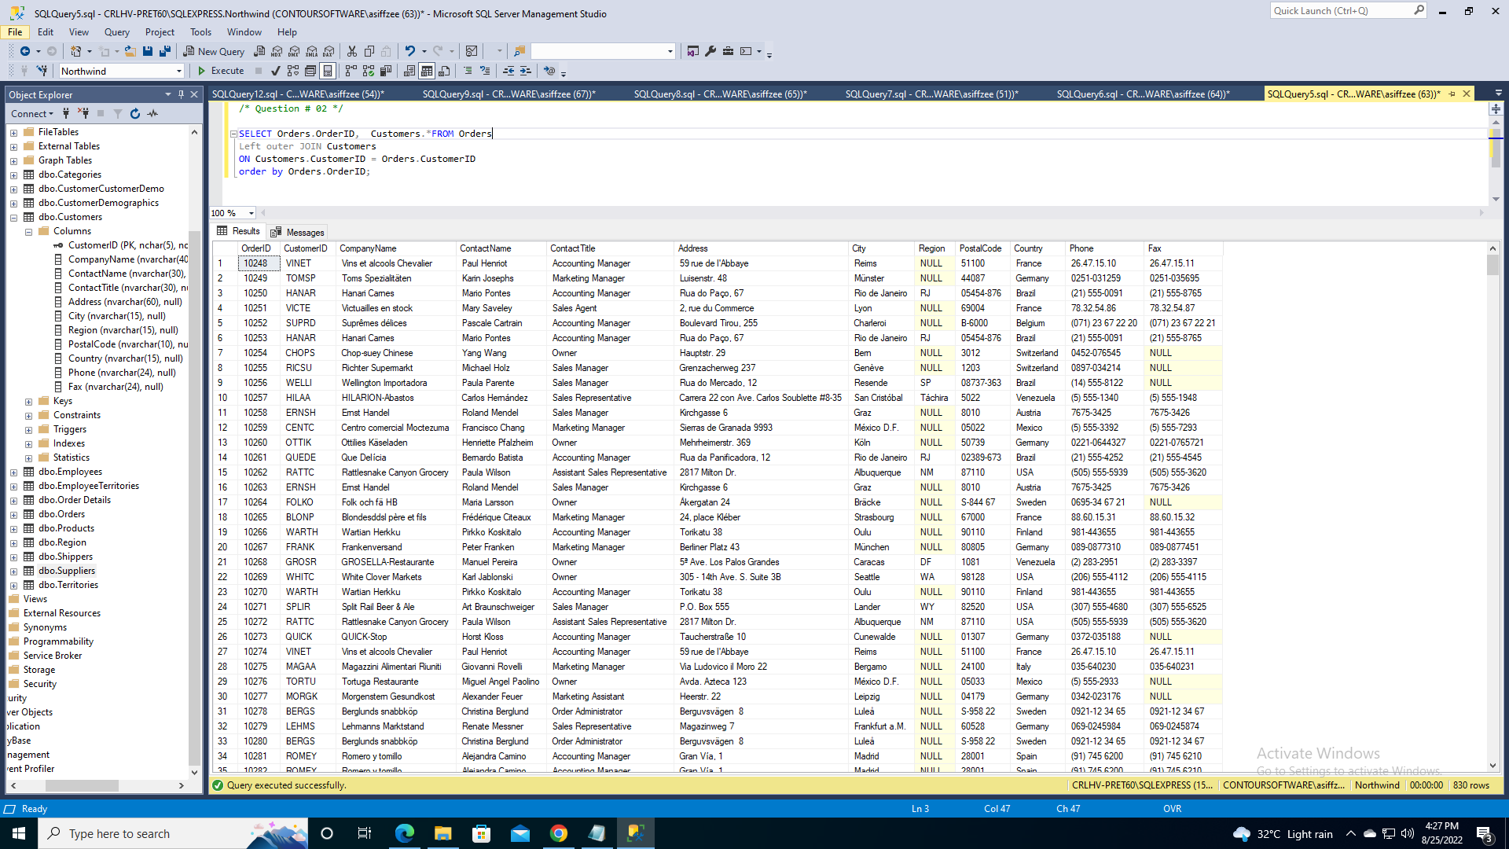

**/* Question # 02 */**

SELECT Orders.OrderID, Customers.*FROM Orders

Left outer JOIN Customers

ON Customers.CustomerID = Orders.CustomerID

order by Orders.OrderID;

[**Task3: Write an SQL Query that select all shipper ids, and any orders they might have**](https://docs.google.com/document/d/1mUwtDWwerq0TS1xz2Lk6Wd8Hp_96PXL0-s4hgOEXeX4/edit#heading=h.3dy6vkm).

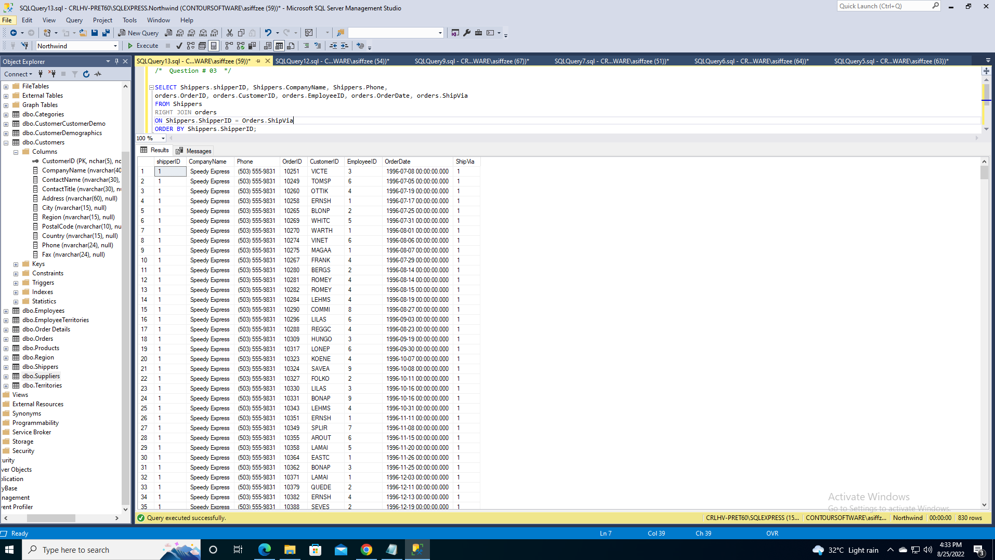

**/* Question # 03 */**

SELECT Shippers.shipperID, Shippers.CompanyName, Shippers.Phone,

orders.OrderID, orders.CustomerID, orders.EmployeeID, orders.OrderDate, orders.ShipVia

FROM Shippers

RIGHT JOIN orders

ON Shippers.ShipperID = Orders.ShipVia

ORDER BY Shippers.ShipperID;

[**Task4: Write an SQL Query that return all employees, and any orders they might have placed.**](https://docs.google.com/document/d/1mUwtDWwerq0TS1xz2Lk6Wd8Hp_96PXL0-s4hgOEXeX4/edit#heading=h.1t3h5sf)

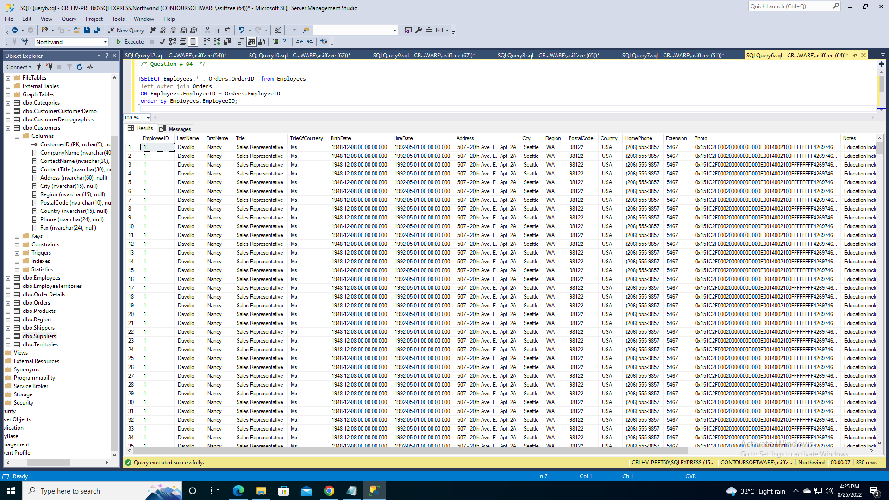

**/* Question # 04 */**

SELECT Employees.* , Orders.OrderID from Employees

left outer join Orders

ON Employees.EmployeeID = Orders.EmployeeID

order by Employees.EmployeeID;

[**Task5: Write an SQL query that selects all customers, and all orders**](https://docs.google.com/document/d/1mUwtDWwerq0TS1xz2Lk6Wd8Hp_96PXL0-s4hgOEXeX4/edit#heading=h.4d34og8)

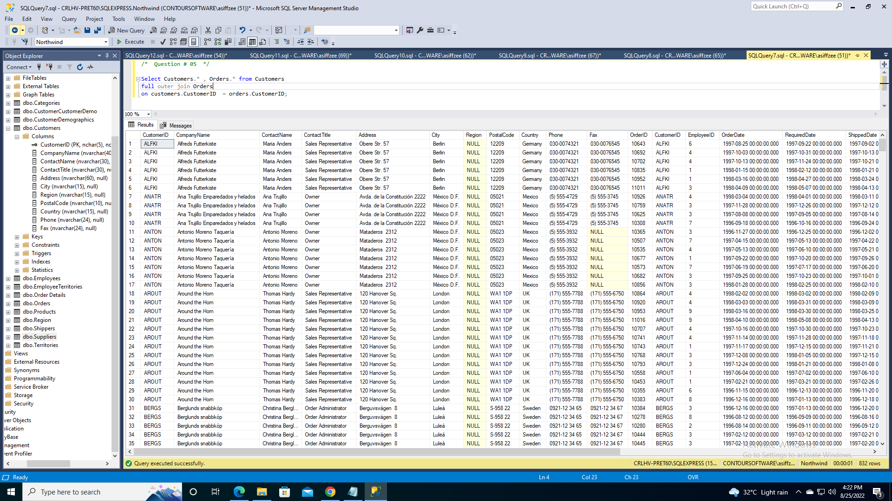

**/* Question # 05 */**

Select Customers.* , Orders.* from Customers

full outer join Orders

on customers.CustomerID = orders.CustomerID;

[**Task6: Write an SQL query that matches customers that are from the same city**](https://docs.google.com/document/d/1mUwtDWwerq0TS1xz2Lk6Wd8Hp_96PXL0-s4hgOEXeX4/edit#heading=h.2s8eyo1)

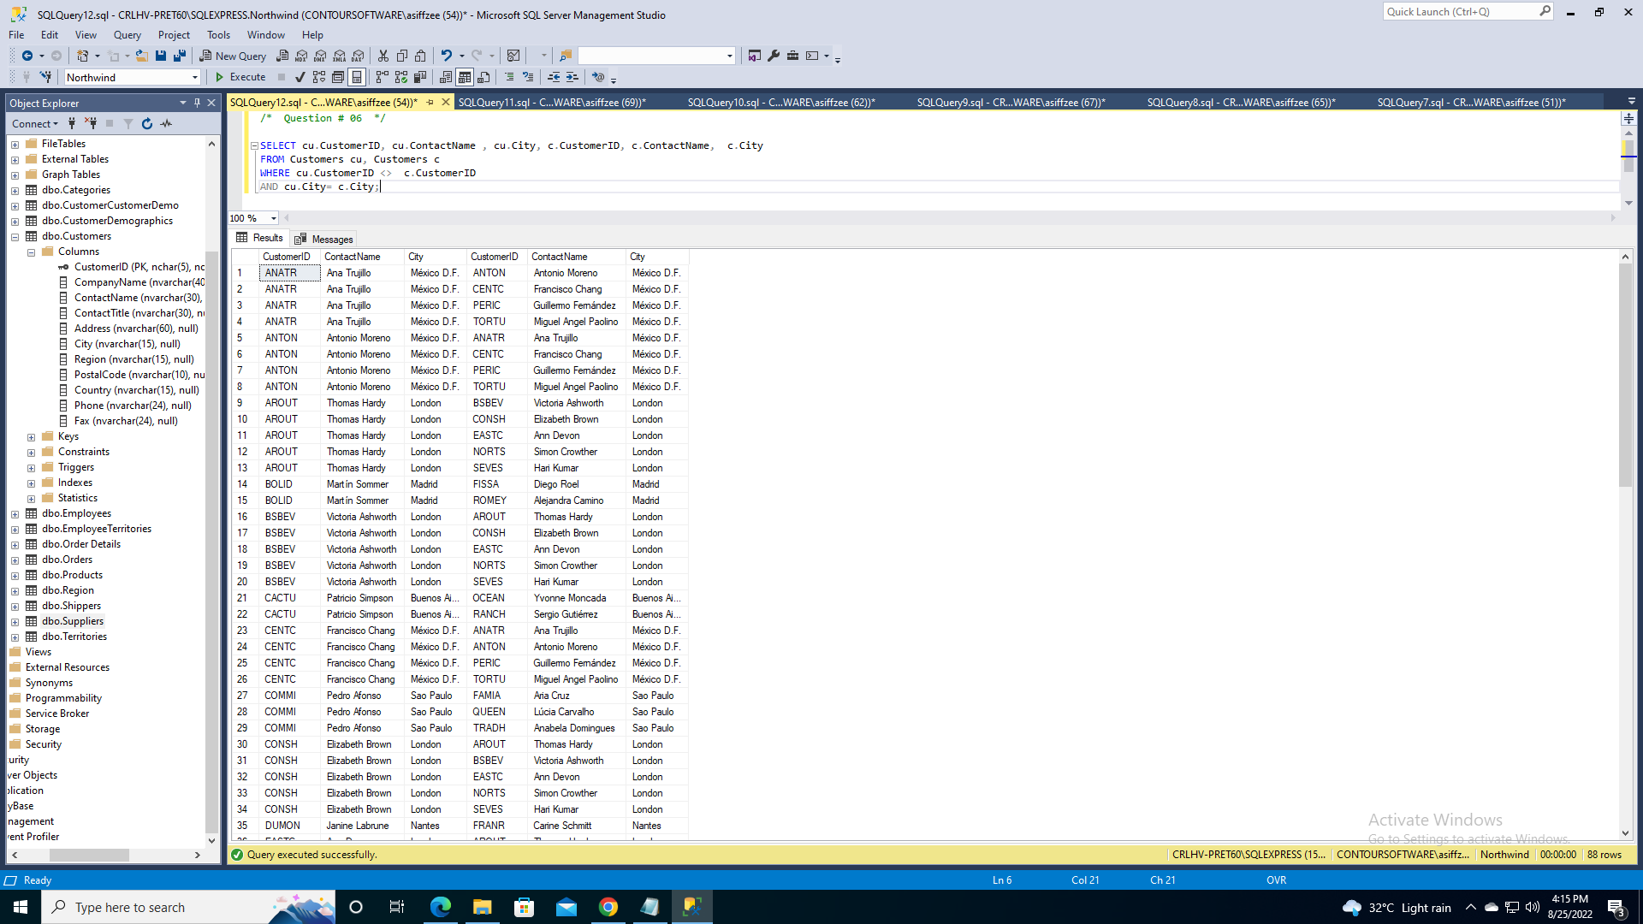

**/* Question # 06 */**

SELECT cu.CustomerID, cu.ContactName , cu.City, c.CustomerID, c.ContactName, c.City

FROM Customers cu, Customers c

WHERE cu.CustomerID <> c.CustomerID

AND cu.City= c.City;

[**Task7: Write an SQL query that returns the cities (only distinct values) from both the Customers and the Suppliers table**](https://docs.google.com/document/d/1mUwtDWwerq0TS1xz2Lk6Wd8Hp_96PXL0-s4hgOEXeX4/edit#heading=h.17dp8vu)

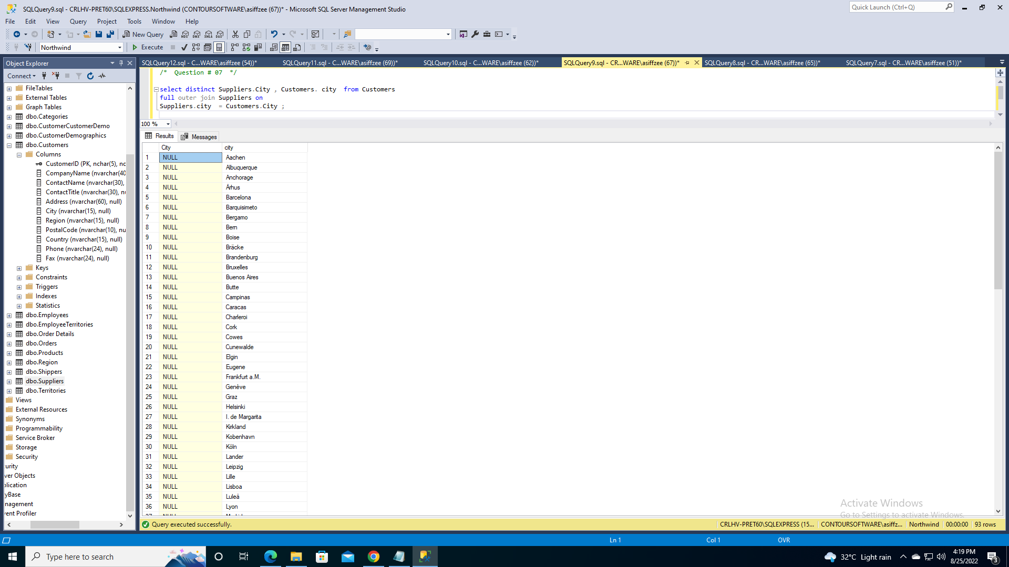

**/* Question # 07 */**

select distinct Suppliers.City , Customers. city from Customers

full outer join Suppliers on

Suppliers.city = Customers.City ;

[**Task8: Write an SQL query that lists the number of customers in each country, sorted high to low**](https://docs.google.com/document/d/1mUwtDWwerq0TS1xz2Lk6Wd8Hp_96PXL0-s4hgOEXeX4/edit#heading=h.3rdcrjn)

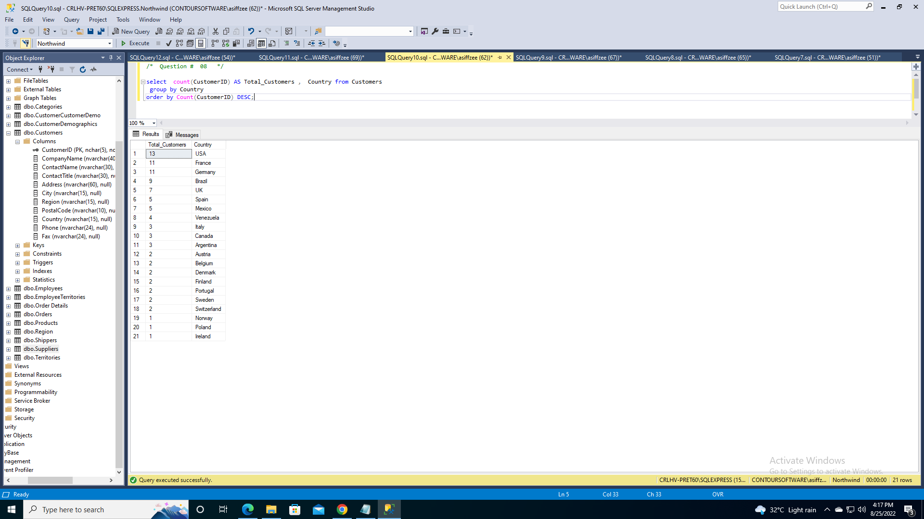

**/* Question # 08 */**

select count(CustomerID) AS Total_Customers , Country from Customers

group by Country

order by Count(CustomerID) DESC;

[**Task9: Write an SQL query that lists the number of customers in each country, sorted high to low (Only include countries with more than 3 customers)**](https://docs.google.com/document/d/1mUwtDWwerq0TS1xz2Lk6Wd8Hp_96PXL0-s4hgOEXeX4/edit#heading=h.26in1rg)

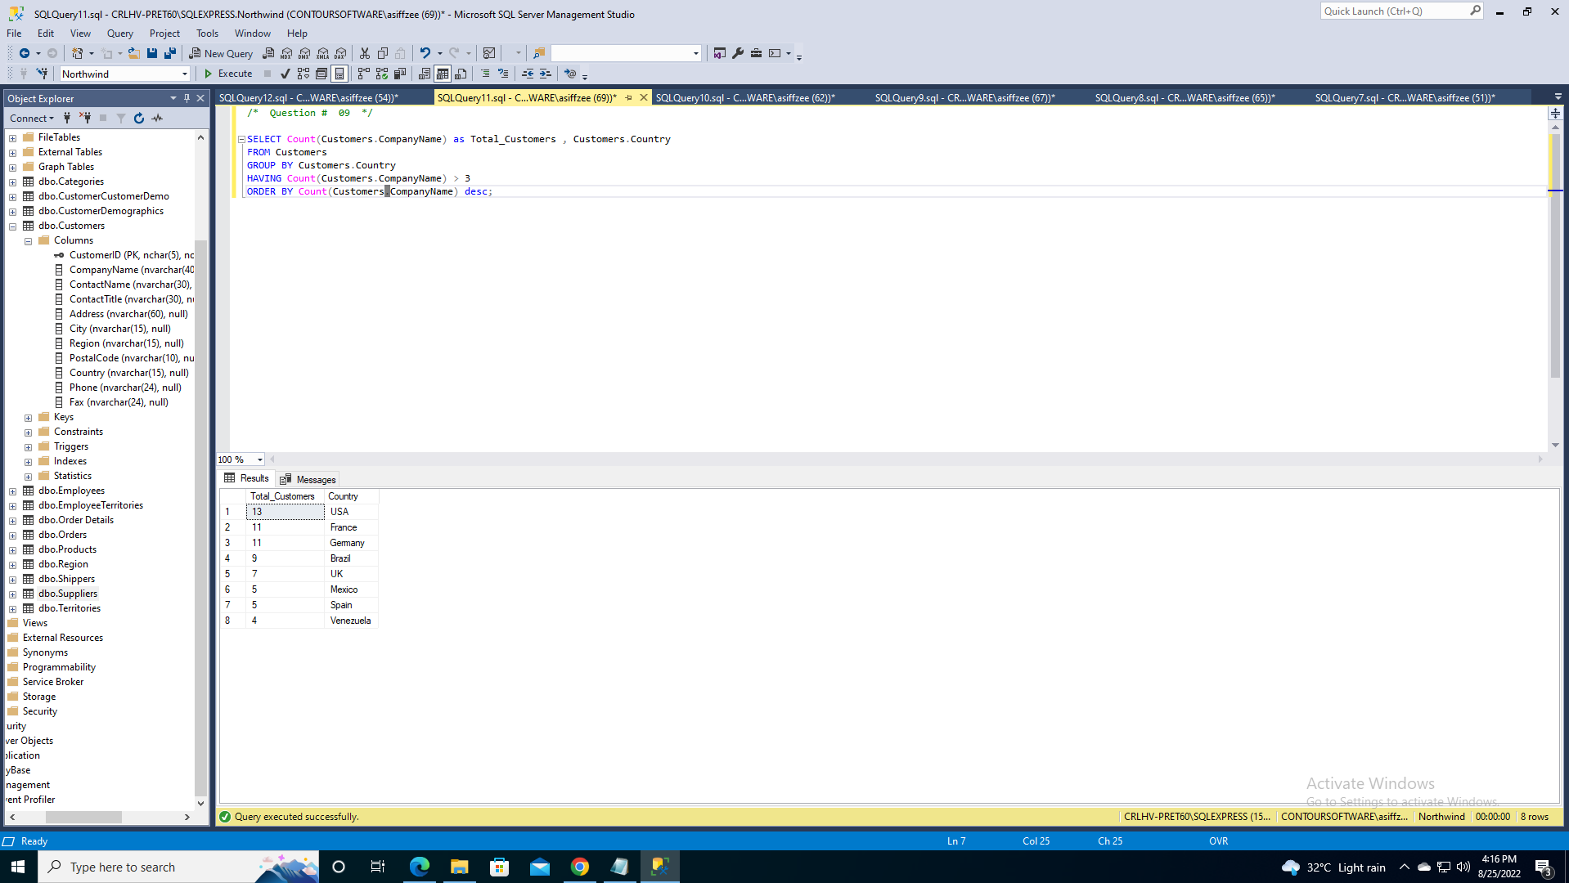

**/* Question # 09 */**

SELECT Count(Customers.CompanyName) as Total_Customers , Customers.Country

FROM Customers

GROUP BY Customers.Country

HAVING Count(Customers.CompanyName) > 3

ORDER BY Count(Customers.CompanyName) desc;

[**Task10: Write an SQL query that lists the suppliers with a product price less than 20**](https://docs.google.com/document/d/1mUwtDWwerq0TS1xz2Lk6Wd8Hp_96PXL0-s4hgOEXeX4/edit#heading=h.lnxbz9)

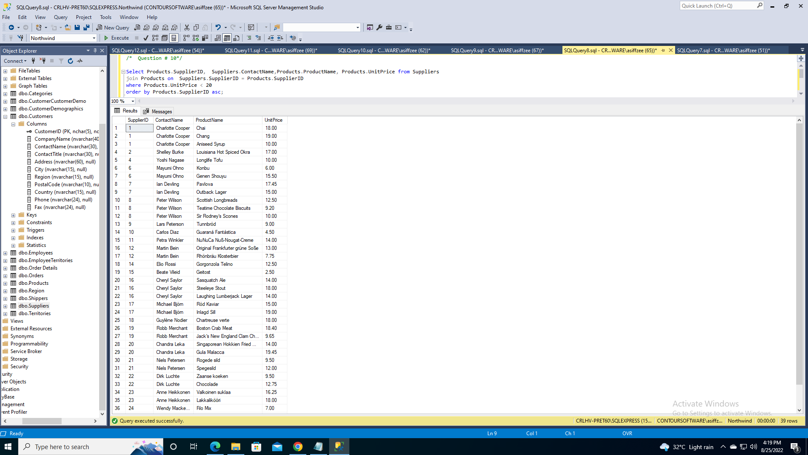

**/* Question # 10 */**

Select Products.SupplierID, Suppliers.ContactName,Products.ProductName, Products.UnitPrice from Suppliers

join Products on Suppliers.SupplierID = Products.SupplierID

where Products.UnitPrice < 20

order by Products.SupplierID asc;

[**Task 12: With the provided link, perform GET, PUT, POST and DELETE methods.**](https://docs.google.com/document/d/1mUwtDWwerq0TS1xz2Lk6Wd8Hp_96PXL0-s4hgOEXeX4/edit#heading=h.1ksv4uv)

**Get:**

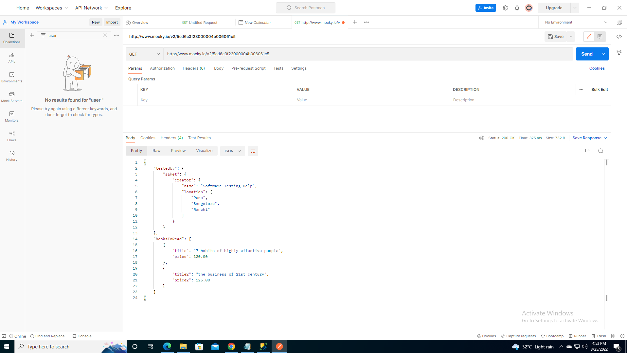

**Post:**

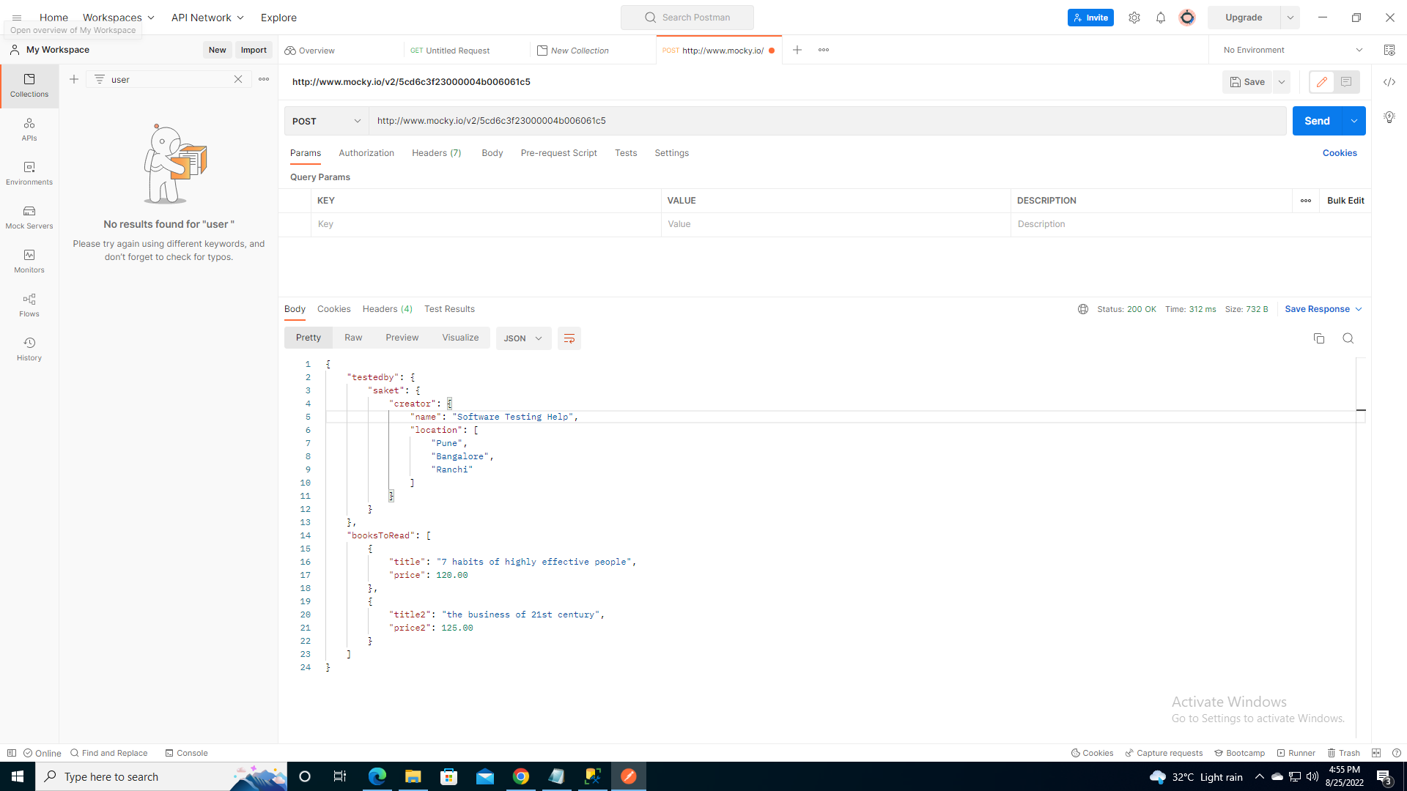

**Put:**

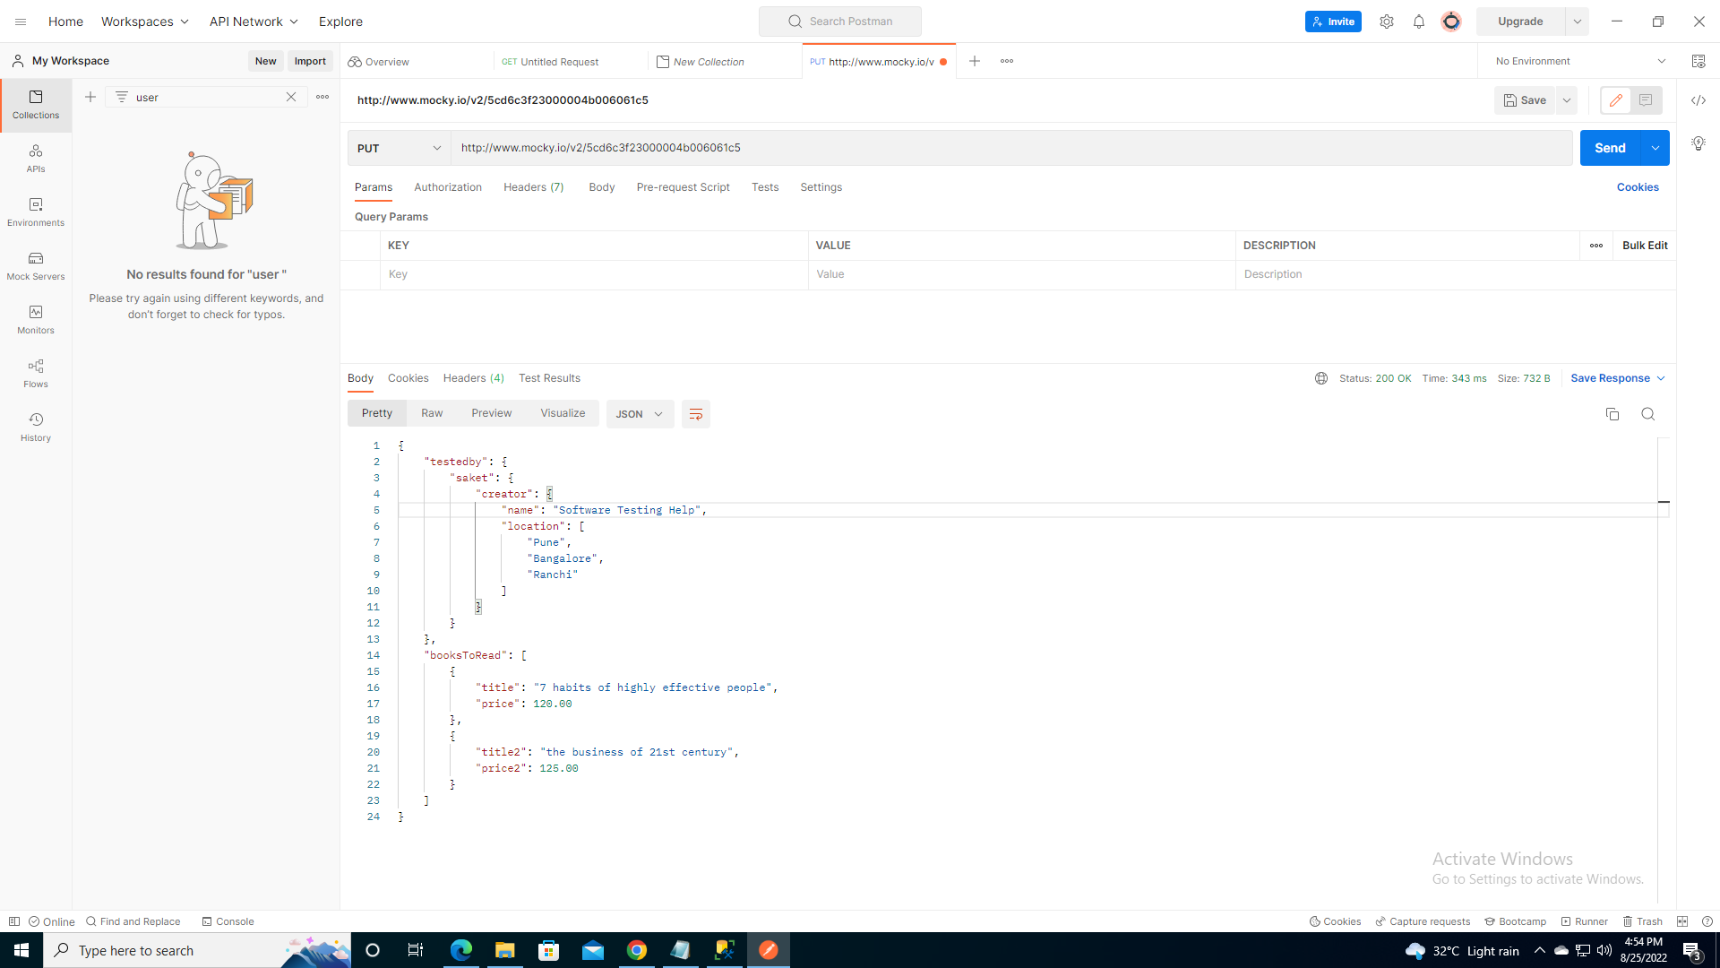

**Delete:**

