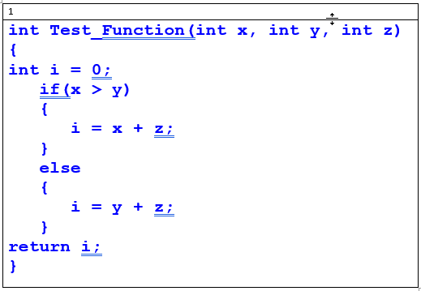

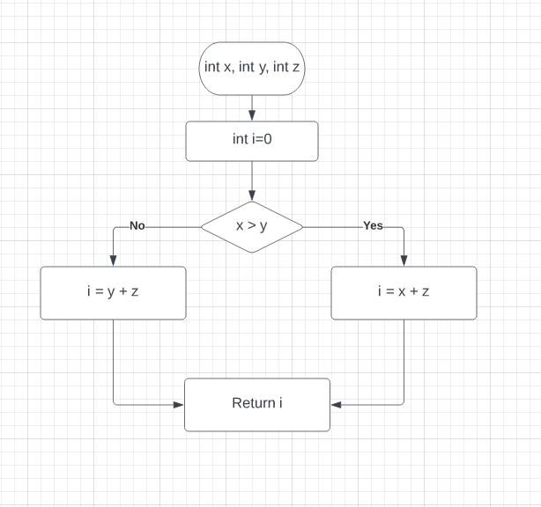

Cyclomatic Code Complexity  
**CC = E – N + 2P**

CC = 6 - 6 + 2(1)

CC = 2

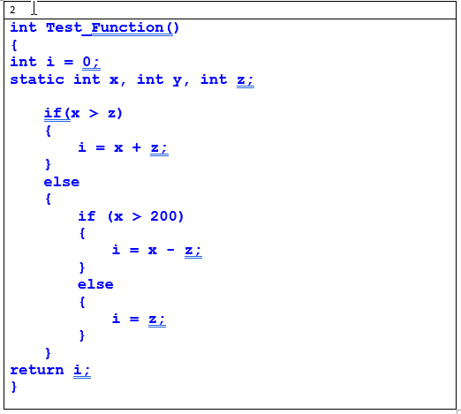

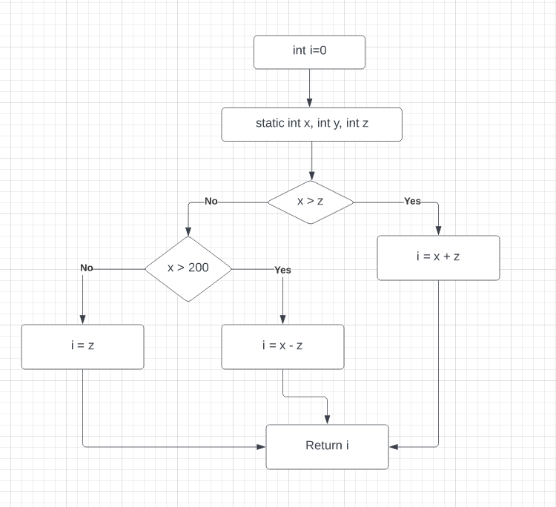\

Cyclomatic Code Complexity  
**CC = E – N + 2P**

CC = 9 - 8 + 2(1)

CC = 1 + 2

CC = 3

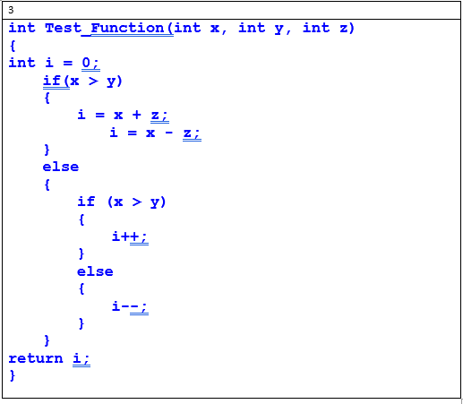

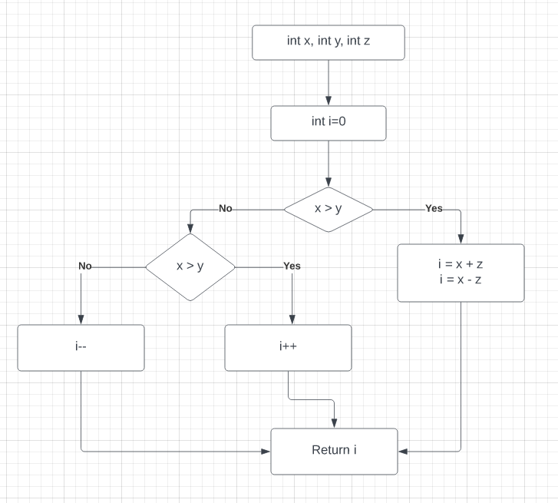

Cyclomatic Code Complexity  
**CC = E – N + 2P**

CC = 9 - 8 + 2(1)

CC = 1 + 2

CC = 3

**Coding Mistakes:**

There is an indentation error in the above code and ‘i’ is updated two times, there is no need to write two times.

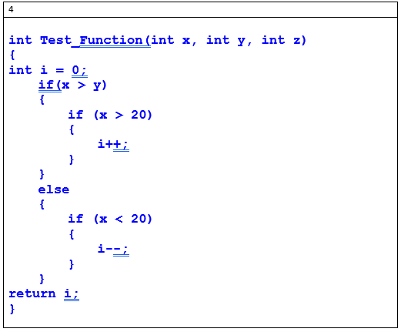

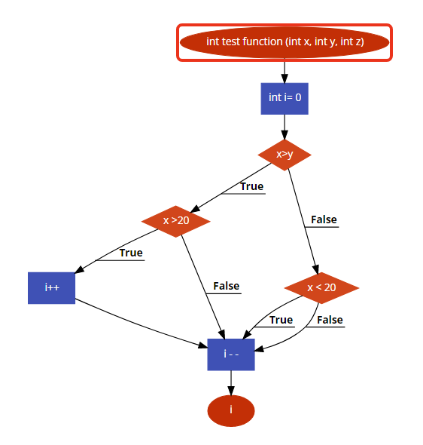

Cyclomatic Code Complexity  
**CC = E – N + 2P**

CC = 10 - 8 + 2(1)

CC = 2 + 2

CC = 4

**Coding Mistakes:**

In the above code “if statement” should have defined the else block but the else block is missing.

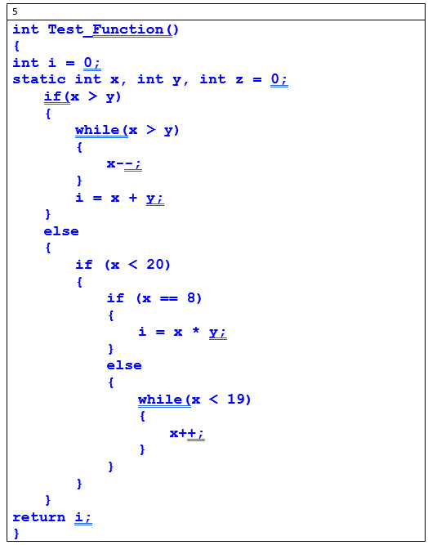

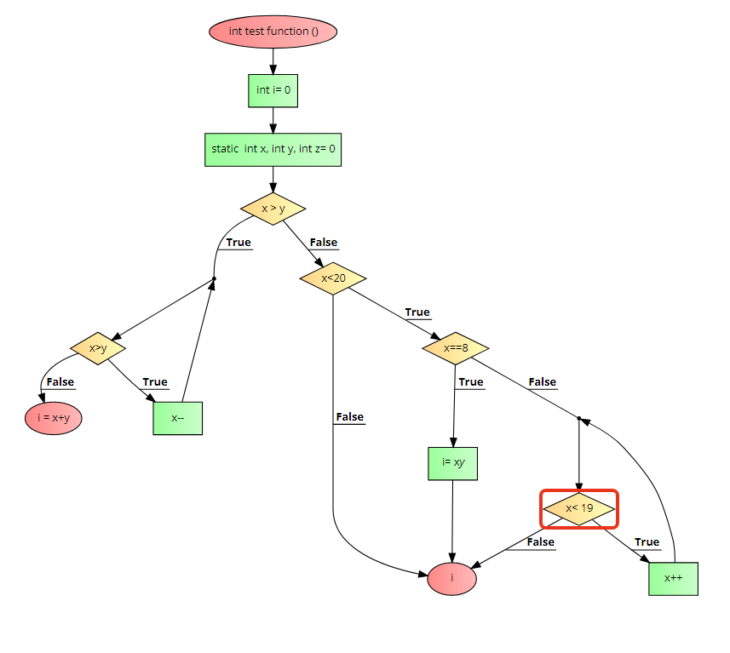

Cyclomatic Code Complexity  
**CC = E – N + 2P**

CC = 16 - 13 + 2(1)

CC = 3 + 2

CC = 5

**Coding Mistakes:**

In the above code “if statement” should have defined the else block but the else block is missing.