| 1 |
| --- |
| **int Test_Function(int x, int y, int z)**  **{**  **int i = 0;**  **if(x > y)**  **{**  **i = x + z;**  **}**  **else**  **{**  **if (x > y)**  **{**  **i++;**  **}**  **else**  **{**  **i--;**  **}**  **}**  **return i;**  **}** |

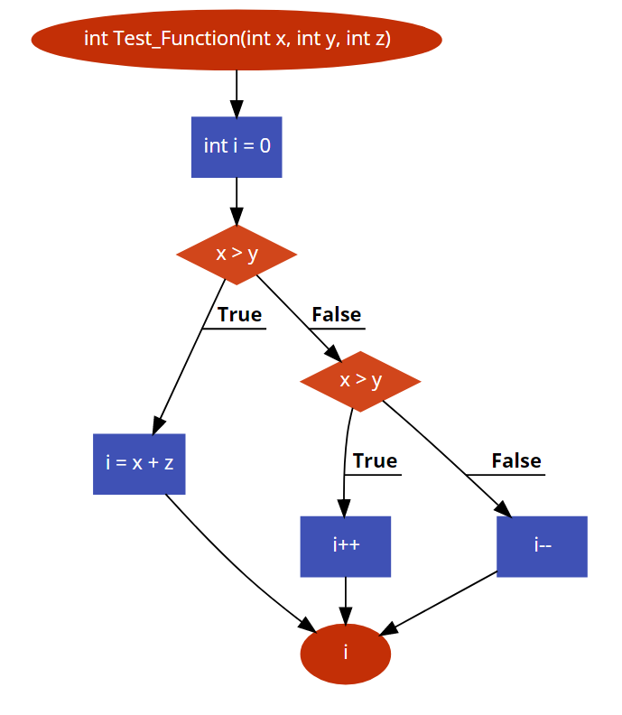

**Points:**

1. Minimum number of test cases for decision coverage is **“2”**
2. Minimum number of test cases for statement coverage is **“2”**
3. Minimum number of test cases for condition coverage is **“1”**
4. Number of statements in each code is **“4”**
5. Number of conditions in each code is **“2”**
6. Number of decisions in each code is **“2”**

| 2 |
| --- |
| **int Test_Function(int x, int y, int z)**  **{**  **int i = 0;**  **if(x > y)**  **{**  **if (x > 20)**  **{**  **i++;**  **}**  **}**  **else**  **{**  **if (x < 20)**  **{**  **i--;**  **}**  **}**  **return i;**  **}** |

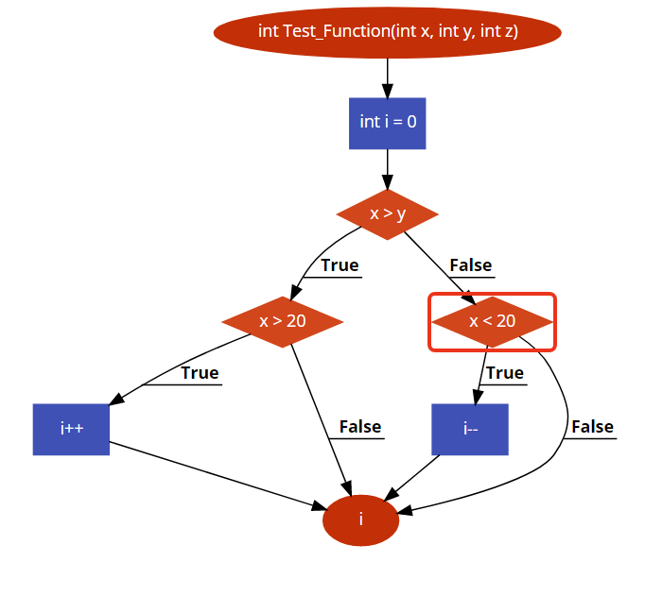

**Points:**

1. Minimum number of test cases for decision coverage is **“3”**
2. Minimum number of test cases for statement coverage is **“2”**
3. Minimum number of test cases for condition coverage is **“2”**
4. Number of statements in each code is **“3”**
5. Number of conditions in each code is **“3”**
6. Number of decisions in each code is **“3”**

| 3 |
| --- |
| **int Test_Function(int x, int y, int z)**  **{**  **int i = 0;**  **if(x > y)**  **{**  **while(x > y)**  **{**  **x--;**  **}**  **i = x + y;**  **}**  **else**  **{**  **if (x < 20)**  **{**  **if (x == 8)**  **{**  **i = x * y;**  **}**  **else**  **{**  **while(x < 19)**  **{**  **x++;**  **}**  **}**  **}**  **}**  **return i;**  **}** |

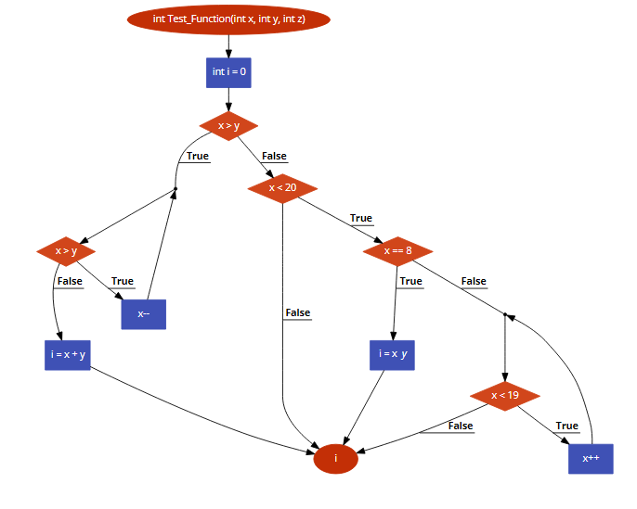

1. Minimum number of test cases for decision coverage is **“5”**
2. Minimum number of test cases for statement coverage is **“5”**
3. Minimum number of test cases for condition coverage is **“4”**
4. Number of statements in each code is **“5”**
5. Number of conditions in each code is **“5”**
6. Number of decisions in each code is **“5”**

| 4 |
| --- |
| **int Test_Function(int x, int y, int z)**  **{**  **int i = 0;**    **switch (x)**  **{**  **case 0:**  **i = x * y;**  **break;**    **case 1:**  **i = x + y;**  **break;**    **case 2:**  **i = x - y;**  **break;**    **case 3:**  **i = x++;**  **break;**    **default:**  **i = x--;**  **break;**  **}**    **return i;**  **}** |

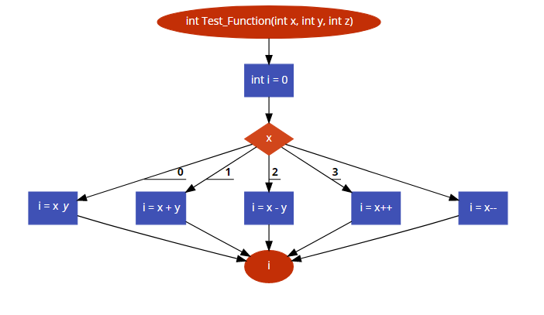

1. Minimum number of test cases for decision coverage is **“5”**
2. Minimum number of test cases for statement coverage is **“5”**
3. Minimum number of test cases for condition coverage is **“5”**
4. Number of statements in each code is **“5”**
5. Number of conditions in each code is **“1”**
6. Number of decisions in each code is

| 5 |
| --- |
| **int Test_Function(int x, int y, int z)**  **{**  **int i = 0;**    **switch (x)**  **{**  **case 0:**  **i = x * y;**  **break;**    **case 1:**  **if(x > y)**  **{**  **i = z + y;**  **}**  **break;**    **case 2:**  **i = x - y;**  **break;**    **case 3:**  **if(z == y)**  **{**  **i = z + y;**  **}**  **else**  **{**  **i = x++;**  **}**  **break;**    **default:**  **i = x--;**  **break;**  **}**    **return i;**  } |

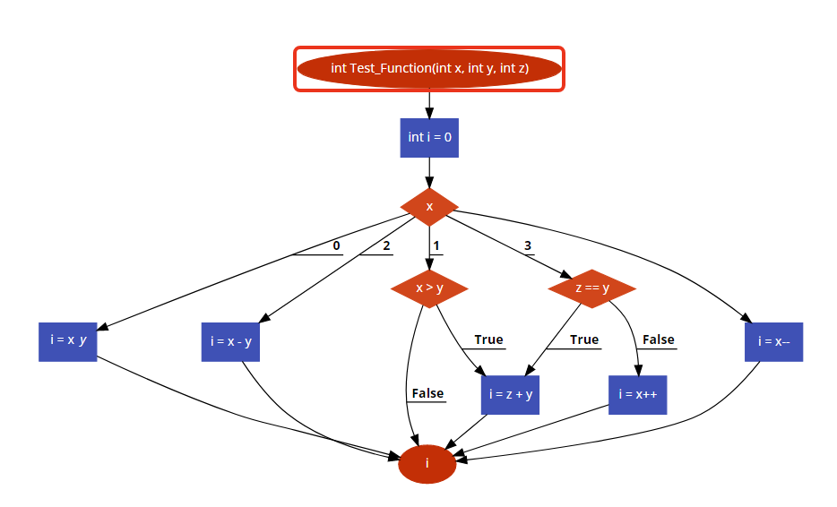

1. Minimum number of test cases for decision coverage is **“2”**
2. Minimum number of test cases for statement coverage is **“6”**
3. Minimum number of test cases for condition coverage is **“4”**
4. Number of statements in each code is **“5”**
5. Number of conditions in each code is **“3”**
6. Number of decisions in each code is **“2”**