Project – MOBILE APPLIACTION

(Watch Hub)

Submitted By:
Zeeshan, Muhmmad, Ali Taqi, Syed Shayan

GROUP MEMBERS

S# | Name: | Student ID: | Email:
1. | Zeeshan | 1418296 | zeeahmed2001@gmail.com
2. | Muhammad | 1429335 | muhammadtaimur044@gmail.com
3. | Ali Taqi | 1435143 | taqis0300@gmail.com
4. | Shayan | 1431412 | shayan@gmail.com

ACKNOWLEDGEMENT
We express our gratitude to APTECH for providing us with the opportunity and resources to complete this project-based laboratory report. Special thanks to our APTECH Projecting In charge for guidance and support.

Introduction

The Watch Hub Mobile App aims to provide a seamless and user-friendly platform for purchasing premium watches. It bridges the gap between traditional shopping and the increasing trend of e-commerce. Designed for a well-established watch retailer, the app ensures a robust online shopping experience with advanced features, making it easy for users to browse, select, and purchase high-quality watches.

Objectives
- Develop a real-life mobile application showcasing end-to-end e-commerce capabilities.
- Simulate a professional project development lifecycle with tools and frameworks like Flutter and Dart.
- Provide a step-by-step guide for learners to understand app development from ideation to deployment.

Problem Statement
Modern IT professionals and students struggle to keep up with rapidly evolving technology trends. Watch Hub addresses this challenge by offering an integrated platform that:
- Caters to user needs for premium watch shopping.
- Demonstrates modern application design and implementation.
- Provides a live example of solving real-world e-commerce problems.

Functional Requirements

4.1 User Authentication
- Features: Account creation, secure login/logout, and password recovery.
- Objective: Ensure safe and seamless access for users.

4.2 Browse Watches
- Features: Catalog browsing with filtering and sorting by brand, type, price, and popularity.
- Objective: Enhance product discovery.

4.3 Product Details
- Features: High-quality images, descriptions, specifications, prices, availability, and stock information.
- Objective: Provide a comprehensive overview of each product.

4.4 Shopping Cart
- Features: Add/remove items, adjust quantities, and display total prices.
- Objective: Simplify the shopping process.

4.5 Search and Filters
- Features: Robust search engine with multiple filters.
- Objective: Help users find specific products quickly.

4.6 Admin Panel
- Features: Manage products, users, reviews, and orders.
- Objective: Enable efficient app management.

Non-Functional Requirements
- Responsiveness: Quick response times (<2 seconds) for smooth interactions.
- Loading Time: Minimized initial loading time.
- User Interface: Intuitive and accessible, adhering to design best practices.
- Error Handling: Clear and informative error messages.
- Scalability: Handle increasing traffic and feature expansions.
- Security: Secure authentication and access control for registered users.
- Documentation: User and developer guides for smooth navigation and maintenance.

Hardware and Software Requirements

6.1 Hardware
- Minimum Pentium 166 system with 128 MB RAM.
- Preferred OS: Windows 2000 Server or higher.

6.2 Software
- Development Tools: Windows OS, Java, Android SDK, Notepad, SQL, Dart, Flutter.

Key Features
- E-Project Learning Environment: Step-by-step implementation simulating real-world projects.
- Interactive and Modern Design: Intuitive navigation and user-friendly features.
- Integrated Feedback Loop: User reviews and admin monitoring ensure continuous improvement.

Conclusion
The Watch Hub Mobile App demonstrates a robust e-commerce solution with real-world relevance. It serves as both a practical application and a learning tool for students and developers, showcasing how technology can simplify and enhance user experiences.
For queries or detailed guidance, please refer to the provided user and developer documentation or contact the development team.

Screen Shot of the project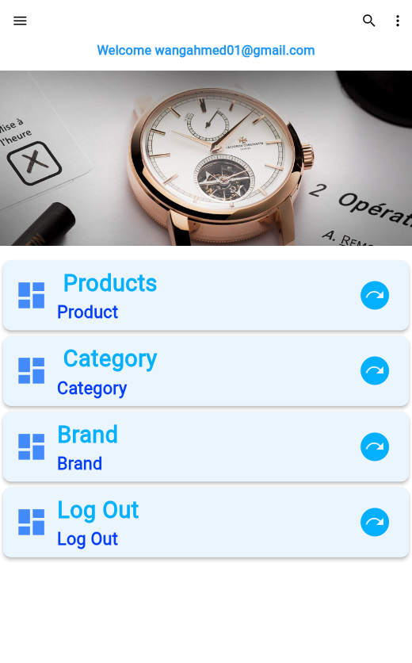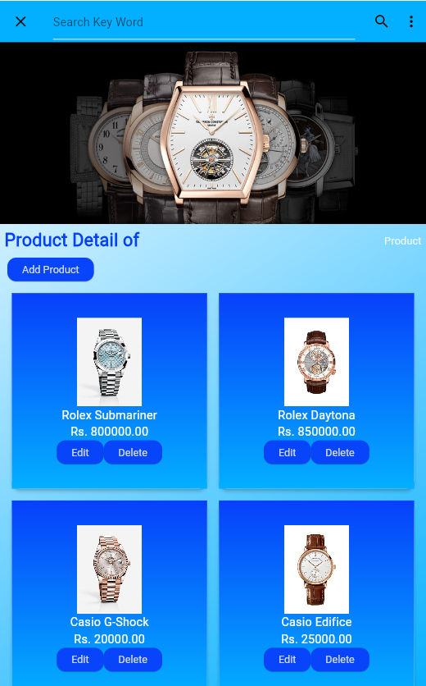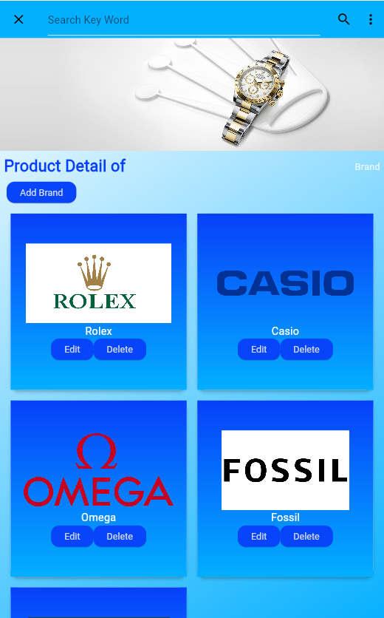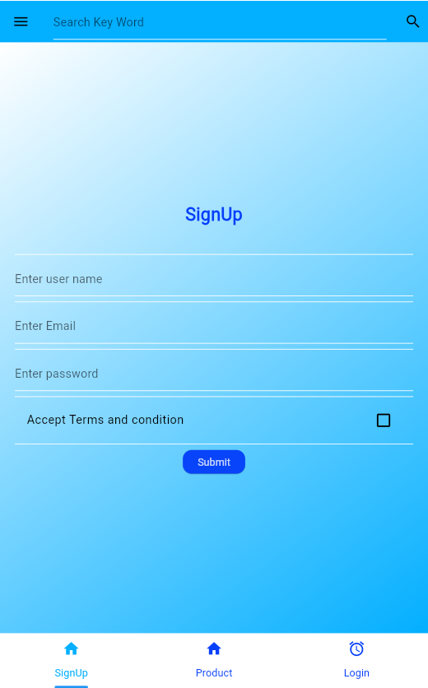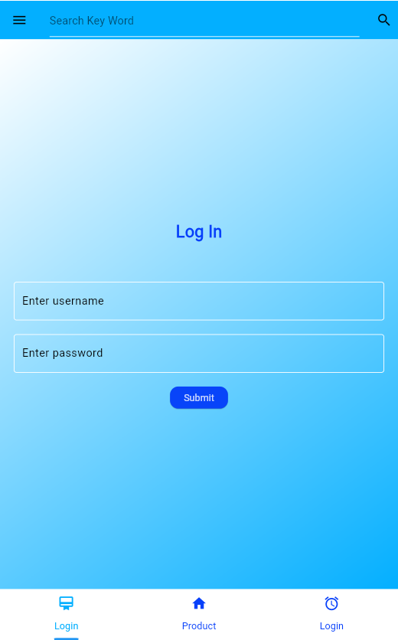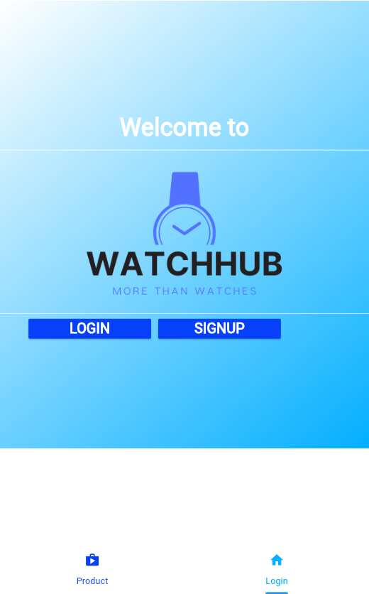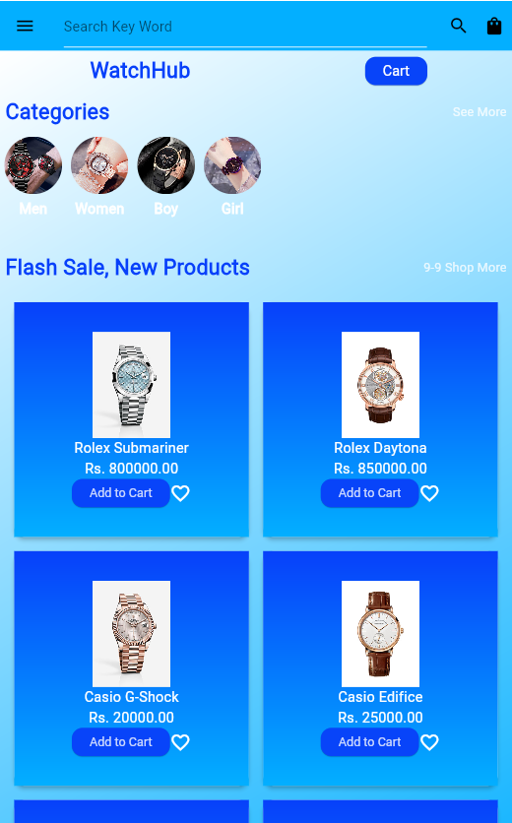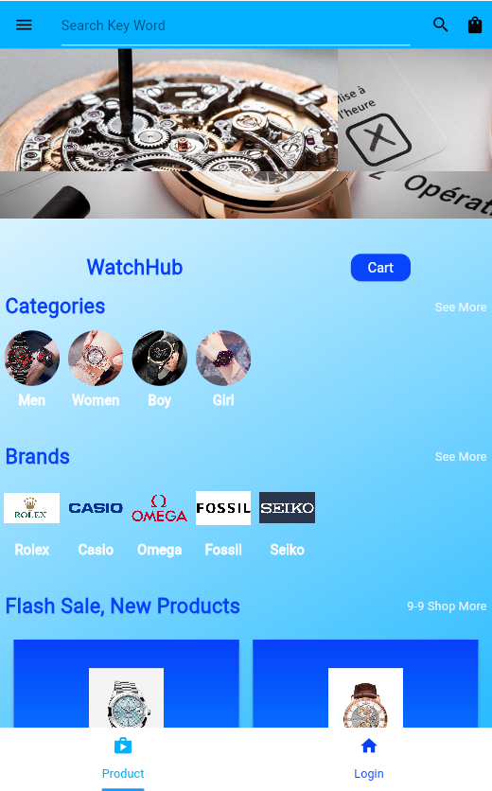

DFDS Watches
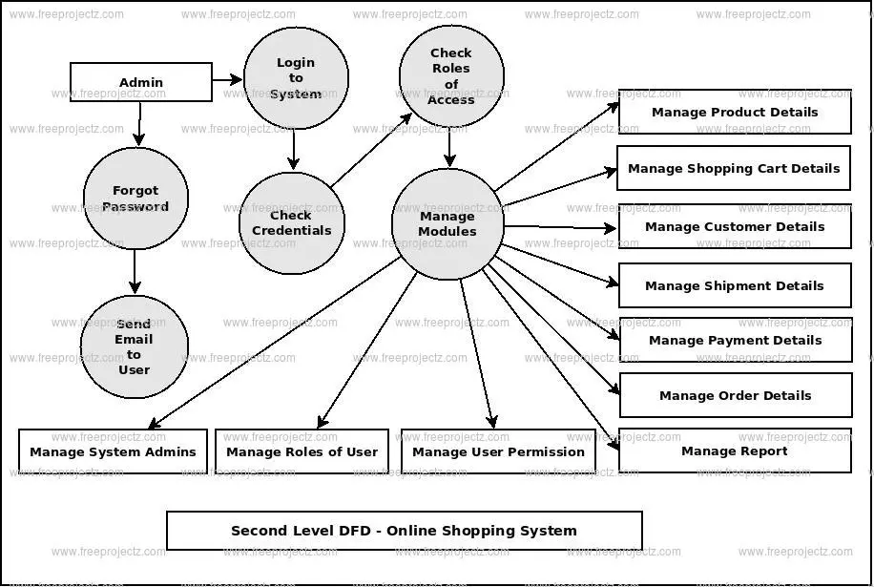

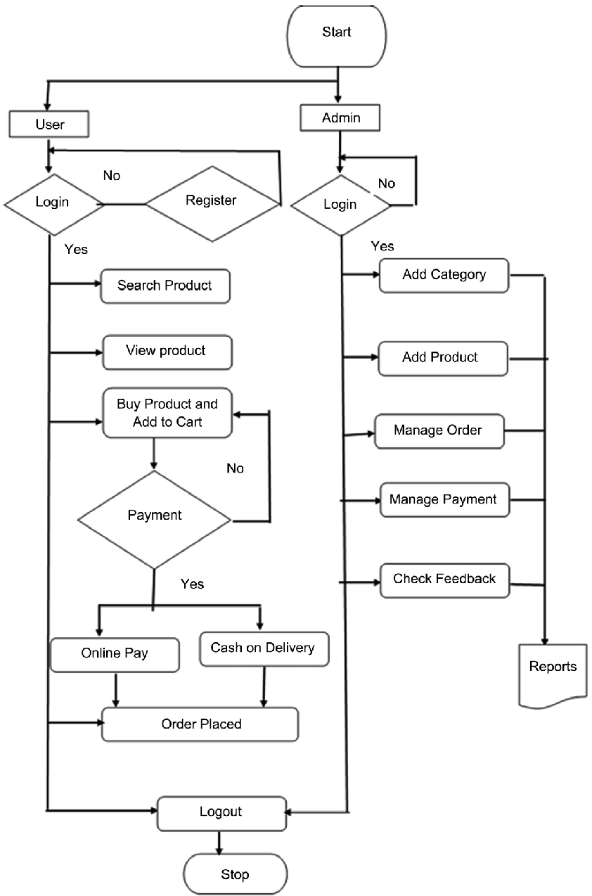
Flow Chart Watches:

