Zeeshan Khurram

Smk190009

Bitmap Project

RING – Pattern Recognition Board Game

INSTRUCTIONS

The game is called Ring, it is a pattern recognition game. You will be shown 10 commands.

#2. The goal is to press those 10 commands in the order they light up, if you get them right you win, else you lose

#3. To start the game, open the bitmap display and keyboard display, connect both to mips

#4.IN BITMAP DISPLAY, SET UNIT WIDTH AND HEIGHT OF PIXELS TO 4. DISPLAY WIDTH AND HEIGHT TO 256, BASE ADDRESS TO GP

#5. Then Assemble and Run the program, you will be prompted to the home screen, which says RING

#6. Type 0 in the keyboard display to start the game, press space button to terminate

#7. Once you start the game, a red board screen will show up, it will look like a 3x3 box with dots to indicate numbers

#8. One dot means 1, 9 dots means 9, etc... a box will be highlighted at random, then pause, then highlight again

#9. This will continue 10 times, meaning 10 boxes will be highlighted, keep track of the number, and order they highlight

#10. Once they are finished highlighting, the box turns white, that means this is your turn to input in the Keyboard Display

#11. Input the numbers of the boxes that were highlighted in the order they were highlighted

#12. After typing a number, if the number was correct, the box highlights green

#13. Wait for the box to turn white again, then input the next number

#14. If you type all the 10 numbers correctly, a win message in the console will show up.

#15. If any number was wrong, a lose screen will show up and program terminates, GAME OVER

#16. Reset Bitmap Display and re execute program if you want to play again

WHAT THE PROGRAM DOES

The program is a game that tests your ability to remember patterns, the game highlights a random box 10 times, and the user is then prompted to type, in order, the 10 boxes highlighted, if correct, you win, else you lose.

FLOWCHART

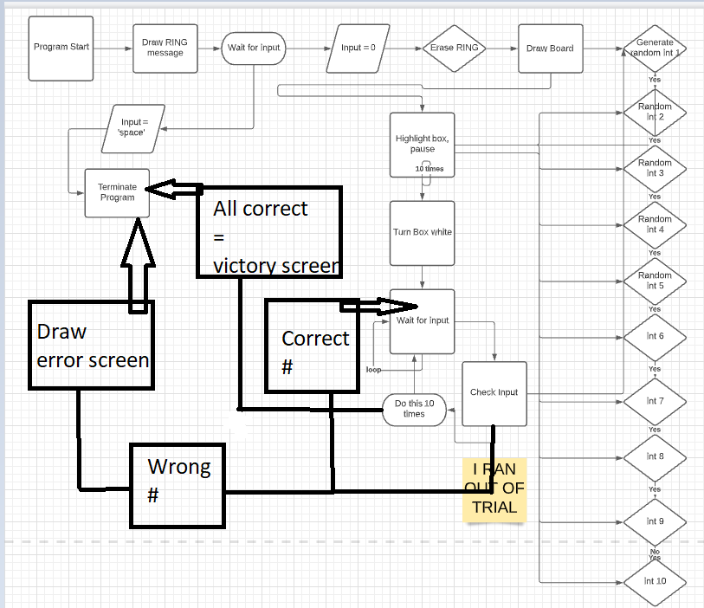

Halfway through the flow chart, my flow chart free trial ran out, so I had to finish in paint, ran out of space in paint so not detailed in the end. After the trial ran out, the pseudocode is:

code loops for 10 waiting for input. Input received? ->check input. Input correct? -> green message, restart loop. Else, error screen and terminate program.

PICTURES OF PROJECT

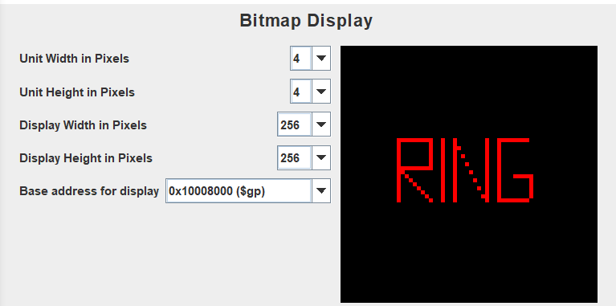

Set up of bitmap plus menu screen.

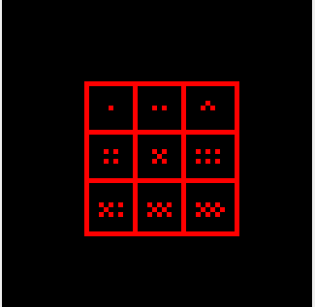 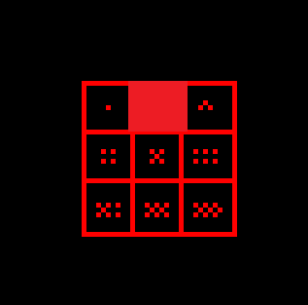

Number being highlighted

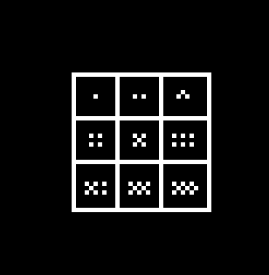The board looks like this, but is green instead when the input is correct, happens too fast to take picture…

 Wrong input, end screen

THINGS I WANT THE USER TO KNOW

1. Input slowly, wait for the box to be white when inputting, do not input when box is red or green, the program could mess up otherwise.
2. This game is really hard to win, that is why the winning screen is only a message, by the time I started drawing winning screen, I could not traverse the project easily, so it was hard for me to see if I am drawing right, since I would barely win at my own game.
3. Mips is sometimes slow, so the box sometimes looks glitchy.