***Mohammad Zeshan Khan’s website report***

**Section A:**

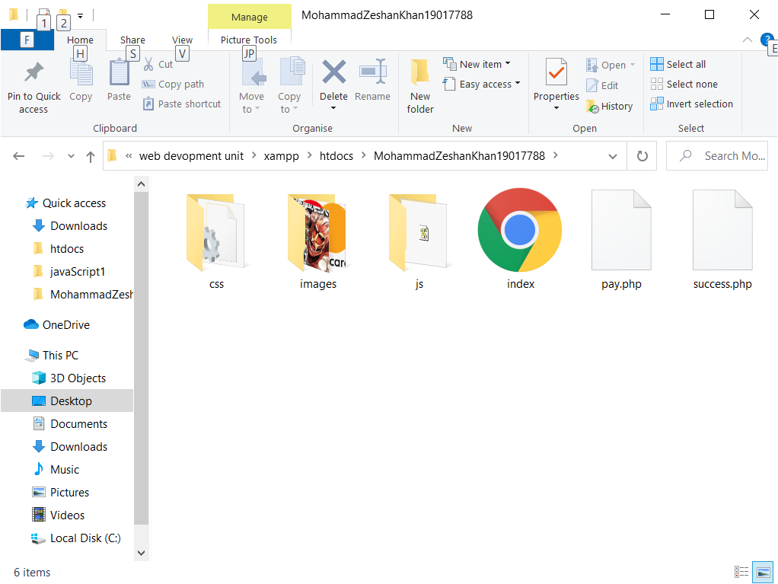

The coursework’s directory structure is that the pages are on the front of the directory, without any additional folders to place them in. Then the CSS, JavaScript and Images have been placed in their own separate folders. The folders have been linked using a tag that links them files together.

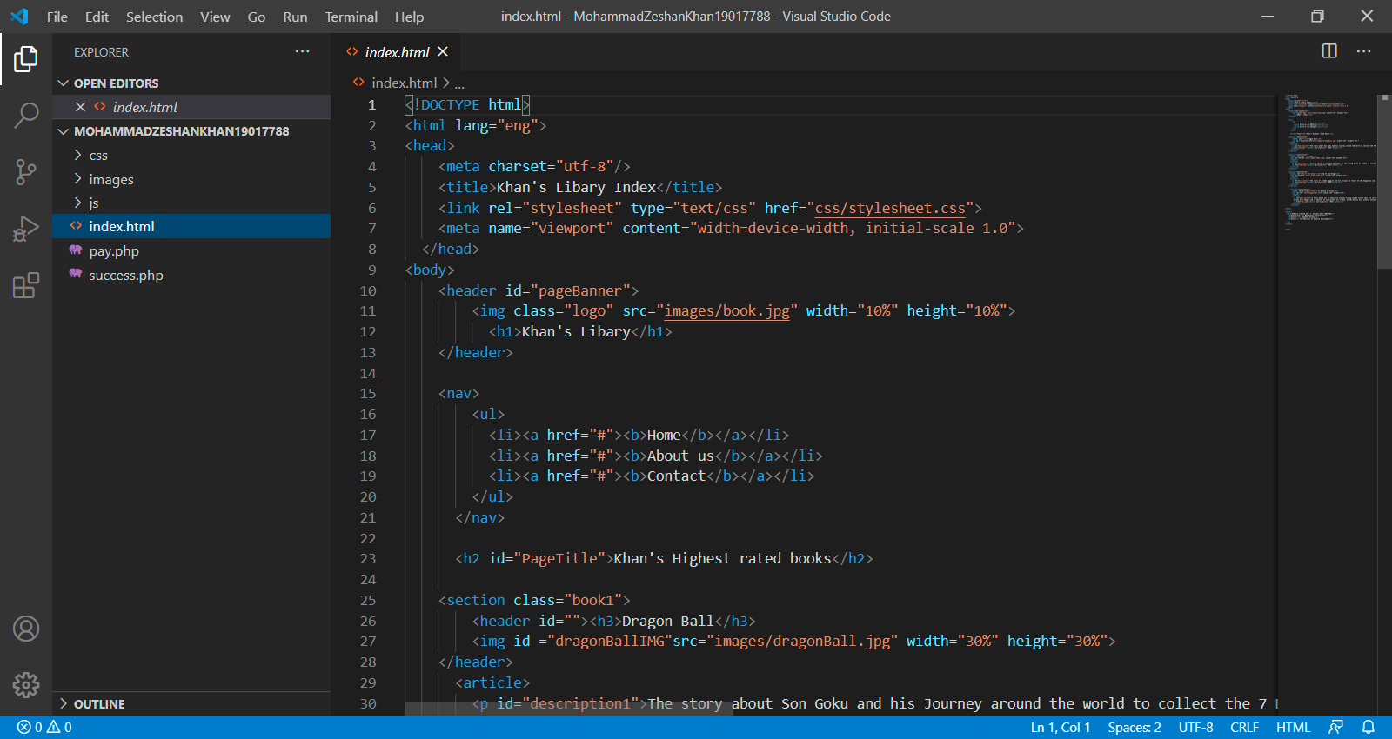

The image above shows the pages being linked to the CSS file. “Link rel” attribute tells the page that it is being linked to a stylesheet file. The “type” attribute indicates to the pages that it is a CSS file. And the “href” attribute tells the page where the CSS file is located



The image above shows how images in the “images” folder are being accessed. It is done by the “img” tag to the tell the page to load an image and the “src” attribute tells the page where to locate the image.

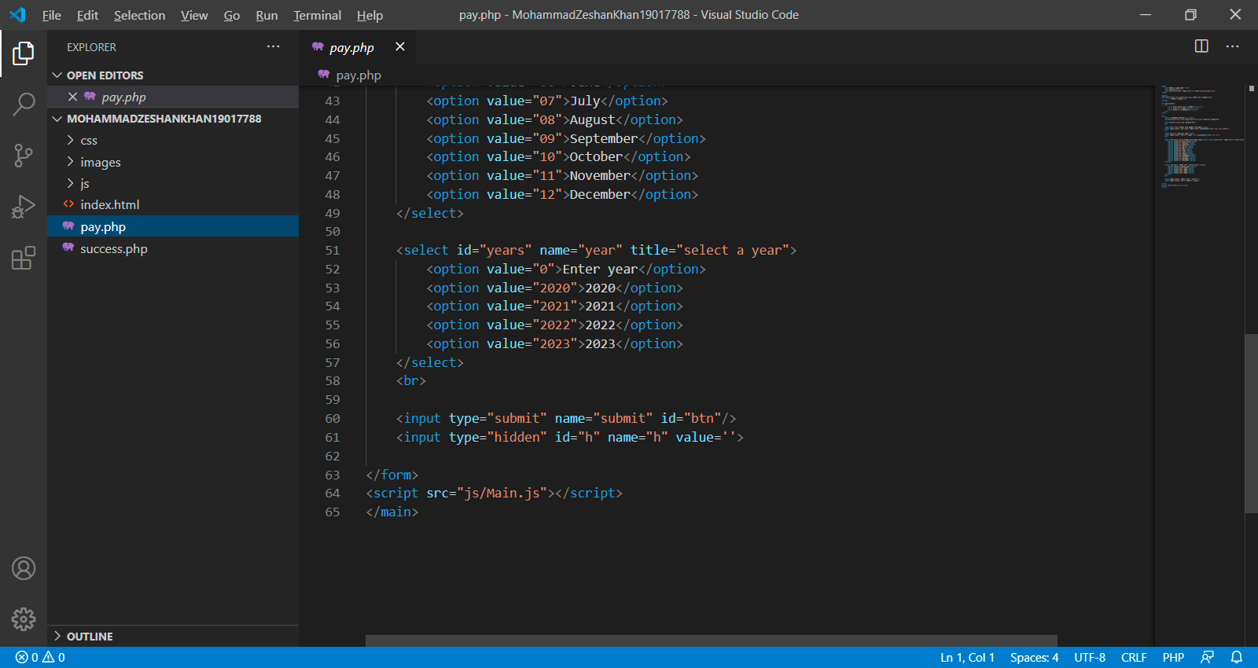

The image above shows how the page is connected to the JavaScript file. The “src” attribute specifies the URL of the JavaScript file.

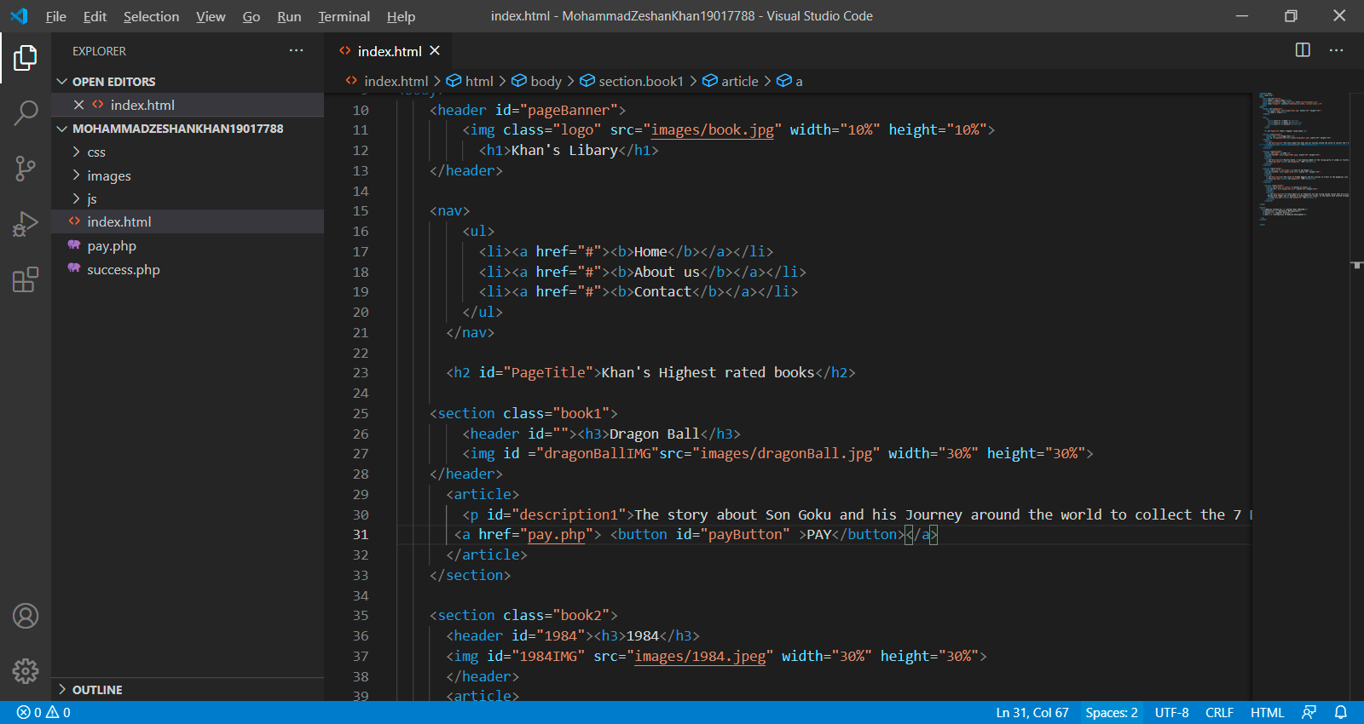

The image above shows how the index.html page and the pay.php are connected. It is done when the user clicks on a button that says “PAY”. When the user does this, they will be directed to the pay.php page.

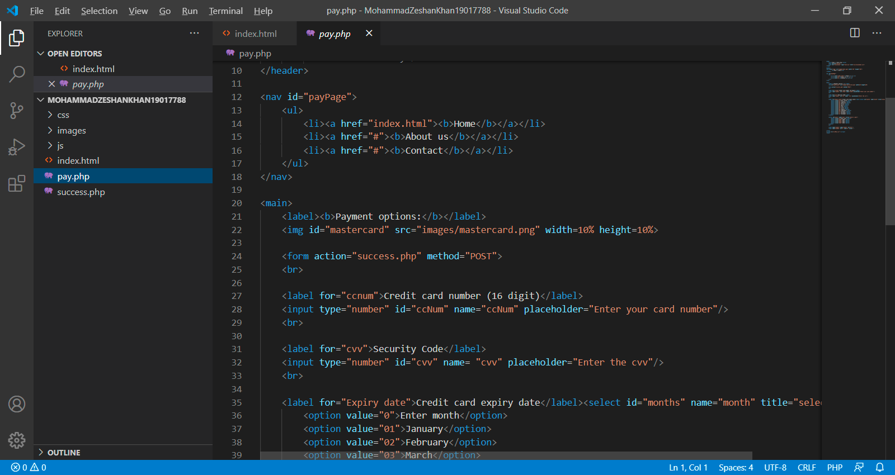

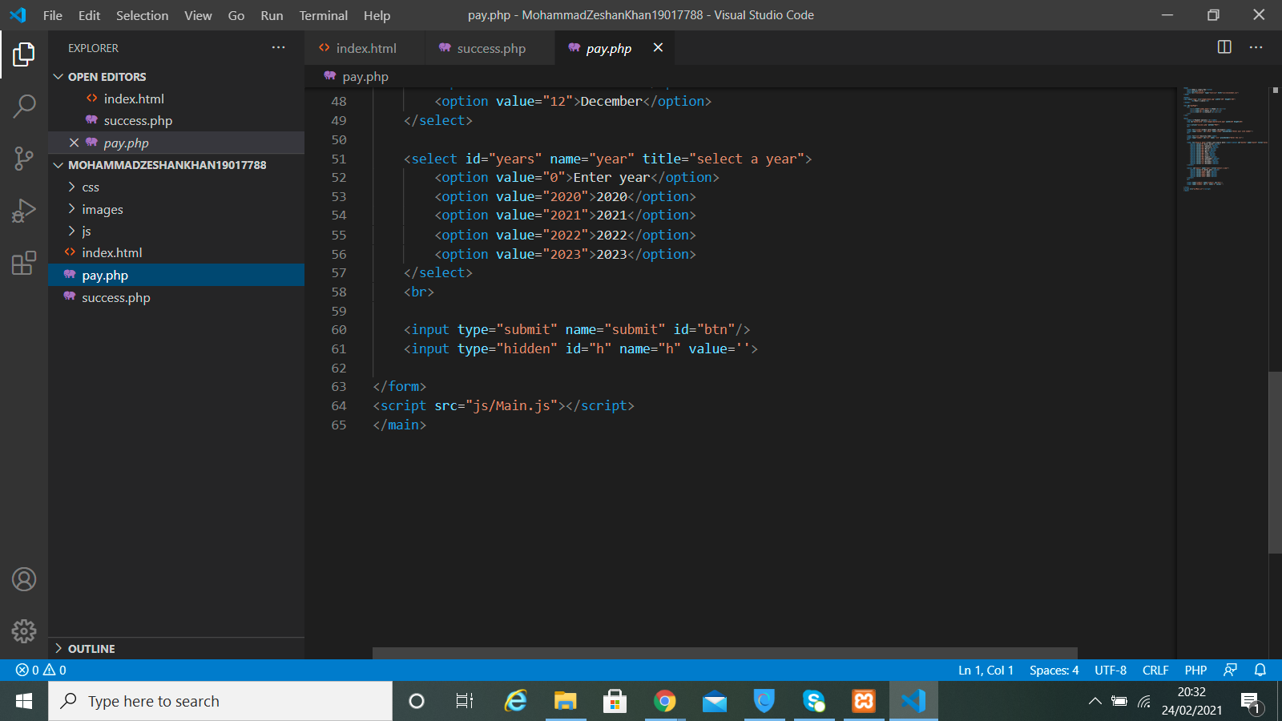

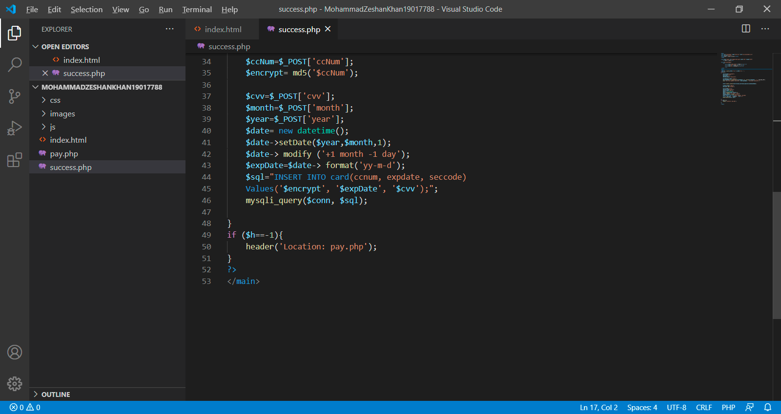

The above images show how the user will get directed to the success.php file. The form action on the pay.php file will direct them to the success.php when the user clicks on the button called submit. However, if the conditions in the linked JavaScript files are not met, the page will redirect the user back to the pay.php page again until the conditions are met.

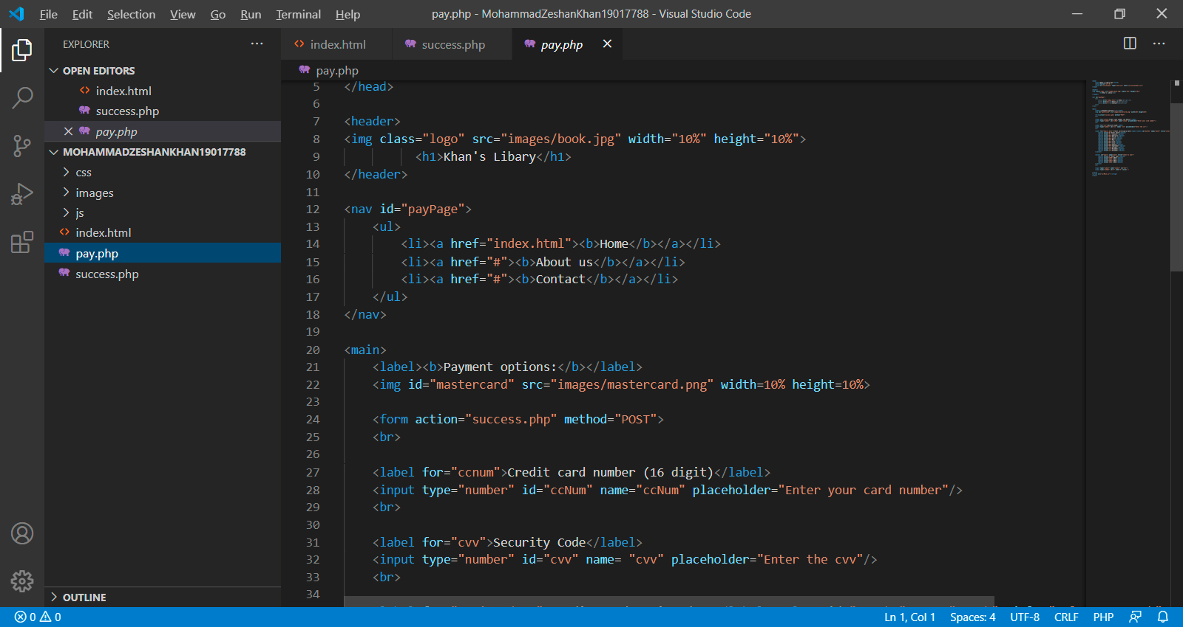

The above image shows the navigation link on the pay.php and success.php pages. If the user clicks on this link, it will redirect them to the index.html page. This link is also present on the index.html file.

**Section B:**

**Homepage:**

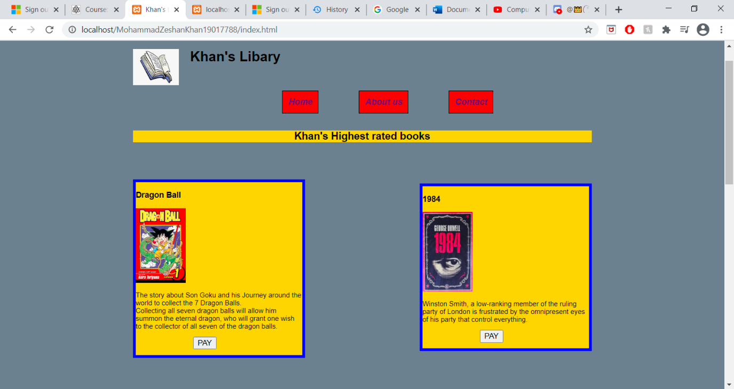

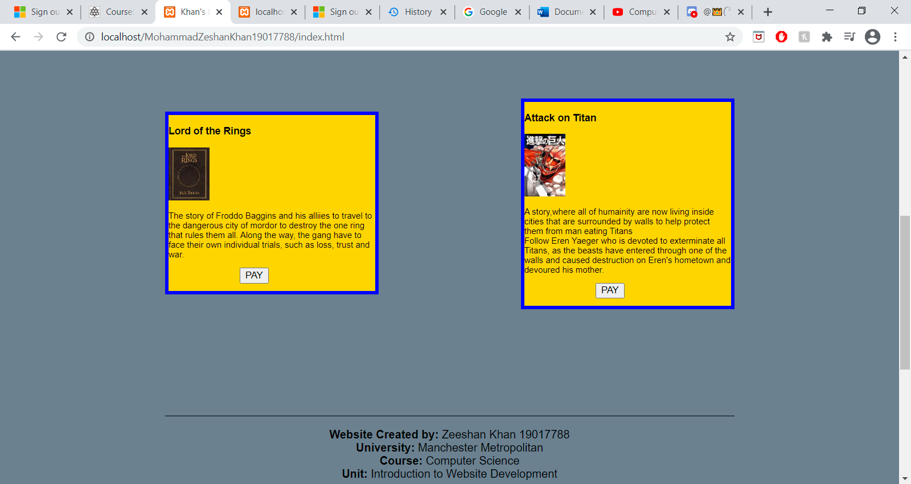

**Homepage mobile:**

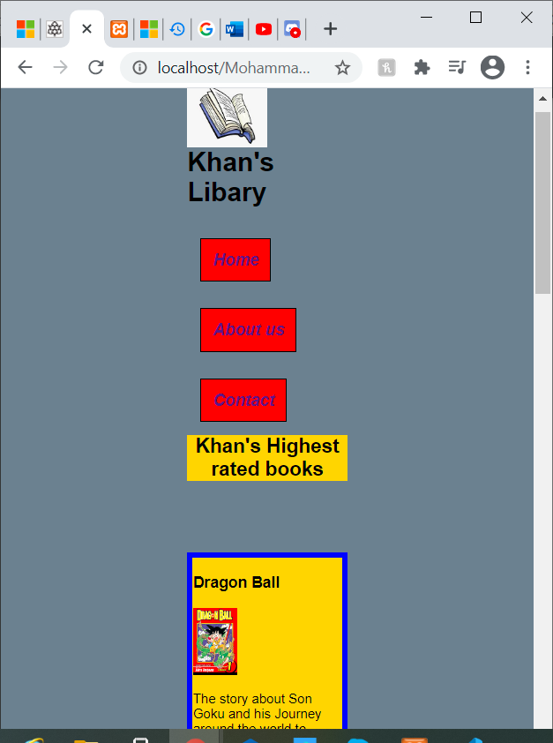

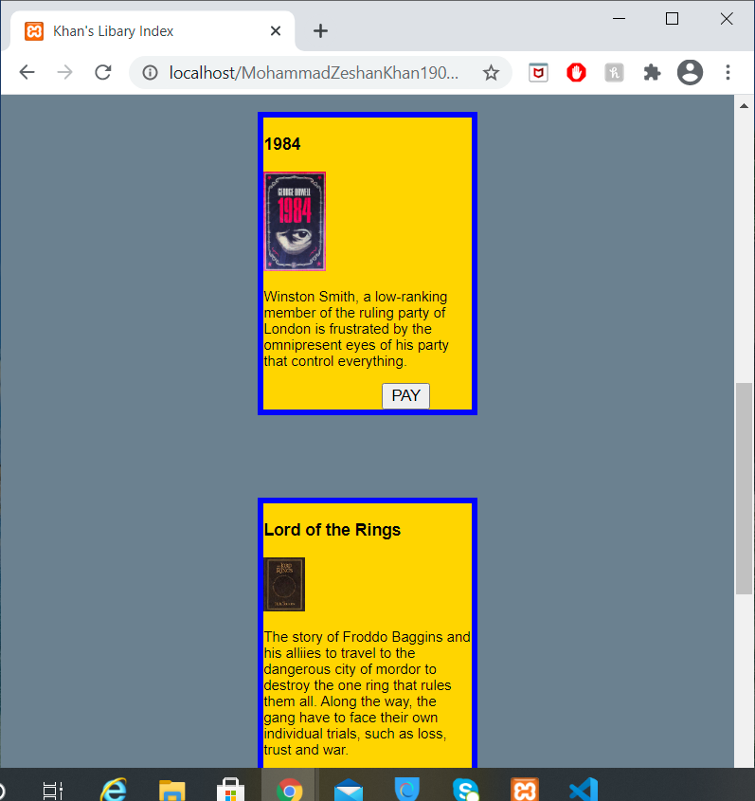

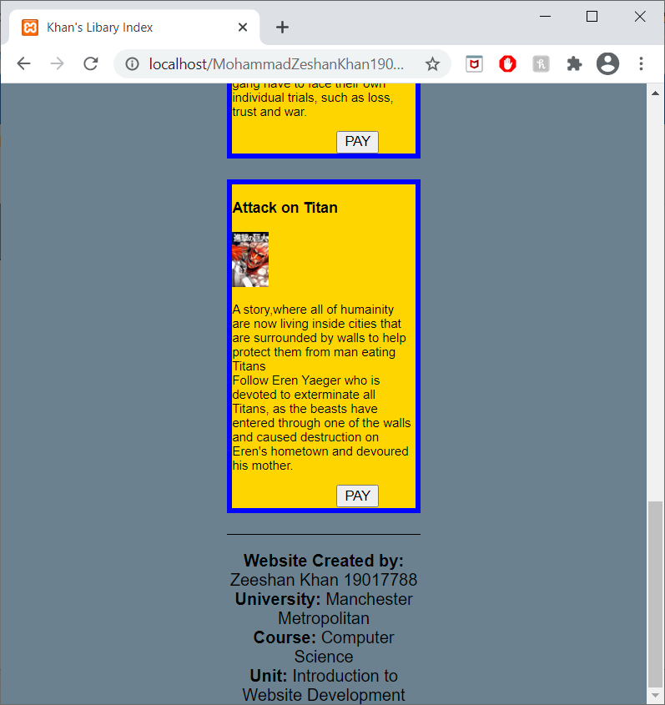

**Pay.php (if JavaScript fails)**

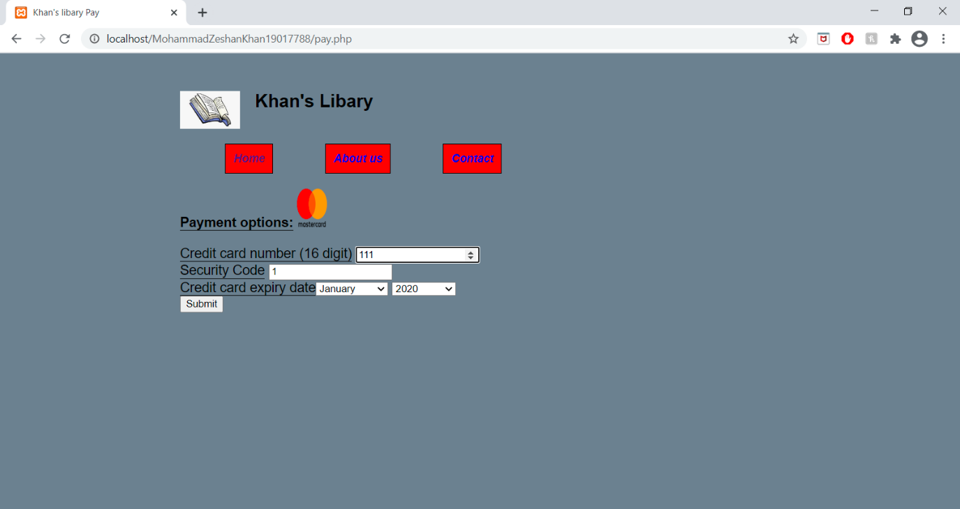

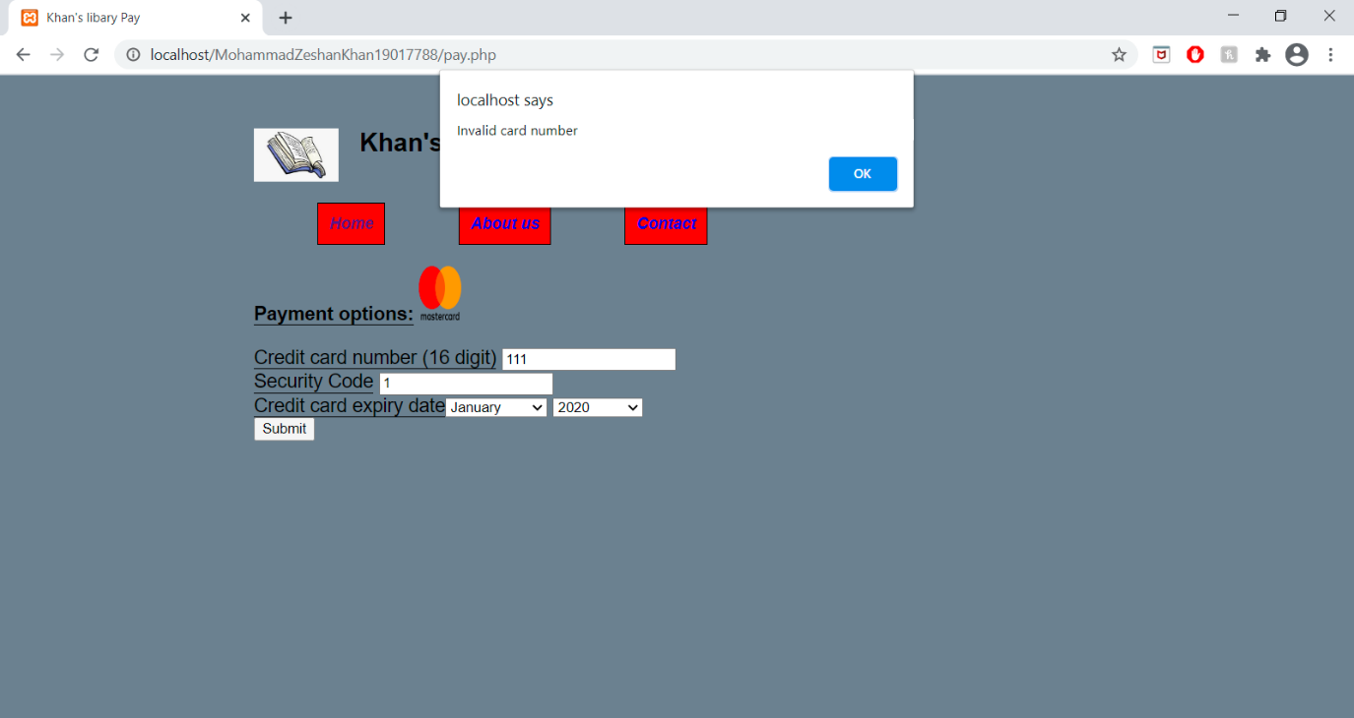

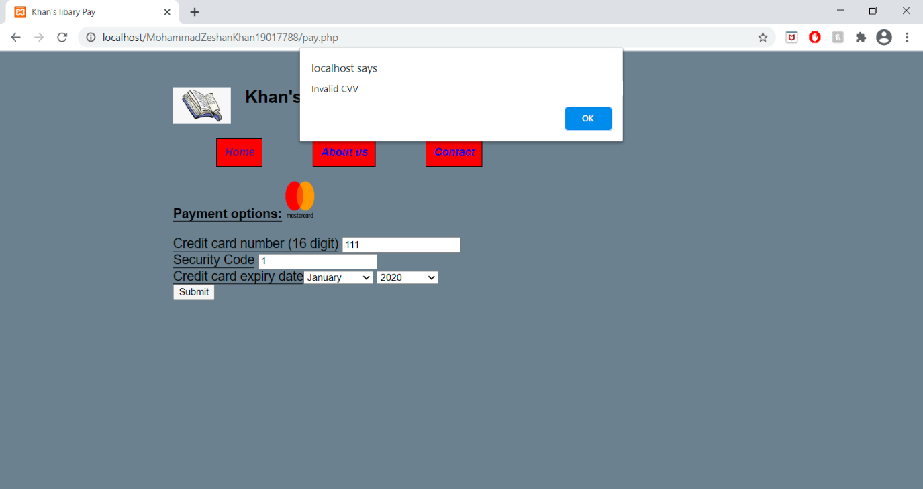

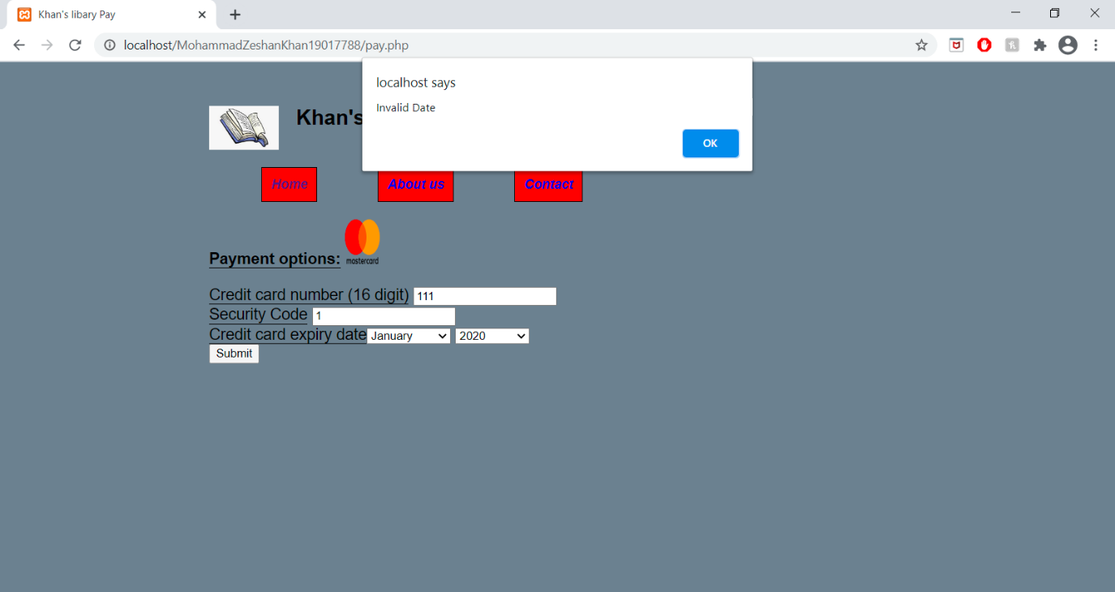

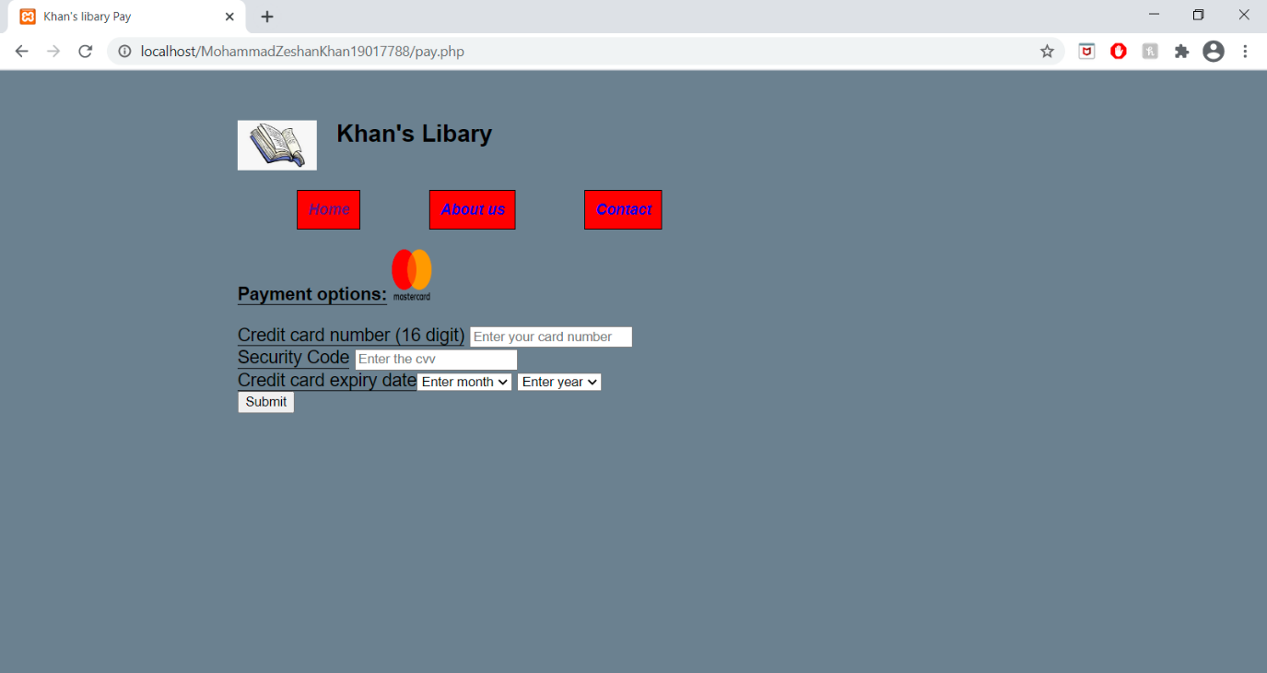

**Pay.php (if JavaScript is successful)**

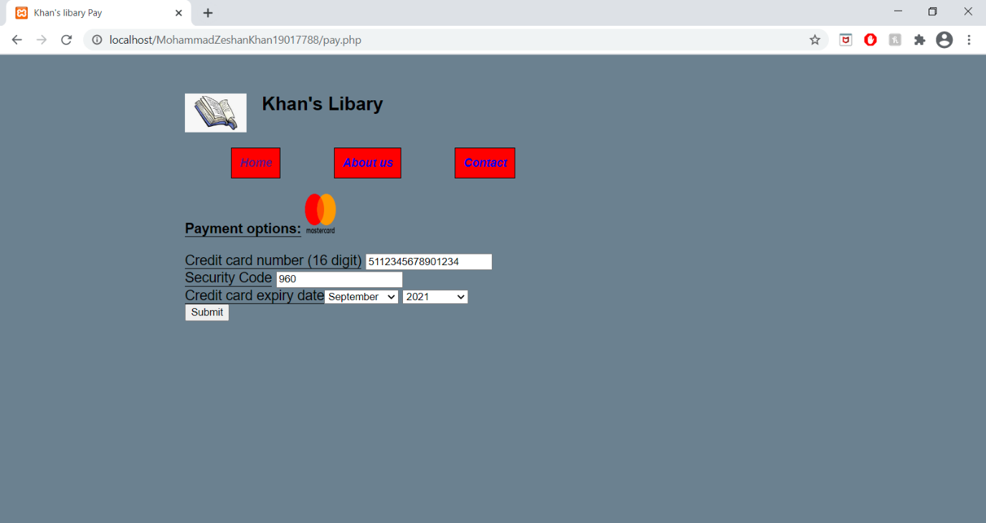

**Success.php**

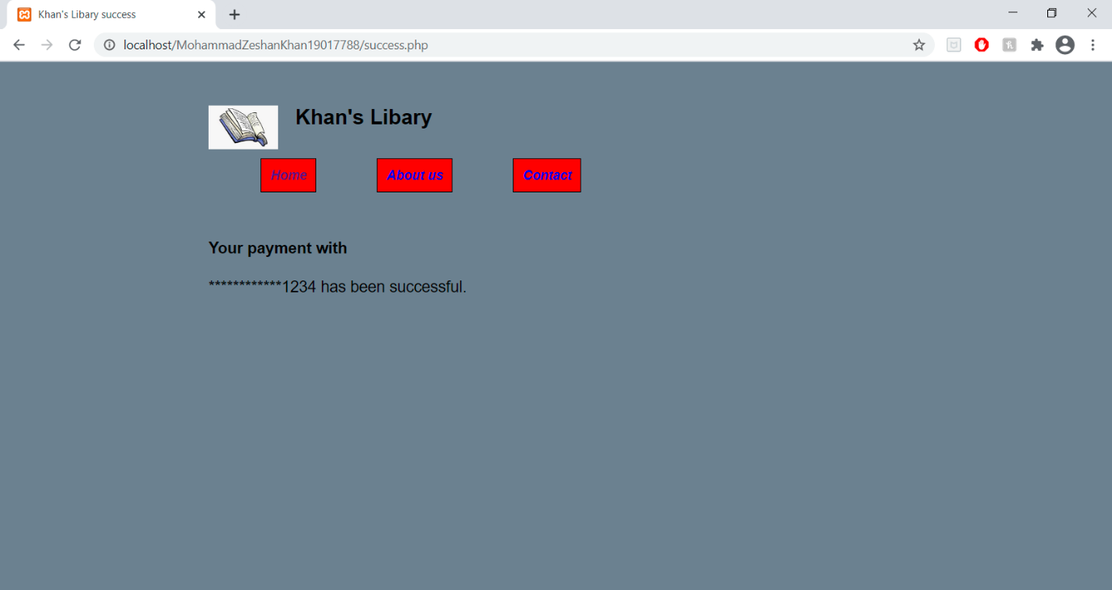

**Section C:**

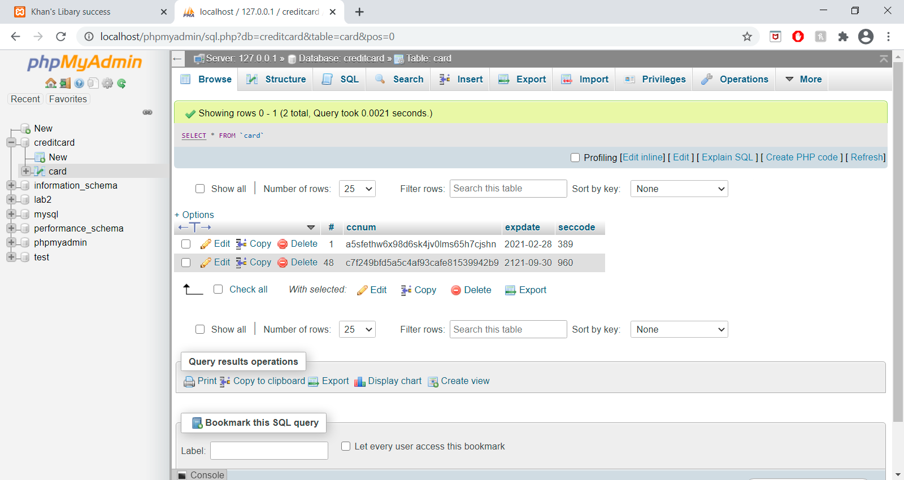

The second column is the card that was entered. It has been encrypted using md5.

**Section D**

**Images references**

<https://www.kindpng.com/imgv/ioxRxJi_open-book-cartoon-open-book-cartoon-png-transparent/>

<https://dragonball.fandom.com/wiki/List_of_Dragon_Ball_manga_chapters>

<https://www.penguin.com.au/books/1984-9780141036144>

<https://www.thereadinglists.com/darren-shan-reading-list/the-lord-of-the-rings-book-cover/>

<https://attackontitan.fandom.com/wiki/List_of_Attack_on_Titan_chapters>

**Index.html**

<!DOCTYPE html>

<html lang="eng">

<head>

<meta charset="utf-8"/>

<title>Khan's Libary Index</title>

<link rel="stylesheet" type="text/css" href="css/stylesheet.css">

<meta name="viewport" content="width=device-width, initial-scale 1.0">

</head>

<body>

<header id="pageBanner">

<img class="logo" alt="logo" src="images/book.jpg" width="10%" height="10%">

<h1>Khan's Libary</h1>

</header>

<br>

<h2 id="pageHeading">Homepage</h2>

<nav>

<ul>

<li><a href="index.html"><b>Home</b></a></li>

<li><a href="#"><b>About us</b></a></li>

<li><a href="#"><b>Contact</b></a></li>

</ul>

</nav>

<h2 id="PageTitle">Khan's Highest rated books</h2>

<section class="book1">

<header id=""><h3><strong>Dragon Ball</strong></h3>

<img id ="dragonBallIMG" alt="Dragon Ball image"src="images/dragonBall.jpg" width="30%" height="30%">

</header>

<article>

<p id="description1">The story about Son Goku and his Journey around the world to collect the 7 Dragon Balls. <br> Collecting all seven dragon balls will allow him summon the eternal dragon, who will grant one wish to the collector of all seven of the dragon balls.</p>

<a href="pay.php"> <button id="payButton" >PAY</button></a>

</article>

</section>

<section class="book2">

<header id="1984"><h3><strong>1984</strong></h3>

<img id="1984IMG" src="images/1984.jfif" alt="1984 image" width="30%" height="30%">

</header>

<article>

<p id="description2">Winston Smith, a low-ranking member of the ruling party of London is frustrated by the omnipresent eyes of his party that control everything.</p>

<a href="pay.php"><button id="payButton" >PAY</button></a>

</article>

</section>

<section class="book3">

<header id="Lord of the Rings"><h3><strong>Lord the rings</strong></h3>

<img id="LOTRIMG" src="images/LOTR.jfif" alt="Lord of the rings image" width="20%" height="20%">

</header>

<article>

<p id="description3">The story of Froddo Baggins and his alliies to travel to the dangerous city of mordor to destroy the one ring that rules them all. Along the way, the gang have to face their own individual trials, such as loss, trust and war.</p>

<a href="pay.php"><button id="payButton" >PAY</button></a>

</article>

</section>

<section class="book4">

<header id="Attack on Titan"><h3><strong>Attack on Titan</strong></h3>

<img id="AOT" src="images/AOT.jfif" alt="Attack on titan image" width="20%" height="20%">

</header>

<article>

<p id="description4">A story,where all of humainity are now living inside cities that are surrounded by walls to help protect them from man eating Titans<br>

Follow Eren Yaeger who is devoted to exterminate all Titans, as the beasts have entered through one of the walls and caused destruction on Eren's hometown and devoured his mother. </p>

<a href="pay.php"><button id="payButton" >PAY</button></a>

</article>

</section>

</body>

<footer>

<p><b>Website Created by:</b> Zeeshan Khan 19017788<br>

<b>University:</b> Manchester Metropolitan<br>

<b>Course:</b> Computer Science<br>

<b>Unit:</b> Introduction to Website Development<br>

</p>

</footer>

</html>

**Pay.php**

<header>

<img class="logo" alt="logo" src="images/book.jpg" width="10%" height="10%">

<h1>Khan's Libary</h1>

</header>

<br>

<h2 id="pageHeading">Payment</h2>

<nav id="payPage">

<ul>

<li><a href="index.html"><b>Home</b></a></li>

<li><a href="#"><b>About us</b></a></li>

<li><a href="#"><b>Contact</b></a></li>

</ul>

</nav>

<main>

<label><b>Payment options:</b></label>

<img id="mastercard" alt= "mastercard" src="images/mastercard.png" width=10% height=10%>

<form action="success.php" method="POST">

<br>

<label for="ccnum">Credit card number (16 digit)</label>

<input type="number" id="ccNum" name="ccNum" placeholder="Enter your card number"/>

<br>

<label for="cvv">Security Code</label>

<input type="number" id="cvv" name= "cvv" placeholder="Enter the cvv"/>

<br>

<label for="Expiry date">Credit card expiry date</label><select id="months" name="month" title="select a month">

<option value="0">Enter month</option>

<option value="01">January</option>

<option value="02">February</option>

<option value="03">March</option>

<option value="04">April</option>

<option value="05">May</option>

<option value="06">June</option>

<option value="07">July</option>

<option value="08">August</option>

<option value="09">September</option>

<option value="10">October</option>

<option value="11">November</option>

<option value="12">December</option>

</select>

<select id="years" name="year" title="select a year">

<option value="0">Enter year</option>

<option value="2020">2020</option>

<option value="2021">2021</option>

<option value="2022">2022</option>

<option value="2023">2023</option>

</select>

<br>

<input type="submit" name="submit" id="btn"/>

<input type="hidden" id="h" name="h" value=''>

</form>

<script src="js/Main.js"></script>

</main>

</html>

**Success.php**

<html lang="eng">

<head>

<link rel="stylesheet" type="text/css" href="css/stylesheet.css">

<meta charset="utf-8"/>

<title>Khan's Libary success</title>

</head>

<img class="logo" alt="logo" src="images/book.jpg" width="10%" height="10%">

<h1>Khan's Libary</h1>

<br>

<h2 id="pageHeading">Success</h2>

<nav id="successPage">

<ul>

<li><a href="index.html"><b>Home</b></a></li>

<li><a href="#"><b>About us</b></a></li>

<li><a href="#"><b>Contact</b></a></li>

</ul>

</nav>

<main>

<?php $h = isset($_POST['h']) ? $_POST['h']: '';

if($h==1)

{

$servername="localhost";

$username="root";

$password="";

$databaseName="creditcard";

$cardNumber=$_POST['ccNum'];

$encryptedNum= str_pad(substr($cardNumber,-4), strlen($cardNumber), '*', STR_PAD_LEFT);

echo "<h4> Your payment with</h4>". "<em> $encryptedNum </em>" . " has been successful.";

$conn= mysqli_connect($servername,$username,$password,$databaseName);

$ccNum=$_POST['ccNum'];

$encrypt= md5('$ccNum');

$cvv=$_POST['cvv'];

$month=$_POST['month'];

$year=$_POST['year'];

$date= new datetime();

$date->setDate($year,$month,1);

$date-> modify ('+1 month -1 day');

$expDate=$date-> format('yy-m-d');

$sql="INSERT INTO card(ccnum, expdate, seccode)

Values('$encrypt', '$expDate', '$cvv');";

mysqli_query($conn, $sql);

}

if ($h==-1){

header('Location: pay.php');

}

?>

</main>

</html>

**CSS**

body{

clear: left;

font-family: Arial, Helvetica, sans-serif;

font-size: 12px;

margin: 0 auto;

padding: 50px;

width: 800px;

background:#708090

}

.logo{

float: left;

margin-right: 20px;

position: relative;

}

pageBanner h1{

margin-left: 200px;

font-size: larger;

color: 0A4B54;

}

ul{

clear:left;

}

a{

text-decoration: none;

font-style: italic;

font-size: 15px;

}

ul li{

position: relative; left:200px;

float: left;

display: inline;

list-style-type: none;

width: auto;

margin: 10px 50px 30px 20px;

border: 1px solid black;

padding: 10px 10px 10px 10px;

background: red;

}

.tagline{

text-align: left;

padding-top: 10px;

font-size: 50px;

font-style: italic;

}

#PageTitle{

clear: left;

margin-top: 50px;

text-align: center;

background: gold;

}

section{

border: 5px solid blue;

box-sizing: border-box;

background: gold;

padding: 0 0 10px 0;

width: 300px;

clear: left;

display: inline;

}

.book1{

position: relative;

float: left;

margin-top: 50px;

margin-bottom: 20px;

}

.book2{

display: inline;

position: relative; bottom: 325px;

clear: left;

float: right;

}

.book3{

position: relative; bottom: 225px;

float: left;

clear: both;

}

.book4{

position: relative; bottom: 500px;

float: right;

clear: both;

}

#payButton{

position: relative; left: 100px;

}

footer{

clear: both;

position: relative; bottom: 350px;

width: auto;

border-top: 1px solid black;

text-align: center;

font-size: 16px;

}

@media (max-width: 700px)

{

body,p,header,ul,li,nav,a,h1,h2,h3,section,article,footer{

padding: 0;

}

#pageBanner h1{

position: relative;

}

body,main{

width: 30%;

}

.logo{

width: 50%;

height: 50%;

}

ul li{

margin: 1em 1em 1em 1em;

position: relative; left: auto;

margin: 1em 1em 1em 1em;

}

#PageTitle{

margin-top: 1em;

}

section{

width: auto;

margin-bottom: 20px;

display: table-column;

}

.book1 {

position: relative;

margin-bottom: 1px;

}

.book2{

position: relative; top :50px;

}

.book3{

position: relative; top :100px;

}

.book4{

position: relative; top :100px;

}

footer{

position: relative; top :100px;

}

#payPage{

clear: left;

position: relative; right: 100px;

}

#successPage{

display: inline;

}

#mastercard{

width:200%;

height: 25%;

}

}

.tagline{

position: relative;

}

#success{

clear: left;

}

#successPage{

position: relative; right: 200px;

}

#payPage {

position: relative; right: 200px; top: 10px;

}

label{

border-bottom: 1px solid black;

}

main{

float: left;

clear: left;

font-size: 150%;

}

**JavaScript**

btn.addEventListener('click', checkCard);

function checkCard()

{

let cardNumber=document.getElementById("ccNum").value;

let cvv=document.getElementById("cvv").value;

let patt1 = /^(?:5[1-5][0-9]{14})$/;

let patt2 = /^(?:[0-9]{3,4})$/;

let validCardNum=false;

let validCvv=false;

let month=document.getElementById("months").value;

let year=document.getElementById("years").value;

let today = new Date ();

let someDay= new Date();

let validDate=false;

someDay.setFullYear(year,month);

if(patt1.test(cardNumber)) {

validCardNum=true;

}

else{

alert("Invalid card number");

}

if(patt2.test(cvv)) {

validCvv=true;

}

else{

alert("Invalid CVV");

}

if(someDay< today) {

alert("Invalid Date")

}

else{

validDate=true;

}

if(validCardNum==true && validDate==true && validCvv==true){

document.getElementById("h").value = 1;

}

else{

document.getElementById("h").value= -1;

}

}

**Section E**

**Usability:**

* Navigation links are easy to get to because they are on the top of every page, which is a common place to put navigation links and they are quite big so they are easy to see.
* The information about the books on the index page is easy to find and read because every book has a border around them with a different background colour and are spaced out from each other. The background within the borders is gold, which allows the text within the borders to stand out.
* Every page also has a heading. This is useful because it makes it easier for the user to know what page they are on
* Buttons and input boxes have labels that explain what they do or what the user needs to put in them. This is useful because it makes it very easy for the user understand the purpose of these tags
* The website a responsive layout. This is beneficial for people with smaller displays, such as mobile phones, as the website will change to accommodate these users.
* The layout is simple to follow, where the title and navigation links are at the top and the main content is at the bottom. This is common way of presenting websites, which is beneficial for the user because it means they can easily click on the site and find the content they are looking for.

**Accessibility**

* All the pages have the language declared as English. This helps users display the content correctly.
* All the pages have a <title> tag that says what the page is. This is useful for users that rely on screen readers, as it clearly tells them what page they are on.
* Pages have different heading levels and have different alignments. This makes it easy to understand what order information should be read.
* Images have an <alt> tag with them. This would aid people who may have difficulty viewing the images.
* The <strong> tag has been used to emphasis important text for screen readers.