**Build a Model :**

1. **Task Description**

The HTML to PDF Converter project allows users to upload an HTML file and convert it into a PDF format. The application features a user-friendly interface with a background animation and displays the selected file name once a file is chosen. This project showcases the integration of Django with frontend technologies to create a dynamic web application.

1. **Task Output Screenshot**

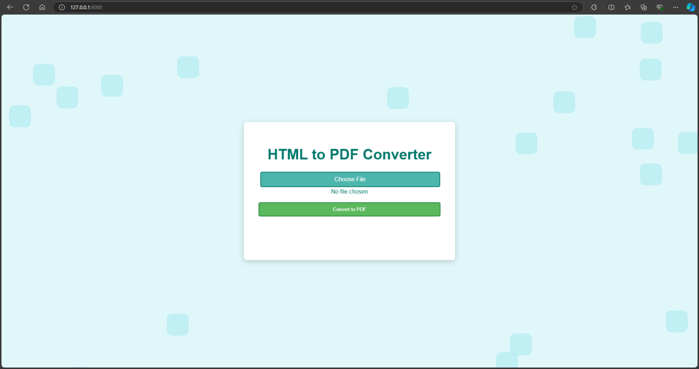

## Project Setup

### Starting the Project-

* The project was initiated using Django, a high-level Python web framework.
* A new Django project named pdf_converter was created
* A new app named converter was added

### Creating the Model-

## A simple model for handling uploaded HTML files was created. The model consists of a file field to store the uploaded HTML documents.

## User Interface Development

* The user interface was developed using HTML and CSS, creating a visually appealing form for file uploads.
* A custom file upload button was implemented to enhance user experience.
* The design features a background animation of moving cubes to create an engaging visual effect.

## Functionality Improvements

1. functionality was enhanced by implementing JavaScript to display the name of the selected file dynamically.
2. The project uses the WeasyPrint library to handle the conversion of HTML to PDF.

### Categorizing Inserted Data-

The uploaded files are categorized and stored in a designated directory within the project. The structure allows easy retrieval and management of uploaded HTML files.

## Conclusion

The HTML to PDF Converter project successfully demonstrates the integration of Django with frontend technologies to create a functional web application. It provides users with a seamless experience for converting HTML files into PDF format, with added visual enhancements and interactivity. Future improvements could include supporting more complex HTML/CSS structures and adding user authentication for enhanced security.